API Security Architecture Recommendation
Introducing Client ID Enforcement via Anypoint Exchange alongside Entra AD JWT Validation
Document Type | Architecture Recommendation / Options Paper
Prepared By | Integration Team
Target Audience | Development Team, Security Team, Platform Architects
Platform | MuleSoft Anypoint Platform — CloudHub 2.0
Status | Draft — For Review

1. Executive Summary
The current API security model relies exclusively on JSON Web Tokens (JWT) issued by Microsoft Entra AD (formerly Azure AD). While this provides strong identity authentication, it does not provide consumer-level API governance — meaning any caller with a valid Entra AD token can invoke any API without restriction, tracking, or per-consumer policy enforcement.

This document recommends augmenting the existing JWT validation with Client ID Enforcement using credentials issued by Anypoint Exchange. This dual-layer approach preserves the existing authentication trust model while unlocking per-consumer rate limiting, SLA tiers, analytics, and customer-specific restrictions at the API Gateway level.

2. Current State — JWT-Only Authentication
In the current architecture, API consumers authenticate solely via a Bearer JWT token obtained from Entra AD. The MuleSoft API Manager applies a JWT Validation policy to verify the token's signature against Entra AD's JWKS endpoint and validate standard claims (audience, issuer, expiry).
Current flow summary:
- Client obtains a JWT from Entra AD using Client Credentials or Auth Code flow
- Client submits request with Authorization: Bearer <JWT> header
- MuleSoft API Manager validates the JWT signature and claims
- On success, the request is forwarded to the MuleSoft API implementation
- Backend systems have no visibility of the originating consumer application
Identified gaps:
- No per-consumer identity registered in Anypoint Exchange — all callers are anonymous at the API layer
- Rate limiting and SLA tier policies cannot be scoped per consumer application
- API Analytics in Anypoint does not distinguish between different consumer apps
- Revoking access for one consumer requires changes to Entra AD, impacting all their tokens
- Customer-specific restrictions (e.g. allowed API endpoints, data scope) are not enforceable without custom code

3. Proposed State — JWT + Client ID Enforcement
The recommendation is to register all API consumers as applications in Anypoint Exchange and require them to pass their Exchange-issued Client ID in the x-client-id request header (in addition to the existing Bearer JWT). API Manager is configured with two policies applied in sequence:

# | Policy | Purpose | Credential Source
1 | JWT Validation | Validates the Bearer JWT signature and claims against Entra AD JWKS. Ensures the caller is a legitimate Entra AD principal. | Microsoft Entra AD (JWKS)
2 | Client ID Enforcement | Validates the x-client-id header against registered applications in Anypoint Exchange. Enables per-consumer governance, SLA tiers, rate limiting, and analytics. | Anypoint Exchange (App Registry)

4. Architecture Flow Diagram
The diagram below illustrates both the current state (JWT-only) and the proposed state (JWT + Client ID Enforcement), showing the policy evaluation sequence and consumer registration model.

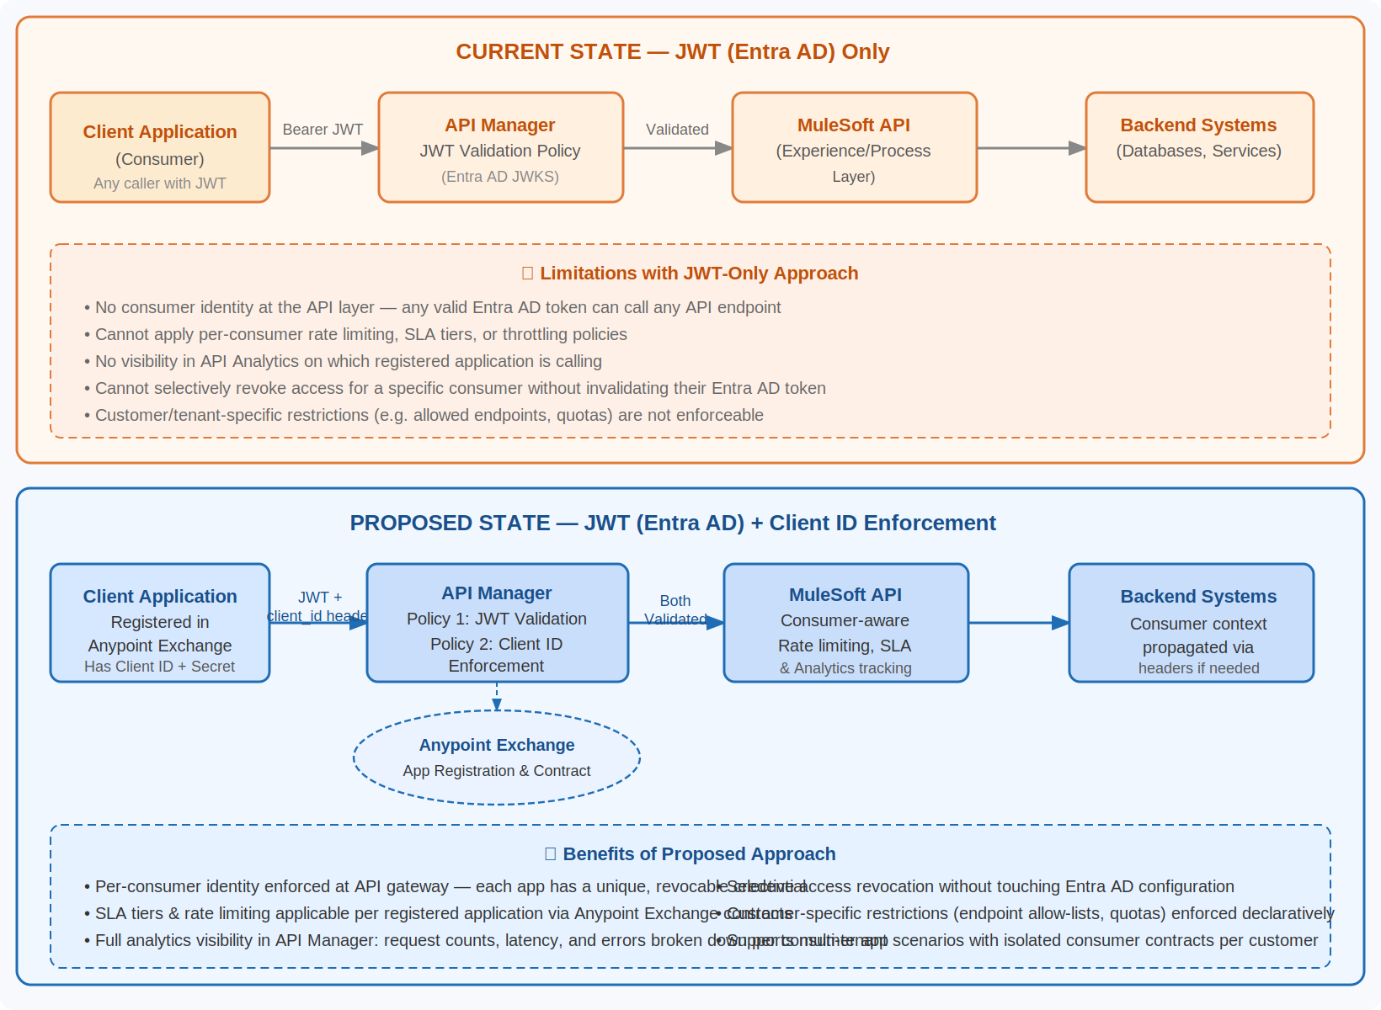
Figure 1 — Current vs Proposed API Security Flow

5. Advantages & Reasoning
The following table details the key benefits that Client ID Enforcement brings to the platform, along with the business and technical impact of each:

# | Capability | Description | Business Impact
1 | Per-Consumer Identity | Each registered application in Exchange is assigned a unique Client ID. API Manager validates this credential independently of the JWT, establishing a distinct API-layer identity for every consumer. | Full accountability — every API call is attributable to a specific registered app
2 | Selective Access Revocation | An application's Exchange credentials can be revoked or suspended without touching Entra AD. This allows immediate, targeted removal of API access for a specific consumer. | Reduces incident response time; no blast radius on other consumers
3 | SLA Tiers & Rate Limiting | Anypoint Exchange contracts support SLA tier assignment per application. Rate limiting and throttling policies in API Manager can be scoped per Client ID, enabling differentiated service levels. | Enables commercial tiering (e.g. free vs premium consumers) and abuse prevention
4 | API Analytics Visibility | Anypoint API Manager analytics track request volumes, error rates, and latency broken down by Client ID. This is not possible with JWT-only authentication where callers are indistinguishable. | Operational intelligence per consumer; easier troubleshooting and capacity planning
5 | Customer-Specific Restrictions | Custom policies or routing logic can reference the Client ID to enforce customer-specific rules: allowed endpoint lists, data scope restrictions, or tenant-specific configurations. | Supports multi-tenant product models and customer SLA guarantees
6 | Decoupled Credential Lifecycle | Client ID credentials in Exchange have their own lifecycle (create, rotate, expire) independent of the Entra AD application registrations. This provides defence-in-depth. | Reduces coupling between IdP and API governance; supports zero-trust principles

6. Implementation Approach

6.1 Application Registration
- Register each API consumer as an application in Anypoint Exchange under the relevant environment (e.g. Production, UAT)
- Issue a Client ID and Client Secret to each registered application via Exchange
- Communicate credentials to the consumer team securely (do not embed in source control)

6.2 API Manager Policy Configuration
- Apply Client ID Enforcement policy to the API instance in API Manager
- Configure the policy to read credentials from the x-client-id header (and optionally x-client-secret if mutual secret validation is required)
- Set policy order: JWT Validation executes first, Client ID Enforcement second
- Configure SLA tier assignments for each application contract as required

6.3 Consumer Integration
- Consumer applications include the x-client-id header in every API request alongside the existing Authorization: Bearer <JWT> header
- No changes required to the JWT acquisition flow from Entra AD
- Header name can be customised in the Client ID Enforcement policy if required to match existing conventions

6.4 Considerations
- Client Secret in header is optional — Client ID alone is sufficient for enforcement; include the secret only if a second shared-secret factor is desired
- Ensure the Client ID Enforcement policy is applied consistently across all API instances that require consumer governance
- For automated deployments, the policy application should be scripted via Anypoint CLI or REST API as part of the CI/CD pipeline

7. Recommendation
It is recommended to proceed with implementing Client ID Enforcement via Anypoint Exchange across all externally consumed APIs. The change is additive — it augments rather than replaces the existing Entra AD JWT validation — and introduces no breaking change to the JWT authentication flow consumers already rely on.

The net result is a significantly more governable API platform: access is attributable, revocable, ratable, and observable at the individual consumer level. These are standard capabilities in enterprise API management and align with MuleSoft Anypoint Platform's intended operating model.

Priority: High — recommended for inclusion in the next platform hardening sprint.

