MuleSoft API Patterns
& Policy Recommendation Guide

Architecture, Governance & Best Practices

Version 1.0 | March 2026
CONFIDENTIAL – Internal Use Only

Table of Contents

1. Introduction
This document provides comprehensive recommendations for designing, securing, and governing MuleSoft APIs. It covers API Manager policy patterns, architectural tier selection, header management strategies, and communication patterns including synchronous, asynchronous, and event-driven approaches. The goal is to establish a consistent, secure, and performant API ecosystem across the organisation.

2. API Architecture Tiers
MuleSoft’s Anypoint Platform promotes a layered API architecture. Choosing the right number of layers depends on the complexity of your integration landscape, reuse requirements, and governance needs. The diagram below illustrates the four architecture patterns from simplest to most comprehensive.

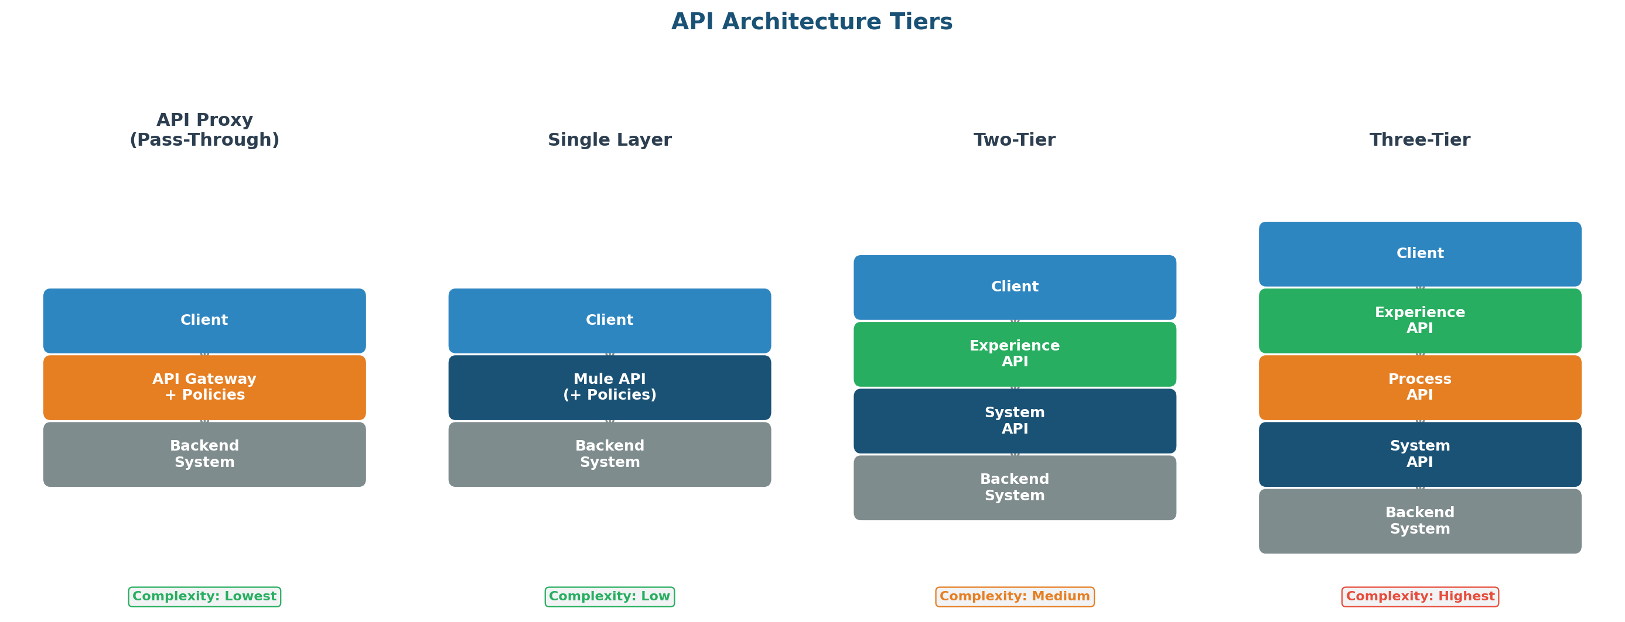
Figure 1: API Architecture Tiers — from API Proxy to full Three-Tier API-Led Connectivity

2.1 Single-Layer Architecture (API Proxy / Pass-Through)
A single-layer architecture is used when an existing backend system already exposes a well-designed API and you only need to apply governance, security policies, or traffic management on top of it without transformation logic.

When to use:
- The backend already has a stable, well-documented REST or SOAP API that clients can consume directly.
- No data transformation, orchestration, or enrichment is required between the client and the backend.
- The primary need is to front the API with Anypoint API Manager for policy enforcement such as rate limiting, client ID enforcement, or IP whitelisting.
- You need a quick, low-effort way to expose a SaaS or legacy system through the Anypoint gateway.
- There is no foreseeable requirement for reusability of the data by other APIs or consumers.

✔ Example Scenario
A third-party SaaS vendor exposes a REST API for order lookup. You create an API Proxy in API Manager
to enforce client credentials and rate limiting without writing any Mule application code.

2.2 Two-Tier Architecture (Experience + System / Process + System)
A two-tier architecture introduces a separation between the consumer-facing layer and the backend integration layer. This is appropriate when moderate transformation or aggregation is needed but the domain is not complex enough to justify a full three-tier model.

When to use:
- You need to transform, filter, or reshape backend responses before exposing them to clients, but there is no shared business logic that other APIs would reuse.
- You are aggregating data from two or three backend systems into a single consumer-facing API.
- The project scope is limited to a single domain such as customer or order, and the integration complexity is moderate.
- You want to decouple the client contract from the backend contract to allow independent evolution, but adding a middle orchestration layer would be over-engineering.

2.3 Three-Tier Architecture (Experience + Process + System)
The full three-tier architecture is MuleSoft’s recommended API-led connectivity approach. It separates concerns into Experience APIs (channel-specific), Process APIs (business logic and orchestration), and System APIs (backend connectivity).

When to use:
- Multiple consumer channels such as web, mobile, partner portals, and internal tools need different views of the same underlying data.
- Shared business logic exists, for example order validation, eligibility checks, or pricing rules, that multiple Experience APIs should reuse rather than duplicate.
- The integration involves five or more backend systems with complex orchestration, compensation, or saga patterns.
- Your organisation has an API Centre of Excellence and wants to build a reusable asset catalogue where Process and System APIs serve as building blocks.
- Governance, versioning, and lifecycle management require clear ownership boundaries between teams.

2.4 Architecture Selection Decision Tree
Use the following decision tree to determine the appropriate architecture tier for any given integration scenario. Start at the top and follow the branches based on your requirements.

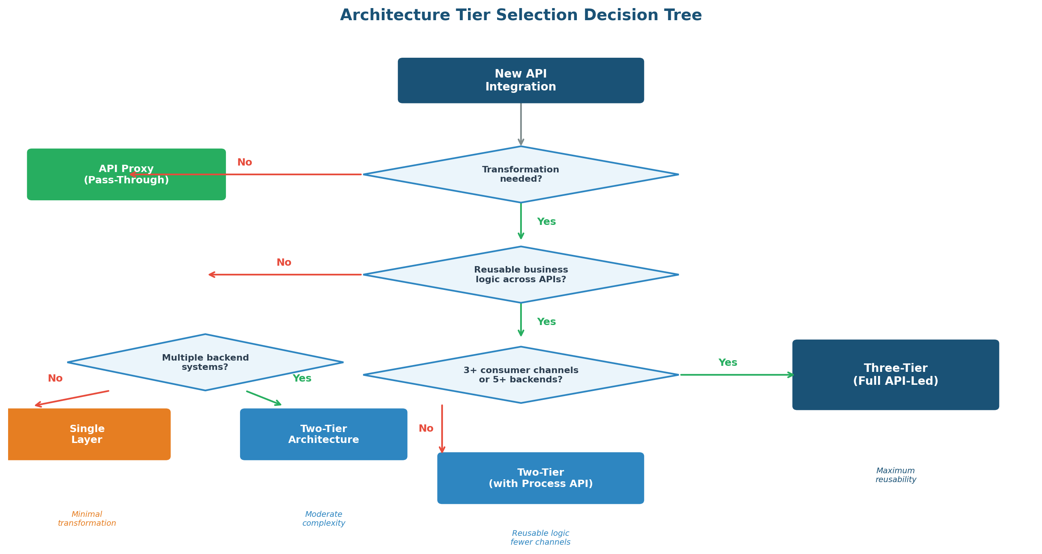
Figure 2: Architecture Tier Selection Decision Tree

2.5 Architecture Selection Decision Matrix
The table below provides a quick-reference comparison across key criteria for each architecture tier.

Criteria | Single Layer | Two-Tier | Three-Tier | Key Consideration
Backend transformation needed | None | Moderate | Complex | Extent of data reshaping
Number of backend systems | 1 | 2–3 | 4+ | Integration complexity
Reusable business logic | No | Minimal | Significant | Process API justification
Consumer channels | 1 | 1–2 | 3+ | Experience API variations
Time to market priority | Highest | Balanced | Invest upfront | Speed vs reusability trade-off
Team structure | Single team | Small team | Multiple teams | Ownership boundaries

3. API Manager Policy Patterns
Anypoint API Manager provides a rich set of out-of-the-box policies that can be applied to APIs without modifying application code. This section details when and how to apply each policy pattern.

3.1 Client ID Enforcement
Client ID Enforcement is the foundational access control policy. It requires every API consumer to register an application in Anypoint Exchange and obtain a client_id and client_secret pair. This is the minimum policy that should be applied to every API exposed through the gateway.

When to apply:
- Every API that is published to Anypoint Exchange and accessible via the API gateway, with no exceptions.
- Internal APIs that are consumed by other MuleSoft applications within the same organisation.
- Partner and external APIs where you need an audit trail of which consuming application is making requests.
- As the base layer before adding other policies such as rate limiting or SLA-based tiers on top.

How it works: Consumers must pass client_id and client_secret either as HTTP headers (X-Client-Id / X-Client-Secret), as query parameters, or encoded in a Bearer token. The gateway validates these credentials against the registered application in API Manager.

⚠ Best Practice
Always pass credentials in HTTP headers rather than query parameters. Query parameters appear
in server access logs and browser history, increasing the risk of credential leakage.

3.2 Rate Limiting
Rate Limiting restricts the number of requests a client can make within a defined time window. This protects backend systems from being overwhelmed and ensures fair usage across all API consumers.

When to apply:
- All externally facing APIs where you cannot fully control the behaviour of consuming applications.
- APIs that connect to backend systems with known throughput limitations such as legacy mainframes or ERP systems.
- APIs in shared environments where one consumer’s traffic spike could degrade service quality for others.
- During initial API launches when actual traffic patterns are unknown, as a safety net.

Configuration guidance:
- Set limits based on backend capacity testing. If the backend handles 500 TPS, set the aggregate limit to 400 TPS for headroom.
- Use per-client limits when individual consumer fairness matters. Use aggregate limits when overall backend protection is the priority.
- Start with generous limits and tighten based on observed traffic patterns from API Analytics.
- Always return a 429 Too Many Requests response with a Retry-After header.

3.3 SLA-Based Rate Limiting
SLA-based rate limiting extends basic rate limiting by assigning different throughput limits to different consumer tiers. This enables a tiered API offering where premium consumers get higher throughput.

When to apply:
- You have multiple classes of consumers such as free-tier, standard, and premium who need different levels of access.
- Monetised APIs where throughput is a differentiating factor in the commercial offering.
- Partner APIs where strategic partners require higher limits than general partners.
- Internal APIs where mission-critical applications need guaranteed throughput.

SLA tier example:

Tier | Rate Limit | Approval | Use Case
Free / Basic | 100 req/min | Auto-approved | Exploration, sandbox, PoC
Standard | 500 req/min | Auto-approved | Production internal apps
Premium | 2000 req/min | Manual approval | High-traffic production, partners
Unlimited | No limit | Manual approval | Mission-critical internal systems

3.4 When to Use Rate Limiting vs SLA-Based Tiers

Factor | Simple Rate Limiting | SLA-Based Tiers
Consumer diversity | All consumers are equal | Different consumer classes
Commercial model | Internal or flat-fee | Tiered pricing / monetisation
Management overhead | Low (single config) | Higher (tier lifecycle)
Backend protection need | Uniform protection | Differentiated access

3.5 Policy Selection Decision Flowchart
The following flowchart guides you through the decision process for selecting which policies to apply to any new API. Start at the top and follow each decision branch.

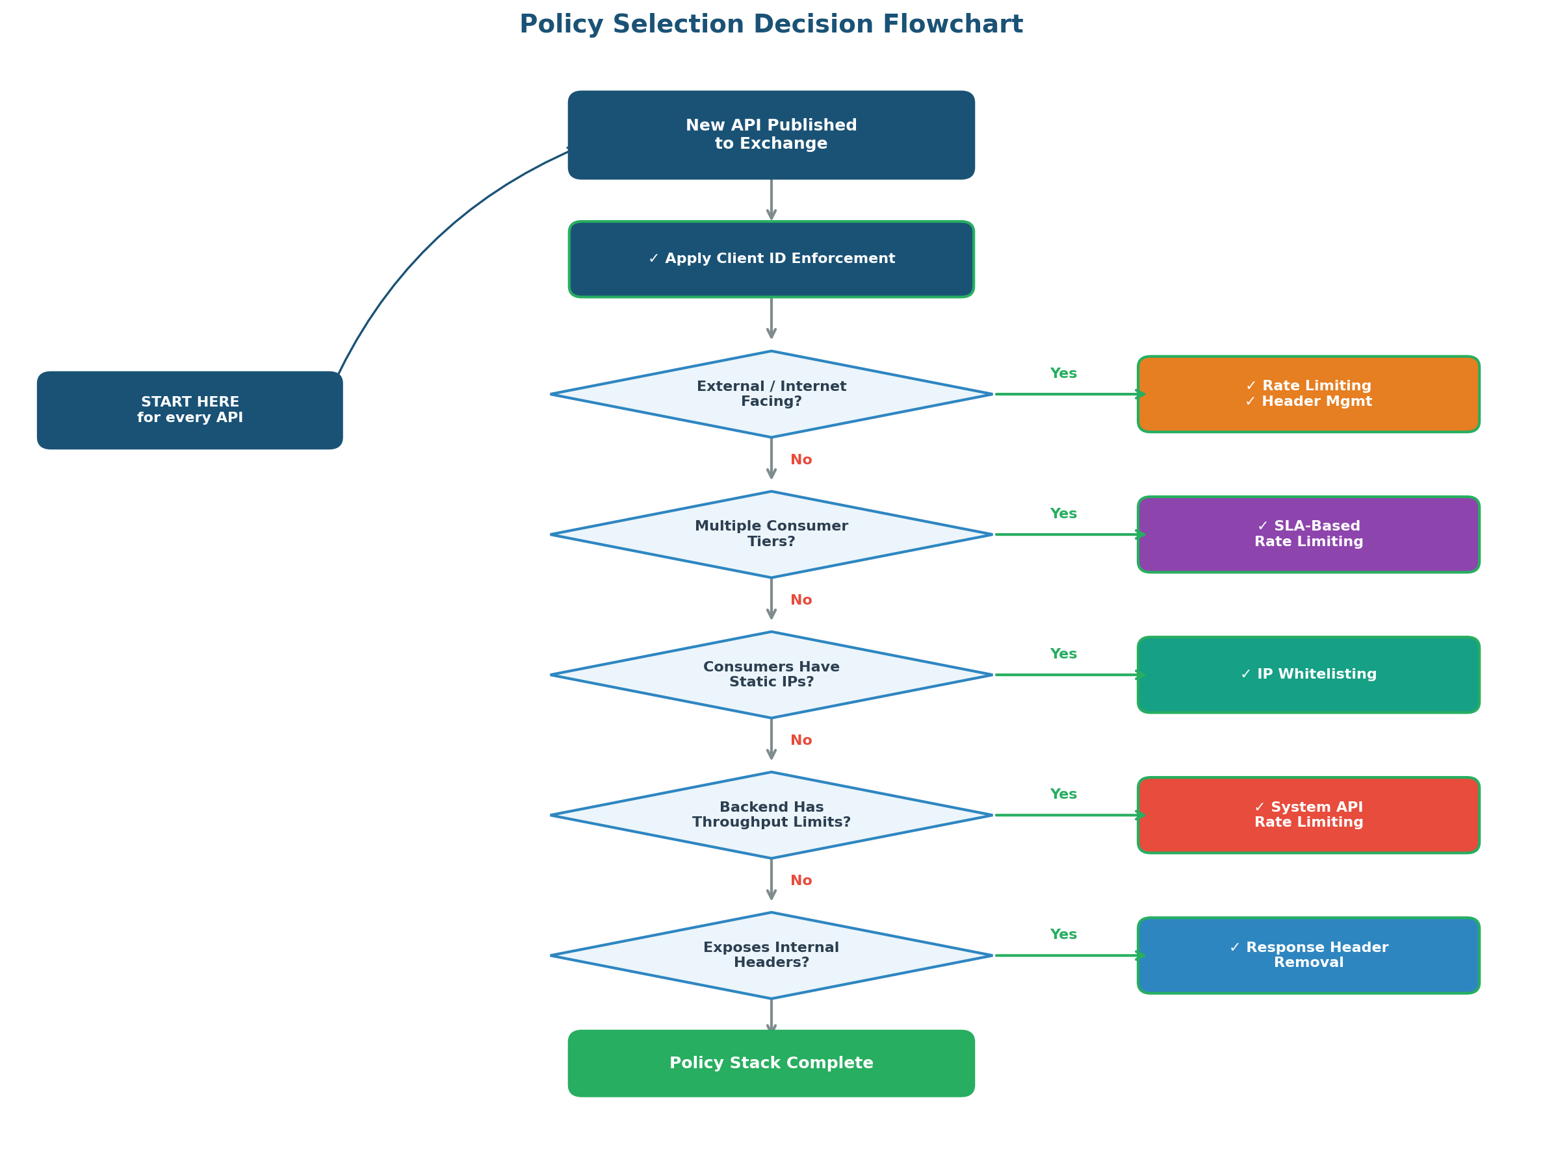
Figure 3: Policy Selection Decision Flowchart

3.6 IP Whitelisting / IP Allowlisting
IP whitelisting restricts API access to requests originating from a predefined set of IP addresses or CIDR ranges. This adds a network-level security layer on top of application-level authentication.

When to apply:
- Partner and B2B integrations where partners connect from known, static IP addresses.
- System-to-system APIs called only by specific on-premises servers, VPN endpoints, or known cloud infrastructure.
- Compliance-driven scenarios where regulations require network-level access controls (PCI-DSS, HIPAA).
- APIs that expose sensitive data such as PII, financial records, or health data.
- When you need to ensure API access comes only from your corporate network or approved partner networks.

When NOT to apply:
- Mobile or web consumer-facing APIs where end users connect from dynamic IP addresses.
- APIs consumed by serverless or auto-scaling cloud infrastructure where IP addresses change frequently.
- As the sole security mechanism — IP whitelisting should always complement, never replace, authentication.

⚠ Important Consideration
IP whitelisting requires ongoing maintenance. Establish a process for partners to request IP changes
and document the approval workflow. Use CIDR ranges rather than individual IPs where possible.

3.7 Header Management Policies
Header management policies control which HTTP headers are forwarded between the client, the API gateway, and the backend systems. Proper header hygiene prevents information leakage, reduces the attack surface, and ensures only necessary metadata flows between layers.

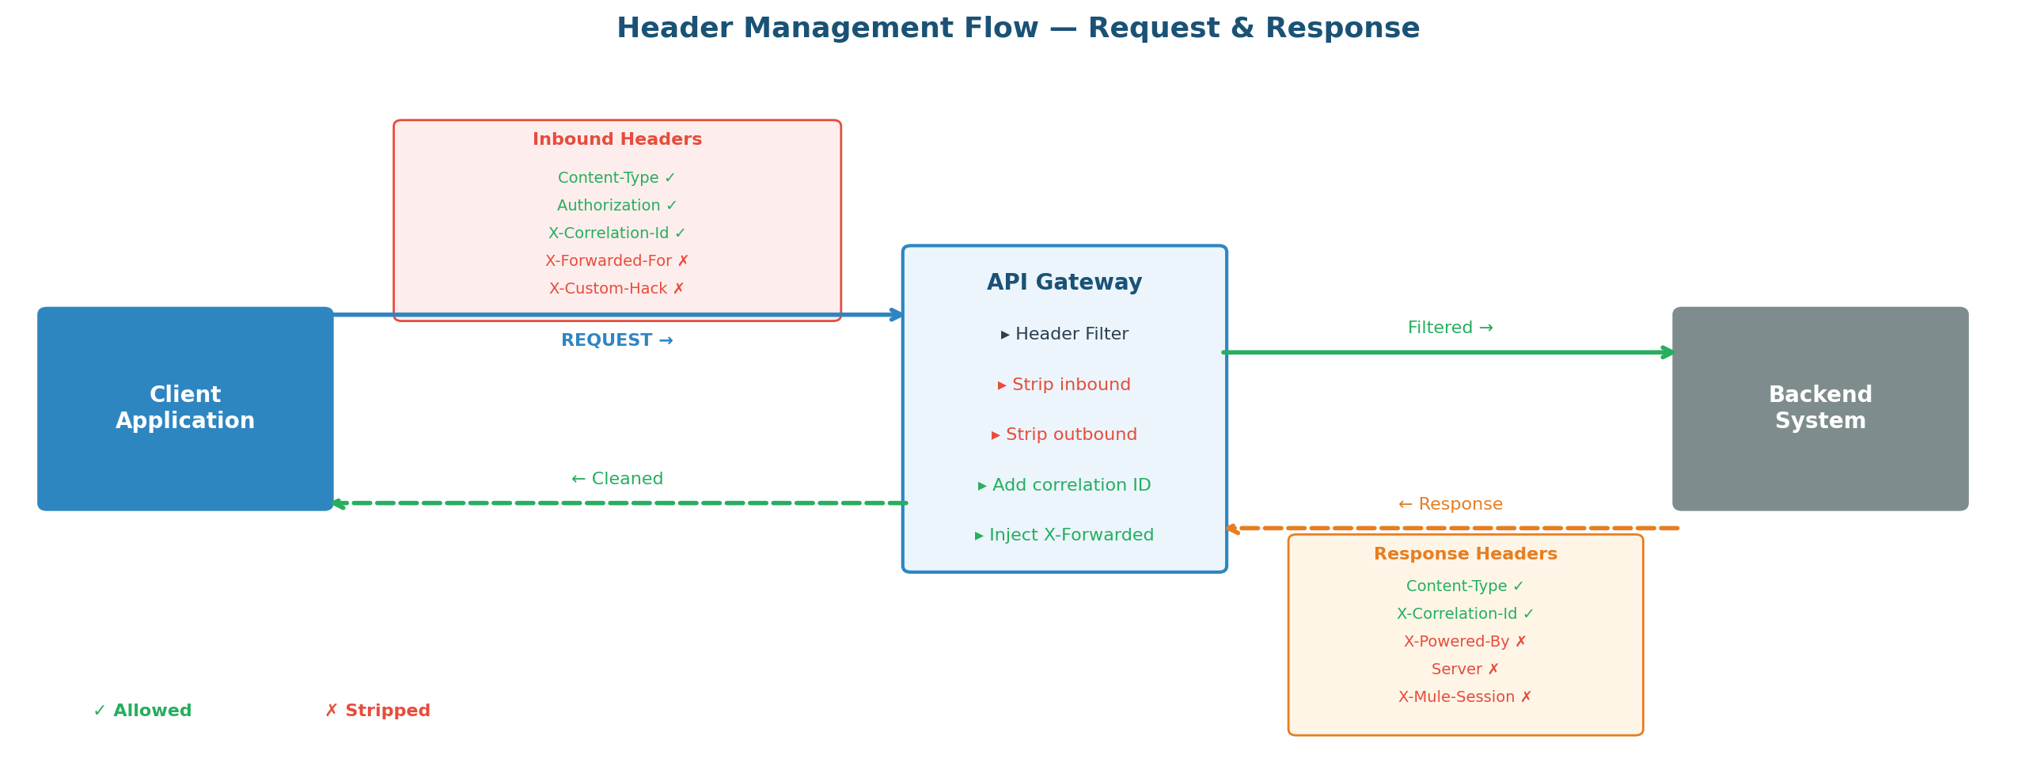
Figure 4: Header Management Flow — Request & Response filtering at the API Gateway

3.7.1 Response Header Removal (Gateway to Client)
Remove internal or sensitive headers from API responses before they reach the client. Exposing backend infrastructure details in response headers is a common security anti-pattern.

Headers to remove from responses:
- X-Powered-By: Reveals the backend technology stack such as Mule, Java, or Express.
- Server: Exposes the web server software and version.
- X-Mule-Session, X-Mule-Encoding: MuleSoft-specific internal headers with no value for consumers.
- X-Debug-*, X-Trace-*: Internal debugging and tracing headers that should never leave the network boundary.
- Set-Cookie: If the API is stateless, cookies should not be forwarded to clients.
- X-Backend-Server, X-Upstream-*: Any header revealing internal routing, server names, or cluster topology.

3.7.2 Request Header Filtering (Client to Backend)
Filter inbound headers to ensure only expected and required headers are forwarded to the backend system.

Headers to allow through to backend:
- Content-Type, Accept, Accept-Encoding: Standard content negotiation headers.
- Authorization: Required for end-to-end security propagation if the backend validates tokens independently.
- X-Correlation-Id, X-Request-Id: Traceability headers for end-to-end request tracking.
- Custom business headers defined in the API’s RAML or OAS specification.

Headers to strip from inbound requests:
- X-Forwarded-For, X-Forwarded-Host: Let the gateway set these to prevent IP spoofing.
- Any header not defined in the API specification should be treated as untrusted and removed.

4. Policy Layering Strategy
Policies should not be applied in isolation. A defence-in-depth approach ensures that multiple layers of security work together to protect the API and its backend systems. The pyramid below illustrates how policies layer from the outermost network boundary inward.

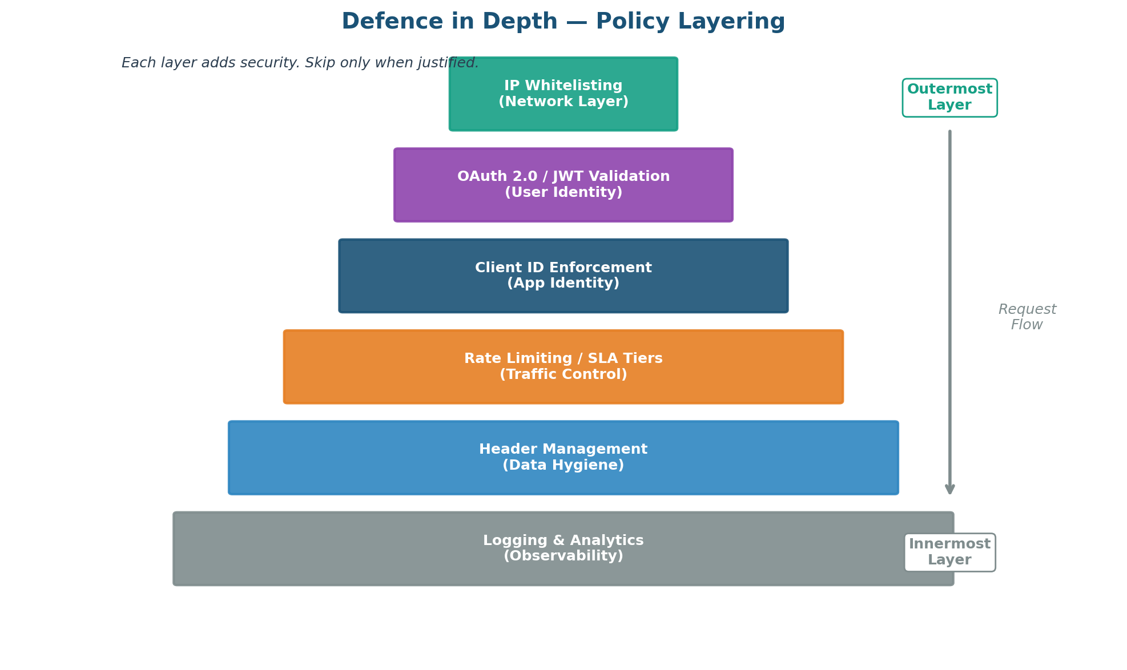
Figure 5: Defence in Depth — Policy Layering Pyramid

The following table recommends specific policy combinations for each API type and exposure level.

API Type | Client ID | Rate Limit | IP Whitelist | Header Mgmt
Experience API (external) | ✅ Required | ✅ SLA Tiers | ⭕ Optional | ✅ Full filtering
Experience API (internal) | ✅ Required | ✅ Simple | ❌ Not needed | ✅ Response strip
Process API | ✅ Required | ⭕ Optional | ❌ Not needed | ⭕ Minimal
System API | ✅ Required | ✅ Backend limit | ❌ Not needed | ⭕ Minimal
Partner B2B API | ✅ Required | ✅ SLA Tiers | ✅ Required | ✅ Full filtering
API Proxy (pass-through) | ✅ Required | ✅ Simple | ⭕ If B2B | ✅ Response strip

5. API Communication Patterns
Selecting the right communication pattern is critical to meeting non-functional requirements such as latency, reliability, decoupling, and throughput. The diagram below provides a visual comparison of the three core patterns.

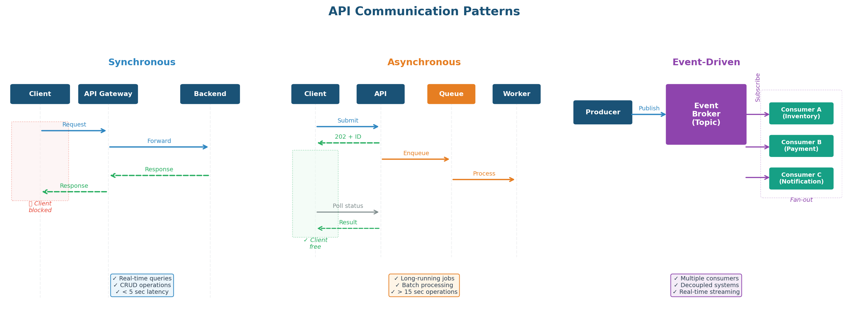
Figure 6: Synchronous vs Asynchronous vs Event-Driven Communication Patterns

5.1 Synchronous APIs
Synchronous APIs follow a request-response model where the client sends a request and blocks until the server returns a response. This is the most common pattern for real-time data retrieval and simple transactional operations.

When to use:
- The client needs an immediate response such as fetching a customer profile, checking inventory, or validating an address.
- The operation completes in under 5 seconds, the acceptable threshold before client timeouts.
- The operation is idempotent or naturally transactional such as a database read or simple create.
- The consumer is a user-facing application expecting real-time feedback.

When NOT to use:
- Backend processing takes more than 10–15 seconds. Long-running synchronous calls tie up threads and risk timeouts.
- The operation involves multiple sequential calls to slow downstream systems.
- The client does not need to wait for the result.

Recommended policies:
- Client ID Enforcement on all synchronous APIs.
- Rate Limiting to prevent backend overload from high-frequency polling.
- Response header removal to strip internal metadata.

5.2 Asynchronous APIs
Asynchronous APIs decouple the request submission from the response delivery. The client submits a request and receives an immediate 202 acknowledgement with a tracking identifier.

When to use:
- Long-running operations taking 15+ seconds such as report generation, bulk imports, or complex orchestrations.
- Batch processing scenarios where clients submit large datasets for background processing.
- Fire-and-forget patterns where the client needs confirmation of receipt but not the final outcome.
- Improving user experience by returning 202 Accepted immediately.

Implementation patterns:
- Polling: Client receives a status URL in the 202 response and periodically checks. Simple but generates traffic.
- Callback / Webhook: Client provides a callback URL; server sends result when done. Efficient but client must expose an endpoint.
- Queue-based: Request placed on a message queue (Anypoint MQ, JMS). Worker processes and stores result. Durable and natural load levelling.

5.3 Event-Driven APIs
Event-driven APIs use a publish-subscribe model where producers emit events and interested consumers subscribe to receive them. In MuleSoft, this is typically implemented using Anypoint MQ, Apache Kafka connectors, or platform events.

When to use:
- Multiple independent consumers need to react to the same business event simultaneously.
- Systems need to be highly decoupled for independent development, deployment, and scaling.
- Event sourcing or CQRS architectures where downstream systems build their own read models.
- Real-time data streaming such as IoT telemetry, clickstream processing, or fraud detection.
- Reliable delivery with replay capability for reprocessing historical events.

When NOT to use:
- The interaction requires a synchronous response with immediate visual feedback.
- There is only a single consumer and no need for additional subscribers.
- Strict ordering and exactly-once delivery are critical without supporting infrastructure.

5.4 Communication Pattern Comparison

Attribute | Synchronous | Asynchronous | Event-Driven
Coupling | Tight (client waits) | Loose (poll/callback) | Loosest (pub-sub)
Latency | Real-time (ms–sec) | Delayed (sec–min) | Near-real-time
Reliability | Depends on uptime | High (queued/durable) | High (persistent topics)
Scalability | Moderate (thread-bound) | High (worker pools) | Highest (consumer groups)
Use case | Queries, lookups, CRUD | Long jobs, batch ops | Notifications, streaming
MuleSoft tooling | HTTP Listener/Request | Anypoint MQ, Watermark | Anypoint MQ, Kafka

6. Security Best Practices

6.1 Defence in Depth
Never rely on a single policy for security. Combine multiple policies to create layered protection as illustrated in the policy pyramid (Figure 5).

Recommended Minimum Security Stack for External APIs
1. Client ID Enforcement – Identifies and authenticates the consuming application.
2. OAuth 2.0 Token Enforcement – Validates bearer tokens for user-level authorisation.
3. Rate Limiting / SLA Tiers – Protects against abuse and ensures fair usage.
4. Header Management – Strips sensitive metadata and filters untrusted inbound headers.
5. IP Whitelisting – Additional layer for B2B or compliance-sensitive APIs.

6.2 Credential Handling
- Never pass client credentials as query parameters. Always use HTTP headers or the Authorization header.
- Rotate client secrets periodically and enforce rotation policies in API Manager.
- Use separate client credentials for each environment (sandbox, QA, production).

6.3 Monitoring and Alerting
- Enable API Analytics for all managed APIs to track usage, error rates, and latency trends.
- Set up alerts for unusual patterns such as sudden traffic spikes or high error rates.
- Regularly review rate-limiting 429 responses to determine whether limits need adjustment.
- Monitor policy violation logs in API Manager to detect potential security incidents.

7. Quick Reference Summary
Use this table as a quick lookup for the most common API scenarios and their recommended configuration.

Scenario | Architecture | Pattern | Key Policies
Mobile app querying customer data | Three-tier | Synchronous | Client ID, SLA, OAuth, Headers
Partner submitting bulk orders | Two-tier | Asynchronous | Client ID, Rate limit, IP whitelist
IoT device telemetry ingestion | Two-tier | Event-driven | Client ID, Rate limit, IP whitelist
Internal report generation | Single layer proxy | Asynchronous | Client ID, Rate limit
SaaS integration (e.g. SFDC) | API Proxy | Synchronous | Client ID, Rate limit, Headers
Real-time notifications hub | Three-tier | Event-driven | Client ID, Rate limit, Headers
B2B EDI file exchange | Two-tier | Asynchronous | Client ID, SLA, IP whitelist

Revision History

Date | Version | Author | Changes
Mar 30, 2026 | 1.0 | [Your Name] | Initial version with diagrams

