DAY-37

<https://github.com/rvsp/database/tree/master/mongodb>

1.Find all the information about each products

**db.product.find()**

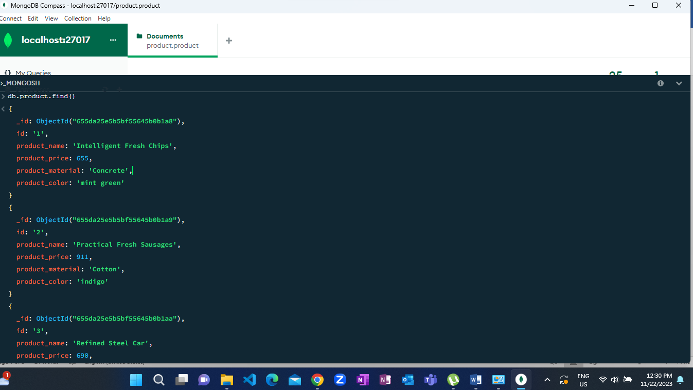

**2.Find the product price which are between 400 to 800**

**db.product.find({product_price:{$gte:400,$lte:800}})**

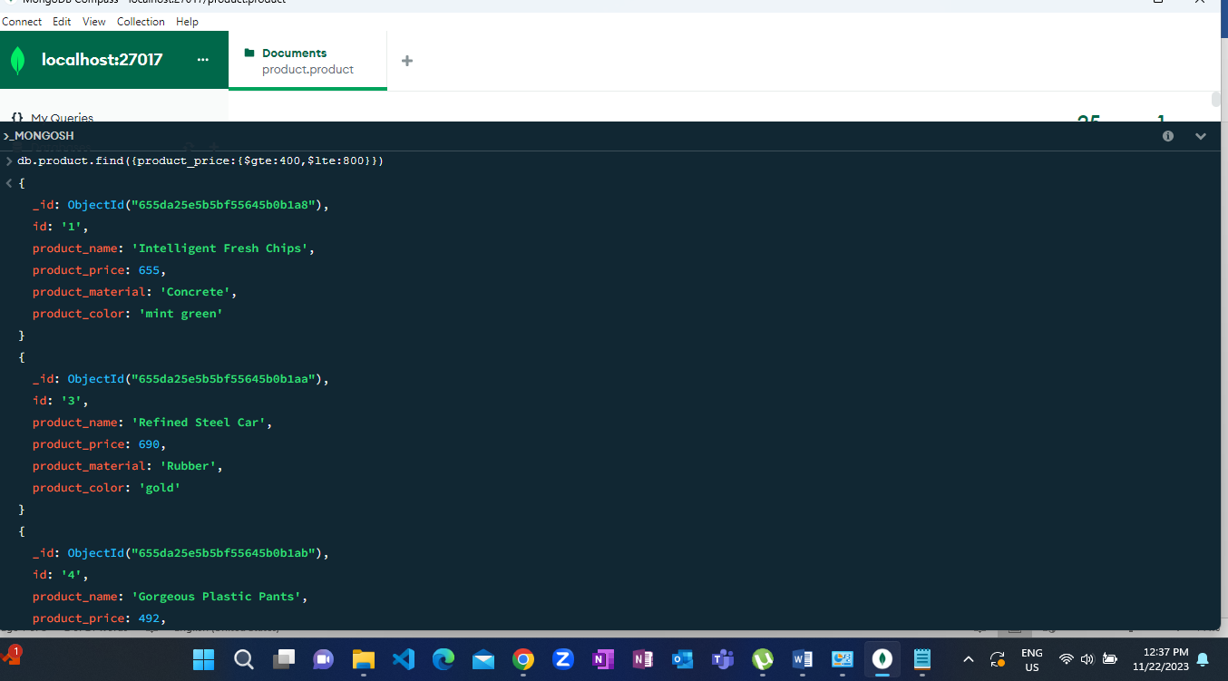

3.Find the product price which are not between 400 to 600

**db.product.find({product_price:{$not:{$gte:400, $lte:600}}})**

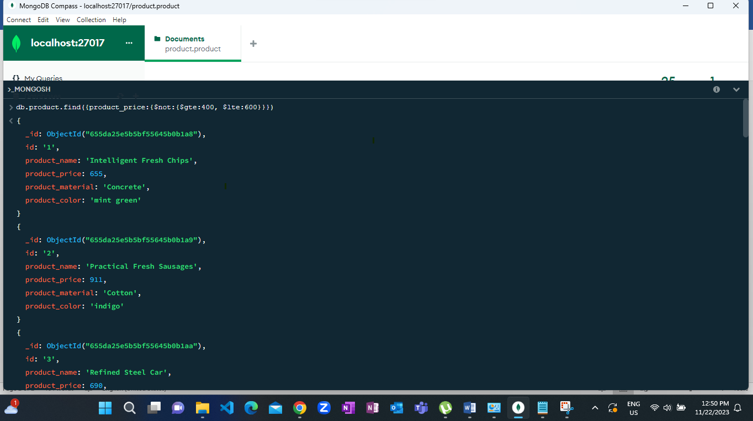

4.List the four product which are grater than 500 in price

**db.product.find({product_price:{$gte:500}}).limit(4)**



5.Find the product name and product material of each products

**db.product.find({product_price:{$gte:0}},{product_price:1,product_name:1,_id:0})**

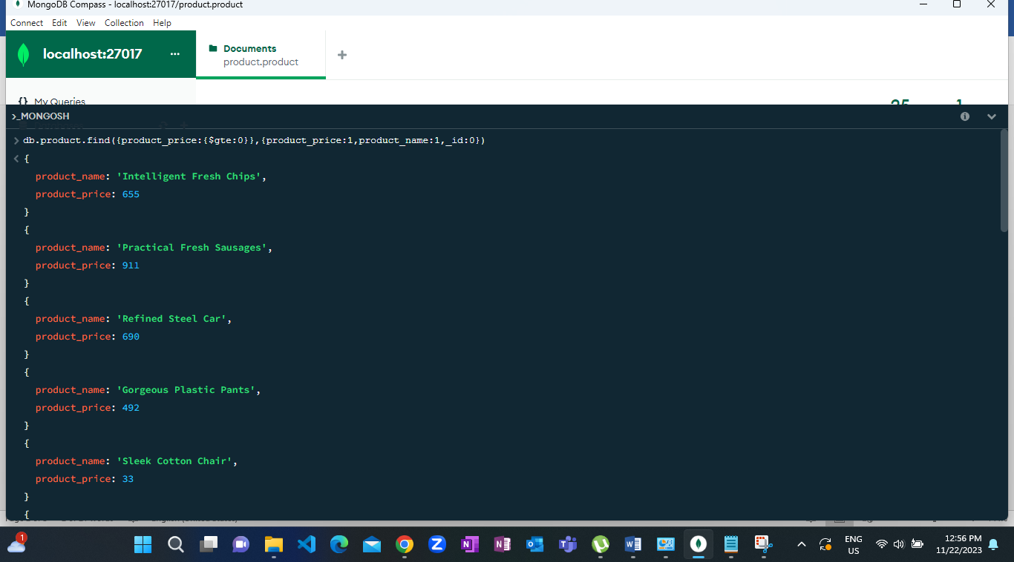

6.Find the product with a row id of 10

**db.product.find({id:'10'})**

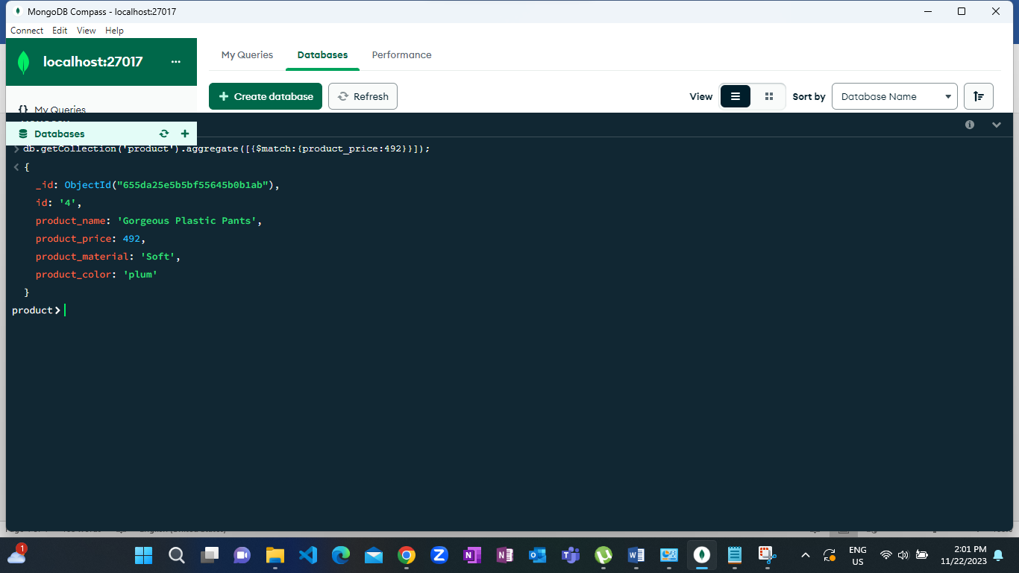

7.Find only the product name and product material

**db.product.find({product_price:{$gte:0}},{product_material:1,product_name:1,_id:0})**

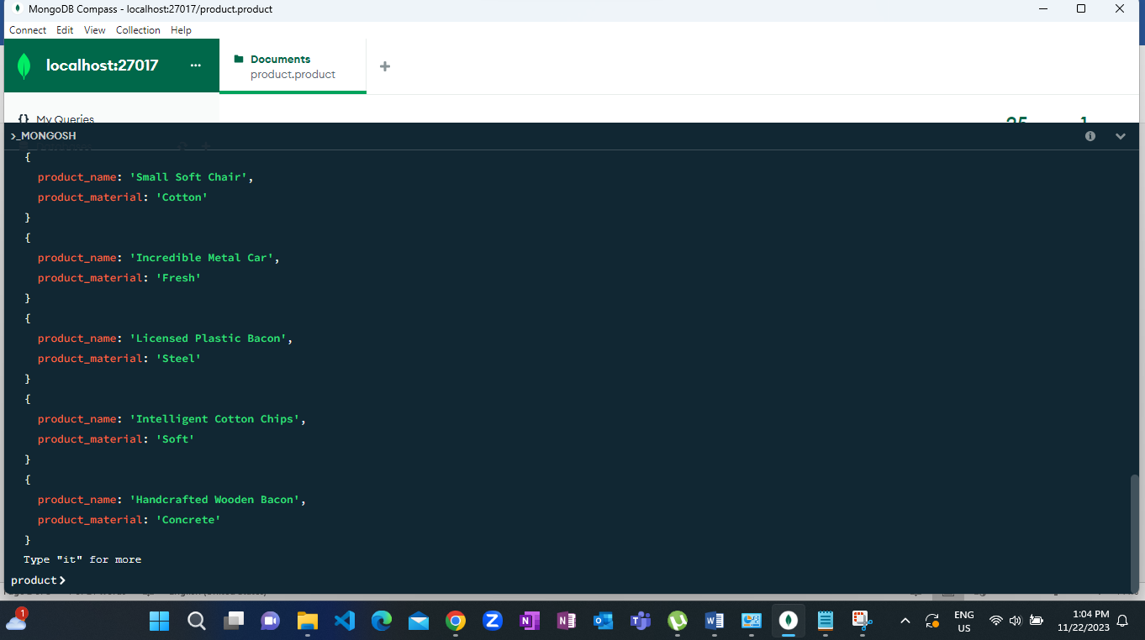

8.Find all products which contain the value of soft in product material

**db.product.find({product_material:{$regex:'Soft'}})**



9.Find products which contain product color indigo and product price 492.00

**db.getCollection('product').aggregate([{$match:{product_color:'indigo'}}]);**

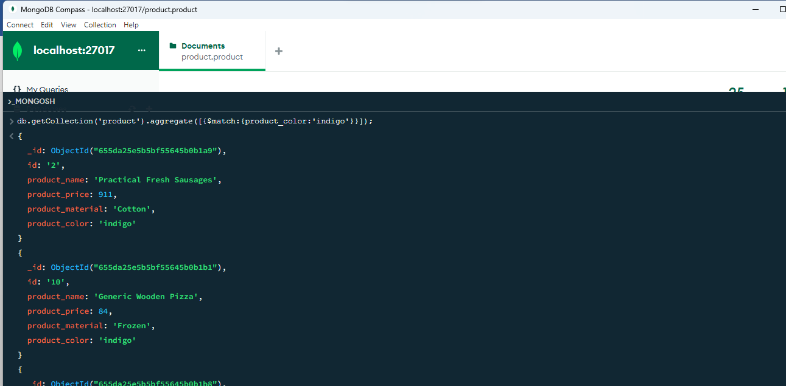

10.Delete the products which product price value are same

**db.getCollection('product').aggregate([{$match:{product_price:492}}]);**

