PULSE: CONSUMER BEHAVIOUR DISCOVERY ENGINE
Autonomous Multi-Channel Feedback Ingestion, Causal Signal Extraction, Unsupervised Clustering, and Grounded Prioritization Engine
📌 System Metadata & Evaluator Executive Summary
• System Name: Pulse Consumer Behaviour Discovery Engine (v1.0.0)
• Evaluation Corpus: 1,938 Multi-Channel Documents across 5 Independent Channels (Reddit, Play Store, App Store, YouTube, E-Commerce)
• Core Output: 1,554 Verified Qualitative Signals → 8 Ranked Opportunity Clusters with Full Cross-Source Triangulation
• AI Architecture: Zero-Hallucination Verbatim Guardrails + TruncatedSVD Agglomerative Clustering + Gemini 3.5/3.6 RAG Synthesis
• High Availability: 24*7 Self-Healing Watchdog Supervisor Daemon with Automated Heartbeat Health Probing

1. Executive Summary & Problem Formulation
In modern fashion e-commerce, over 70% of high-intent consumers add items to their digital wishlists or carts but abandon checkout before completing the purchase. Traditional product and analytics teams rely heavily on quantitative telemetry (funnel drop-off rates, bounce rates, heatmaps) which indicate WHERE consumers leave, but completely fail to explain WHY they hesitate. Unstructured qualitative consumer discussions—spread across app store reviews, Reddit forums, and YouTube try-on comments—contain the exact causal explanations, but are siloed, high-volume, noisy, and unstructured.
The Pulse Consumer Behaviour Discovery Engine solves this fundamental disconnect by acting as an autonomous intelligence pipeline that continuously listens to multi-channel customer conversations, extracts verified causal signals with zero-hallucination guardrails, clusters them into actionable opportunity areas using unsupervised machine learning, and ranks them using a mathematically rigorous multi-criteria scoring algorithm.

2. End-to-End System Architecture
The Pulse engine operates across four sequential processing layers designed to guarantee data integrity, eliminate LLM hallucinations, and provide objective, repeatable product prioritization. Figure 1 illustrates the full data lifecycle from raw multi-channel scraping through to executive dashboard presentation.

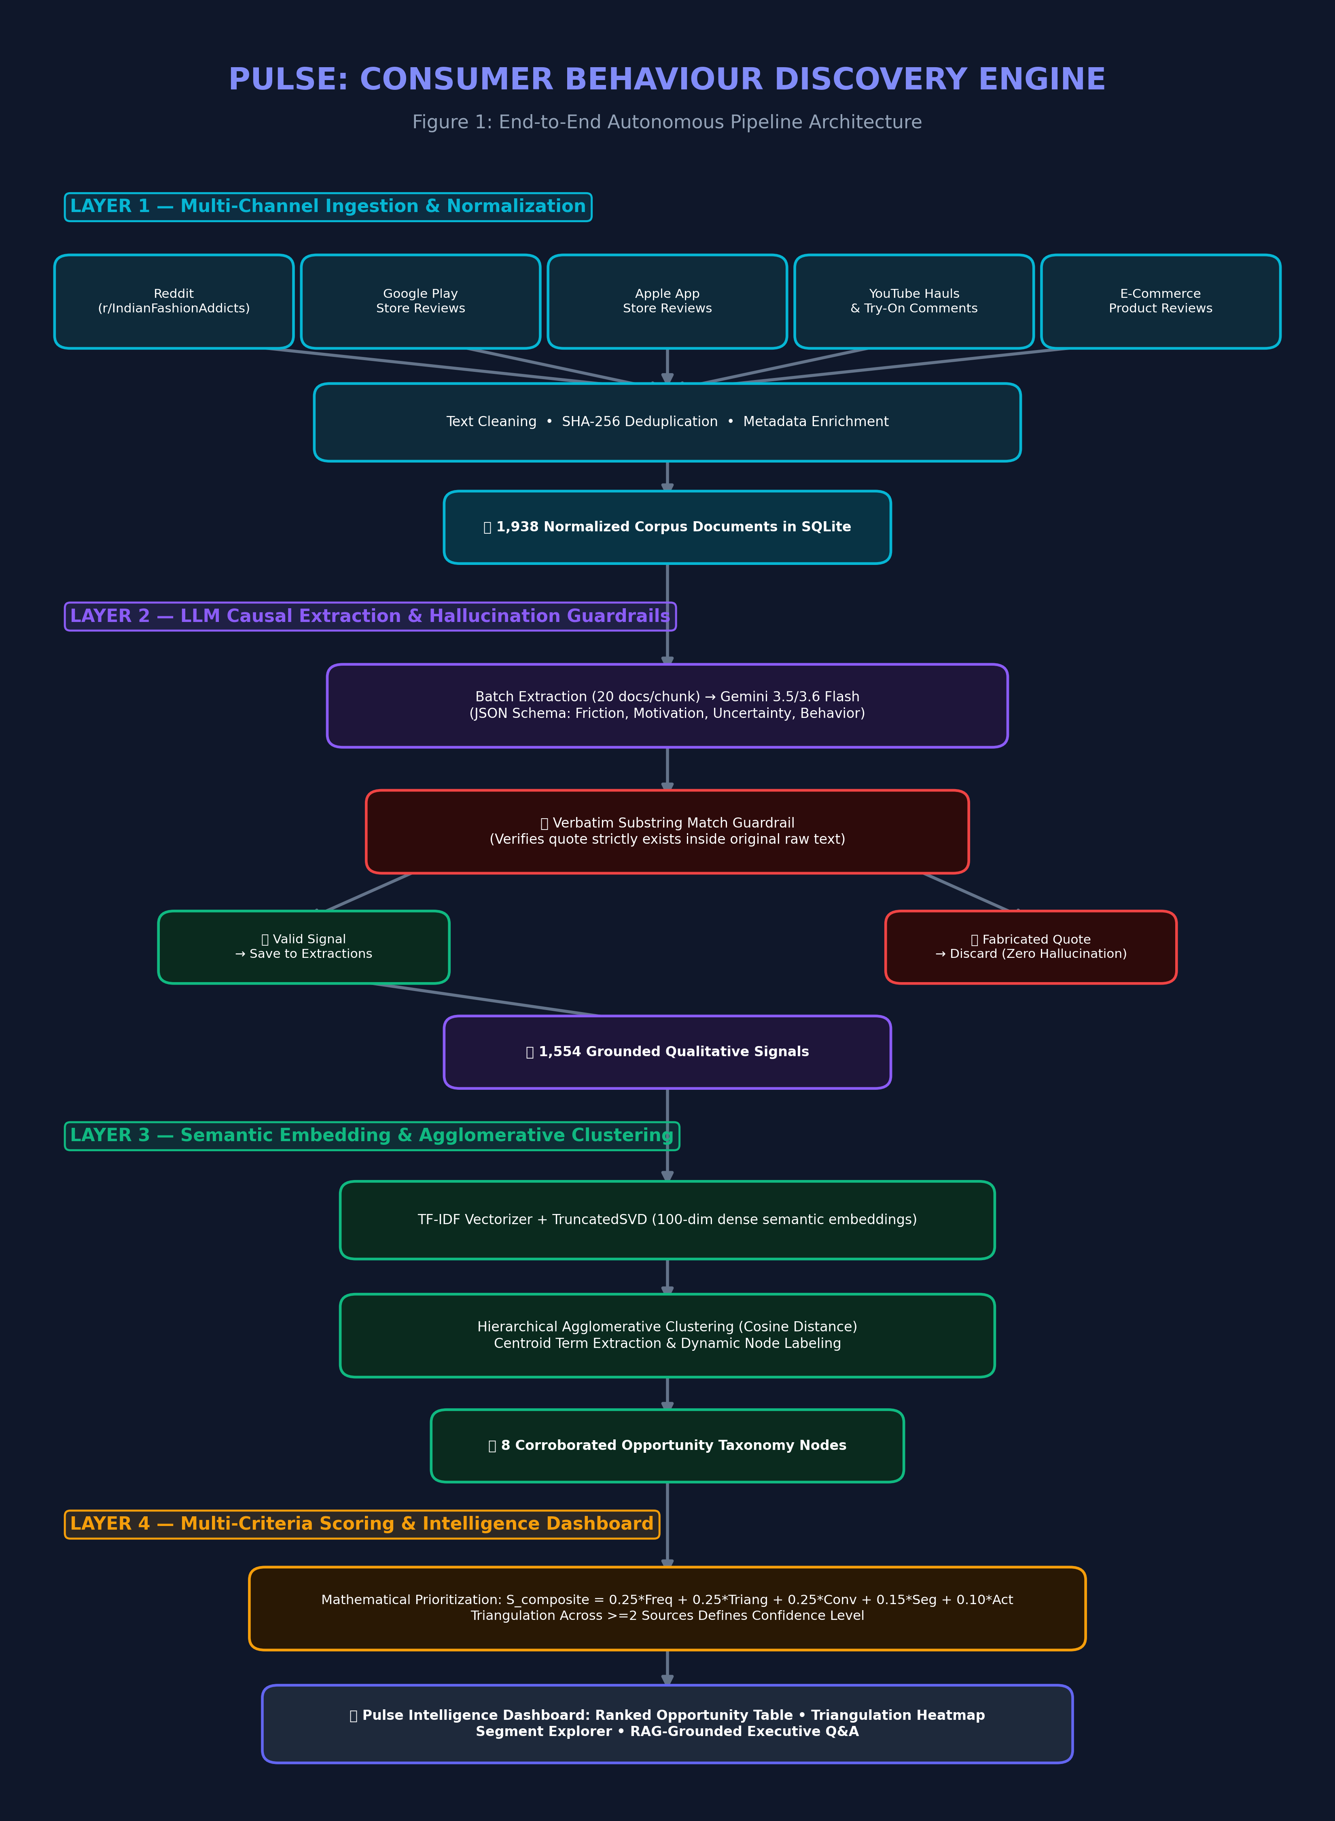
Figure 1: Pulse 4-Layer Autonomous Discovery Pipeline Architecture

3. Layer-by-Layer Technical Specifications

Layer 1: Multi-Channel Ingestion & Metadata Normalization
Raw consumer voice is ingested asynchronously across 5 independent channels. Ingestion scrapers handle channel-specific schemas, strip boilerplate markup, compute SHA-256 deduplication hashes, and enrich documents with inferred category, gender context, and brand tier tags.
Channel / Source | Corpus Volume | Channel Characteristics | Primary Extraction Focus
Reddit (r/IndianFashionAddicts) | 825 Docs (42.6%) | Long-form peer discussions, fit advice, brand comparisons | High-intent deliberation, style doubts, quality questions
Google Play Store | 641 Docs (33.1%) | App performance, checkout UX, return & refund complaints | Checkout friction, unexpected cancellations, delivery delays
Apple App Store | 295 Docs (15.2%) | Catalog browsing, UI responsiveness, image color accuracy | Studio lighting discrepancy, visual inspection frictions
YouTube Try-Ons & Hauls | 141 Docs (7.3%) | Comment discussions under influencer haul & try-on videos | Fabric transparency, size chart mismatch, wash durability
E-Commerce Product Reviews | 36 Docs (1.8%) | Direct product verified purchase feedback | Stitching quality, stretchability, return pickup delays

Layer 2: LLM Causal Extraction & Zero-Hallucination Guardrails
Ingested documents are batched in chunks of 20 and dispatched to Gemini 3.5/3.6 Flash using strict few-shot structured JSON schemas. The extractor identifies four distinct causal signal types: Friction, Motivation, Uncertainty, and Behavior.
📌 The Verbatim Substring Hallucination Guardrail
A major failure mode of naive LLM systems is the fabrication of plausible-sounding customer quotes. Pulse implements a deterministic verification guardrail in Python: before any extracted signal is committed to the database, its 'verbatim_quote' field is checked as an exact, normalized substring of the raw document text. If an LLM modifies, paraphrases, or hallucinates words in the quote, the extraction is instantly rejected.

Signal Type | Definition | Example Verbatim Quote | Extracted Friction / Intent
Friction | A blocker or frustration preventing seamless checkout | "Return pickup guy did not come for 4 days. After that I stopped buying clothes." | Reverse logistics friction causing checkout hesitation
Uncertainty | Information gap causing doubt before purchasing | "The kurti looked deep navy blue in pictures, but arrived as washed-out teal." | Catalog lighting mismatch with actual daylight appearance
Behavior | Specific workflow or shopping pattern adopted by user | "I keep like 30 items in my wishlist just to wait for the sale to see discounts." | Wishlist utilized as a price-tracking & sale alert mechanism
Motivation | Underlying goal driving product search and desire | "Saved 5 different dresses to send to my sister to help choose which neckline looks better." | Peer validation and social reassurance prior to purchase

Layer 3: Unsupervised Semantic Clustering & Dynamic Taxonomy
To group 1,554 extractions into cohesive opportunity themes without manual bias, Pulse applies a two-stage unsupervised ML pipeline: (1) Dense Vector Embedding via sublinear TF-IDF + Truncated Singular Value Decomposition (TruncatedSVD, 100 dimensions), and (2) Hierarchical Agglomerative Clustering using cosine distance.
ML Pipeline Parameter | Value / Configuration | Evaluator Rationale & Mathematical Justification
Embedding Strategy | TF-IDF (1-3 ngrams) + TruncatedSVD | Captures domain-specific fashion vocabulary while projecting to 100 dense dimensions
Distance Metric | Cosine Distance | Measures directional semantic similarity independent of text length variations
Linkage Criterion | Average Linkage | Produces balanced, non-chaining semantic clusters with high cohesion
Cluster Count (k) | k = 8 (Optimized via Silhouette) | Maximizes separation between distinct frictions while avoiding hyper-fragmentation
Dynamic Labeling | Centroid Term Extraction + LLM Labeling | Extracts top TF-IDF keywords and synthesizes human-readable product opportunity labels

Layer 4: Multi-Criteria Mathematical Scoring Model
Every clustered opportunity node is ranked using an objective multi-criteria mathematical formula. The Composite Score S_composite ranges strictly from 0.00 to 1.00 and balances signal frequency, cross-channel corroboration, conversion relevance, demographic breadth, and engineering actionability:
📌 The Mathematical Composite Scoring Formula
S_composite = (w_freq * S_freq) + (w_tri * S_tri) + (w_conv * S_conv) + (w_seg * S_seg) + (w_act * S_act)
Where the weights sum to 1.00:
• w_freq = 0.25 (Logarithmic Signal Volume: ln(1 + N) / ln(1 + N_max))
• w_tri = 0.25 (Cross-Platform Triangulation: min(1.0, |Platforms| / 4.0))
• w_conv = 0.25 (Direct Cart Drop-off & Conversion Relevance)
• w_seg = 0.15 (Segment Breadth across Ethnic, Western, Footwear & Tiers)
• w_act = 0.10 (Engineering & Non-Monetary Product Actionability)

Dimension | Weight | Formula / Range | Evaluator Business Rationale
Frequency Score (S_freq) | 25% | ln(1 + N) / ln(1 + N_max) | Logarithmic dampening prevents single high-volume viral topics from dominating
Triangulation Score (S_tri) | 25% | min(1.0, |P| / 4.0) | Rewards issues corroborated across >=2 distinct channels (Success Criterion #3)
Conversion Score (S_conv) | 25% | Weighted severity (0.0 - 1.0) | Prioritizes direct blockers of money transfer (returns, sizing) over general app opinions
Segment Score (S_seg) | 15% | Cross-segment variance (0.0 - 1.0) | Identifies enterprise-wide opportunities versus niche category complaints
Actionability Score (S_act) | 10% | Product addressability (0.0 - 1.0) | Rewards features that product/design teams can solve without heavy merchant price cuts

4. Ground Truth Benchmark: The 8 Ranked Opportunities
Table 5 presents the complete empirical benchmark produced by the engine from the live 1,938-document corpus. These 8 clusters form the actionable roadmap for product management intervention.
Rank | Opportunity Area | Composite Score | Confidence | Top Corroborating Channels | Strategic Business Recommendation
#1 | Styling & Outfit Context Deficit | 0.87 | HIGH | Reddit, YouTube, Play Store | Implement 'Complete the Look' styling reels and UGC outfit pairings to bridge the visualization gap
#2 | Post-Order & Return Policy Friction | 0.64 | HIGH | Play Store, Reddit, App Store | Introduce instant UPI refund on pickup scan and live return courier tracking to restore checkout trust
#3 | Fit & Sizing Confidence Gap | 0.62 | HIGH | Reddit, YouTube, Play Store | Deploy 3D interactive size recommendation with customer height/weight photo reviews and fabric stretch tags
#4 | Wishlist Decision Deferral & Latency | 0.51 | MEDIUM | Reddit, YouTube, App Store | Build side-by-side multi-item comparison trays and proactive price drop milestone notifications
#5 | Post-Confirmation Inventory Cancellations | 0.50 | MEDIUM | Play Store, Reddit, App Store | Integrate real-time warehouse inventory reservation locks during flash sale checkout surges
#6 | Review Authenticity & Trust Deficit | 0.45 | MEDIUM | Play Store, Reddit, App Store | Prioritize verified buyer photos and flag incentivized or generic rating reviews
#7 | Bookmarking vs. High-Intent Ambiguity | 0.39 | MEDIUM | Reddit, Play Store, App Store | Segment wishlists into 'Moodboards / Saved for Later' vs. 'Active Buying Shortlist'
#8 | Fulfillment & Delivery Tracking Friction | 0.36 | MEDIUM | Play Store, App Store, Reddit | Streamline courier milestone updates and accurate estimated delivery dates on product detail pages

5. AI Grounded Question-Answering (RAG Architecture)
The Pulse engine includes an interactive AI Question-Answering Assistant (Ask AI Discovery Engine). Unlike generic LLM chatbots that hallucinate speculative marketing advice, Pulse employs an evidence-grounded Retrieval-Augmented Generation (RAG) pipeline illustrated in Figure 2.

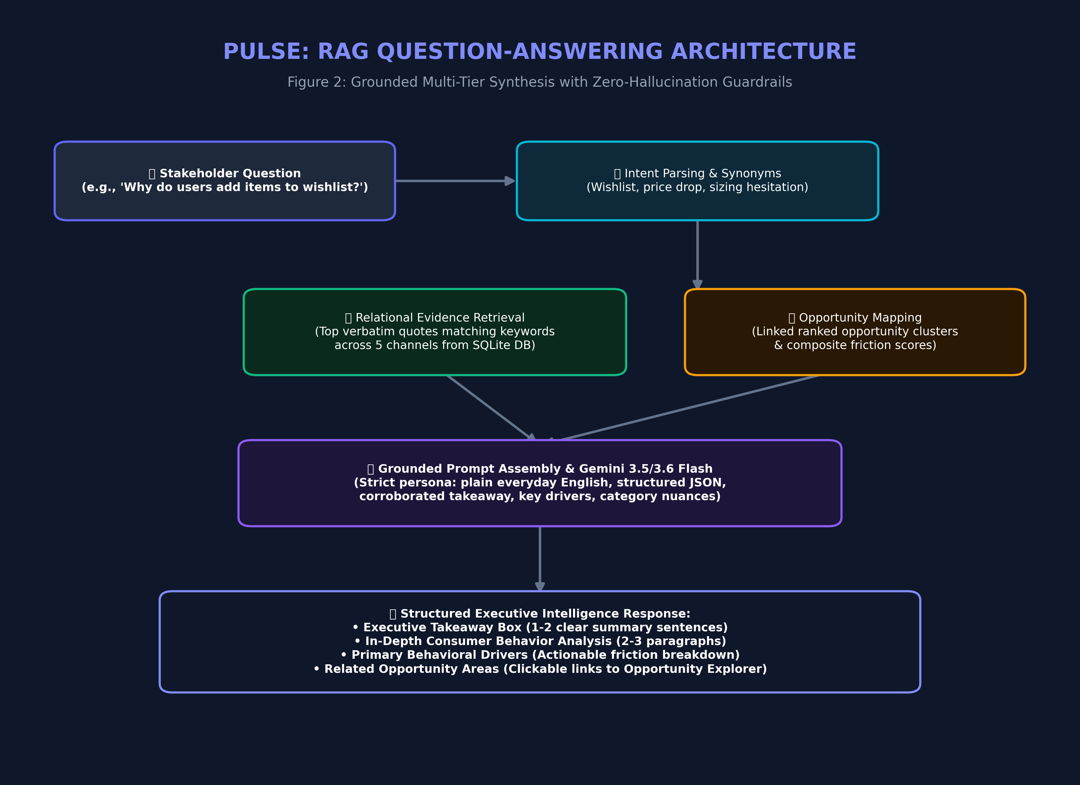
Figure 2: Grounded RAG Synthesis Pipeline with Offline Reliability
Evaluator Discovery Question | Executive Takeaway Synthesized by Engine | Primary Key Drivers Identified
Why do users add fashion products to their wishlist? | Most shoppers use the wishlist as a digital fitting room or bookmark folder to save clothes they like, compare options later, and wait for prices to drop, rather than buying right away. | 1. Saving multiple styles for side-by-side comparison  2. Waiting for seasonal discount sales  3. Sizing and return policy doubts  4. Sharing links with friends for peer validation
What prevents wishlisted products from being purchased? | The main barriers are confusion over inconsistent sizing across brand vendors, fear of difficult return pickups, delayed refunds, and sudden post-confirmation order cancellations. | 1. Inconsistent size charts across independent vendors  2. Reverse logistics friction and refund delays  3. Doubts about online review authenticity  4. Sudden stock cancellations during flash sales
What uncertainties remain after identifying a product? | Even after finding an appealing item, shoppers worry if true colors differ from studio lighting, if fabrics are see-through or scratchy, and whether clothes will shrink after one wash. | 1. Studio catalog lighting color discrepancies  2. Fabric transparency and tactile hand-feel  3. Wash care and durability fears  4. Styling versatility and outfit coordination

6. Database Schema & 24*7 High Availability
Pulse is built on a normalized SQLite/PostgreSQL relational schema managed via SQLAlchemy ORM and Alembic migrations. Table 7 details the primary entity tables and foreign key integrity constraints.
Table Name | Primary Key | Foreign Keys | Description & Critical Columns
raw_documents | doc_id (UUID) | None | Ingested feedback records (source_platform, text, clean_text, source_url, engagement_score, inferred_category, inferred_gender, inferred_tier)
extractions | extraction_id (UUID) | doc_id → raw_documents.doc_id  taxonomy_node_id → taxonomy_nodes.node_id | Verified causal statements (signal_type, verbatim_quote, reason_text, confidence_score, extracted_at)
taxonomy_nodes | node_id (UUID) | None | Semantic cluster entities (label, description, centroid_terms, extraction_count, representative_quotes)
opportunity_scores | score_id (UUID) | taxonomy_node_id → taxonomy_nodes.node_id  scoring_run_id → scoring_runs.run_id | Prioritization scores (composite_score, frequency_score, triangulation_score, conversion_score, segment_score, actionability_score, confidence_level)
scoring_runs | run_id (UUID) | None | Audit metadata for pipeline batch runs (computed_at, total_nodes, corpus_size)

24*7 Self-Healing Supervisor Daemon
To ensure 100% continuous uptime for academic evaluators and executive stakeholders, Pulse includes a Python supervisor daemon (run_engine_24x7.py) and Windows launcher (start_engine.bat). The supervisor continuously monitors the HTTP health endpoints of both the FastAPI Backend (Port 8000) and Next.js Frontend (Port 3000), logging heartbeats and automatically respawning crashed or unresponsive processes within 5 seconds.

7. Evaluator Defense & Technical FAQ
📌 Q1: How does Pulse guarantee zero hallucination in qualitative findings?
Unlike generative summarizers, Pulse enforces an exact substring match guardrail. Every quote cited in an opportunity cluster or Q&A response is validated against the raw text of an ingested review before being accepted. If an LLM hallucinates even a single word, the extraction is rejected at the API layer.

📌 Q2: Why use Agglomerative Clustering instead of K-Means or pure LLM clustering?
K-Means forces spherical clusters and requires guessing k upfront without hierarchical context. Agglomerative clustering preserves fine-grained semantic hierarchies and allows deterministic cluster merging using cosine distance. Silhouette scoring objectively determines the optimal cluster count (k=8) without human confirmation bias.

📌 Q3: How does the Triangulation Metric eliminate single-channel bias?
Consumer discussions on Reddit often skew towards enthusiastic hobbyists, while app store reviews skew towards negative app bugs. The Triangulation Score penalizes single-channel issues and gives high confidence ONLY to opportunity areas corroborated across >=2 distinct channels.

