**Assumptions**

* No unusual occurrences between 2015 and 2017 will have a substantial impact on the data used.
* The information is still current and can be used to analyze a hotel's possible plans in an efficient manner.
* There are no unanticipated negatives to the hotel employing any advised technique. 4. The hotels are not currently using any of the suggested solutions.
* The biggest factor affecting the effectiveness of earning income is booking cancellations.
* Cancellations result in vacant rooms for the booked length of time.
* Clients make hotel reservations the same year they make cancellations.

**Hypothesis**

* More cancellations occur when prices are higher.
* When there is a longer waiting list, customers tend to cancel more frequently.
* Most clients are coming from offline travel agents to make their reservations.

**Analysis and Findings**

The above bar graph shows the percentage of reservations that are canceled and those that are not. It is obvious that there are still a significant number of reservations that have not been canceled. There are still 37% of clients who canceled their reservation, which has a significant impact on the hotels' earnings.

In comparison to the Resort hotels City hotels have more bookings. Its possible that Resort hotels are more expensive than the City hotels.

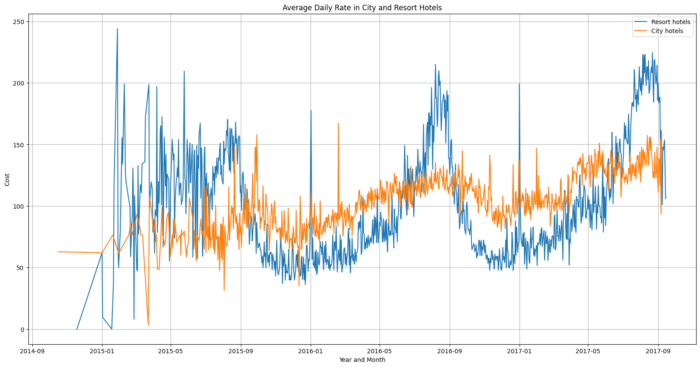

The above line graph shows that, on certain days, the average daily rate for city hotel is less than that of resort hotel, and on other days it’s even less. It goes without saying that weekends and holidays may see a rise in hotel rates.

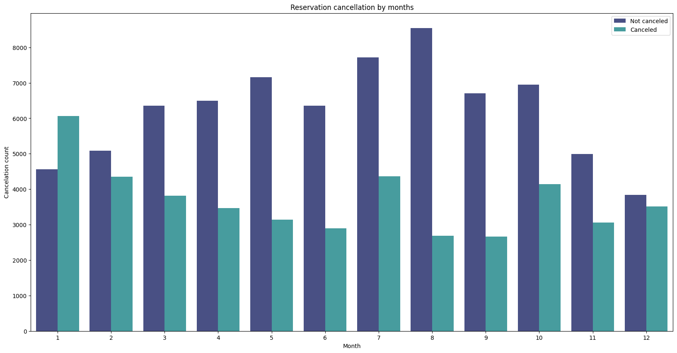

We have developed the grouped bar graph to analyze the months with the highest and lowest reservation levels according to reservation status. As can be seen, both the number of confirmed reservations and the number of canceled reservations is largest in the month of August. whereas January is the month with the most canceled reservations.

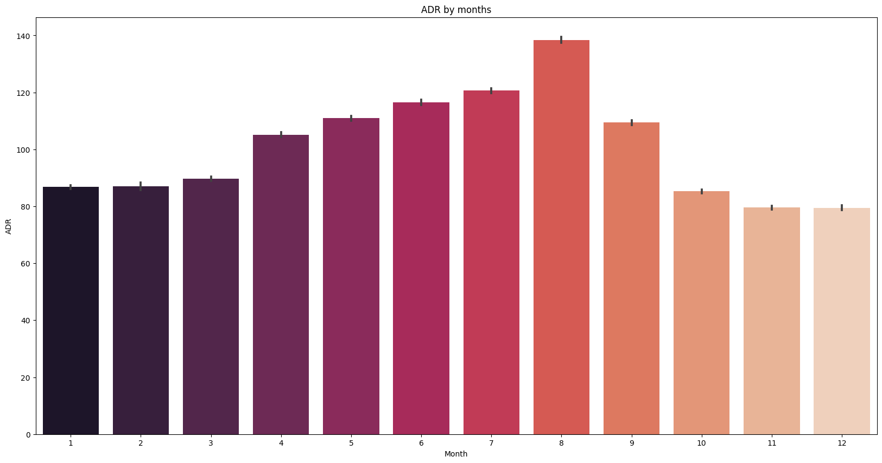

This bar graph demonstrates that cancellations are most common when prices are greatest and are least common when they are lowest. Therefore, the cost of the accommodation is solely responsible for the cancellation.

Now, let's see which country has the highest reservation canceled. The top country is Portugal with the highest number of cancellations.

The above pie chart shows us the least cancellations country wise. 5 out of 10 countries have negligible cancellation rate.

Now let’s check the area from where guests are visiting the hotels and making reservations. Is it coming from Direct or Groups, Online or Offline Travel Agents? Around 46% of the clients come from online travel agencies, whereas 27% come from groups. Only 4% of clients book hotels directly by visiting them and making reservations.

As seen in the graph, reservations are canceled when the average daily rate is higher than when it is not canceled. It clearly proves all the above analysis, that the higher price leads to higher cancellation.

**Suggestions**

* Cancellation rates rise as the price does. To prevent cancellations of reservations, hotels could work on their pricing strategies and try to lower the prices for specific hotels based on locations. They can also provide some discounts to the consumers.
* As the ratio of the cancellation and not cancellation of the resort hotel is higher in the resort hotel than the city hotels. So, the hotels should provide a reasonable discount on the room prices on weekends or on holidays.
* In the month of January, hotels can start campaigns or marketing with area sonable amount to increase their revenue as the cancellation is the highest in this month.
* They can also increase the quality of their hotels and their services mainly in Portugal to reduce the cancellation rate.