I was doing research on this and would like to share some notes:
- Primary Clustering is the tendency for a collision resolution scheme such as linear probing to create long runs of filled slots near the hash position of keys.

- If the primary hash index is x, subsequent probes go to x+1, x+2, x+3 and so on, this results in Primary Clustering.

- Once the primary cluster forms, the bigger the cluster gets, the faster it grows. And it reduces the performance.

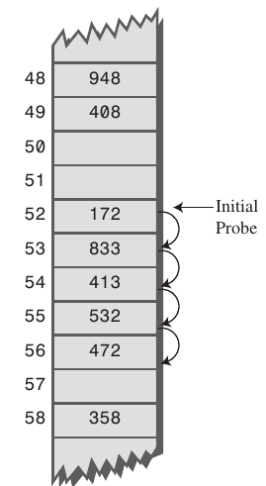

Secondary Clustering is the tendency for a collision resolution scheme such as quadratic probing to create long runs of filled slots away from the hash position of keys.
- If the primary hash index is x, probes go to x+1, x+4, x+9, x+16, x+25 and so on, this results in Secondary Clustering.

- Secondary clustering is less severe in terms of performance hit than primary clustering, and is an attempt to keep clusters from forming by using Quadratic Probing. The idea is to probe more widely separated cells, instead of those adjacent to the primary hash site.

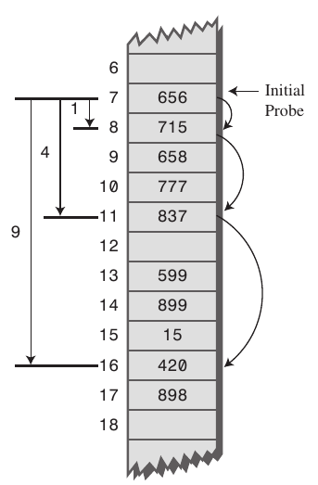

OPEN AND CLOSED HASHING
he use of "closed" vs. "open" reflects whether or not we are locked in to using a certain position or data structure (this is an extremely vague description, but hopefully the rest helps).

For instance, the "open" in "open addressing" tells us the index (aka. address) at which an object will be stored in the hash table is not completely determined by its hash code. Instead, the index may vary depending on what's already in the hash table.

The "closed" in "closed hashing" refers to the fact that we never leave the hash table; every object is stored directly at an index in the hash table's internal array. Note that this is only possible by using some sort of open addressing strategy. This explains why "closed hashing" and "open addressing" are synonyms.

Contrast this with open hashing - in this strategy, none of the objects are actually stored in the hash table's array; instead once an object is hashed, it is stored in a list which is separate from the hash table's internal array. "open" refers to the freedom we get by leaving the hash table, and using a separate list. By the way, "separate list" hints at why open hashing is also known as "separate chaining".

In short, "closed" always refers to some sort of strict guarantee, like when we guarantee that objects are always stored directly within the hash table (closed hashing). Then, the opposite of "closed" is "open", so if you don't have such guarantees, the strategy is considered "open".

What is load factor ?
The amount of capacity which is to be exhausted for the HashMap to increase its capacity ?

Why load factor ?
Load factor is by default 0.75 of the initial capacity (16) therefore 25% of the buckets will be free before there is an increase in the capacity & this makes many new buckets with new hashcodes pointing to them to exist just after the increase in the number of buckets.

Now why should you keep many free buckets & what is the impact of keeping free buckets on the performance ?
If you set the loading factor to say 1.0 then something very interesting might happen.
Say you are adding an object x to your hashmap whose hashCode is 888 & in your hashmap the bucket representing the hashcode is free , so the object x gets added to the bucket, but now again say if you are adding another object y whose hashCode is also 888 then your object y will get added for sure BUT at the end of the bucket (because the buckets are nothing but linkedList implementation storing key,value & next) now this has a performance impact ! Since your object yis no longer present in the head of the bucket if you perform a lookup the time taken is not going to be O(1) this time it depend on how many items are there in the same bucket. This is called hash collision by the way & this even happen when your loading factor is less than 1.

Correlation between performance , hash collision & loading factor ?
Lower load factor = more free buckets = less chances of collision = high performance = high space requirement.

