From code level analysis we have found that AOM_struct.val_inval_ind == VALID_INDICATOR and ret != EVERYTHING_MATCHED(In bauu9060.cxx), system will throw exception.
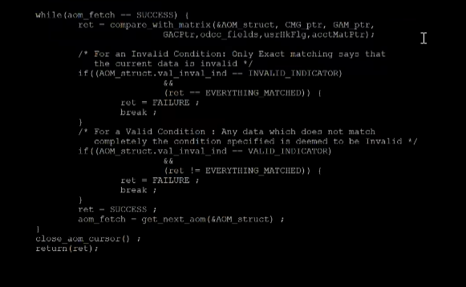
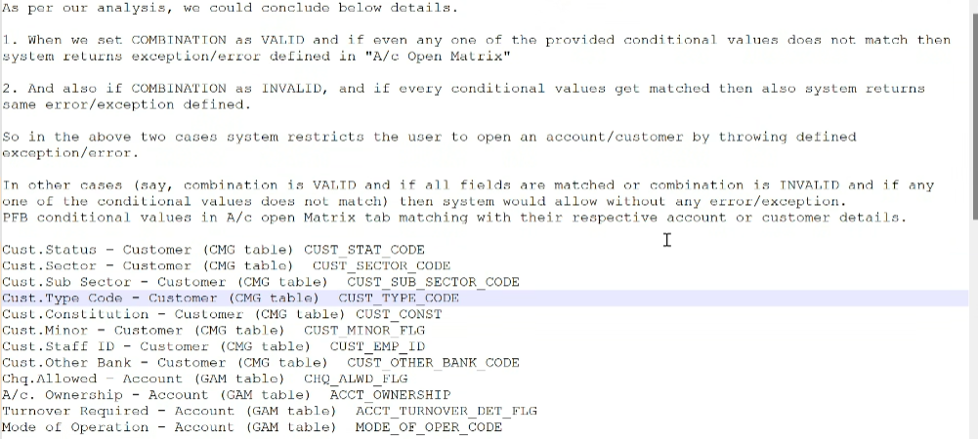
Here in our case HTDGSPM – Customer constitution – ASM but in CMG table level cust_const- PN which is not matching this case, So according to case1: it should be valid as the combination is not matching
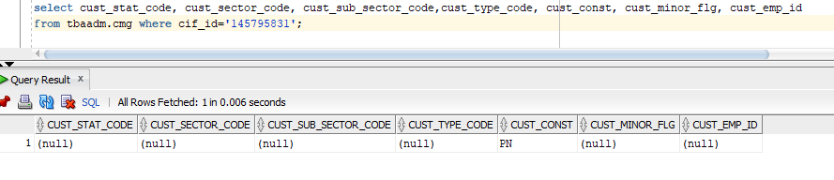
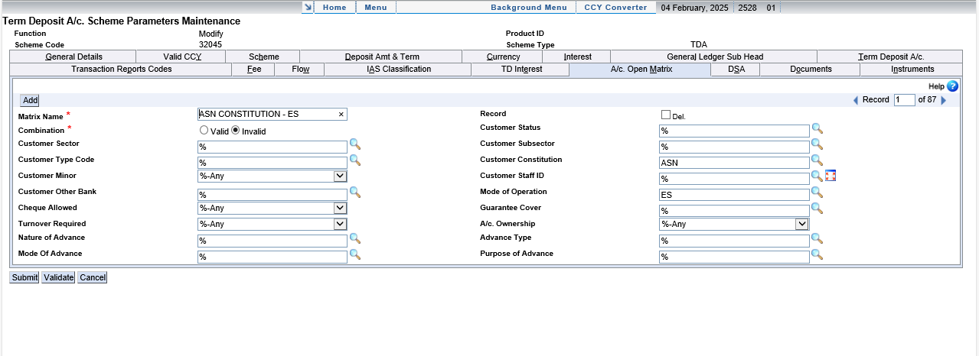
Following is the behaviour:
- If val_inval_ind= INVALID, the Exception “Acct Open Matrix” will be raised only if everything is Matching.
- If val_inval_ind= VALID, the Exception “Acct Open Matrix” will be raised only if everything is not Matching.ie, even though not a single field is matching.

