SVM using CUDA

By:
Gokul Venugopal

Table of Contents

1. INTRODUCTION 3
2. THEORY 4
3. DATA SET 5
4. CPU IMPLEMENTATION 6
5. GPU IMPLEMENTATION 6
6. WORKING 7
7. PROFILING 8
8. CONTINUING PROBLEMS 11
9. CONCLUSION 11
10. REFERENCES 11
11. APPENDIX 12

INTRODUCTION

Support Vector Machines are supervised learning models for classification and regression problems. They can solve linear and non-linear problems and work well for many practical problems [1]. The objective of the support vector machine algorithm is to find a hyperplane in an N-dimensional space (N — the number of features) that distinctly classifies the data points [2]. Through this project, I plan to implement the SVM in CPU and GPU using CUDA. To implement it, the focus will be to calculate a hyperplane that separates sample data set into classes to find the least parameters. Using those parameters, we will be able to find classes for new data. By implementing in GPU, we can obtain higher performance over CPU implementation.

THEORY

The idea of SVM is to implement a hyper plane that lies at maximum distance from all data points. The distance of a data point from hyperplane is the vector projection. This projection needs to maximize for all data points. This is calculated as parameter, w for the model. However, some data points may fall on the other side of the hyperplane even if it belongs to other class. To adjust this, we need to add another factor called bias, b. The best model will have low w and low b which means that all data points have large margin from hyper plane and lowest bias to include all data points. Hyper plane is defined as:
$${\overline{y}}_{i}\left({\overline{x}}_{i}⋅\overline{w}+b\right)-1=0$$
Where ${\overline{y}}_{i}$ - class of a data point
${\overline{x}}_{i}$ - input data point (features)
$\overline{w}$ - weights
$b$ - bias

There are a lot of possible hyperplanes that satisfy the above equation as shown below. Out of these number of hyperplanes, one of them will have least magnitude for w and b.
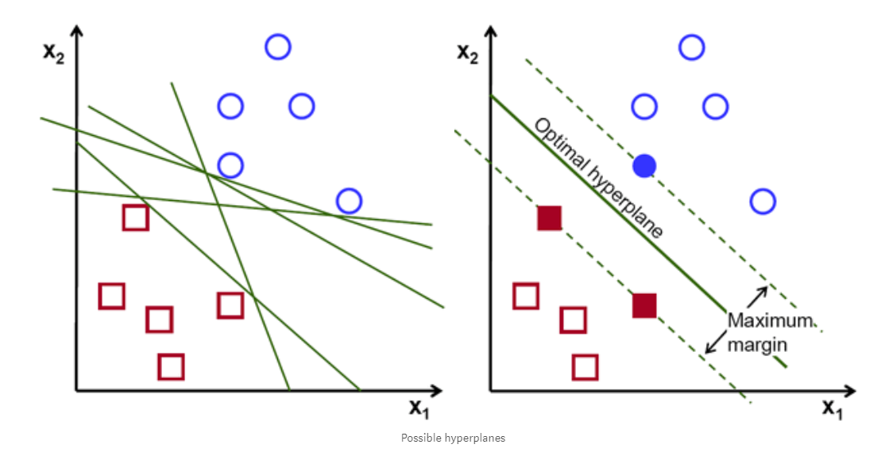

The idea for finding optimal w and b is an optimization problem which is implemented through this project in both CPU and GPU.

The idea of optimization is as shown below where x axis shows difference of ${\overline{y}}_{i}\left({\overline{x}}_{i}⋅\overline{w}+b\right)-1$ from 0 and y axis shows magnitude of w. As shown below first jump will be using one learning step value and then step value will be decreased as it gets closer and closer to median value.

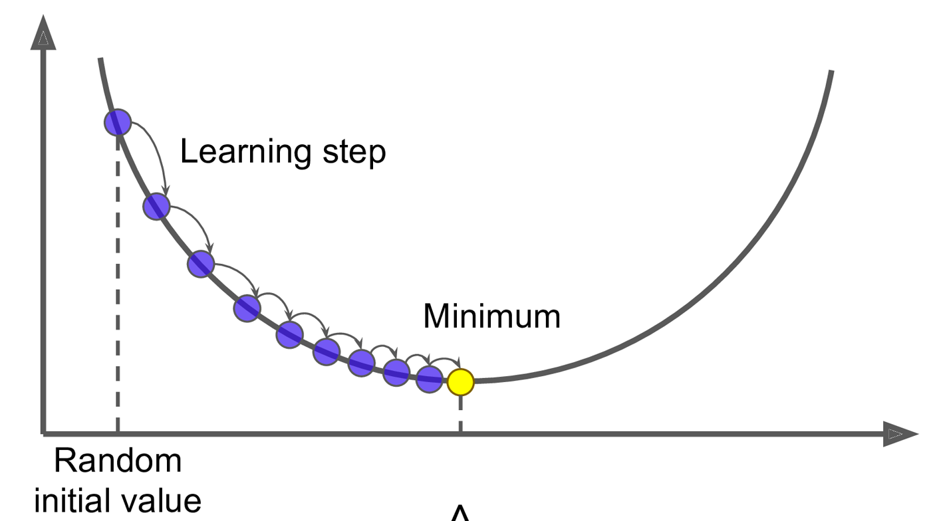

Once the value are calculated we can classify other data points using the value of ${\overline{y}}_{i}\left({\overline{x}}_{i}⋅\overline{w}+b\right)-1$. If this is greater than 0 then it belongs to class 1. Otherwise it belongs to class -1.

DATA SET
To make the implementation and testing faster, the size of the input and prediction data set has been limited. Throughout the implementation the following data set was used:
- Sample Input Data Points: { (1,7), (2,8), (3,8), (5,1), (7,3), (6,-1)}
- Sample Output class: { -1, -1, -1, 1, 1, 1 }
- Sample data to be predicted: { (0,10), (1,3), (3,4), (3,5), (5,5), (5,6), (6,-5), (5,8) }
While adding more data points to training set will help, to make it easier to understand and implemented the data set was not expanded.

CPU IMPLEMENTATION
The optimization problem is resolved by going through each possible combination of vector w and b. To make calculation easier, I have defined three step sizes 0.1, 0.01, 0.001 to cover all possible smallest values at the same time not going to more decimal places which can cause computation cost. Using this step values, all possible values of w0, w1 and b are iterated from – (maximum value of input data) * 10 to (maximum value of input data)*10 and –(maximum value of input data)*5 to (maximum value of input data * 5) respectively. After each iteration using step value, range of w will be updated with the least value of w from the previous iteration. This is to make computation faster and to ignore those cases which are known to be thrown out. This iteration processes the loop compiles all iterations of w and b using step values. An high level implementation logic is as follows:
- Find maximum value in the input data set
- Initialize weights vector w with max value. i.e w0 and w1 is equal to max value
- Define max value for b
- Define step sizes
- Iterate though step sizes.
- For each step size, Iterate over b from -(max value * 5) to (max value *5) with intervals at step size*5
- Along with this iteration, iterate over w from –(max value * 10) to (max value * 10) with intervals at step size.
- Thought the magnitude of w will be same, there can be many cases of w that can happen. So we find out (w0,w1), (w0,-w1), (-w0,-w1), and (-w0,w1)
- For all these combinations find if it satisfies hyperplane equation.
- If yes, then store the combination until one iteration over step is over.
- When that iteration is over, then find least value of optimal.
- This value is store as the value of w.
- Continue till all iterations are over.
- Find least magnitude index of w, and store w0, w1 and b of that combination.
- Use these parameters to predict the new data set.

GPU IMPLEMENTATION

Implementation in GPU is far faster owing to the parallel execution. Considering this advantage, the implementation is divided into three kernels:
- d_getAllOptimal – This kernel function used to find all possible combination of ||w||, w & b. It is done by scanning through a 3d matrix given by weights and bias. X axis is denoted by w0, y axis is denoted by w1 and z axis by b. The values in each axis represents the number of iterations/divisions within the range. w0 and w1 ranges from w_min - w_max with division = w range/step value. i.e w0 and w1 is equal to 2 * (maximum value of input data) * 10 / step, b is equal to (maximum value of input data * 5)/ step value for the first iteration. These dimensions are used to decide number of blocks and threads. This is shown below:

<<< (#of w division/32 +1, #of w1 divisions/32, # of b divisions), (32,32) >>>

The result of this kernel is a list of combination of ||w||, w0, w1, and b. This list is then searched for minimum value.

- d_findMinOptimal – This module calls cublas functions to search through the list of magnitudes ||w|| to find the index of the least magnitude. Then cublas returns the index which is then used to find the optimal b and optimal w0 and w1. cublasIsamin is the function used to find the index of the lowest magnitude. Syntax of the cublasIsamin is shown below:

cublasStatus_t cublasIsamin(cublasHandle_t handle, int n, const float *x, int incx, int *result)

The result of this kernel is a set of w0, w1, b and magnitude that is used later to predict the value.

- d_callpredict – Executes the hyperplane equation for data set for prediction. This kernel received the set with least magnitude, w0, w1 and b. It uses the hyper plane equation shown below to calculate the class.
$$hyper plane equaltion=\left({\overline{x}}_{i}⋅\overline{w}+b\right)-1$$
If this equation is less than 0, then class is -1. Otherwise class is 1. This kernel is executed with the following dimension

<<< (# of data points/32 +1, size of data points/32 + 1), (32, 32)>>>

The resultant array contains the classification for each data points.

WORKING

Both CPU and GPU code were executed to first train model and then predict the given samples. The optimal parameters obtained were
$\overline{w}$ = {0.227486 x -0.227486}
||w|| = 0.321714
b = 0.12

The results have been identified as follows:
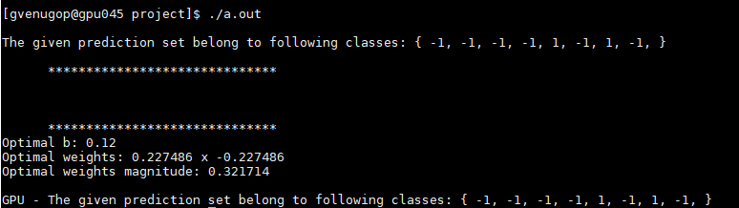

PROFILING

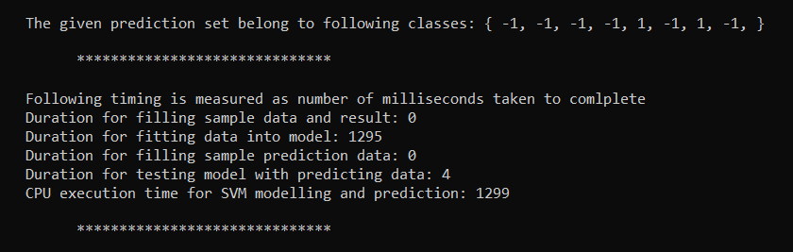
Using high precision timer, CPU implementation was timed to find the results as follows:

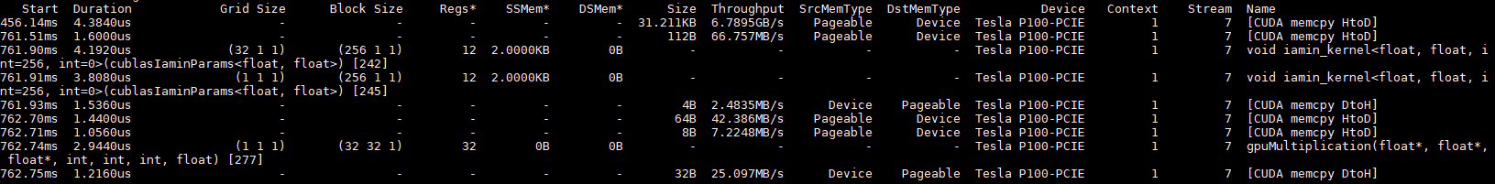
GPU implementation was profiled using Nvidia Visual Profiler as shown as:

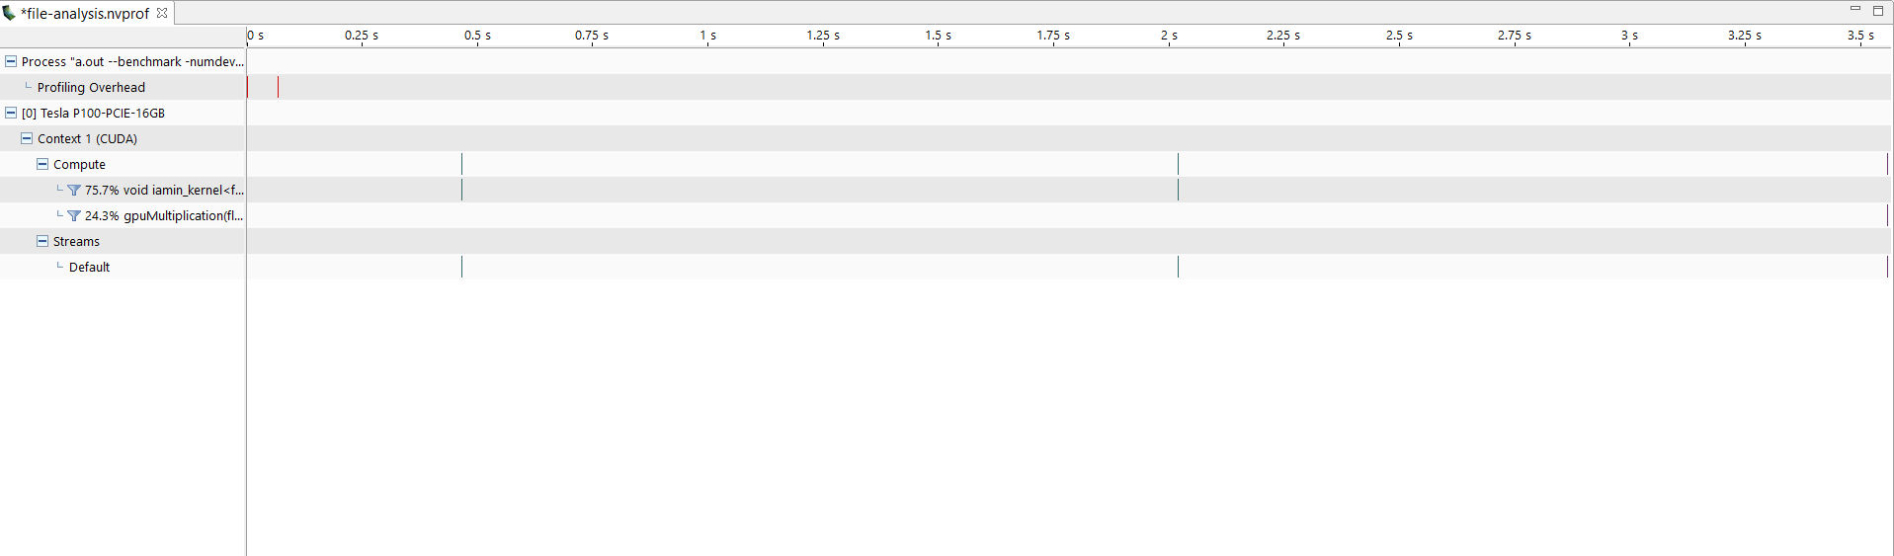
Profiling on all kernels were obtained as shown below:
Profiling for one kernel was zoomed in to find as shown below: We can see how much time does it take to complete execution.
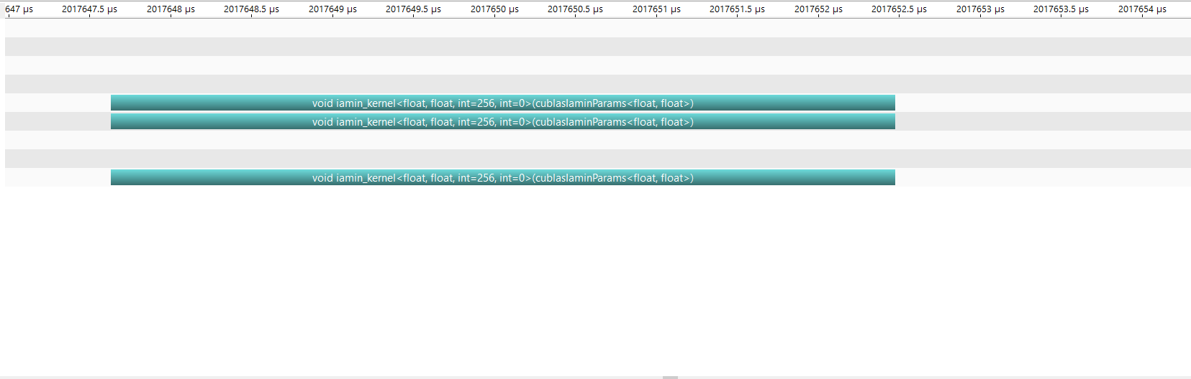

GPU Summary details for d_findMinOptimal as shown below. It was found to complete execution is 9.118 micro seconds with importance as 75%.
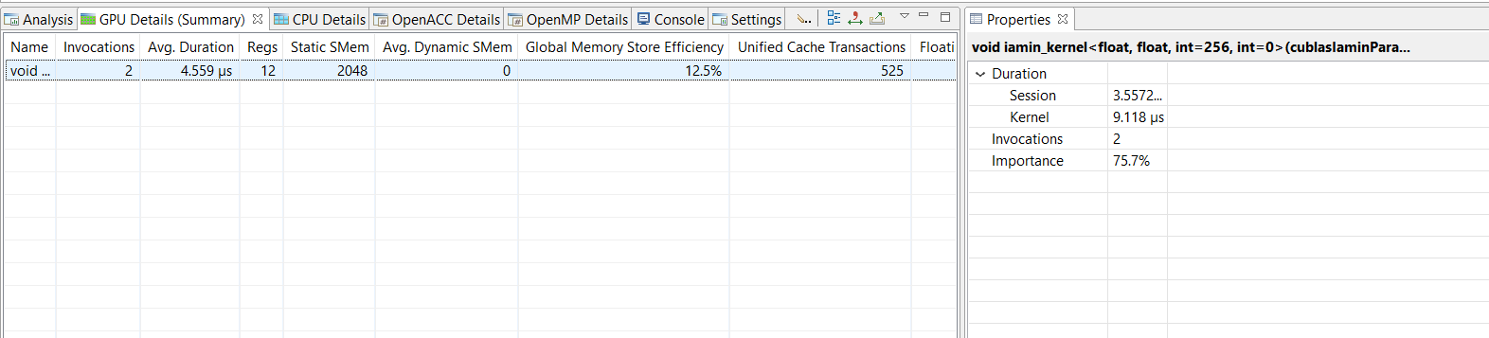

GPU Summary details for d_callPredict profiling as shown below. It was found to execute in 2.9 micro seconds and importance is 24.2%.
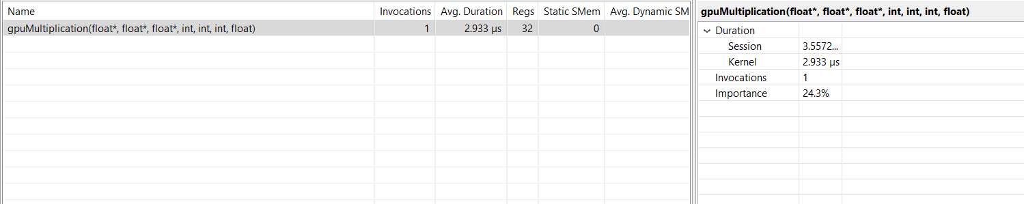

Some other profiling details from command line profiler are included in Appendix. Few major profiling metrics found are:

CONTINUING PROBLEMS

Although the kernels are defined, I was not able to make d_getAllOptimal. The issue was since thread id and blocks id are used to for calculating the index to which the combination of w and b will be stored. Due to the fact that all threads won’t be satisfying the equation, they won’t be updating indexes. So method used to increment thread for threads was proper and so it did not work. As a work around, I took out list of all optimal values from CPU implementation and gave it d_findMinOptimal.
Another error that is persisting is that cublasIsamin is always ignoring the last one fifth of portion o f the set of all possible optimal values. It is returning a value of ||w|| that is not the least element. As a work around I used the optimal value from CPU Implementation.

CONCLUSION
GPU implementation is so much faster than CPU. GPU completes simulation in micro seconds while CPU completes in milliseconds. Profiling on kernels gave idea on how code performs and how it can be improved. This project also gave an overview of how fast this algorithm works on GPU and how it can be used for regression as well as multi class classification problem.

10. REFERENCES
[1] Medium - https://medium.com/@LSchultebraucks/introduction-to-support-vector-machines-9f8161ae2fcb
[2] towardsdatascience.com - https://towardsdatascience.com/support-vector-machine-introduction-to-machine-learning-algorithms-934a444fca47

APPENDIX

Invocations Metric Name Metric Description Min Max Avg
Kernel: gpuMultiplication(float*, float*, float*, int, int, int, float)
1 inst_per_warp Instructions per warp 32.312500 32.312500 32.312500
1 branch_efficiency Branch Efficiency 100.00% 100.00% 100.00%
1 warp_execution_efficiency Warp Execution Efficiency 45.10% 45.10% 45.10%
1 global_hit_rate Global Hit Rate in unified l1/tex 90.62% 90.62% 90.62%
1 local_hit_rate Local Hit Rate 0.00% 0.00% 0.00%
1 local_memory_overhead Local Memory Overhead 0.00% 0.00% 0.00%
1 shared_load_throughput Shared Memory Load Throughput 0.00000B/s 0.00000B/s 0.00000B/s
1 shared_store_throughput Shared Memory Store Throughput 0.00000B/s 0.00000B/s 0.00000B/s
1 flop_count_dp Floating Point Operations(Double Precision) 0 0 0
1 flop_count_dp_add Floating Point Operations(Double Precision Add) 0 0 0
1 flop_count_dp_fma Floating Point Operations(Double Precision FMA) 0 0 0
1 flop_count_dp_mul Floating Point Operations(Double Precision Mul) 0 0 0
1 flop_count_sp Floating Point Operations(Single Precision) 40 40 40
1 flop_count_sp_add Floating Point Operations(Single Precision Add) 8 8 8
1 flop_count_sp_fma Floating Point Operations(Single Precision FMA) 16 16 16
1 flop_count_sp_mul Floating Point Operation(Single Precision Mul) 0 0 0
1 inst_executed Instructions Executed 1034 1034 1034
1 inst_issued Instructions Issued 1113 1113 1113
1 sysmem_utilization System Memory Utilization Low (1) Low (1) Low (1)
1 shared_efficiency Shared Memory Efficiency 0.00% 0.00% 0.00%
1 flop_count_hp Floating Point Operations(Half Precision) 0 0 0
1 flop_count_hp_add Floating Point Operations(Half Precision Add) 0 0 0
1 flop_count_hp_mul Floating Point Operation(Half Precision Mul) 0 0 0
1 flop_count_hp_fma Floating Point Operations(Half Precision FMA) 0 0 0
1 inst_fp_16 HP Instructions(Half) 0 0 0
1 ipc Executed IPC 0.726634 0.726634 0.726634
1 issued_ipc Issued IPC 0.782150 0.782150 0.782150
1 achieved_occupancy Achieved Occupancy 0.290605 0.290605 0.290605
1 shared_utilization Shared Memory Utilization Idle (0) Idle (0) Idle (0)
1 inst_executed_global_loads Warp level instructions for global loads 48 48 48
1 inst_executed_global_stores Warp level instructions for global stores 14 14 14
1 global_load_requests Total number of global load requests from Multiprocessor 32 32 32
1 sysmem_write_bytes System Memory Write Bytes 160 160 160
1 unique_warps_launched Number of warps launched 32 32 32
Kernel: void iamin_kernel<float, float, int=256, int=0>(cublasIaminParams<float, float>)
2 inst_per_warp Instructions per warp 106.000000 112.007812 109.003906
2 branch_efficiency Branch Efficiency 100.00% 100.00% 100.00%
2 warp_execution_efficiency Warp Execution Efficiency 84.73% 88.02% 86.37%
2 warp_nonpred_execution_efficiency Warp Non-Predicated Execution Efficiency 81.43% 83.61% 82.52%
2 gld_requested_throughput Requested Global Load Throughput 78.772MB/s 6.8917GB/s 3.2394GB/s
2 gst_requested_throughput Requested Global Store Throughput 783.13KB/s 56.527MB/s 26.642MB/s
2 gld_throughput Global Load Throughput 183.55MB/s 6.8934GB/s 3.2950GB/s
2 flop_count_dp Floating Point Operations(Double Precision) 0 0 0
2 flop_count_dp_add Floating Point Operations(Double Precision Add) 0 0 0
2 flop_count_dp_fma Floating Point Operations(Double Precision FMA) 0 0 0
2 flop_count_dp_mul Floating Point Operations(Double Precision Mul) 0 0 0
2 flop_count_sp Floating Point Operations(Single Precision) 32 7990 4011
2 flop_count_sp_add Floating Point Operations(Single Precision Add) 32 7990 4011
2 flop_count_sp_fma Floating Point Operations(Single Precision FMA) 0 0 0
2 flop_count_sp_mul Floating Point Operation(Single Precision Mul) 0 0 0
2 flop_count_sp_special Floating Point Operations(Single Precision Special) 0 0 0
2 inst_executed Instructions Executed 848 28674 14761
2 inst_issued Instructions Issued 872 29442 15157
2 dram_utilization Device Memory Utilization Low (1) Low (1) Low (1)
2 sysmem_utilization System Memory Utilization Low (1) Low (1) Low (1)
2 shared_efficiency Shared Memory Efficiency 70.97% 71.73% 71.35%
2 flop_count_hp Floating Point Operations(Half Precision) 0 0 0
2 flop_count_hp_add Floating Point Operations(Half Precision Add) 0 0 0
2 flop_count_hp_mul Floating Point Operation(Half Precision Mul) 0 0 0
2 flop_count_hp_fma Floating Point Operations(Half Precision FMA) 0 0 0
2 inst_fp_16 HP Instructions(Half) 0 0 0
2 ipc Executed IPC 0.192465 0.230624 0.211545
2 issued_ipc Issued IPC 0.220704 0.236741 0.228722
2 flop_hp_efficiency FLOP Efficiency(Peak Half) 0.00% 0.00% 0.00%
2 flop_sp_efficiency FLOP Efficiency(Peak Single) 0.00% 0.01% 0.01%
2 inst_executed_global_loads Warp level instructions for global loads 20 250 135
2 inst_executed_local_loads Warp level instructions for local loads 0 0 0
2 inst_executed_shared_loads Warp level instructions for shared loads 49 1632 840
2 inst_executed_surface_loads Warp level instructions for surface loads 0 0 0
2 inst_executed_global_stores Warp level instructions for global stores 1 96 48
2 inst_executed_local_stores Warp level instructions for local stores 0 0 0
2 inst_executed_shared_stores Warp level instructions for shared stores 40 1280 660
2 inst_executed_surface_stores Warp level instructions for surface stores 0 0 0
2 inst_executed_global_atomics Warp level instructions for global atom and atom cas 0 0 0
2 inst_executed_global_reductions Warp level instructions for global reductions 0 0 0
2 inst_executed_surface_atomics Warp level instructions for surface atom and atom cas 0 0 0
2 inst_executed_surface_reductions Warp level instructions for surface reductions 0 0 0
2 inst_executed_shared_atomics Warp level shared instructions for atom and atom CAS 0 0 0
2 inst_executed_tex_ops Warp level instructions for texture 0 0 0
2 unique_warps_launched Number of warps launched 8 256 132

