
REPORT
E-COMMERCE CUSTOMER & MARKETING ANALYTICS

End-to-End Analysis using SQL, Python, Excel & Power BI

Dataset: Sample Superstore Dataset (Kaggle)

SUBMITTED BY-
GOVIND

Table of Contents
SR. NO. | CONTENT | PAGE NO.
 | Executive Summary | I
1 | Business Problem | 1
2 | Objectives | 2
3 | Dataset Description | 3
4 | Data Cleaning (Python) | 4
5 | Exploratory Data Analysis | 5
6 | Excel Dashboard | 12
7 | SQL Analysis | 14
8 | Power BI Dashboard | 17
9 | Business Insights | 22
10 | Recommendations | 23
11 | Conclusion | 24
12 | Limitations | 25
13 | Future Scope | 26
 | References | 27

Executive Summary
This report presents an end-to-end analysis of the Sample Superstore dataset (sourced from Kaggle), covering four years of retail transactions across the United States. The objective of the project was to build a complete analytics pipeline — from raw data cleaning in Python, through exploratory data analysis and SQL-based querying, to interactive dashboards in Excel and Power BI — in order to uncover the drivers of sales and profitability and to generate actionable business recommendations.
The dataset covers 9,977 orders and 37,820 units sold, generating total sales of approximately ₹9 (2.30M) and total profit of approximately ₹2.86 lakh (286.24K), representing an overall profit margin of 12.0–12.5%. Nearly 1 in 5 orders (18.73%) were sold at a loss, and the average discount applied across all orders was 15.63%.
Key findings show that the Technology category is the strongest profit driver, the West and East regions outperform Central and South, and the Consumer segment contributes roughly half of all profit. Discounting emerges as the single largest controllable driver of unprofitability: discounts above 40% are strongly associated with negative profit, and sub-categories such as Binders, Tables and Machines are chronic loss-makers despite healthy sales volumes.
The report concludes with a set of prioritized, data-backed recommendations — focused on tightening discount governance, reviewing pricing for loss-making sub-categories, and reinforcing investment in high-performing regions and categories — along with a discussion of the project's limitations and scope for future work.
Total Orders | 9,977
Total Quantity Sold | 37,820 units
Total Sales | ₹22,96,195.59 (≈ 2.30M)
Total Profit | ₹2,86,241.42 (≈ 286.24K)
Overall Profit Margin | 12.01% – 12.47%
Average Discount | 15.63%
% of Orders Sold at a Loss | 18.73%

1. Business Problem
Superstore, a multi-category retail business operating across the Central, East, South and West regions of the United States, sells products spanning Furniture, Office Supplies, and Technology. While the company has grown its order volume and top-line sales over time, profitability has not scaled at the same rate — a meaningful share of orders are being sold at a loss, and profit margins vary widely across categories, sub-categories, regions and customer segments.
Management lacks a unified, data-driven view connecting sales, discounting behaviour, and profitability. Decisions on discounting, regional investment, and category focus have historically been made without a clear picture of which combinations of category, region, segment and discount level actually erode margin. This creates a business problem: the company needs to identify where profit is being made and lost, understand the role discounting plays in that outcome, and translate these insights into concrete, prioritized actions.

2. Objectives
The project was designed around the following objectives:
- Clean and prepare the raw Superstore dataset for analysis, handling missing values, duplicates, data types and outliers.
- Perform exploratory data analysis (EDA) in Python to understand the distribution and relationships between Sales, Profit, Discount and Quantity.
- Build an interactive Excel dashboard for quick, spreadsheet-native reporting of key metrics.
- Write SQL queries to answer specific business questions (top/bottom performers, regional and category breakdowns, discount impact).
- Design a multi-page Power BI dashboard for executive-level, interactive exploration of the data with filters for Region, Category, Segment and Ship Mode.
- Synthesize the findings across all tools into a coherent set of business insights and recommendations.

3. Dataset Description
The analysis uses the publicly available Sample Superstore dataset from Kaggle, a widely-used retail transactions dataset commonly used to benchmark BI and analytics workflows. Each row represents a single product line within a customer order.

5.1 Dataset Snapshot
Source | Kaggle — Sample Superstore Dataset
Records | 9,994 orders / order lines
Time Period | Multi-year U.S. retail transactions
Categories | Furniture, Office Supplies, Technology
Regions | Central, East, South, West
Segments | Consumer, Corporate, Home Office

3.2 Key Fields
Column | Description | Type
Order ID | Unique identifier for each order | Text
Order Date / Ship Date | Date the order was placed / shipped | Date
Ship Mode | Standard, Second, First Class, Same Day | Categorical
Customer ID / Name | Customer identifier and name | Text
Segment | Consumer, Corporate, Home Office | Categorical
Country / City / State / Region | Geographic attributes of the order | Text / Categorical
Category / Sub-Category | Product category and sub-category | Categorical
Product Name | Name of the product sold | Text
Sales | Revenue generated by the order line | Numeric
Quantity | Units sold in the order line | Numeric
Discount | Discount rate applied (0–0.8) | Numeric
Profit | Profit or loss on the order line | Numeric

4. Data Cleaning (Python)
Before analysis, the raw dataset was loaded into Python (pandas) and put through a standard cleaning pipeline to ensure downstream charts, SQL queries and dashboards were built on reliable data. The main steps performed were:
- Loaded the CSV export of the Superstore dataset using pandas.read_csv() and inspected shape, dtypes and null counts with .info() and .isnull().sum().
- Checked for and removed exact duplicate rows using drop_duplicates().
- Converted Order Date and Ship Date columns to proper datetime types for time-based analysis.
- Verified categorical fields (Category, Sub-Category, Region, Segment, Ship Mode) for consistent spelling and casing.
- Confirmed Sales, Profit, Discount and Quantity columns were numeric, coercing any stray text entries and re-checking for nulls introduced in the process.
- Reviewed Discount for valid range (0 to 0.8, i.e. 0%–80%) and Profit for extreme outliers, flagging — but retaining — genuine high-loss transactions since they are central to the discount-vs-profit analysis.
- Derived helper fields where useful for analysis, such as Profit Margin (Profit / Sales) and a loss flag (Profit < 0) used to compute the 18.73% loss-order rate.

The cleaned dataset was then exported for use across the three downstream tools: Python (EDA and charting), Excel (pivot-based dashboard), and Power BI (interactive dashboard), and loaded into a SQL database for query-based analysis.

5. Exploratory Data Analysis
Exploratory data analysis was carried out in Python using pandas, matplotlib and seaborn to understand the shape of the data, identify outliers, and surface early relationships between Sales, Profit, Discount and Quantity before moving into SQL and dashboard work.

5.1 Sales Distribution
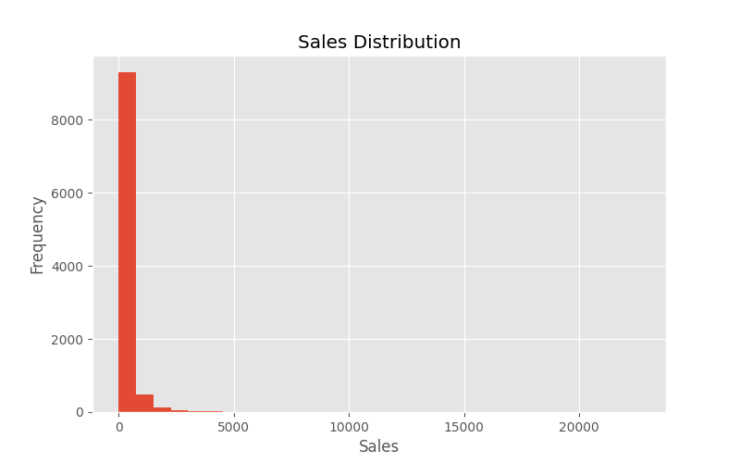
The Sales Distribution histogram shows that the overwhelming majority of order lines are low-value, with most transactions falling under roughly ₹500. The distribution is heavily right-skewed, with a long tail of high-value orders extending out past ₹20,000. This confirms that Superstore's revenue is built on a high volume of small transactions rather than a small number of large ones, and that any aggregate statistics (like averages) should be interpreted alongside the median due to this skew.

5.2 Sales Outliers
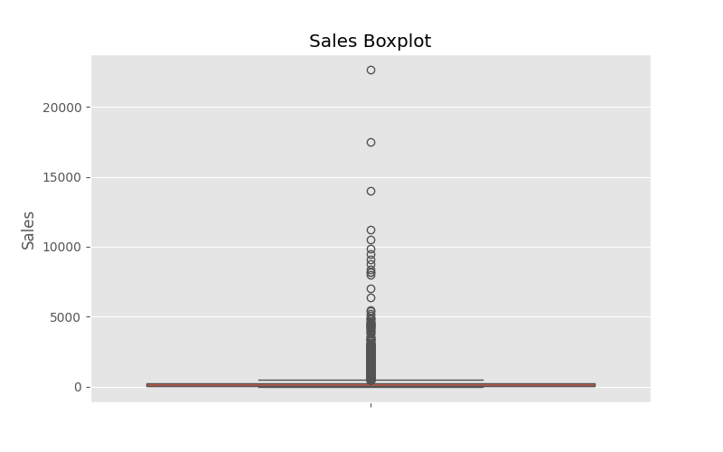
The Sales boxplot reinforces the histogram's finding: the interquartile range sits close to zero on this scale, while a large number of outlier orders — some exceeding ₹20,000 — stretch far above the box. These high-value outliers are legitimate large orders rather than data errors, but they are important to keep in mind when interpreting mean-based summary metrics.

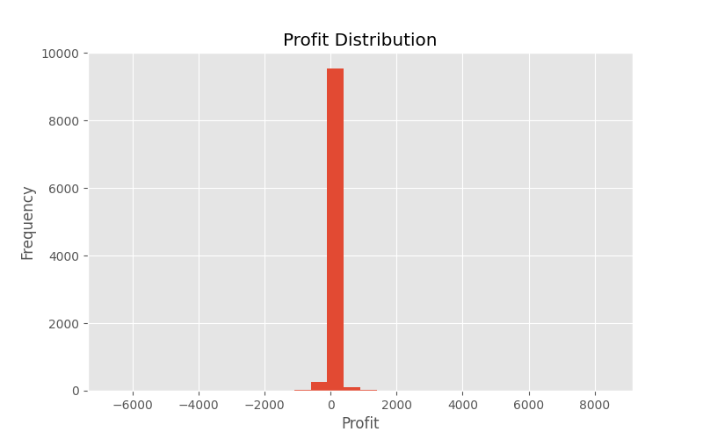
5.3 Profit Distribution
The Profit Distribution histogram is tightly concentrated around zero, with the vast majority of order lines generating a small positive profit. However, the distribution has visible tails on both sides — a smaller cluster of highly profitable orders extending toward ₹8,000, and a cluster of loss-making orders extending down to roughly -₹6,500. This visual is the first clear signal that a meaningful subset of transactions are actively destroying margin.

5.4 Profit Outliers
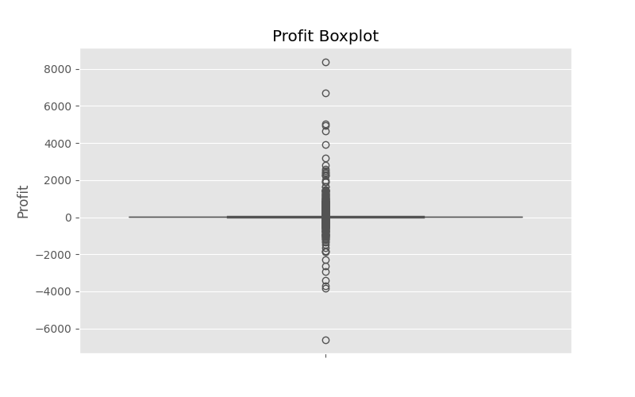
The Profit boxplot shows an interquartile range clustered near zero with dense outliers on both the positive and negative side, confirming that while the typical order is modestly profitable, both large wins and large losses occur regularly enough to materially affect the bottom line.

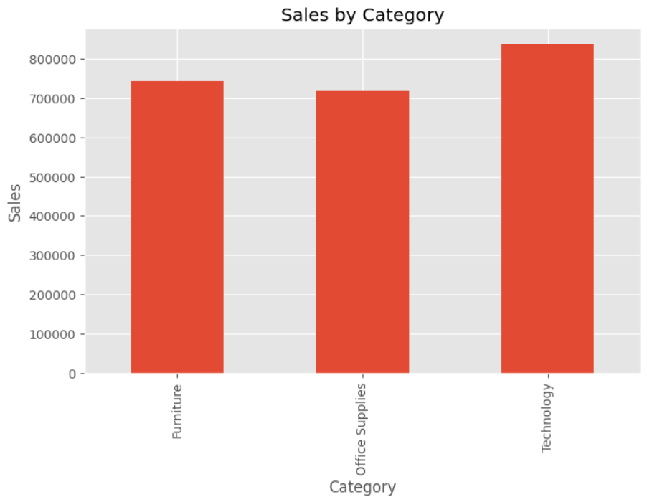
5.5 Sales by Category

Aggregated sales by category show Technology leading (~836K), followed closely by Furniture (~741K) and Office Supplies (~719K). The three categories are more evenly matched on sales than they are on profit, which becomes the key insight once profit-by-category is examined.

5.6 Profit by Category
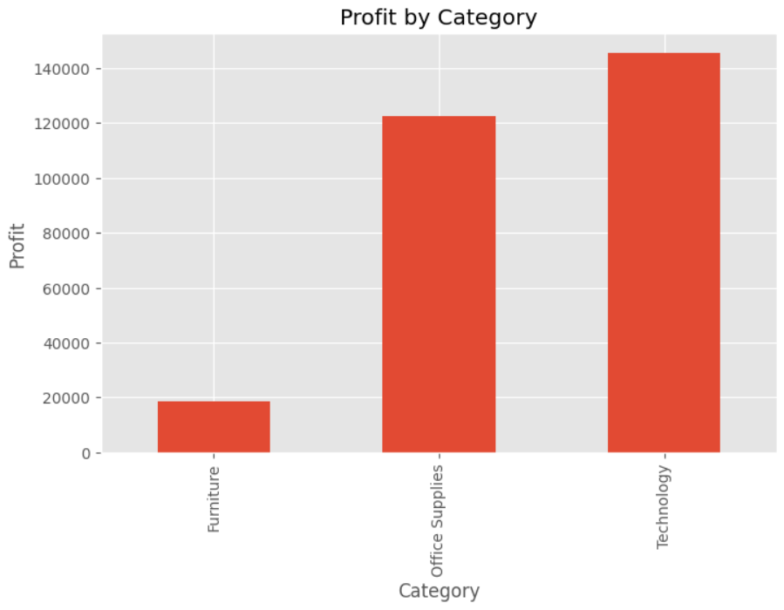
Profit by category tells a very different story from sales: Technology dominates profit contribution (~145K), Office Supplies contributes a solid ~122K, while Furniture lags far behind at only ~19K despite generating comparable sales volume. This gap indicates a margin problem specific to Furniture rather than a demand problem.

5.7 Sales by Region
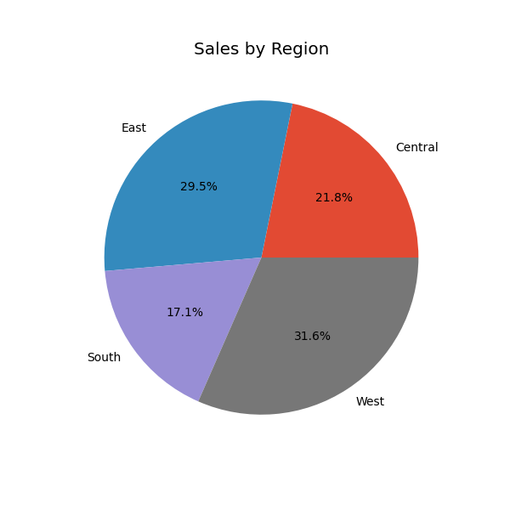
The regional sales split shows the West (31.6%) and East (29.5%) regions together accounting for over 60% of total sales, with Central (21.8%) and South (17.1%) trailing behind. This concentration suggests the West and East are Superstore's core markets.

5.8 Top Sub-Categories by Sales
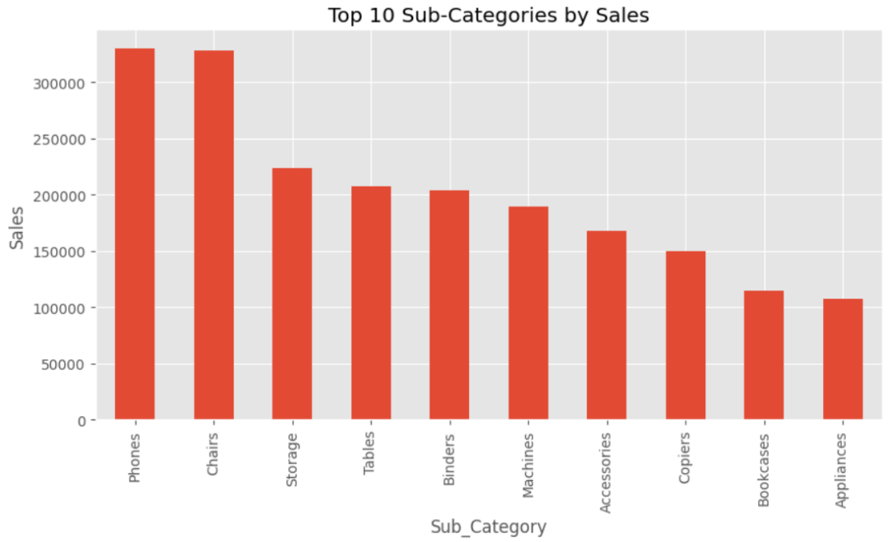
Phones and Chairs are the two largest sub-categories by sales, each contributing roughly 330K, followed by Storage, Tables and Binders. Notably, several of these top-selling sub-categories (Tables, Binders) later prove to be loss-making once profit is examined — high sales volume does not guarantee profitability.

5.9 Correlation Heatmap
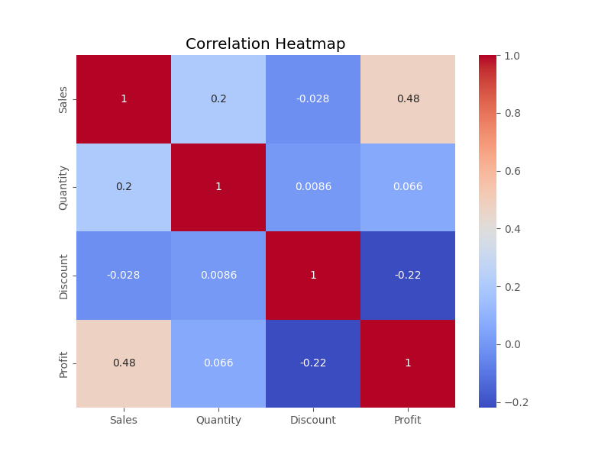
The correlation heatmap quantifies the relationships between the four core numeric fields. Sales and Profit are moderately positively correlated (0.48), confirming that higher-value orders tend to be more profitable on average. Discount and Profit are negatively correlated (-0.22), providing statistical confirmation that increasing the discount rate tends to erode profit. Quantity shows only weak correlation with both Sales (0.2) and Profit (0.066), while Discount and Quantity are essentially uncorrelated (0.0086).

5.10 Discount vs Profit
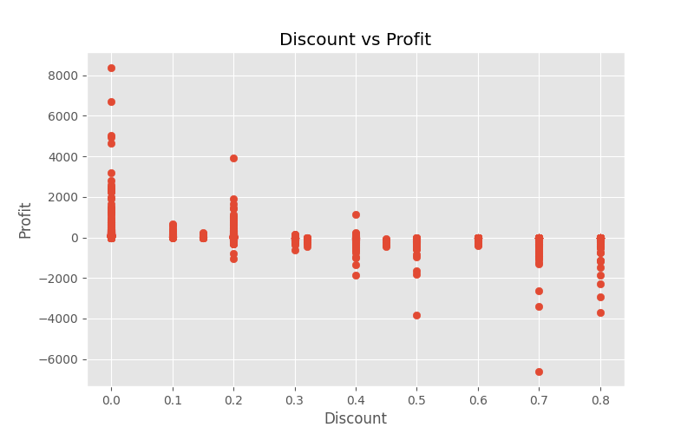
This scatter plot is one of the most important charts in the analysis. At low discount levels (0–10%), profit is highly variable but frequently strongly positive, with several orders exceeding ₹5,000–8,000 in profit. As the discount rate increases past roughly 20–30%, the cloud of points shifts decisively toward zero and then negative, and by the 50–80% discount range almost every order shows a loss, with some exceeding -₹6,000. This chart visually confirms the correlation heatmap's finding and is the strongest single piece of evidence that aggressive discounting is a primary driver of unprofitable orders.

6. Excel Dashboard
A standalone KPI-driven dashboard was built in Excel using PivotTables and PivotCharts, providing a lightweight, spreadsheet-native view of the business for stakeholders who prefer working directly in Excel. The dashboard is filterable by Category, Region and Segment via the underlying pivot fields.

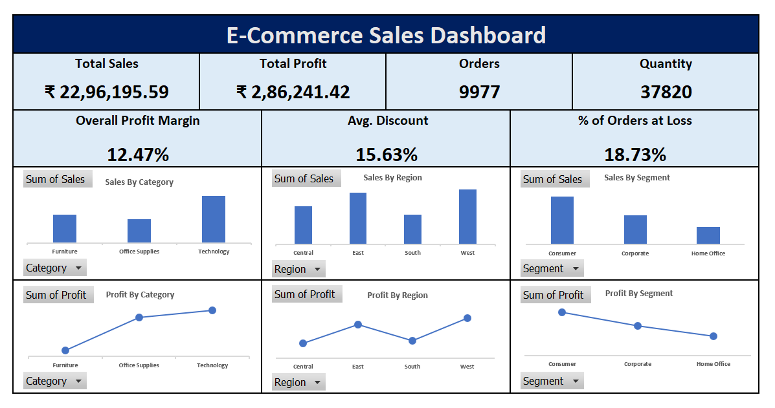
Figure 8.1 — E-Commerce Sales Dashboard (Excel, PivotTable/PivotChart based)

The dashboard header surfaces the top-line KPIs at a glance: Total Sales of ₹22,96,195.59, Total Profit of ₹2,86,241.42, 9,977 Orders and 37,820 units of Quantity sold. Below this, an Overall Profit Margin of 12.47%, an Average Discount of 15.63%, and a % of Orders at Loss of 18.73% give an immediate read on business health and risk.
The lower panels break Sales and Profit down by Category, Region and Segment using paired bar and line charts. Sales by Category confirms Technology as the leader, while Profit by Category shows a rising trend from Furniture through Office Supplies to Technology — visually reinforcing that Furniture sells well but converts poorly to profit. The Region and Segment panels similarly allow quick comparison of where sales and profit are concentrated, making this dashboard a fast, no-code way for business users to monitor performance without opening Power BI or running SQL.

7. SQL Analysis
The cleaned dataset was loaded into a relational database (table: superstore) to answer specific business questions using SQL. This complements the visual dashboards by allowing precise, ad-hoc aggregation and ranking queries. Representative queries and their business interpretation are shown below.

7.1 Total Sales, Profit and Margin by Category
Business question: Which product category drives the most revenue and profit?
SELECT Category,
SUM(Sales) AS Total_Sales,
SUM(Profit) AS Total_Profit,
ROUND(SUM(Profit) / SUM(Sales) * 100, 2) AS Profit_Margin_Pct
FROM superstore
GROUP BY Category
ORDER BY Total_Profit DESC;
This query confirms Technology as the top category on both sales and profit, with Office Supplies close behind on profit despite lower sales, and Furniture trailing well behind on profit margin — matching the Python EDA and Excel dashboard findings.

7.2 Top 10 Loss-Making Sub-Categories
Business question: Which sub-categories are eroding overall profitability?
SELECT Sub_Category,
SUM(Sales) AS Total_Sales,
SUM(Profit) AS Total_Profit
FROM superstore
GROUP BY Sub_Category
HAVING SUM(Profit) < 0
ORDER BY Total_Profit ASC
LIMIT 10;
The result set identifies Binders, Tables and Machines as the largest loss-makers by absolute profit, with Chairs, Appliances, Bookcases and Phones also appearing in negative territory — directly informing the pricing-review recommendation in this report.

7.3 Regional Performance
Business question: How does profitability vary by region, and is regional sales volume a good proxy for profit?
SELECT Region,
SUM(Sales) AS Total_Sales,
SUM(Profit) AS Total_Profit,
COUNT(*) AS Order_Lines
FROM superstore
GROUP BY Region
ORDER BY Total_Profit DESC;
West and East regions rank highest on both sales and profit, while Central and South underperform on both metrics — indicating regional strength is broadly consistent between the two KPIs, unlike category, where sales and profit rankings diverge.

7.4 Discount Impact on Profitability
Business question: At what discount level does the average order stop being profitable?
SELECT CASE
WHEN Discount = 0 THEN '0%'
WHEN Discount <= 0.1 THEN '0-10%'
WHEN Discount <= 0.2 THEN '10-20%'
WHEN Discount <= 0.3 THEN '20-30%'
WHEN Discount <= 0.4 THEN '30-40%'
ELSE '40%+'
END AS Discount_Band,
ROUND(AVG(Profit), 2) AS Avg_Profit,
COUNT(*) AS Orders
FROM superstore
GROUP BY Discount_Band
ORDER BY MIN(Discount);
Average profit per order declines steadily as the discount band increases, turning negative once discounts exceed roughly 20-30% — quantifying, in SQL, the same relationship visualized in the Discount vs Profit scatter plot and the Power BI Discount Analysis page.

7.5 Orders Sold at a Loss
Business question: What share of all orders are unprofitable, and what does that cost the business?
SELECT COUNT(*) FILTER (WHERE Profit < 0) AS Loss_Orders,
COUNT(*) AS Total_Orders,
ROUND(100.0 * COUNT(*) FILTER (WHERE Profit < 0) / COUNT(*), 2) AS Loss_Pct,
ROUND(SUM(Profit) FILTER (WHERE Profit < 0), 2) AS Total_Loss_Amount
FROM superstore;
This query verifies the 18.73% loss-order rate reported on the Excel dashboard and quantifies the total value being lost on unprofitable orders — a figure that directly frames the size of the opportunity available through better discount governance.

8. Power BI Dashboard
A four-page interactive Power BI report was built on top of the cleaned dataset, giving stakeholders a filterable, drill-down view of the business across Region, Category, Segment and Ship Mode. Each page is described below with its corresponding screenshot.

8.1 Executive Dashboard
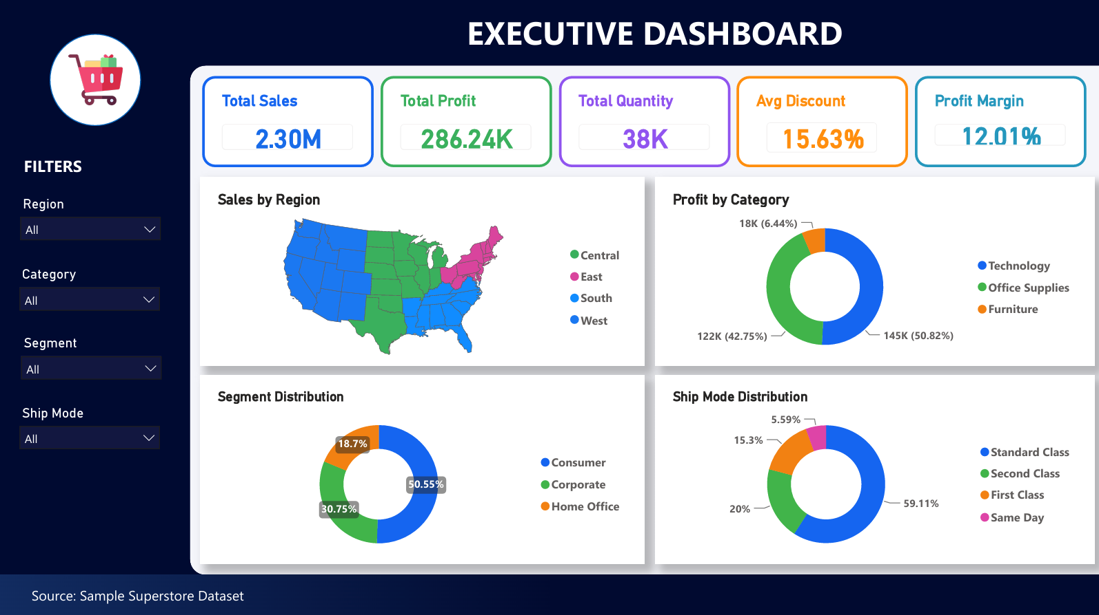
Figure 10.1 — Executive Dashboard: top-line KPIs, sales by region map, profit by category, segment and ship mode distribution
The landing page surfaces headline KPIs — Total Sales of 2.30M, Total Profit of 286.24K, Total Quantity of 38K, Average Discount of 15.63% and a Profit Margin of 12.01% — alongside a U.S. filled map of sales by region, a donut of profit by category (Technology 50.82%, Office Supplies 42.75%, Furniture 6.44%), a segment distribution donut (Consumer 50.55%, Corporate 30.75%, Home Office 18.7%) and a ship mode donut showing Standard Class dominating at 59.11% of shipments.

8.2 Sales Analysis
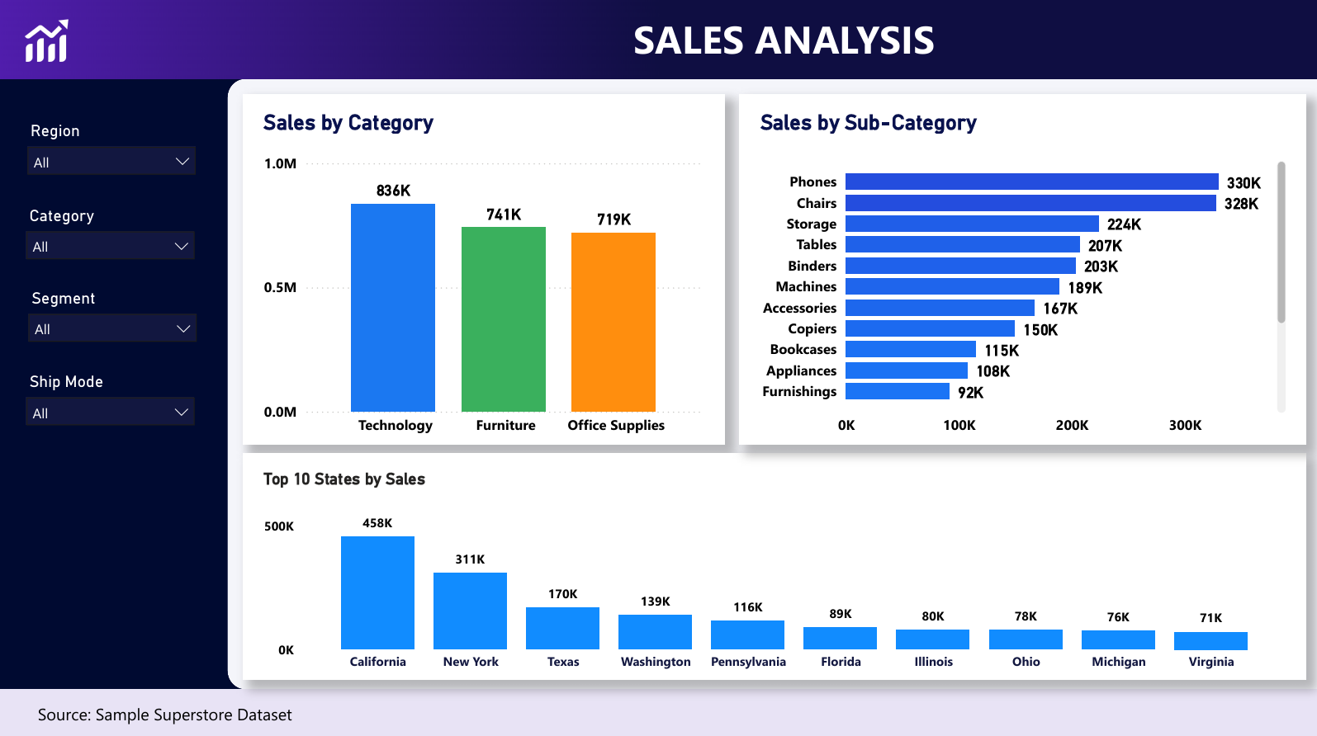
Figure 10.2 — Sales Analysis: sales by category, sales by sub-category, and top 10 states by sales
This page breaks sales down three ways. Sales by Category confirms Technology (836K) ahead of Furniture (741K) and Office Supplies (719K). Sales by Sub-Category ranks all eleven sub-categories from Phones (330K) down to Furnishings (92K), giving a granular view consistent with the Python Pareto chart. The Top 10 States panel shows California (458K) and New York (311K) as by far the largest state markets, with Texas, Washington and Pennsylvania forming a second tier.

8.3 Profit Analysis
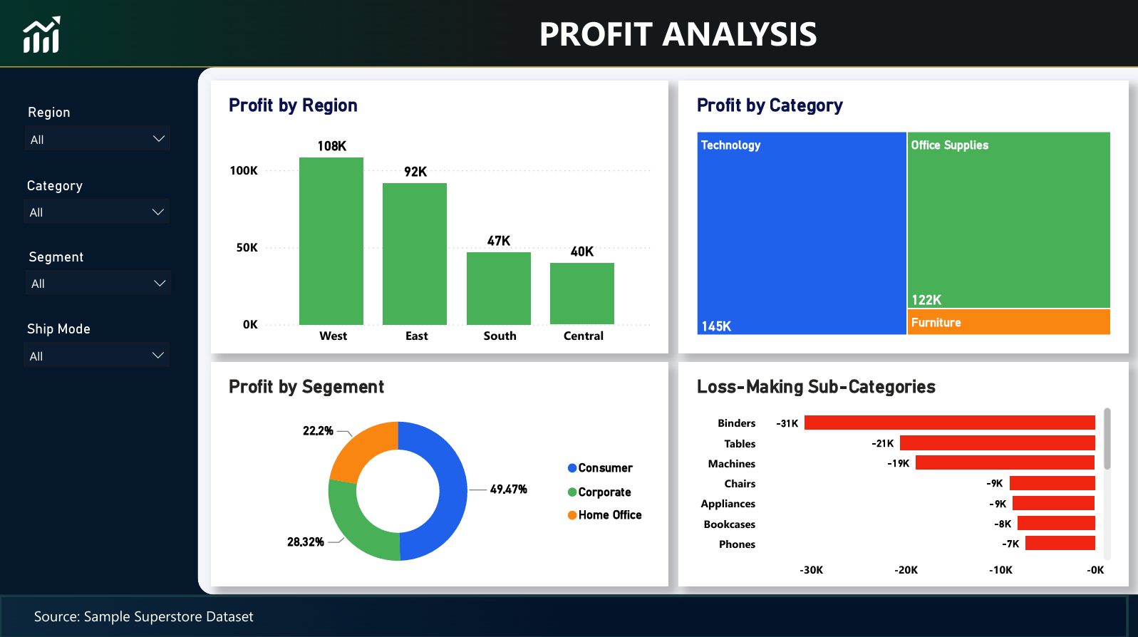
Figure 10.3 — Profit Analysis: profit by region, profit by category, profit by segment, and loss-making sub-categories
The Profit Analysis page is the report's diagnostic core. Profit by Region ranks West (108K) and East (92K) well ahead of South (47K) and Central (40K). The Profit by Category treemap shows Technology (145K) and Office Supplies (122K) dominating, with Furniture contributing only a sliver. The Profit by Segment donut shows Consumer at 49.47%, Corporate at 28.32% and Home Office at 22.2%. Most importantly, the Loss-Making Sub-Categories bar chart quantifies the damage: Binders (-31K), Tables (-21K) and Machines (-19K) are the three largest loss contributors, with Chairs, Appliances, Bookcases and Phones each losing roughly -7K to -9K.

8.4 Discount Analysis
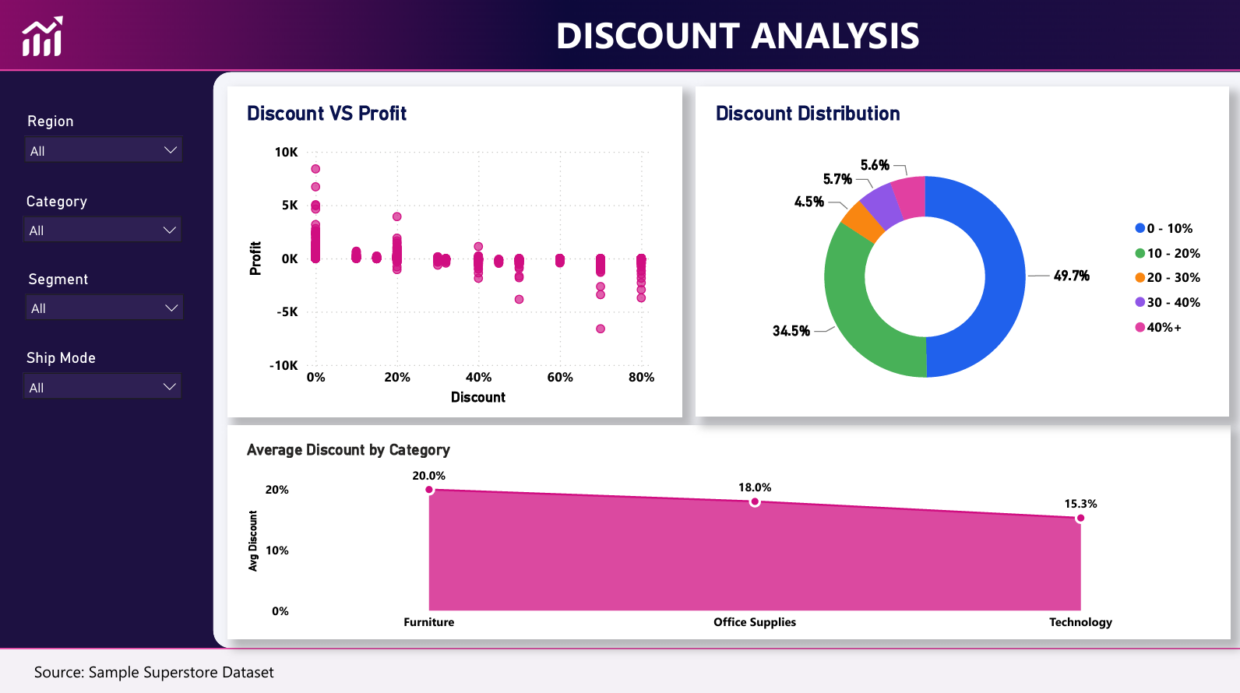
Figure 10.4 — Discount Analysis: discount vs profit, discount distribution, and average discount by category
The Discount vs Profit scatter plot mirrors the Python analysis: profit clusters positively near 0% discount and trends toward zero and negative as discount rate rises, with orders discounted above 60-70% showing consistent losses down to nearly -10K. The Discount Distribution donut shows that while 49.7% of orders carry 0-10% discount and 34.5% carry 10-20%, a combined 15.8% of orders receive discounts of 20% or more — the band most associated with losses. The Average Discount by Category ribbon chart shows Furniture receives the steepest average discount (20.0%), followed by Office Supplies (18.0%) and Technology (15.3%) — aligning with Furniture's comparatively weak profit margin identified elsewhere in this report.

8.5 Business Recommendations Page
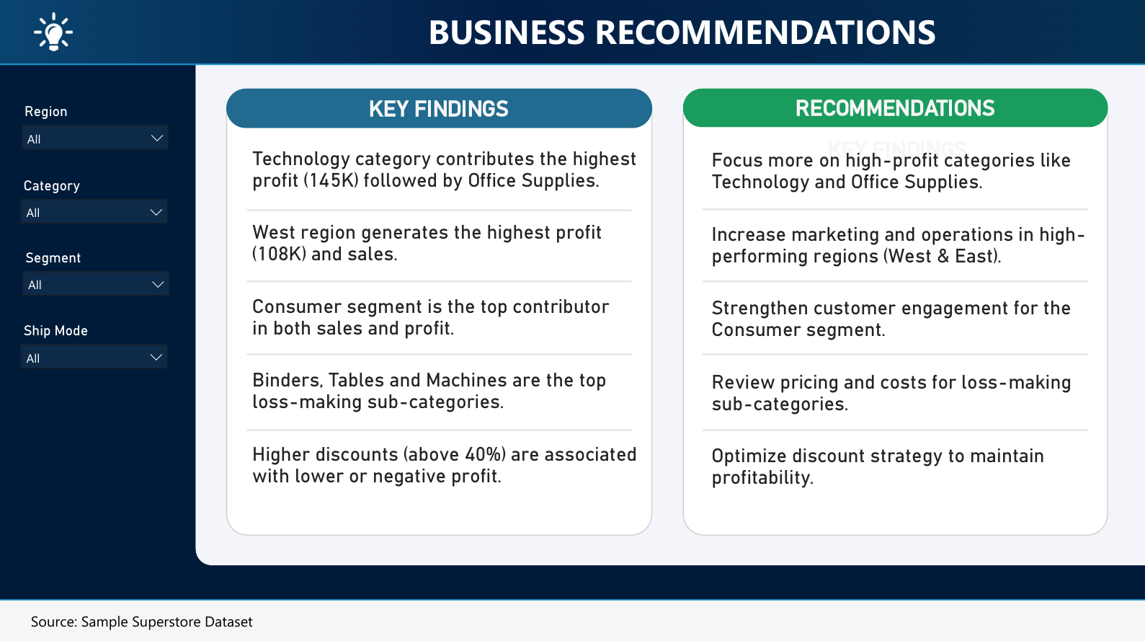
Figure 10.5 — Business Recommendations: key findings paired with corresponding action items, built directly into the dashboard
The final Power BI page distils the analysis into a two-column findings-and-recommendations layout, designed so that business stakeholders reviewing the dashboard see not just what the data shows but what action it implies — the same structure this report follows in Sections 9 and 10.

9. Business Insights
- Technology is the profit engine of the business: it leads on both sales (836K) and profit (145K, 50.8% of total profit), and carries the lowest average discount (15.3%) of the three categories.
- Furniture is a volume category with a margin problem: it generates nearly as much sales as Technology and Office Supplies (741K) but contributes only 18-19K in profit — roughly 6% of total profit — and receives the highest average discount (20.0%) of any category.
- West and East are the core regions: together they account for over 60% of sales and roughly 200K of the 287K total profit, while Central and South underperform on both dimensions.
- The Consumer segment is the primary profit contributor, generating close to half (49.5%) of total profit, ahead of Corporate (28.3%) and Home Office (22.2%).
- Discounting is the single clearest driver of unprofitability in the dataset: the correlation between Discount and Profit is -0.22, and the Discount vs Profit scatter plot shows orders discounted above ~40-50% are overwhelmingly loss-making.
- 18.73% of all orders are sold at a loss — nearly one in five — representing a substantial, quantifiable drag on overall profitability.
- Binders, Tables and Machines are chronic loss-makers by sub-category despite appearing among the higher-volume sub-categories by sales, indicating a pricing or cost-structure issue rather than a demand issue.
- Standard Class shipping dominates fulfillment at 59.1% of orders, suggesting logistics cost structure is concentrated in a single ship mode and worth reviewing alongside profit performance.

10. Recommendations
- Tighten discount governance. Cap or require approval for discounts above 20-30%, the band where average profit turns negative in both the SQL discount-band analysis and the scatter plot visualizations.
- Review pricing and cost structure for Binders, Tables, Machines, Chairs, Appliances, Bookcases and Phones. These sub-categories are losing money at current price/discount/cost combinations and should be re-priced, re-negotiated with suppliers, or have their discount eligibility restricted.
- Re-balance Furniture's discount strategy. At a 20% average discount and the weakest profit margin of the three categories, Furniture should be prioritized for discount reduction or bundling strategies that protect margin.
- Double down on Technology and Office Supplies. These categories combine strong sales with strong margins and the lowest discount dependence — marketing and inventory investment should be weighted toward them.
- Sustain investment in the West and East regions while investigating root causes of Central and South underperformance (e.g., shipping cost, regional pricing, product mix) before allocating further budget there.
- Deepen Consumer segment engagement through loyalty and retention programs, given its outsized 49.5% share of total profit relative to Corporate and Home Office.
- Set a target to reduce the 18.73% loss-order rate, using it as a recurring KPI on the Excel and Power BI dashboards to track the impact of discount-policy changes over time.

11. Conclusion
This end-to-end analysis — spanning Python-based cleaning and EDA, SQL querying, an Excel dashboard and a multi-page Power BI report — converges on a consistent and clear narrative: Superstore's revenue base is healthy and broadly diversified across category, region and segment, but profitability is being materially eroded by uncontrolled discounting and a small set of chronically loss-making sub-categories, particularly within Furniture.
Technology and Office Supplies, along with the West and East regions and the Consumer segment, represent the business's core strengths and should anchor future growth investment. Meanwhile, the ~18.73% loss-order rate and the sub-categories identified in Section 11 represent a concrete, addressable opportunity: tightening discount policy and revisiting pricing on the identified loss-makers could meaningfully lift the overall profit margin without requiring any increase in sales volume.
Together, the four analytical layers used in this project — Python, SQL, Excel and Power BI — reinforced and cross-validated one another at every step, giving high confidence in the findings and the recommendations built on top of them.

12. Limitations
- The dataset is a static, historical snapshot; it does not reflect real-time inventory, live pricing, or current market/competitor conditions.
- Profit figures reflect the cost and pricing assumptions embedded in the original Kaggle dataset, which may not perfectly match real-world cost structures (e.g., shipping cost allocation, overhead).
- The analysis is correlational, not causal — the negative relationship between discount and profit is strong and consistent, but the dataset alone cannot fully isolate discounting from confounding factors such as product mix or seasonality.
- Geographic analysis is limited to U.S. states/regions present in the dataset and does not generalize to other markets.
- The dataset does not include customer-level lifetime value, marketing spend, or acquisition cost, limiting the depth of segment- and customer-level ROI analysis.

13. Future Scope
- Build a time-series forecasting model (e.g., using Python's Prophet or ARIMA) to predict future sales and profit trends by category and region.
- Develop a customer segmentation model (RFM analysis or clustering) to identify high-value customers and tailor marketing/discount strategy at the customer level.
- Introduce a discount-optimization or price-elasticity model to recommend maximum profitable discount thresholds per sub-category rather than a single blanket cap.
- Automate the Python-to-SQL-to-Power BI pipeline with a scheduled ETL process so dashboards refresh automatically as new orders are recorded.
- Extend the Power BI report with drill-through pages from region/category down to individual product and customer level for root-cause investigation.
- Incorporate external data (marketing spend, competitor pricing, macroeconomic indicators) to enrich the profitability model.

References
- Sample Superstore Dataset — Kaggle. https://www.kaggle.com/datasets/vivek468/superstore-dataset-final
- Python Software Foundation — pandas, matplotlib, seaborn documentation. https://pandas.pydata.org / https://matplotlib.org / https://seaborn.pydata.org
- Microsoft Power BI Documentation. https://learn.microsoft.com/power-bi/
- Microsoft Excel PivotTable & PivotChart Documentation. https://support.microsoft.com/excel
- Standard SQL (ANSI SQL) reference documentation.

