IntelBoost App
Gokul Krishna Radhakrishnan Nair
300204264
University of the Fraser Valley
GokulKrishna.RadhakrishnanNair@student.ufv.ca

Summary
IntelBoost App throws a bunch of quiz of images, patterns and puzzles. Aids in memory retention and problem-solving capabilities. The app makes the user more conscious of the task at hand and reduce stress.

Market Research
Demand for various Brain Training Apps in the market encourages us to produce an application useful. Lumosity App which allows user to train exercise memory, speed, attention, flexibility, and problem-solving inspires us to incorporate similar features to make daily goals and remainder to challenge in set time intervals. Target
Customers includes Senior People and Teenagers (benefit from playing Brain games). Teen population finds the games interesting and stimulate Brain cells for proper growth and functioning. Seniors find the game as an aid for cognitive functioning and memory retention.

Name: | IntelBoost App
Actor: | Customer/Application
Description: | Home Screen of the App shows the Tasks for the user to complete along with option to set goals and get remainders. Game Screens consists of three tasks: Memory, Attention and Speed. Each Task focus on quizzes that increases user's ability on particular domain.
Successful Completion: | - Customer downloads app from Google Play Store  - Select Tasks or chosen by System  - Plays Game  - Get Score
Alternative: | - Customer selects app from Google Play Store  - Downloads new Build  - Play Game  - Use additional features
Pre-Condition: | Customer wants to improve Brain functionalities. Should download App from Application Store.
Post-Condition: | - - - - - - -
Assumptions: | User engages in Tasks.

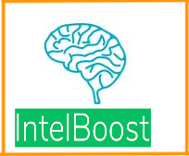

WireFrame
Home Screen features Challenges of the user choice. Memory, Attention and Speed Buttons navigate the game to tasks which measures the player's ability. Daily Goals are set tasks to take for calendar days and remainder tasks shows the tasks need to complete. IntelBot, our game Bot to choose random tasks for the session. Check for total scores by clicking on Scores Button.

(Prototype Screen Image 1)
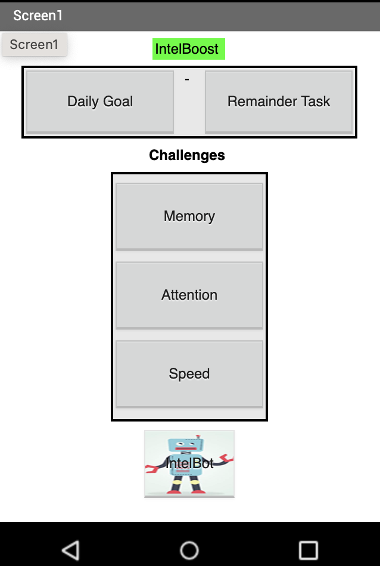

Memory Tasks consists of quizzes to select appropriate figures by matching with previous shown figure. Choose Button allows the player to select the option.

(Prototype Screen Image 2)
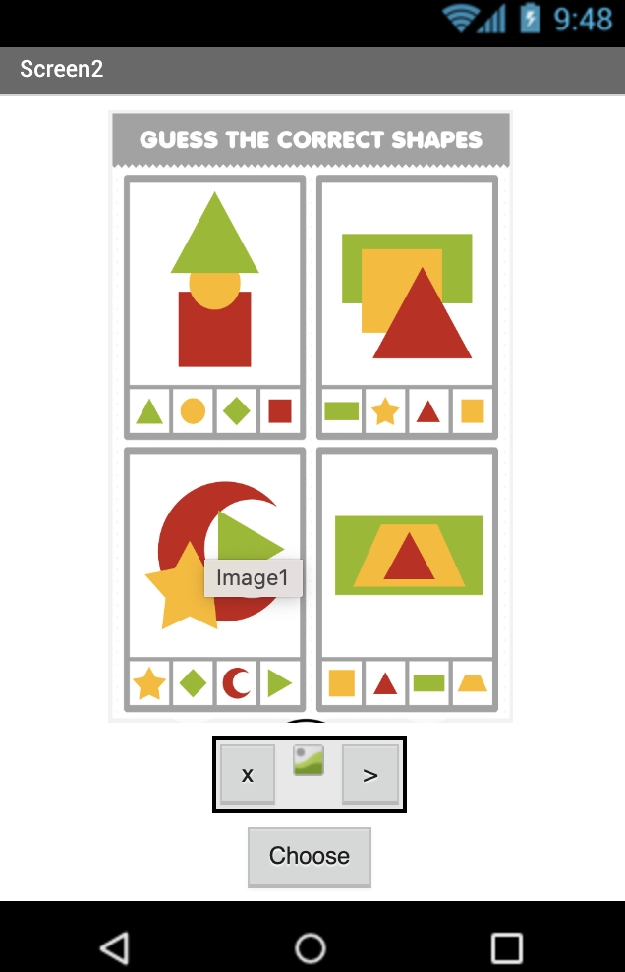

Attention Task consists of quizzes for selecting pattern figures that follows the sequence. Pick Button allows the player to select the correct option from given Boxes. Arrow Button shows the next quiz for the user.

(Prototype Screen Image 3)
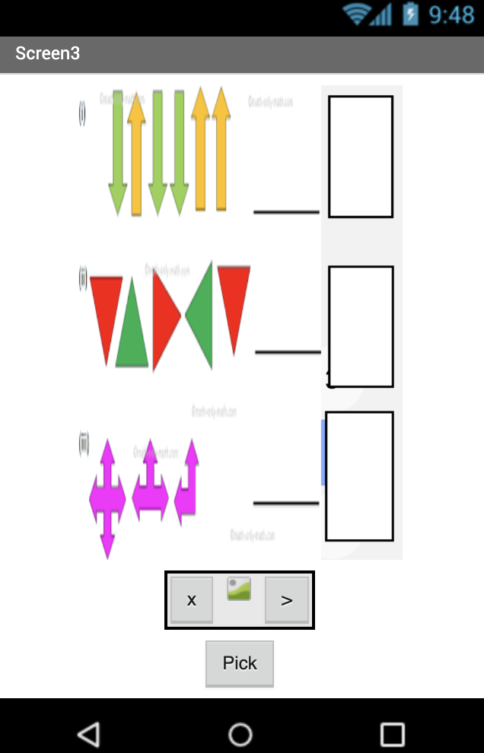

Speed Task checks the user's ability to complete the puzzles on time. Timer runs as the player focusses on solving the puzzle and closes the task on reaching the limit. OK Button allows the user to submit the task.

(Prototype Screen Image 4)
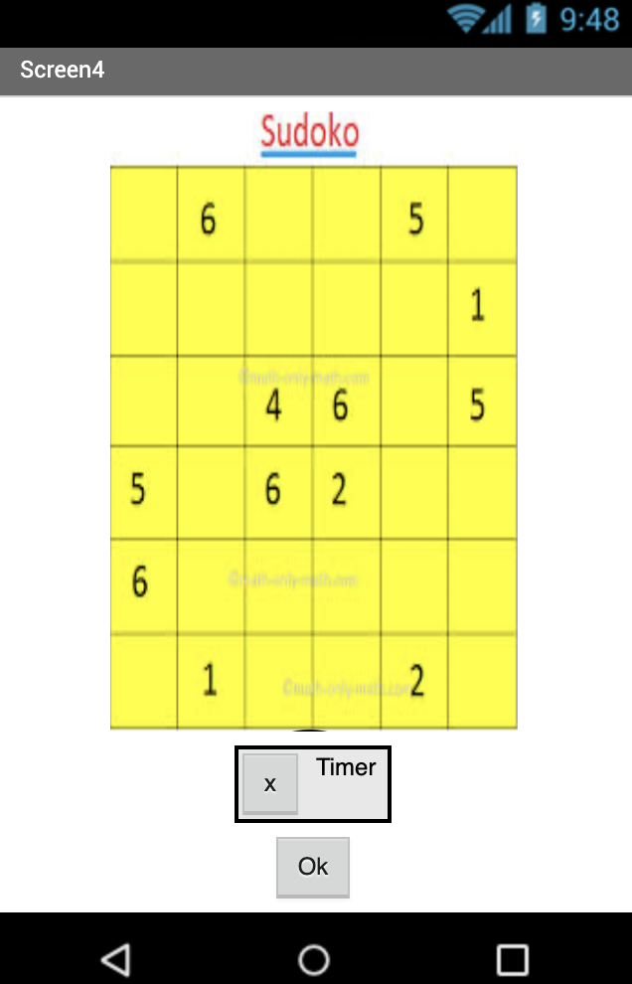
Prototype Code Image 1
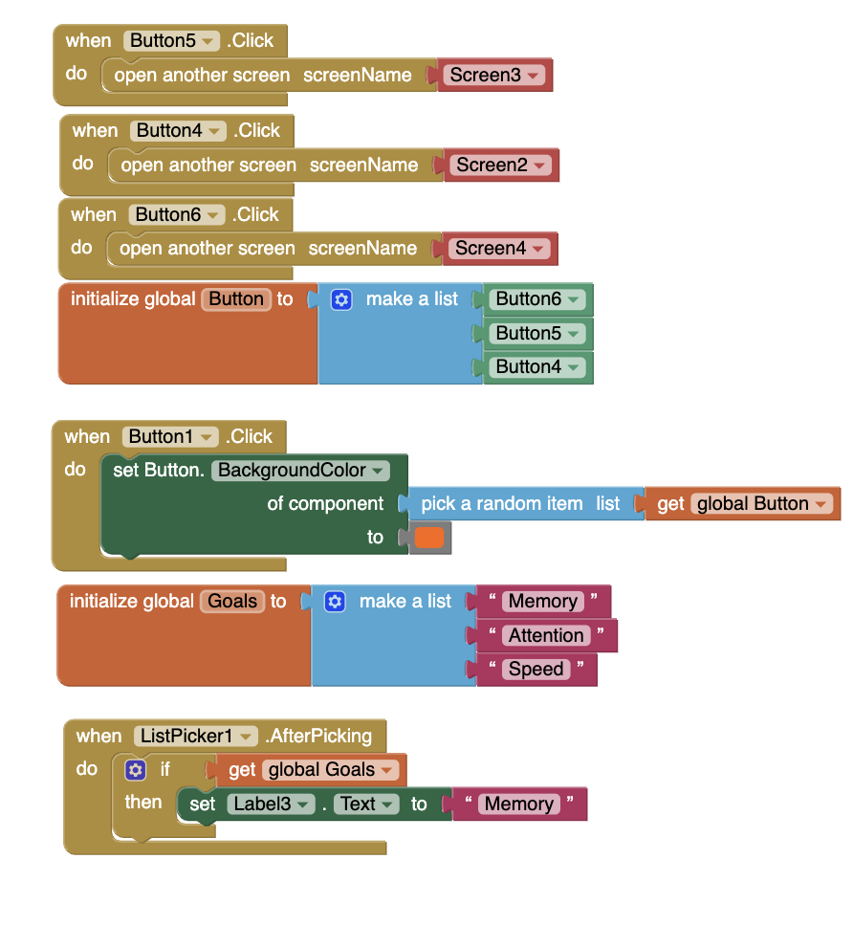

Initialize Global Button to list of Buttons(Button6,Button5,Button4).When Button for IntelBot on Click illuminate random Task from the Home Screen Layout. Each Buttons for Tasks (Memory, Attention and Speed) opens respective screens upon click.

Prototype Code Image 2
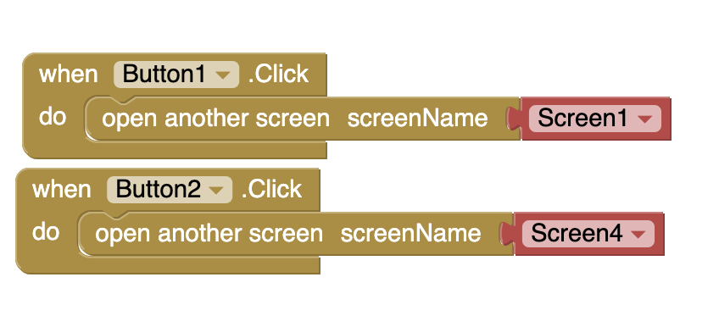
Game Screens consist of two Buttons (x and >) to return to Home Screen and proceed to next Task upon click.

UML Diagram

- Use Case Diagram

Game Screen - Memory
Select Memory Screen

Game Screen – Attention
Select Attention Screen

Home Screen

USER
Select Speed Screen
Game Screen - Speed

Total Score

The Use Case Diagram the way user interacts with Object and have the option to interact with Puzzles and Quizes to select patterns and insert Numbers. Return Total score by computing the summation of score from each Tasks.

- Class Diagram

Home Screen

Memory Task
Attention Task
Speed Task
IntelBot
Daily Goal
Remainder Task

Select Screen
Set Goal
Random Task
Display Score

Game Screen

Memory Screen
Attention Screen
Speed Screen

Get Score

Choose

Return

Play Game

Puzzles
Quizzes
Logic Game

Timer

Class Diagram shows Home Screen Class and Game Screen Class, viz, Memory, Attention and Speed. Diagram shows interaction of buttons between two classes and composition of games in the game Tasks.

- Sequence Diagram

STUDENT
X
Buys App
Selects Tasks to play Game
Download App
User
Google Play (Transaction)
Gameplay
Results Screen
Calculates Total Scores
Sent Scores and Feedback

Records Transaction

New Build (User Update App)
User play Game with Additional features

Sequence Diagram shows Process from User Purchases App and Game Play to App update with additional features. Diagram shows Results Screen Calculating Scores from Tasks and sent Total Score to the User.

Conclusion

Purpose of IntelBoost App is to improve Brain functions for Senior and Teenage Population. Studies shows declining memory retention among senior people and poor attention among growing teens. Considering the market need, IntelBoost App brings Games that stimulates parts of the Brain and produces considerable results. User can choose the area of improvement and achieve by setting Goals on day-to-day bases. Feedback from players allows developers to make necessary improvements and produce Version (Build) for the user.

REFERENCES

Unified Modelling Language. (2023). Specification
https://www.omg.org/spec/UML/

Lumosity. (2023).
https://www.lumosity.com/en/

Fairview ADC. (2023). Benefits of Games
https://fairviewadc.com/tbi/benefi ts-of-games-for-the-memory-in- older-adults/

Google Play. (2023). Top Grossing
https://play.google.com/store/app%20s/collection/topgrossing?%20clp=ChMKEQoLdG9wZ3

PC Magazine. (2023). Top 10 Games
https://www.pcmag.com/news/10 -mobile-games-to-keep-your- mind-sharp

MIT App Inventor. (2023). Create Apps
http://ai2.appinventor.mit.edu/

MIT App Inventor. (2023). Installing and Running the Emulator in AI2
http://appinventor.mit.edu/explore/ai2/setup-emulator

