**Hospital Management System**

ID:

ID:

This Report Presented in Partial Fulfillment of the Requirements for the Degree of Bachelor of Science in Computer Science and Engineering

Supervised By

Assistant Professor

Department of CSE

Uttara University

|  |  |
| --- | --- |
| Description: Description: UU LOGO | Uttara University  **Department of Computer Science & Engineering**  Faculty of Computer Science and Engineering |

Uttara University



**Project Title: Hospital Management System**

(Course Title: Project-II, Course code: CSEC-499)

**Submitted To:**

**Chowdhury Sajadul Islam**

Assistant Professor

Department of CSE

Uttara University

Uttara, Dhaka.

**Submitted By:**

:

ID :

Batch :

Program :

Dept. :

:

ID :

Batch :

Program :

Dept. :

**Approval**

This project work titled ***“Hospital Management System”***. Course Title: ***Project- II***, Course Code: ----, Submitted by: ***Fatema Banu*** ,ID No. :***----***, Registration No.:----**,** Batch No. : ***---- and Naznin Sultana*** ,ID No. :***----***, Registration No.:----**,** Batch No. : ***----***. This project has been approved as it is satisfied the academic requirement in respect of minor work prescribed for B.Sc. This project is doe under the guidance of ***Chowdhury SajadulIslam,***Assistant Professor, Department of Computer Science & Engineering, Uttara University Uttara, Dhaka.

**Course Supervisor**

. . . . . . . . . . . . . . . . . . . . . . . . . . .

Assistant Professor,

Department of CSE.

Uttara University.

Uttara, Dhaka.

**Abstract**

In order to ensure, health care for 180 million people of our country, the Ministry of Health and Family Welfare, private organizations and donor’s countries are making unremitting efforts.

In light of that,if we want to digitize the health sector, first of all we have to bring clinical hospital and other health care centers under software solutions. So that the quality of healthcare can be improved, the patients will get maximum heath facilities and from this perspective we actually plan to develop hospital automation software.

Our goals and objectives are that we want to develop a hospital solution through which our country will try to solve in this problem entire the health sector.

**Table of Contents**

DECLARATION……………………………………………………....................................................…………………. DEDICATION……………………………………………………....................................................……………………. ACKNOWLEDGEMENT………………………………..................................................…………………………….. TABLES……………………………………………………...................................................................……………...

LIST OF FIGURES………………………………….....................................................………………………..………

ABSTRACT………………………………………….........................................………………………………............….

LIST OF ABBREVIATION………………….……………………………..................................................…….…….

**CHAPTER-1INTRODUCTION**

* 1. Introduction….…………….............………………..................................................…….…….
  2. Background to study….……………………………..................................................…….…….
  3. Problem Statement….………………,.……………..................................................…….…….
  4. Projct Objectives….………....………..................................................................…….…….
  5. Specific Objectives….…………………………….....................................................…….…….
  6. Scope of Work….……………………………............................................................…….…….

**CHAPTER-2LITERATURE REVIEW**

2.1Existing businessprocess of Khulna Shishu Hospital ....................................…….…….

2.2Patient Information Processing Problem ....................................…….……..................

2.3 Administration Issues ....................................…….……................................................

2.4 Billing Department and their process flow ....................................…….……................

2.5 Accounts Department and process flow ...................................................................

2.6 Quality of Paperbased collected data ....................................…….…….......................

2.7 Benefits of Electronic Patient Records Management ....................................…….…..

**CHAPTER-3 METHODOLOGY**

3.1 Introduction ....................................…….…….............................................................

3.2 Project Design and Development Plan....................................…….……....................

3.3 Data Collection Methods ...................................…….……..........................................

3.3.1 Hospital Visit

3.3.2 Interviewing

3.3.3 Quesitionnaire

3.4 Data Analysis ....................................…….……............................................................

3.5 System Moc-up tool selection and planning .............................................................

3.6 System Design Technologies Specification ...............................................................

3.7 System Hardware and Software Technologies Specification .....................................

**CHAPTER-4 SYSTEM ANALYSIS, DESIGN& DEVELOPMENT**

4.1 System Study ....................................…….……...........................................................

4.2 System Analysis ....................................…….…….......................................................

4.2.1User Requirements

4.2.2Actual Requirements Specification

4.2.3Funational and Non-Funtional Requirements

4.2.3 System Requirements

4.2.4 Propsed Features for the new system

4.3 System Design ...................................…….……...........................................................

4.3.1 System flow diagram design ...................................…….…….....................

4.3.2Database Design ...................................…….…….......................................

4.3.2.1 Database Table Specification

4.3.2.2 Database Tabe Schema Spefication

4.3.2.3 Database Schema Design

4.3.2.4 Database Entity Relationship (ER) diagram

4.3.3System Architecture desing ...................................…….…….......................

4.3.3.1 User Interface Moc-up design in Paper

4.3.3.2 Actual UI Design using stated technologies

4.3.4 System Development ...................................…….…….................................

4.3.4.1 Login Page Design and Development

4.3.4.2 Dashboard Development

4.3.4.3 Employee Registration & View Employee Information

4.3.4.4 System User Registration, Login, Logout& View User Information

4.3.4.5 New Patient Admission, View Patients information

4.3.4.6Disease Type Setup

4.3.4.7 Store Prouduct Setup

4.3.4.8 Patient Re-admission

**CHAPTER-5 SYSTEM TESTING, SERVER SETUP, IMPLEMENTATION, USER TRAINING& DOCUMENTATION**

5.1 System Testing ...................................…….……............................................................

5.1.1 Integration testing

5.1.2 Unit Testing

5.1.3 System Testing

5.1.4 Security Testing

5.2 Server Setup and Implemenation ...................................…….…….................................

5.2.1 Server Configuration

5.2.2 Server database and application upload

5.2.3 Server level testing

5.3 User Level Training ...................................…….……......................................................

5.4 User Guideline Development ...................................…….…….......................................

**CHAPTER-6 SUMMARY, CHALLANGES AND RECOMMENDATIONS**….…….......................................

**CHAPTER-1**

**INTRODUCTION**

In order to ensure, health care for 180 million people of our country, the Ministry of Health and Family Welfare, private organizations and donor’s countries are making unremitting efforts.

In light of that, if we want to digitize the health sector, first of all we have to bring clinical hospital and other health care centers under software solutions. So that the quality of healthcare can be improved, the patients will get maximum heath facilities and from this perspective we actually plan to develop hospital automation software.

Our goals and objectives are that we want to develop a hospital solution through which our country will try to solve in this problem entire the health sector.

**Problem Statement:**

There is a variety of problems when a patient goes to hospital. Like-

1.To collect token this is really time consuming

2.To wait long time for doctors/consultants

3.Storing patient information in hard paper

4.Patient follow-ups information stored in manuals process

5.Don’t trackseach period of medicines taking of each patients

6.Patient Re-admission problem due to manual process

**Main Objectives:**

Our main objectives are to automate hospital activities, so that patient can get maximum facility to take health services.

Specific Objective:

1.To develop an automatic patient admission system

2.To develop an automatic patient follow-ups system

3.To develop and record patient medicines-chart information

4. To develop a mechanism for collecting patient billing information

5.To develop a system to automatic discharge or death certificate generate

6.To readmit patients by searching patient process information

So, finally we want to automate our entire health systems by using digital software solutions.

**Scope of the Project:**

1. Initially we will work for a Upazila hospital to collect patient admission information, patient medicines information, patient billing information,patient discharge info & patient re-admission information
2. If we success in a Upazilathen will roll-out this system to all other Upazila’s of a single distinct.
3. Ultimately,we want to implement this software in a whole distinct as well as whole country.

**Significance:**

1. We will be able to collect and store patient information electrometrically.

2. It will minimize time of a patient to get services.

3. It will minimize the work load of hospital authorities.

4. Patient will get maximum services quickly

5. It will minimize not only time but also money

6. Finally it will impact to develop digital Bangladesh

**CHAPTER-2**

**LITERATURE REVIEW**

**CHAPTER-3**

**METHODOLOGY**

**Methodology:**

1. We will analyze patient and other information.

2. We will design a software moc-up.

3.We will start development.

4.We will install it in server and collect some patient information

**Major Modules:**

* Patient Admission
* Patient Search
* Patient Re-admission
* Doctors and Nurses Profile management
* Employee Information Management
* Users Profile management
* Geographical Area Management(Division, District, Upazila, Union)
* Complain Types Management
* Bed Allocation and Management
* Pharmacy Management (Add, update, delete, search)
* Billing
* Blood Bank Management
* Diagnostic center management
* Patient Discharge

**Software Requirement’s Specifications:**

Languages and Development Platforms:

* Server side language: PHP
* Client Slide language: JavaScript
* Front end: HTML and CSS
* Database: MySQL

**Hardware and Other resources Specification:**

* Domain and Hosting: Selection of specific domain for it and 1GB space for hosting
* Hardware for local server:
* Processor: 2.0 GHz, Core i-5
* Memory (RAM): 4 GB
* System Type 64/32-bit operating system
* Hard disk: 20GB

**CHAPTER-4**

**SYSTEM ANALYSIS, DESIGN & DEVELOPMENT**

**Data Flow diagram:**

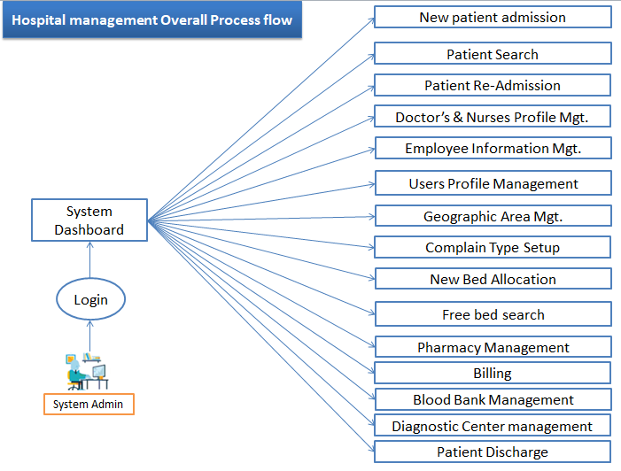

**Figure-01 # Hospital Management Overall Process flow**

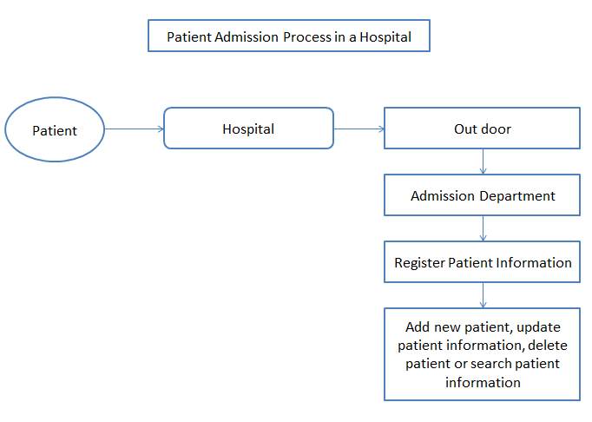

**Figure No # 02: Patient Admission Process Flow diagram**

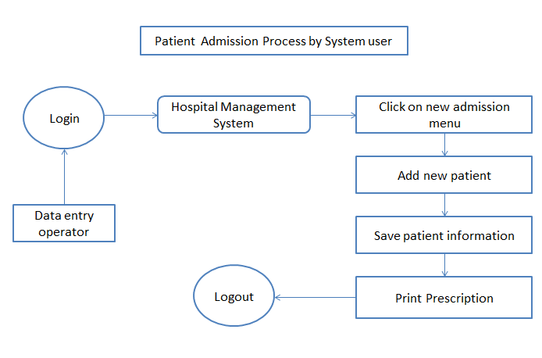

**Figure No # 03: Patient Admission Process by System User**

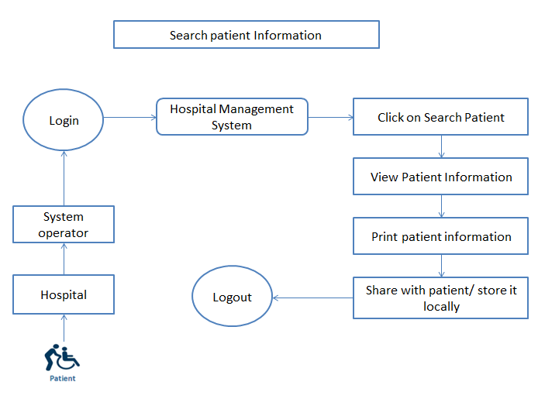

**Figure No # 04: Patient Information Search**

**The seven phases of the SDLC**

**1. Planning**

This is the first phase in the systems development process. It identifies whether or not there is the need for a new system to achieve a business’s strategic objectives. This is a preliminary plan (or a feasibility study) for a company’s business initiative to acquire the resources to build on an infrastructure to modify or improve a service. The company might be trying to meet or exceed expectations for their employees, customers and stakeholders too. The purpose of this step is to find out the scope of the problem and determine solutions. Resources, costs, time, benefits and other items should be considered at this stage.

**2. Systems Analysis and Requirements**

The second phase is where businesses will work on the source of their problem or the need for a change. In the event of a problem, possible solutions are submitted and analyzed to identify the best fit for the ultimate goal(s) of the project. This is where teams consider the functional requirements of the project or solution. It is also where system analysis takes place—or analyzing the needs of the end users to ensure the new system can meet their expectations. Systems analysis is vital in determining what a business’s needs are, as well as how they can be met, who will be responsible for individual pieces of the project, and what sort of timeline should be expected.

There are several tools businesses can use that are specific to the second phase. They include:

* CASE (Computer Aided Systems/Software Engineering)
* Requirements gathering
* Structured analysis

**3. Systems Design**

The third phase describes, in detail, the necessary specifications, features and operations that will satisfy the functional requirements of the proposed system which will be in place. This is the step for end users to discuss and determine their specific business information needs for the proposed system. It’s during this phase that they will consider the essential components (hardware and/or software) structure (networking capabilities), processing and procedures for the system to accomplish its objectives.

**4. Development**

The fourth phase is when the real work begins—in particular, when a programmer, network engineer and/or database developer are brought on to do the major work on the project. This work includes using a flow chart to ensure that the process of the system is properly organized. The development phase marks the end of the initial section of the process. Additionally, this phase signifies the start of production. The development stage is also characterized by instillation and change. Focusing on training can be a huge benefit during this phase.

**5. Integration and Testing**

The fifth phase involves systems integration and system testing (of programs and procedures)—normally carried out by a Quality Assurance (QA) professional—to determine if the proposed design meets the initial set of business goals. Testing may be repeated, specifically to check for errors, bugs and interoperability. This testing will be performed until the end user finds it acceptable. Another part of this phase is verification and validation, both of which will help ensure the program’s successful completion.

**6. Implementation**

The sixth phase is when the majority of the code for the program is written. Additionally, this phase involves the actual installation of the newly-developed system. This step puts the project into production by moving the data and components from the old system and placing them in the new system via a direct cutover. While this can be a risky (and complicated) move, the cutover typically happens during off-peak hours, thus minimizing the risk. Both system analysts and end-users should now see the realization of the project that has implemented changes.

**7. Operations and Maintenance**

The seventh and final phase involves maintenance and regular required updates. This step is when end users can fine-tune the system, if they wish, to boost performance, add new capabilities or meet additional user requirements.

**Entity Relationship Diagram:**

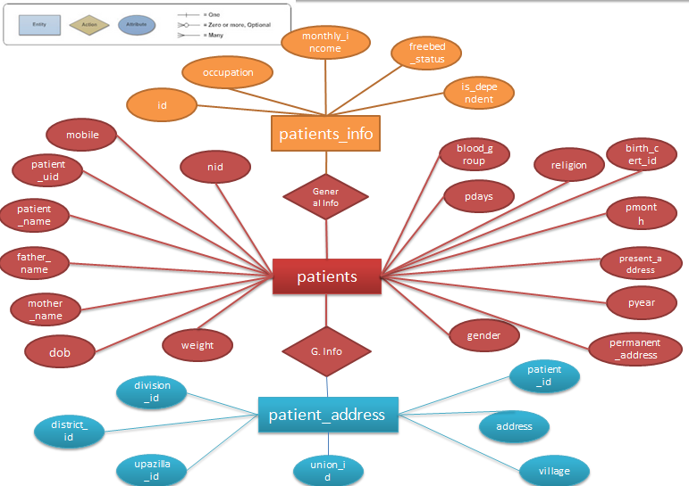

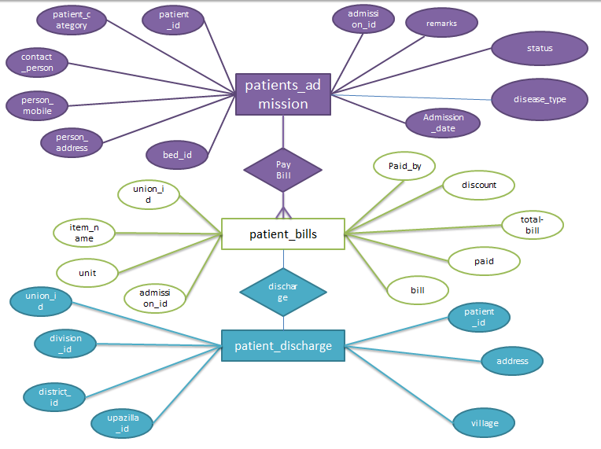

**Database Schema Design:**

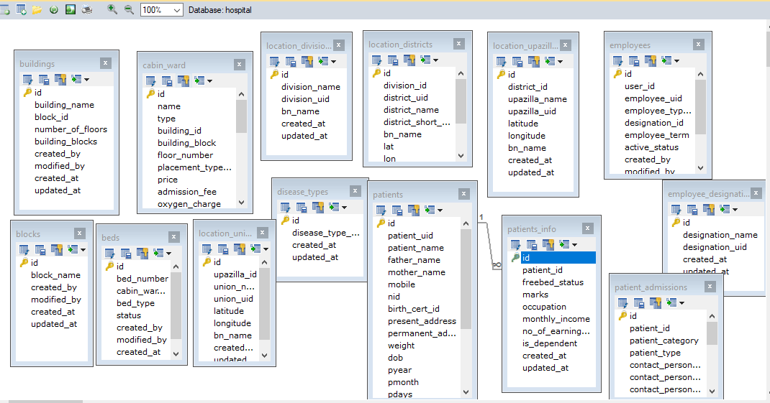

**CHAPTER-5**

**SYSTEM TESTING, SERVER SETUP, IMPLEMENTATION, USER TRAINING & DOCUMENTATION**

**CHAPTER-6**

**SUMMARY, CHALLANGES AND RECOMMENDATIONS**

**Conclusion:**

We hope that if we can develop this application and implement it in a hospital then the patients will be benefited as well as we the hospital service quality will be increased.

**References:**

1. JBRSOFT: <http://www.jbrsoft.com/product/tucana-hospital-automation>
2. Khulna Shihu Hospital Management System: [http://ksh-his.org](http://ksh-his.org/)
3. OpenMRS: <https://openmrs.org/>