Packet size 128
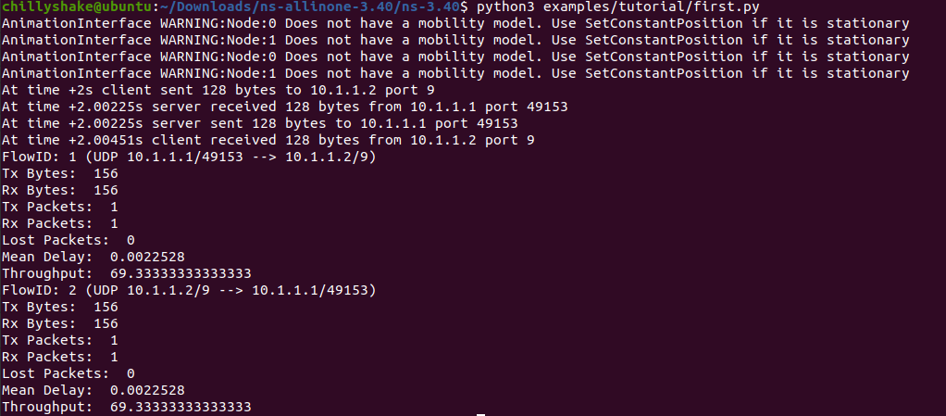

Packet size 256
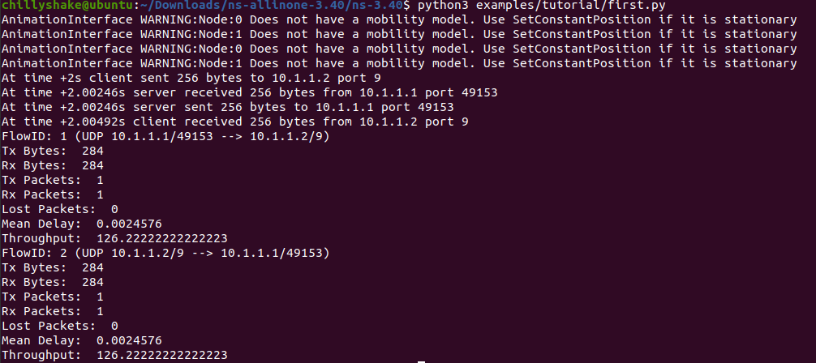

Packet size 512
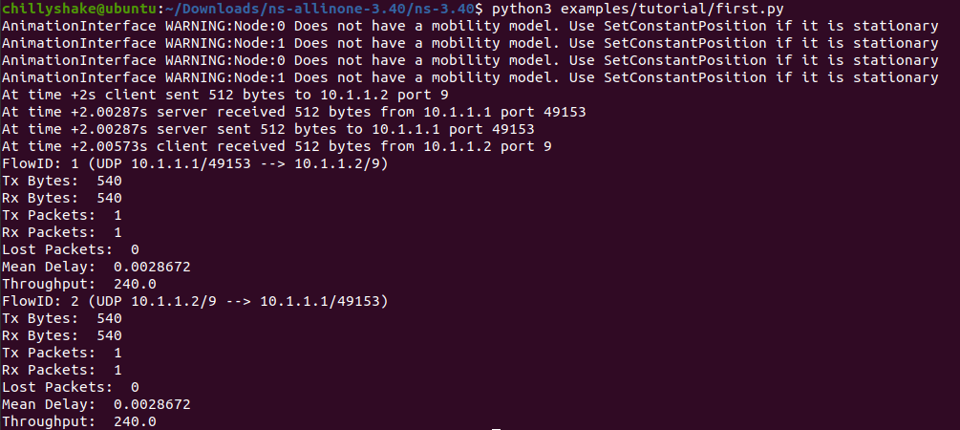

Packet size 1024
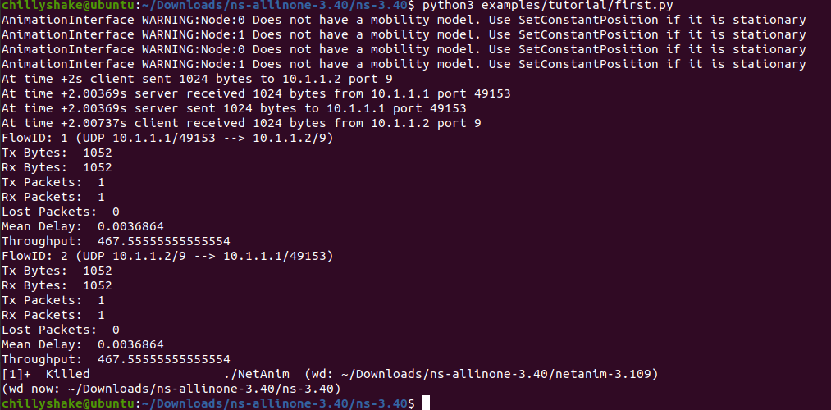

Packet size 2048
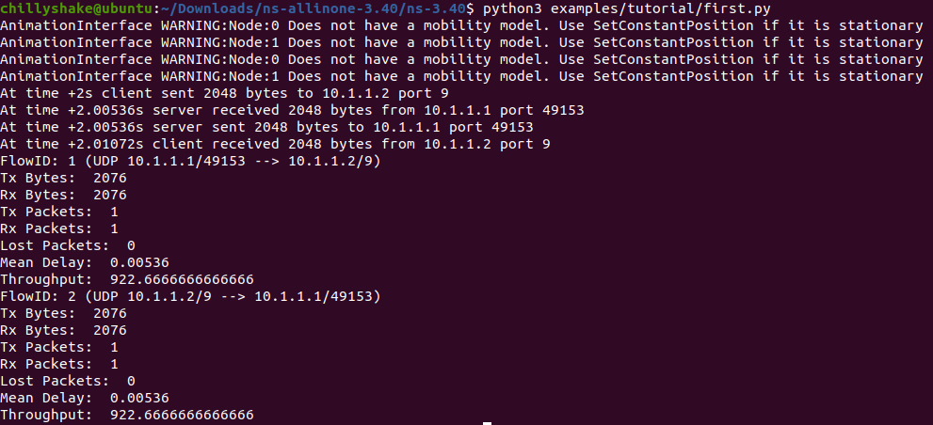

Throughput vs Packet size
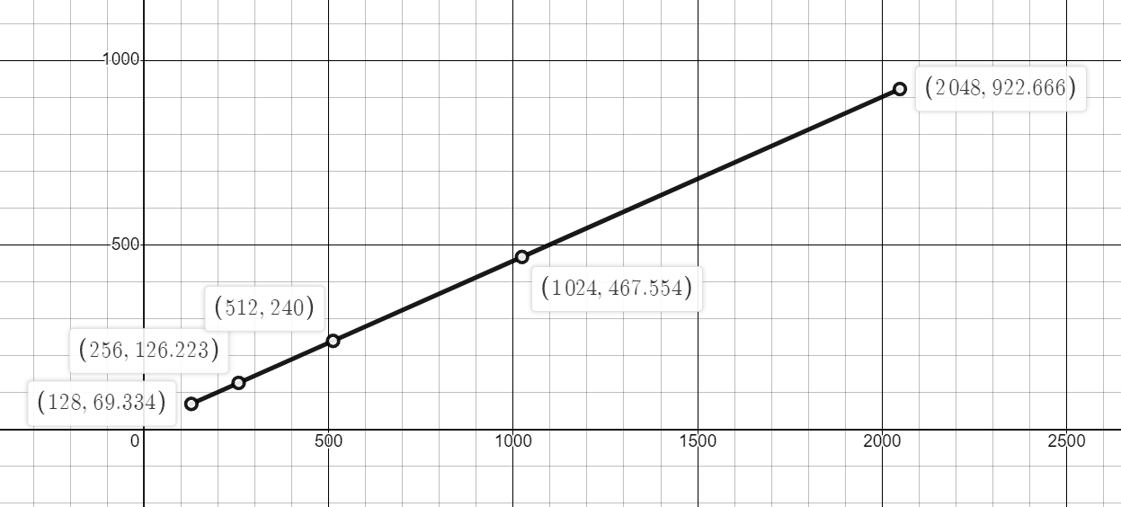
The graph shows us that with the increase in packet size, the throughput also increases. This indicates a positive correlation, and the relationship is non-linear, as throughput increases as the packet size grows.

