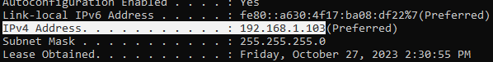
Figure: Client’s IP address

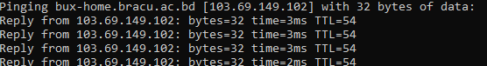
Figure: Server’s IP address

HTTP REQUEST:

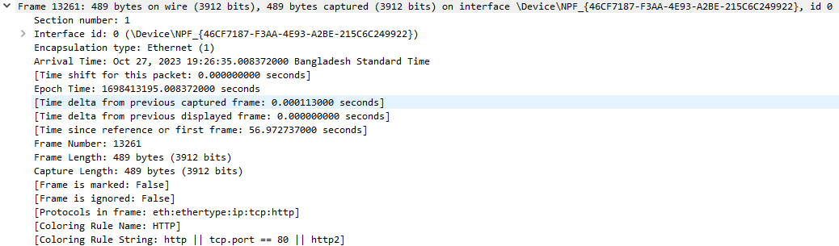
This is the Data Link Layer. This layer is responsible for moving frames from one hop to the next.

Ethernet II falls under Data Link Layer.
Destination MAC address: 5c:62:8b:b7:55:e1 (Server)
Source MAC address : 18:c0:4d:00:bb:ad (Client)

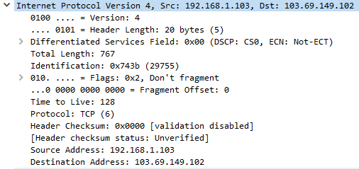
This is the Network Layer.
Source IP address: 192.168.1.103 (client)
Destination IP address: 103.69.149.102 (server).

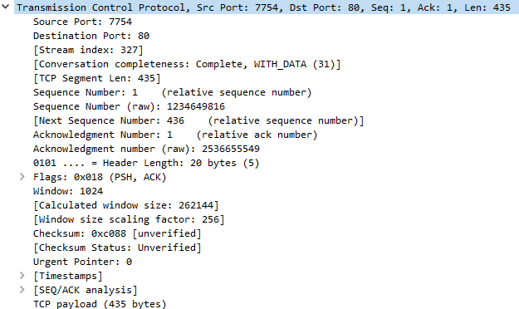
TCP falls under the Transport layer.
Source port: 7754 (Client)
Destination port: 80 (Server)
SEQ and ACK number 1, indicates the order of data transmission.
Flags: Push and Acknowledgement
Window size: 1024, means client can receive up to data size 1024 at a time.
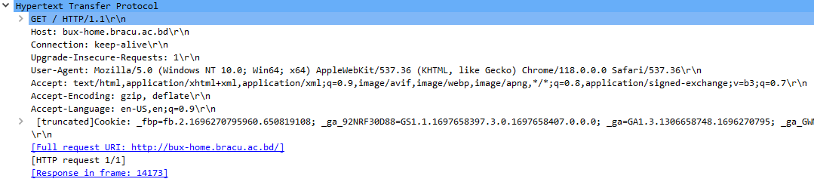
HTTP GET request was sent using HTTP v1.1
Host specifies the domain name
Keep-alive type connection is used
The accepted headers, languages, and encoding are also specified.
Previous cookie data is also sent with the request.

HTTP RESPONSE:

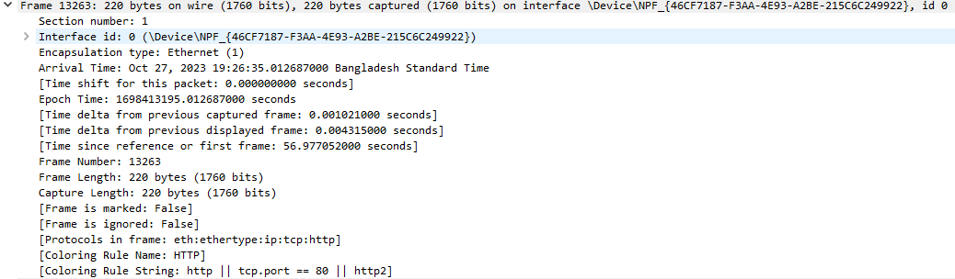
This is the Data Link Layer. This layer is responsible for moving frames from one hop to the next.

Ethernet II falls under Data Link Layer.
Destination MAC address: 18:c0:4d:00:bb:ad (Client)
Source MAC address : 5c:62:8b:b7:55:e1 (Server)

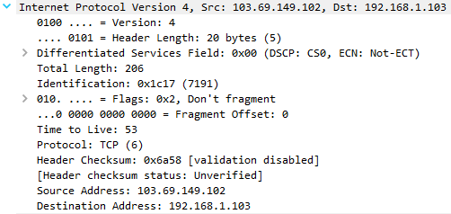
This is the Network Layer.
Source IP address: 103.69.149.102 (server)
Destination IP address: 192.168.1.103 (client)

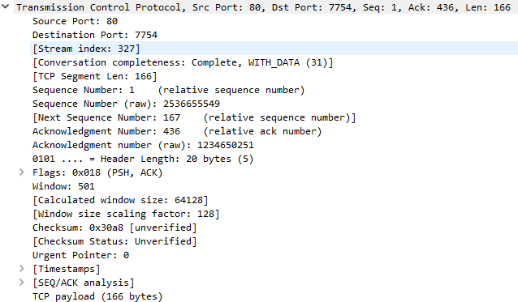
TCP falls under the Transport layer.
Source port: 80 (Server)
Destination port: 7754 (Client)
SEQ no. 1 ; ACK no. 436
Flags: Push and Acknowledgement
Window size: 501, means server can receive up to data size 501 at a time.

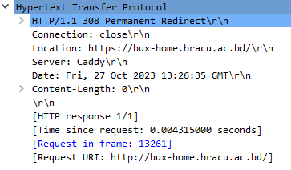
This is HTTP Response
Version: HTTP/1.1
Status Code 308 means the client should change to new location for all future requests
Connection will be closed after this response

