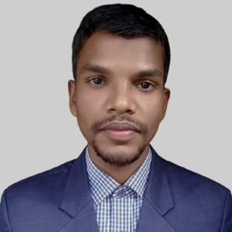
CURRICULUM VITAE
Golam Rabbani
Cell:01876986352
E-mail:golamrabbani.eco@gmail.com

Career Objectives:
To build up your organization very much strong and also to build up my career as a job seeker.Seeking a challenging position where I can contribute my expertise to ensure the highest quality.I am ready to deliver my knowledge,creativity and so on in your organization in a dynamic and challenging environment.A challenging job competition environment where my knowledge ability can be exploited yield the optimum benefit to the organization as well as me.lkkoko

ACADEMIC QUALIFICATIONS:
Bachelor of Social science(BSS):
Institution : Begum Rokeya University,Rangpur
Subject : Economics
Session :22018-19
Result : CGPA3.25(out of 4)
Passing Year :2022

Higher Secondary Certificate:
Institution :Lions School And College,Rangpur
Group :Science
Result :GPA4.75(out of 5)
Passing Year : 2017
Board :Dinajpur

Secondary School Certificate(SSC):
Institution :Kaimary School And College
Group :Science
Result :GPA 4.94(out of 5)
Passing year :2015
Board :Dinajpur

COMPUTER SKILLS:
MS Word,MS Excel,MS Access,MS Powerpoint&Internet browsing,SPSS,STATA.

SELF ASSESSMENT:
Good interpersonal,communication & analytical skills.
Good at teamwork capability and adaptability.
Optimistic,Confident and Self-motivated.
Energetic,Sincere and Dutiful

PERSONAL PROFILE:
Name : Golam Rabbani
Father’s name :Golam Mostafa
Mother's name :Rafika Begum
Present Address :Mouja Soulmari,Kaimari,Jaldhaka,Nilphamari
Permanent Address :Mouja Soulmari,Kaimari,Jaldhaka,Nilphamari
Birth of Date :10/10/1998
National ID : 1031179631
Gender :Male
Religion :Islam
Marital Status :Single
Nationality :Bangladeshi
Mobile Number :01876986352
Blood Group :O⁺

REFERENCE:
1
Name :Kazi Newaz Mostafa
Designation :Assistant Professor
Organization :Begum Rokeya University,Rangpur
Department :Economics
E-mail :kmn.eco@brur.ac.bd
Mbile :01720214411
2
Name : Md. Belal Uddin
Designation :Associate Professor
Organization :Begum Rokeya University,Rangpur
Department :Economics
E-mail :belal.eco@brur.ac.bd
Mobile :01722845715

Declaration:
I,hereby declare to the best of my knowledge and belief that this resume correctly describes my out qualifications and about me.

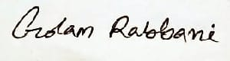
Signature:

