1:

The client ip is 192.168.1.72



2:

Dns server ip is 192.168.1.254



3:

The dns response time is 0.256361



4:

This trace was taken Closer to the client because we see the largest gap is while waiting to the server response. While the client response is faster

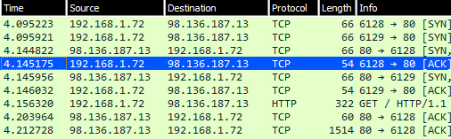

5:

Connected to 92.136.189.13 and 98.139.206.151 succesfuly

But in the end failed with the 92.136.189.13 one

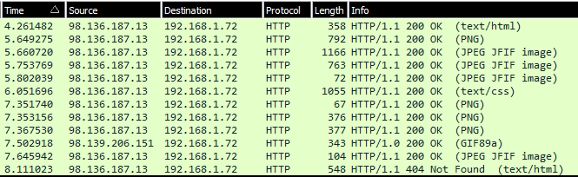

6:

www.wiresharktraining.com



7:

8 total syn packet were sent by the client

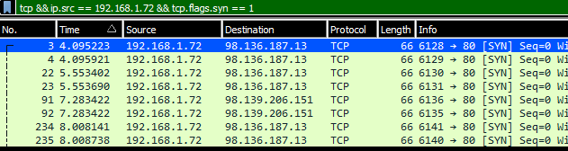

8:

The first dns request [www.wiresharktraining.com](http://www.wiresharktraining.com)

9:

Only error code 40 showed up

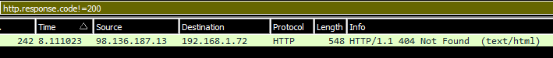

10:

404 couldn’t find favicon.ico

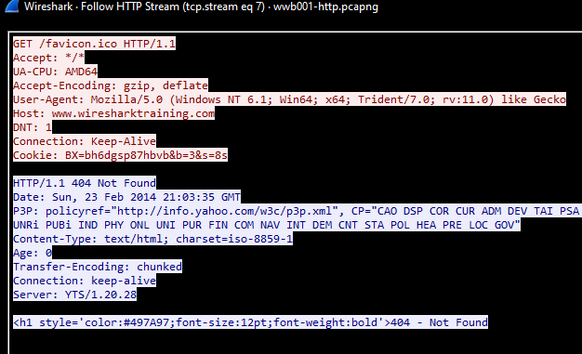

11:

The client opened port 6128 to communicate with the HTTP server

