Golay Nie

Note: Coefficients are listed from HIGHEST order first.

generated data points:

X: [0. 0.11111111 0.22222222 0.33333333 0.44444444 0.55555556

0.66666667 0.77777778 0.88888889 1. ]

Y: [.3123, .9111, .9912, .9874, .0545, .0642, -.9132, -.5456, -.6123, .2112]

lamda=0:

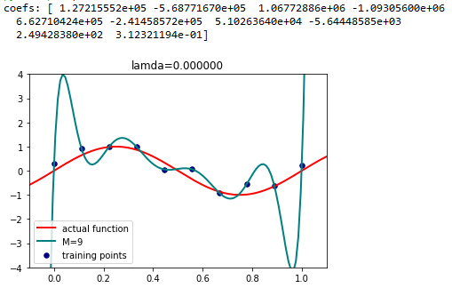

lamda=10^-20

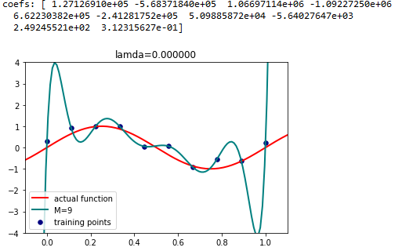

lamda=10^-10

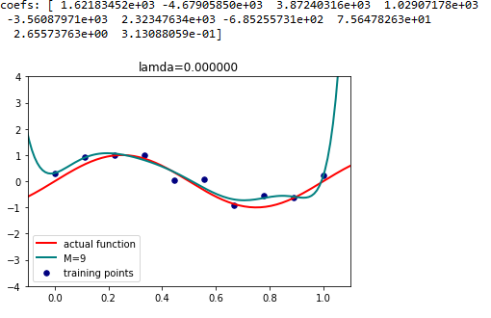

lamda=10^-6

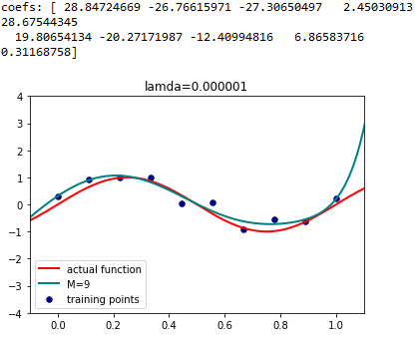

lamda=10^-4

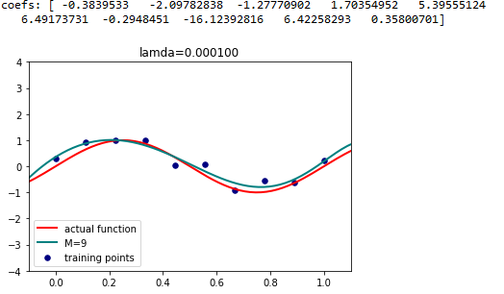

lamda=10^-2

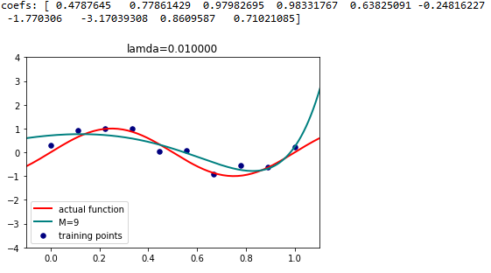

lamda=1:

