Golay Nie 1001678015

CSE 5321 Homework 1

Spring 2019

1)

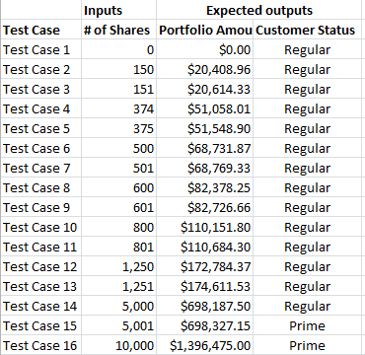

2)

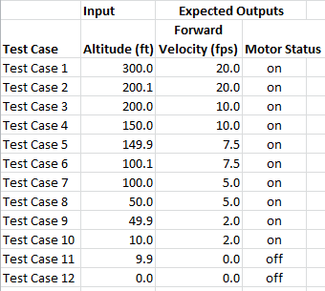

3)

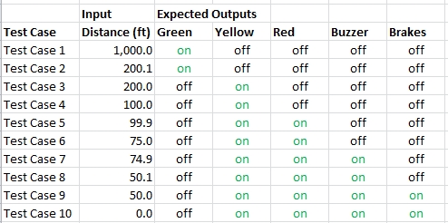

4)

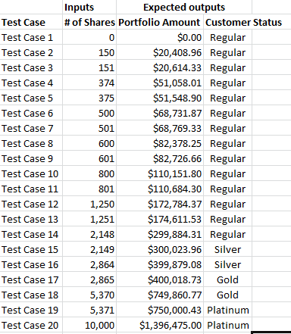

5a)

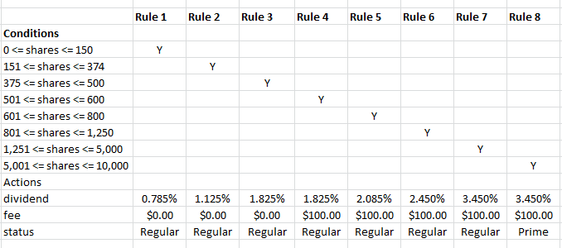

Table implements first-of rule.

16 test cases required. This agrees with above.

5b)

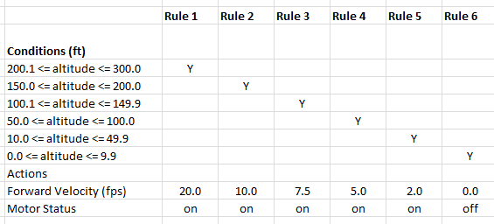

Table implements first-of rule.

12 test cases required. This agrees with above.

5c)

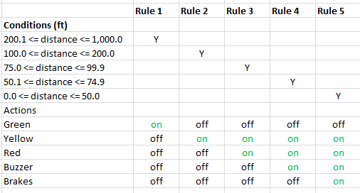

Table implements first-of rule.

10 test cases required. This agrees with above.

6)

larger image included in zip file:

