Golay Nie 1001678015

CSE 5321 Homework 2

Spring 2019

1) 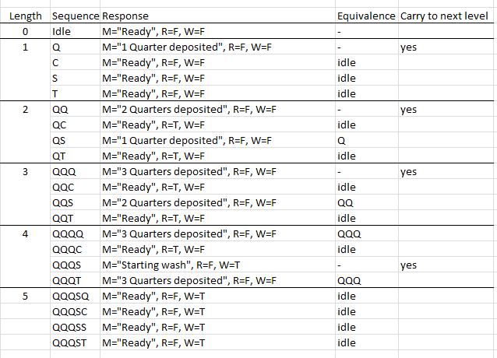

Canonical states: Q, QQ, QQQ, QQQS

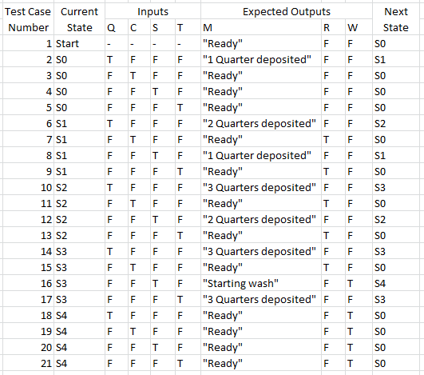

2)

|  |  |  |  |  |  |  |
| --- | --- | --- | --- | --- | --- | --- |
| Test case # | Inputs | | | | | Exp Out |
| Fuel level | Discount type | Fuel type | Special purchases | Payment type | Return |
| 1 | 0.00 | None | Unleaded | None | Cash | $0.00 |
| 2 | 0.00 | Student | Midrange | CarWash | CreditCard | $5.41 |
| 3 | 0.00 | Teacher | Premium | AirTires | DebitCard | $1.62 |
| 4 | 14.28 | None | Midrange | AirTires | Cash | $31.76 |
| 5 | 14.28 | Student | Unleaded | StoreDiscount | DebitCard | $27.10 |
| 6 | 14.28 | Teacher | Diesel | None | CreditCard | $36.00 |
| 7 | 28.56 | None | Premium | CarWash | CreditCard | $77.38 |
| 8 | 28.56 | Student | Diesel | AirTires | Cash | $65.86 |
| 9 | 28.56 | Teacher | Unleaded | CarWash | Cash | $58.69 |
| 10 | 28.56 | Military | Midrange | None | DebitCard | $52.82 |
| 11 | 42.84 | None | Diesel | StoreDiscount | DebitCard | $111.45 |
| 12 | 42.84 | Military | Unleaded | AirTires | CreditCard | $77.55 |
| 13 | 42.84 | Frequent | Premium | None | Cash | $81.33 |
| 14 | 57.12 | Military | E-85 | CarWash | Cash | $93.61 |
| 15 | 57.12 | Frequent | Midrange | StoreDiscount | CreditCard | $103.49 |
| 16 | 57.12 | Employee | Premium | StoreDiscount | Cash | $102.74 |
| 17 | 57.12 | Student | E-85 | None | DebitCard | $96.27 |
| 18 | 71.40 | Frequent | E-85 | CarWash | DebitCard | $112.38 |
| 19 | 71.40 | Employee | Diesel | None | CreditCard | $142.10 |
| 20 | 71.40 | Teacher | E-85 | StoreDiscount | Cash | $124.30 |
| 21 | 85.68 | Employee | E-85 | AirTires | CreditCard | $125.58 |
| 22 | 85.68 | Military | Diesel | CarWash | DebitCard | $193.04 |
| 23 | 85.68 | Frequent | Unleaded | AirTires | Cash | $136.21 |
| 24 | 100.00 | Employee | Unleaded | CarWash | DebitCard | $157.23 |
| 25 | 100.00 | Military | Premium | StoreDiscount | CreditCard | $215.27 |
| 26 | 100.00 | None | E-85 | AirTires | Cash | $183.28 |
| 27 | 0.00 | Frequent | Diesel | StoreDiscount | Cash | $1.08 |
| 28 | 14.28 | Employee | Midrange | CarWash | Cash | $28.02 |
| 29 | 28.56 | Student | Premium | StoreDiscount | CreditCard | $65.85 |
| 30 | 42.84 | Teacher | Midrange | CarWash | DebitCard | $93.96 |
| 31 | 57.12 | None | Unleaded | AirTires | CreditCard | $120.72 |
| 32 | 71.40 | None | Premium | AirTires | DebitCard | $176.30 |
| 33 | 85.68 | Student | Midrange | None | Cash | $162.75 |
| 34 | 85.68 | Teacher | Premium | StoreDiscount | CreditCard | $206.19 |
| 35 | 100.00 | Frequent | Midrange | None | CreditCard | $179.29 |
| 36 | 0.00 | Military | E-85 | None | CreditCard | $0.00 |
| 37 | 14.28 | Military | Premium | None | DebitCard | $29.70 |
| 38 | 14.28 | Frequent | E-85 | CarWash | CreditCard | $27.45 |
| 39 | 28.56 | Frequent | E-85 | AirTires | DebitCard | $44.41 |
| 40 | 42.84 | Employee | E-85 | StoreDiscount | DebitCard | $61.25 |
| 41 | 57.12 | Teacher | Diesel | AirTires | DebitCard | $141.43 |
| 42 | 71.40 | Military | Unleaded | StoreDiscount | Cash | $120.25 |
| 43 | 71.40 | Student | Midrange | AirTires | CreditCard | $145.64 |
| 44 | 100.00 | Student | Diesel | CarWash | Cash | $230.33 |
| 45 | 0.00 | Employee | Unleaded | None | DebitCard | $0.00 |
| 46 | 42.84 | Student | Premium | CarWash | Cash | $96.91 |
| 47 | 85.68 | None | Midrange | StoreDiscount | DebitCard | $187.51 |
| 48 | 100.00 | Teacher | Unleaded | None | DebitCard | $192.31 |
| 49 | 28.56 | Employee | Diesel | None | CreditCard | $56.84 |

3a)

|  |  |  |  |  |  |
| --- | --- | --- | --- | --- | --- |
|  | | CD | | | |
| 00 | 01 | 11 | 10 |
| AB | 00 | 1 | 1 | 1 | 1 |
| 01 | 0 | 1 | 1 | 0 |
| 11 | 0 | 1 | 0 | 0 |
| 10 | 0 | 1 | 0 | 0 |

A’B’ + A’D + C’D

3b)

|  |  |  |  |  |  |
| --- | --- | --- | --- | --- | --- |
|  | | CD | | | |
| 00 | 01 | 11 | 10 |
| AB | 00 | 0 | **1** | 0 | 0 |
| 01 | 0 | 0 | **1** | 0 |
| 11 | 0 | 1 | 1 | 0 |
| 10 | 0 | 1 | 1 | 0 |

AD + B’C’D + BCD

3c)

|  |  |  |  |  |  |
| --- | --- | --- | --- | --- | --- |
|  | | CD | | | |
| 00 | 01 | 11 | 10 |
| AB | 00 | 1 | 1 | 1 | 1 |
| 01 | 0 | 1 | 0 | 0 |
| 11 | 0 | 1 | 0 | 0 |
| 10 | 0 | 1 | 0 | 0 |

A’B’ + C’D

3d)

|  |  |  |  |  |  |
| --- | --- | --- | --- | --- | --- |
|  | | CD | | | |
| 00 | 01 | 11 | 10 |
| AB | 00 | 0 | 1 | 0 | 0 |
| 01 | 1 | 1 | 0 | 0 |
| 11 | 1 | 1 | 0 | 0 |
| 10 | 1 | 1 | 0 | 0 |

BC’ + AC’ + C’D

3e)

|  |  |  |  |  |  |
| --- | --- | --- | --- | --- | --- |
|  | | CD | | | |
| 00 | 01 | 11 | 10 |
| AB | 00 | 1 | 1 | 0 | 0 |
| 01 | 1 | 0 | 0 | 0 |
| 11 | 1 | 0 | 0 | 0 |
| 10 | 1 | 0 | 0 | 1 |

C’D’ + AB’D’ + A’B’C’

4a)

|  |  |  |  |  |
| --- | --- | --- | --- | --- |
| A | B | C | A’ or (B’ and C) |  |
| F | F | F | T | c/d1 |
| F | F | T | T |  |
| F | T | F | T | C1 |
| F | T | T | T |  |
| T | F | F | F |  |
| T | F | T | T | C1 |
| T | T | F | F |  |
| T | T | T | F | c/d1 |

condition/decision coverage: (FFF, TTT)

condition coverage: (FTF, TFT)

decision coverage: (FFF, TFF)

TOFs: (A’, B’C)

TNFs: (A+B’C, A’+!(B’C))

4b)

|  |  |  |  |  |
| --- | --- | --- | --- | --- |
| A | C | D | (A and c’) or  (a and d) |  |
| F | F | F | F | c/d1, d1 |
| F | F | T | F | C1 |
| F | T | F | F |  |
| F | T | T | F |  |
| T | F | F | T | D1 |
| T | F | T | T |  |
| T | T | F | F | C1 |
| T | T | T | T | c/d1 |

condition/decision coverage: (FFF, TTT)

condition coverage: (FTF, TFT)

decision coverage: (FFF, TFF)

TOFs: (AC’, AD)

TNFs: ( !(AC’)+AD, AC’+!(AD) )

4c)

|  |  |  |  |  |  |
| --- | --- | --- | --- | --- | --- |
| A | B | C | D | A or b or  (c’ and d’) |  |
| F | F | F | F | T | C1, d1 |
| F | F | F | T | F | d/c1, d1 |
| F | F | T | F | F |  |
| F | F | T | T | F |  |
| F | T | F | F | T |  |
| F | T | F | T | T |  |
| F | T | T | F | T |  |
| F | T | T | T | T |  |
| T | F | F | F | T |  |
| T | F | F | T | T |  |
| T | F | T | F | T |  |
| T | F | T | T | T |  |
| T | T | F | F | T |  |
| T | T | F | T | T |  |
| T | T | T | F | T | d/c1 |
| T | T | T | T | T | C1 |

condition/decision coverage: (FFFT, TTTF)

condition coverage: (FFFF, TTTT)

decision coverage: (FFFF, FFFT)

TOF: (B+C’D’, A+C’D’, A+B)

TNF: (A’+B+C’D’, A+B’+C’D’, A+B+!(C’D’))

4d)

|  |  |  |  |  |  |
| --- | --- | --- | --- | --- | --- |
| A | B | C | D | ((A’ and b’) XOR (c and d))  Or (a’ and b’ and c and d) |  |
| F | F | F | F | T | C1, d1 |
| F | F | F | T | T | c/d1 |
| F | F | T | F | T |  |
| F | F | T | T | T |  |
| F | T | F | F | F | D1 |
| F | T | F | T | F |  |
| F | T | T | F | F |  |
| F | T | T | T | T |  |
| T | F | F | F | F |  |
| T | F | F | T | F |  |
| T | F | T | F | F |  |
| T | F | T | T | T |  |
| T | T | F | F | F |  |
| T | T | F | T | F |  |
| T | T | T | F | F | c/d1 |
| T | T | T | T | T | C1 |

condition/decision coverage: (FFFT, TTTF)

condition coverage: (FFFF, TTTT)

decision coverage: (FFFF, FTFF)

TOF: (A’B’ XOR CD, A’B’CD)

TNF: ( !(A’B’ XOR CD)+A’B’CD, (A’B’ XOR CD)+!(A”B”CD) )

5a)

|  |  |  |  |
| --- | --- | --- | --- |
|  | **Inputs** | | **Expected Outputs** |
| **Test Case** | **b** | **c** | **a** |
| 1 | 10 | T | T |
| 2 | 10 | F | T |
| 3 | 9 | T | T |
| 4 | 9 | F | F |

5b)

|  |  |  |  |
| --- | --- | --- | --- |
|  | **Inputs** | | **Expected Outputs** |
| **Test Case** | **b** | **c** | **a** |
| 1 | T | 4 | T |
| 2 | T | 5 | T |
| 3 | F | 4 | T |
| 4 | F | 5 | F |

5c)

|  |  |  |  |
| --- | --- | --- | --- |
|  | **Inputs** | | **Expected Outputs** |
| **Test Case** | **b** | **c** | **a** |
| 1 | 6 | 7 | T |
| 2 | 6 | 8 | F |
| 3 | 5 | 7 | F |
| 4 | 5 | 8 | F |

5d)

|  |  |  |  |
| --- | --- | --- | --- |
|  | **Inputs** | | **Expected Outputs** |
| **Test Case** | **b** | **c** | **a** |
| 1 | 1 | 10 | T |
| 2 | 1 | 11 | F |
| 3 | 0 | 10 | F |
| 4 | 0 | 11 | F |