**Week 5 Assignment**

Kupoluyi Samuel Olamide

University of Arkansas, Grantham

CS430: Mobile Application Development

Evelyn Simpson

15th September 2024

**1. Problem the Application Will Solve.**

Busy professionals, students, and parents often struggle with daily meal planning and grocery shopping, leading to last-minute unhealthy food choices or wasted groceries. The app will solve this by offering personalized meal plans and automatically generating a grocery list based on users’ preferences, dietary restrictions, and available ingredients.

**2. Competitive Analysis**

Search Results:

On the Google Play Store and iTunes App Store, several apps focus on meal planning and grocery management, such as:

* Mealime: Offers meal planning and easy grocery lists but lacks advanced customization for specific dietary needs.
* Paprika Recipe Manager: Focuses on organizing recipes but doesn’t offer personalized meal plans.
* Yummly: Provides meal recommendations based on user preferences but can be overwhelming with too many options.

Impact Assessment:

By offering personalized, streamlined meal plans and an easy-to-navigate interface, this app could differentiate itself and potentially tap into the growing market of health-conscious users. With premium features like integration with grocery delivery services, it could generate revenue through subscriptions or partnerships.

**3. User Experience Mapping.**

Personas:

Persona 1: Busy Professional (Alex)

* Issues without the app: Lack of time to plan meals, resulting in unhealthy choices like fast food.
* How the app helps: Automatically generates meal plans based on a weekly schedule and dietary needs, minimizing decision-making.

Persona 2: Student (Jamie)

* Issues without the app: Budget constraints and lack of cooking skills lead to poor nutrition.
* How the app helps: Provides affordable meal ideas with easy step-by-step instructions, allowing the user to stay within budget.

Persona 3: Parent (Taylor)

* Issues without the app: Juggling family meals with picky eaters and dietary restrictions.
* How the app helps: Creates a family-friendly meal plan that accommodates preferences and allergies, with a shared grocery list for seamless shopping.

Essential Problem to Solve:

Helping users save time and reduce food waste through personalized meal planning and an easy-to-use grocery list feature.

**4. App Definition Statement**

An easy-to-use meal planning app that creates personalized weekly meal plans based on dietary preferences, available ingredients, and budget, while seamlessly generating grocery lists to simplify shopping.

**5. Sketch the Application’s Screens and Interaction**

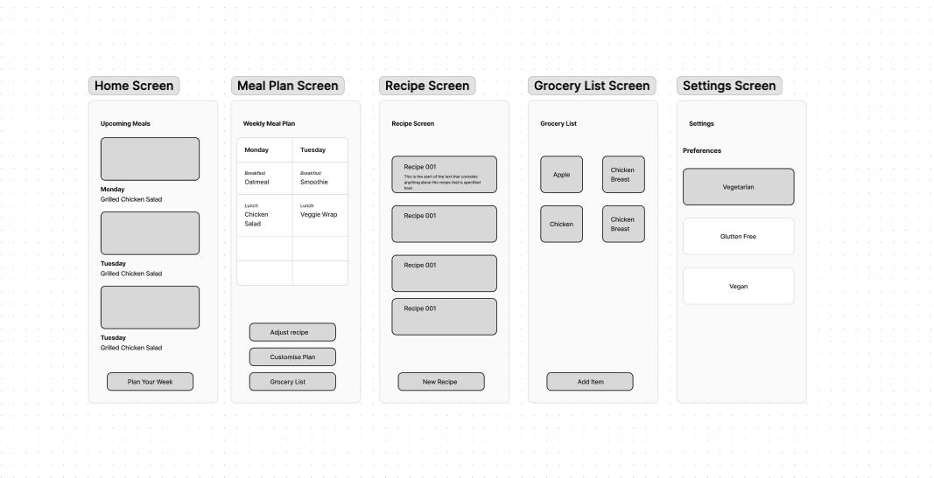

**6. Usability Tests**

Feedback from tests:

Positive: Testers liked the simple interface and quick access to grocery lists.

Areas to improve: Adding more recipe options and an “auto-fill” feature for common grocery items.