CS3691
EMBEDDED SYSTEMS AND IoT
ASSIGNMENT-II

Submitted by,
- Vinshiya Janu
960222243094
III year
AI&DS : B
Date:23-04-2025
INTEGRATION OF SENSORS AND ACTUATORS WITH ARDUINO SENSOR

SENSOR:
A sensor is an input device that detects and responds to various types of input from the physical environment, such as light, heat, motion, moisture, and pressure. A Sensor is a device that converts signals from one energy domain to electrical domain.
Sensors are used in everyday objects such as touch-sensitive elevator buttons and lamps which dim or brighten by touching the base.

CLASSIFICATION OF SENSORS:
Sensors are classified into,
Active sensors
Passive sensors
Active sensors: Active Sensors are those which require an external excitation signal or a power signal.
Passive sensors: Passive Sensors do not require any external power signal and directly generates output response.

TYPES OF SENSORS:
- Temperature Sensors: Measure temperature changes.
- Proximity Sensors: Detect the presence of nearby objects without physical contact.
- Infrared Sensors: Detect infrared radiation, often used in remote controls and motion detectors.
- Pressure Sensors: Measure the pressure of gases or liquids.
- Light Sensors: Measure light intensity. These sensors are widely used in applications ranging from industrial automation to consumer electronics.
CHARACTERISTICS OF SENSORS:
Sensors have several key characteristics that define their performance and suitability for specific applications:
- Sensitivity: The ability of a sensor to detect small changes in the input signal.
- Accuracy: How close the sensor's measurement is to the true value.
- Resolution: The smallest change in input that the sensor can detect.
- Range: The minimum and maximum values of the input signal that the sensor can measure.
- Repeatability: The ability of the sensor to produce the same output for the same input under identical conditions.

ACTUATOR:
An actuator is a component of a machine that produces force, torque, or displacement, usually in a controlled way, when an electrical, pneumatic or hydraulic input is supplied to it in a system. It is a type of transducer. Actuators are used to convert externally available energy into motion based on the control signals. They are used in various machines and devices to achieve physical movements by converting energy, often electrical, air, or hydraulic, into mechanical force.

TYPES OF ACTUATORS:
- Electrical Actuators: use electrical energy and magnetic fields to perform actuation.
- Fluid Power Actuators: use liquids or gases to perform actuation. They can be further divided into hydraulic actuators (use hydraulic power) and pneumatic actuators (use compressed air or vacuum).
- Mechanical Actuators: use mechanical forces to interconvert rotary and linear motion.
- Thermal Actuators: use thermal energy to perform actuation.
- Special Actuators: use other types of energy sources, such as light, sound, or chemical reactions.

CHARACTERISTICS OF ACTUATORS:
Actuators have several important characteristics that determine their performance and suitability for specific applications:
- Speed: The rate at which the actuator can move or rotate.
- Efficiency: How effectively the actuator converts input energy into mechanical motion.
- Precision: The accuracy and control over the actuator's movement.
- Durability: The ability to withstand wear and tear over time.
- Responsiveness: How quickly the actuator reacts to control signals.
- Energy Consumption: The amount of energy required for operation.

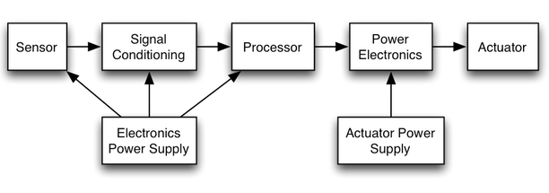

INTEGRATION OF SENSORS AND ACTUATORS WITH ARDUINO SENSOR:

To integrate sensors and actuators with Arduino,
- Connect the Hardware: Physically link sensors and actuators to the Arduino board using analog or digital pins. Ensure a proper power supply and establish correct grounding.

- Understand Sensor and Actuator Functions: Sensors detect changes in the environment and send data to the Arduino, while actuators allow the Arduino to interact with and control the physical world based on sensor data.

- Test and Iterate: Evaluate the integrated system to verify sensor accuracy and actuator response. Make adjustments as necessary to ensure proper functionality.

- Explore Various Components: There are many types of sensors (like temperature, humidity, motion) and actuators (like motors, relays) that can be used with Arduino, depending on your project needs.

- Utilize Resources: Refer to educational materials and community projects for guidance on specific integrations and applications.

RASPBERRY PI ARCHITECTURE

Raspberry Pi is a small single-board computer (SBC). It is a credit card-sized computer that can be plugged into a monitor. It acts as a minicomputer by connecting the keyboard, mouse, and display. Raspberry Pi has an ARM processor and 512MB of RAM.
The Raspberry Pi is a series of small, low-cost, single-board computers developed by the Raspberry Pi Foundation, originally aimed at promoting computer science education and practical skills in programming and electronics. Since its inception in 2012, Raspberry Pi has seen numerous iterations and has become wildly popular for various applications, from simple educational tools to complex embedded systems.

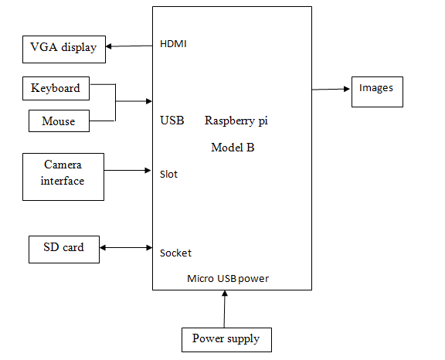
Figure: General block diagram of image processing

BLOCK DIAGRAM OF RASPBERRY PI:
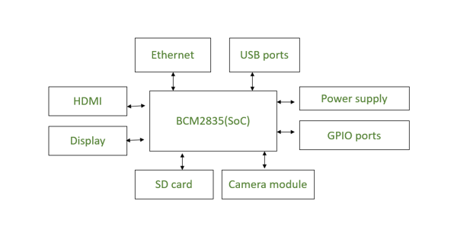
Raspberry Pi mainly consists of the following blocks:
- Processor: Raspberry Pi uses Broadcom BCM2835 system on chip which is an ARM processor and Video core Graphics Processing Unit (GPU). It is the heart of the Raspberry Pi which controls the operations of all the connected devices and handles all the required computations.
- HDMI: High Definition Multimedia Interface is used for transmitting video or digital audio data to a computer monitor or to digital TV. This HDMI port helps Raspberry Pi to connect its signals to any digital device such as a monitor digital TV or display through an HDMI cable.
- GPIO ports: General Purpose Input Output ports are available on Raspberry Pi which allows the user to interface various I/P devices.
- Audio output: An audio connector is available for connecting audio output devices such as headphones and speakers.
- USB ports: This is a common port available for various peripherals such as a mouse, keyboard, or any other I/P device. With the help of a USB port, the system can be expanded by connecting more peripherals.
- SD card: The SD card slot is available on Raspberry Pi. An SD card with an operating system installed is required for booting the device.
- Ethernet: The ethernet connector allows access to the wired network, it is available only on the model B of Raspberry Pi.
- Power supply: A micro USB power connector is available onto which a 5V power supply can be connected.
- Camera module: Camera Serial Interface (CSI) connects the Broadcom processor to the Pi camera.
- Display: Display Serial Interface (DSI) is used for connecting LCD to Raspberry Pi using 15 15-pin ribbon cables. DSI provides a high-resolution display interface that is specifically used for sending video data.

APPLICATIONS:
1. Desktop Replacement: It can be used as a low-cost desktop computer for tasks like web browsing, word processing, and media playback.
2. Home Automation: Raspberry Pi can control lights, appliances, and security systems, making it a hub for smart home projects.
3. IoT Projects: It's widely used in Internet of Things (IoT) applications, connecting sensors and devices to collect and analyze data.
4. Robotics: Raspberry Pi serves as the brain for robots, controlling motors, sensors, and cameras.
5. Educational Tool: It's a favourite for teaching programming and electronics to students and hobbyists.
6. Network Storage: Raspberry Pi can act as a personal cloud or network-attached storage (NAS) device.

ADVANTAGES:
1. Affordability: It's a cost-effective option compared to traditional computers, making it accessible to a wide range of users.
2.Compact Size: Its small, credit-card-sized design makes it portable and easy to integrate into projects with limited space.
3. Low Power Consumption: It consumes significantly less power than standard computers, making it ideal for energy-efficient projects.
4. Educational Value: It's a fantastic tool for learning programming, electronics, and computer science, especially for beginners..
5.Customizability: With its GPIO pins, it allows users to connect and control various hardware components, enabling creative and customized projects.

DISADVANTAGES:
1. Limited Processing Power: It struggles with resource-intensive tasks like video editing or 3D modeling, as it's designed for lightweight computing.
2. Software Compatibility: Not all applications are available for Raspberry Pi, especially those requiring high performance, like Adobe Photoshop.
3. Linux-Based OS: The operating system may be unfamiliar to users accustomed to Windows or macOS.
4. Hardware Constraints: The device has limited RAM and storage compared to traditional computers.
5. No Built-In Analog Input: It lacks native support for analog sensors, requiring additional components.

SMART HEALTHCARE

Smart healthcare refers to the integration of advanced technologies, such as the Internet of Things (IoT), wearable devices, and artificial intelligence, into healthcare systems to enhance patient care, improve efficiency, and enable remote monitoring.
It involves the use of connected devices and intelligent systems to collect, analyze, and respond to health-related data, facilitating better decision-making and personalized treatment.
This approach aims to make healthcare more accessible, cost-effective, and patient-centered.
Examples include smart health monitoring systems, electronic patient records, and telemedicine platforms.
The IoT is a critical component in the transformation of healthcare systems to become smarter, faster, and more efficient.
From glucose monitors and heart rate trackers to smart inhalers and wireless temperature sensors, IoT devices serve their role in improving patient care and hospital management.

MEDICAL SENSORS:
Smart sensors are changing healthcare monitoring by offering new ways to track health and engage patients. They are found in many areas like vital signs checking, telehealth, diabetes care, and wound management.
Medical sensors are specialized devices used in the medical domain to diagnose, monitor, or treat diseases.
Medical devices are categorized based on their risk profile, ranging from Class I (lowest potential risk) to Class IV (highest potential risk).
Medical sensors are the heart of modern healthcare, providing essential data that drives diagnosis, monitoring, and treatment.
As technology advances, the role of medical sensors continues to expand, offering new ways to enhance patient care and improve outcomes.
TYPES OF MEDICAL SENSORS:

- Temperature Probes: Used for measuring body temperature. This helps in providing better medication and treatment of patients. These are commonly known as thermometers.
- Force Sensors: Used in kidney dialysis machines.
- Airflow Sensors: Used in anesthesia delivery systems, laparoscopy, heart pumps, etc.
- Pressure Sensors: Used in infusion pumps and sleep apnea machines. Many pressure sensors are integrated with embedded systems. They are used for medical diagnosis, blood pressure monitoring, infusion pumps, etc.
- Implantable Pacemaker: A real-time embedded sensor system that delivers a synchronized rhythmic electric stimulus to the heart muscle to maintain an effective cardiac rhythm.
- Oximeter: Measures the fraction of oxygen-saturated hemoglobin relative to the total haemoglobin count in the blood.
- Glucometer: Measures the approximate blood glucose concentration.
- Magnetometer: Specifies the direction of a user by examining changes in the Earth’s magnetic field around them.
- Electrocardiogram (ECG) Sensor: Measures the electrical activity of the heart.
- Heart Rate Sensor: Counts the number of heart contractions per minute.
- Electroencephalogram (EEG) Sensor: Measures the electrical activity of the brain.
- Electromyogram (EMG) Sensor: Records electrical activity produced by skeletal muscles.
- Respiration Rate Sensor: Counts how many times the chest rises in a minute.

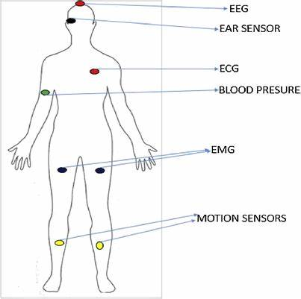

BENEFITS:
1. Improved Patient Monitoring: Wearable devices and IoT sensors enable real-time tracking of vital signs, allowing for early detection of health issues.
2. Personalized Treatment: AI-driven analysis helps tailor treatments to individual patients based on their unique health data.
3. Cost Efficiency: Automation and data-driven decision-making reduce operational costs and improve resource allocation.

CHALLENGES:
1. High Initial Costs: Implementing smart healthcare systems, including IoT devices and AI technologies, can be expensive.
2. Technical Issues: Dependence on technology can lead to disruptions in care if systems fail or experience downtime.
3. Complexity for Users: Patients and healthcare providers may face a learning curve in adopting and effectively using smart healthcare technologies.

