Stock Overflow

User Manual

Reference : MU_UserManualTemplate.doc

Version 1.0

Authors:

Rena Chen

Garrett Oldani

Christian Villa

Zhongyang Gao

Edgar Lugo

CSCI 310 -- Group 12

Purpose of the document

The purpose of this document is to provide the user

with simple steps on how to use our web application.

Contents

Purpose of the document 1

1. Icons Used in the Manual 3

2. Connecting to the Application 4

2.1 Address 4

2.2 Authentication 4

3. Structuring of the Application 4

3.1 Layout 5

3.2 Components 5

3.4 Functionalities 5

3.4.1 Functionalities Presented/Described 5

4. Function 1 / Searching Stocks 6

4.1 Screenshot 6

4.2 Descriptions of fields, content 6

4.3 Description of actions 6

5. Function 2 / Adding Stocks to the Watch List 7

5.1 Screenshot 7

5.2 Descriptions of fields, content 7

5.3 Description of actions 7

6. Function 3 / Showing Stock Info in the Graph 8

6.1 Screenshot 8

6.2 Descriptions of fields, content 8

6.3 Description of actions 8

7. Function 4 / Buying and Selling Stocks 8

7.1 Screenshot 8

7.2 Descriptions of fields, content 8

7.3 Description of actions 8

8. Function 5 / Importing a CSV file 8

8.1 Screenshot 8

8.2 Descriptions of fields, content 8

8.3 Description of actions 8

# Icons Used in the Manual

Throughout this document, the pictograms below are used to underline points or important notions

|  |  |
| --- | --- |
| icono2 | Important information |
| Light Bulb On 32 h g | Good to know - Tricks |
| icono3 | **Risk** in front of a parameter setting or of a specific action |
| icono1 | Action to be avoided |
| icono5 | Mandatory action |

## Support

Please feel free to contact any of the developers for support.

Rena Chen -- renachen@usc.edu

Garrett Oldani -- oldani@usc.edu

Christian Villa -- christdv@usc.edu

Zhongyang Gao -- zhongyag@usc.edu

Edgar Lugo -- edgarlug@usc.edu

## Referenced Documentation

Here is some documents that can help the user in understanding stocks and how to invest :

How do stocks work ?

<http://www.investopedia.com/articles/basics/03/103103.asp>

How to start investing with $2000

<http://www.nasdaq.com/article/how-to-start-investing-with-2000-cm586520>

# Connecting to the Application

## Address

To access StockOverflow, launch Firefox from the sidebar and enter the following **URL: https://localhost**.

## Authentication

The user must provide username and password for authentication. On this application, the username is the users email. You will then be directed to the login page. Your username is **halfond@usc.edu** and your password is **password**.

icono2 If the user forgets its password, it can click on Forgot Password which will send an email for the user to reset their password.

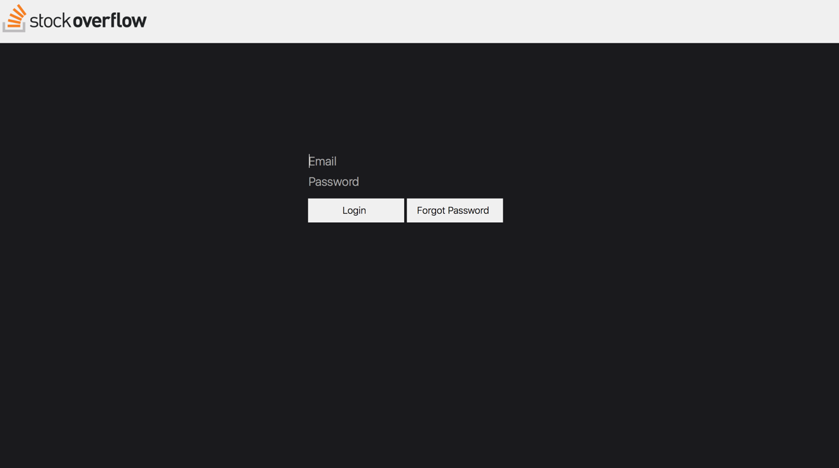

# Structuring of the Application

## Layout

StockOverflow contains three sections, a top bar, left side, and right side. There is a top bar for control, two lists and a box for buying a selling stocks to the left, a graph section and information box to the right of the web page.

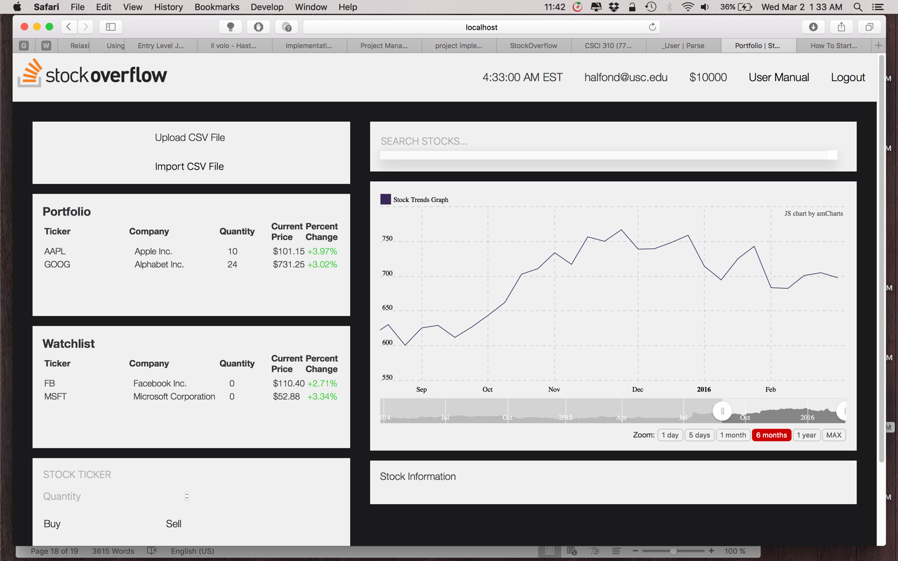

## 3.2 Components

- StockOverflow Logo: Simply our logo which refreshes the webpage on click.

- Time: Shows current time (EST).

- User name: Email provided by the user at authentication.

- Current Balance: Provides current amount of money the user can user to purchase stocks.

- User Manual: Provides a link to this document.

- Logout: Ends the user’s current session.

- Upload CSV file: Uploads the provided file by the user.

- Import CSV file: Imports the provided file by the user, changing his stocks on the lists.

- Owned List: Shows stocks owned by the user with quantities.

- Watch List: Shows stocks the user is interested on.

- Buy/Sell Stock: With input of symbol and quantity, the user can buy stocks that are already on the watch list, or sell stocks that are already on the owned list.

- Search Bar: The user can search by company name or symbol.

- Graph: Shows stock prices for 1 day, 5 days, 3 months, 6 months, 1 years, and all time prices.

- Information Box: Provides information about the stock (company?)

## Functionalities

### Functionalities Presented/Described

1. Searching Stocks
2. Adding stocks to watch list
3. Showing stock info in graph
4. Buying and Selling Stocks
5. Importing a CSV file

# Function 1 / Searching Stocks

Stock overflow provides a search bar right over the graph section that allows the user to search for stocks by both ticker symbol and company name. The search bar provides matches to the search as the user narrows it.

## Screenshot

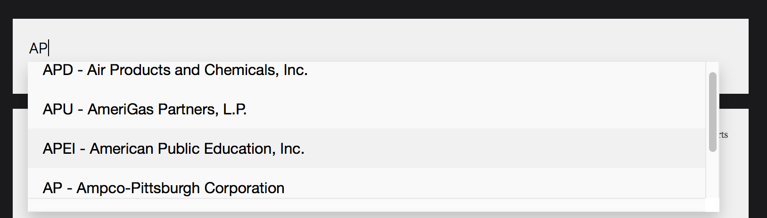

## Descriptions of fields, content

The text in text field for the search bar is in caps. This makes easier the identification of the ticker symbols.

The content shown from the search consists of the first five matches from the input given by the user.

The result is a list with clickable items.

## Description of actions

To search a stock simply type the name or ticker symbol in the search bar.

Light Bulb On 32 h gProceed to search with the ticker symbol if possible.

# Function 2/ Adding Stock to Watch list

StockOverflow provides a Watch List that includes stocks the user is interested in but not yet bought. With the Search Bar provided, the user can add the stock to the watch list, if the stock is not already there.

## Screenshot

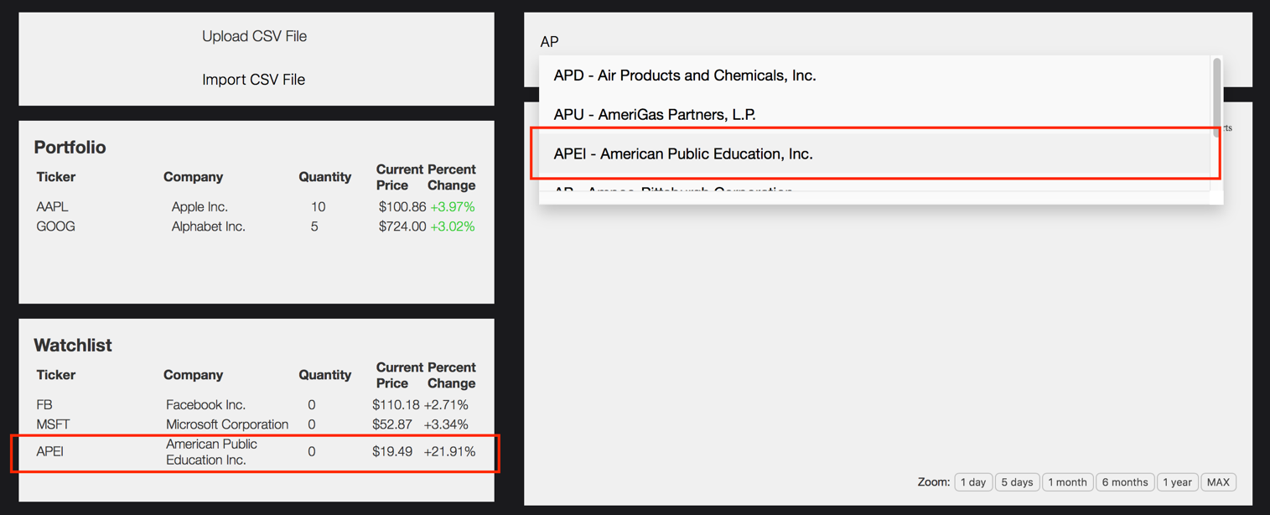

## Descriptions of fields, content

The Watch List itself has clickable items.

## Description of actions

To add a stock to the Watch List, simply follow Function 1 by searching the desired stock. Then click on the desired stock shown on the results.

# Function 3/ Showing Stock Info on Graph and Info Box

StockOverflow provides a graph and information box which gives the user detailed information of a particular stock.

## Screenshot

## Descriptions of fields, content

The graph provides historical data about the prices of the stock. It allows the user to see prices in 1 day, 5 days, 1 months, 6 months, 1 year, and all-time prices. It also allows the user to select a particular interval.

Other information is presented in the information box such as closing and opening price in addition to the information already provided on the lists.

## Description of actions

To show information on the Graph and the Information Box, simply click on any of the stocks at the Watch List or Owned List.

icono2 The graph loads a large amount of data, it may take a few seconds to show information.

# Function 4/ Buying and Selling Stocks

StockOverflow provides the user with the ability of buying and selling stocks. Giving the opportunity to invest on stocks and receive profit.

## Screenshot

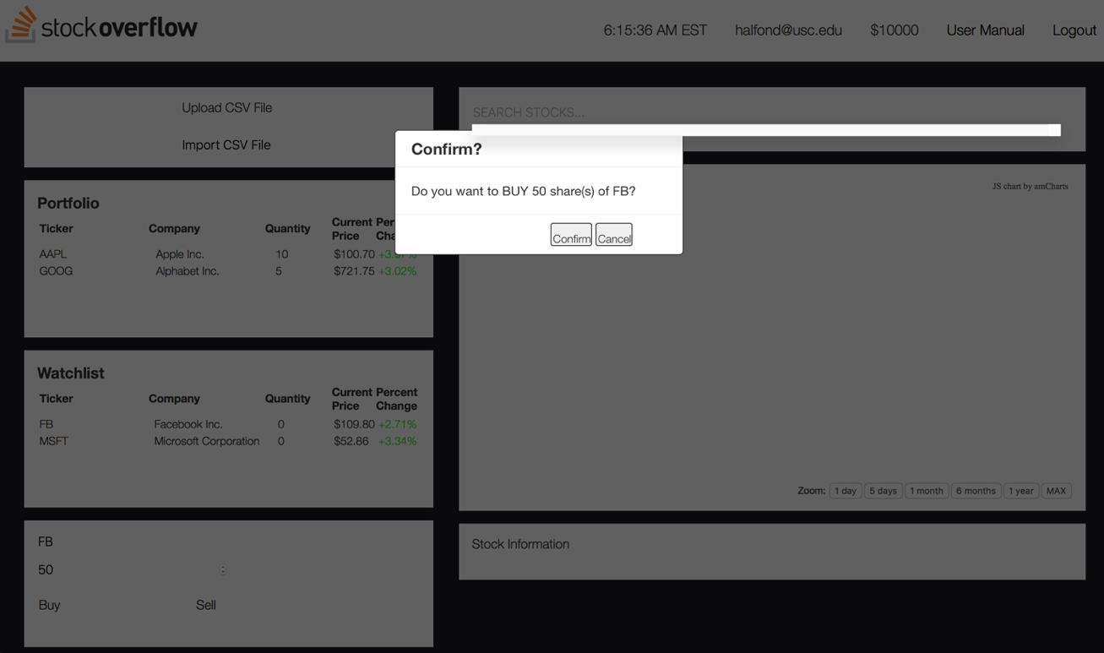

Buying confirmation. Notice the Buy/Sell box and the values inputted.

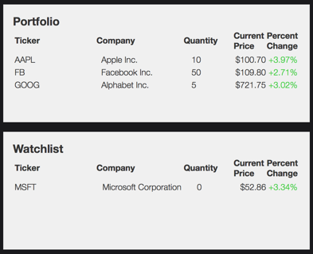

Notice how the stock FB – Facebook moved from the Watch List to the Owned List.

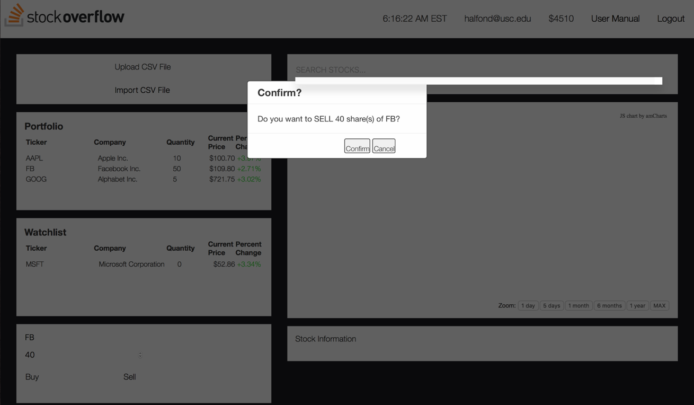

Selling confirmation.

## Descriptions of fields, content

The Buy/Sell box is used for this function. It contains a filed for the Ticker Symbol, the quantity and two buttons Buy and Sell. The quantity field also provides arrows on the side to increase or decrease the quantity by one.

## Description of actions

To buy a stock provide the ticker symbol and quantity desired to buy at the Buy/Sell box, and click the Buy button.

To sell a stock provide the ticker symbol and quantity desired to sell at the Buy/Sell box, and click the Sell button.

icono5 The user must provide a correct ticker symbol or the transaction will not be completed. The stock to buy must be at the user’s Watch List.

The user can only buy during the market hours. That is when the market is open, between 9:30am and 4:00pm EST.

# Function 5/ Importing a CSV File

StockOverflow provides the user the ability to import their own set of stocks to the portfolio by importing a CSV file into the web application.

## Screenshot

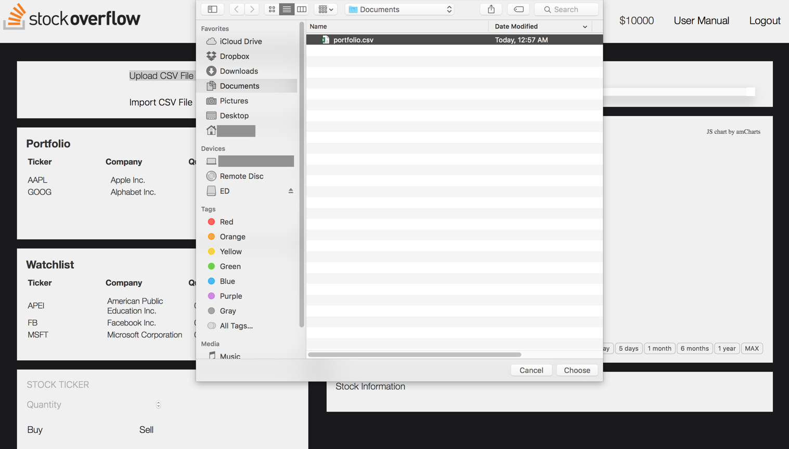

## Descriptions of fields, content

There are two buttons that facilitate the import process: Upload CSV File and Import CSV File. The first prompts the user to select a file from the computer, and the second completes the import process.

## Description of actions

To import a file, click on the button Upload CSV File, choose the file from the computer. Then click Import CSV File to complete the import and update the lists.

icono1 Do not provide files that are not CSV for the web application will NOT import it.