Executing VisionEval on an Experimental Shoestring
The site VisionEval.org has best practices for installing and executing VisionEval and those should be followed in the long term. If, however, you do not have administrative privileges, have a small hard drive that does not provide enough space for the installation, and want to get started running scenarios in VisionEval within a single morning or afternoon just to see what the platform can do, these instructions can help you do that. They have been tested as of October 15, 2024 on an IBM PC where the user does not have administrative privileges and has chosen to install VisionEval and associated data on an external drive or flash drive.
Downloading Software—Do This Once
- Go to VisionEval.org, choose Downloads, and click Get VisionEval Here. The link says “Version 3.1. 468 Mb download! Packaged for R 4.3.2. The result is that a zipped 468 MB file is downloaded.

- Download a version of R that matches VisionEval from step 1. Go to the site that says Previous releases of R for Windows (rstudio.com). Click on the link that says R 4.3.2 and then click on the file that says R-4.3.2-win.exe. The result is that an executable file is downloaded.

- Optional. Move those two files to some other location on your computer, external hard drive, or flash drive. Example: I put them on an external drive in a folder called D:\VE2024.
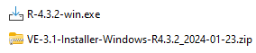

- Extract VE-3.1-Installer-Windows-R4.3.2_2024-01-23.zip. (I placed mine in D:\VE2024\My_VE.)

- Install R without admin privileges. You will get an error message saying you must be an administrator. Ignore that warning—simply press “Next.”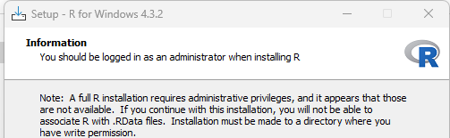

Indicate that you want R installed in a folder on your machine, and frankly you can put R in the same location as VisionEval. For example, I put it in D:\VE2024\R-4.3.2
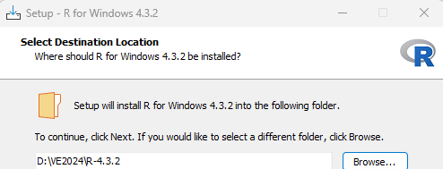
I then accepted the defaults.
I now have four items in D:\VE2024.

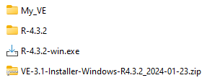
- Install VisionEval.

  - Start R by double clicking on x64 RGui.exe which will be in the R subfolder. In my case, the exact location was D:\VE2024\R-4.3.2\bin\x64\x64 RGui.exe

  - While in R, use the setwd command to set the working directory to be the folder above that contains VE. In my case, that folder is D:\VE2024\My_VE. Thus I type the following in R (notice two slashes \\).

setwd ("D:\\VE2024\\My_VE")

  - Install VisionEval using two commands. The source (VisionEval.R) is in the subdirectory My_VE. In the second command, I am installing the regional model (VERSPM) rather than VE-STATE. Notice the use of dumb quotes—that is, I have " rather than “.

source ("VisionEval.R")
rspm <- installModel("VERSPM")

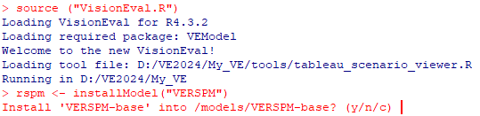
Indicate yes in response
The result is that a folder called VERSPM-base has been placed in the models subdirectory. In my case, the location of this folder is D:\VE2024\My_VE\models\VERSPM-base.

D:\VE2024\My_VE\models D:\VE2024\My_VE\models\VERSPM-base
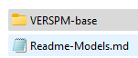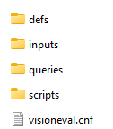

Run a Simple Model (Base Scenario)
- One can place the simple 5 Bzone model in the same models subdirectory. The Sayed.zip model has two Azones and 5 Bzones and is a hypothetical example just designed to allow you to quickly experiment with VE. Inputs are not necessarily realistic but the model runs in about three minutes.

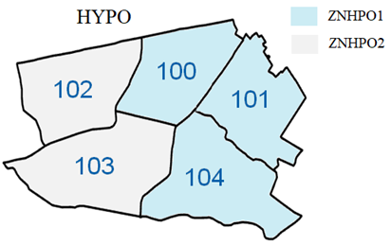
Hypothetical model: Marea (HYPO), 2 Azones (ZNHPO1 and ZNHPO2) and 5 Bzones (100, 101, 102, 103, and 104)

Unzip Sayed.zip into the above models subdirectory. The result is that you now have two models you can run: Sayed or VERSPM-base.

D:\VE2024\My_VE\models
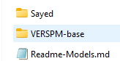

- Exit R. The reason for this is to ensure that the seven lines can work for running any model. Then, re-enter R by going to Rgui.exe. (For example, in my case I went to D:\VE2024\R-4.3.2\bin\x64\Rgui.exe).
These seven commands can be used time you want to run a model—the only item that would change is the name of the model (in this case “Sayed”) shown in yellow.
setwd ("D:\\VE2024\\My_VE")
source ("VisionEval.R")
setwd ("D:\\VE2024\\My_VE\\models")
rspm <- openModel("Sayed")
rspm$run()
results <- rspm$results()
results$export()
The model should run quickly and export several .CSV files into a subfolder within the results subdirectory for this model. For example, in my case the results are placed in D:\VE2024\My_VE\models\Sayed\results\output\Sayed_CSV_202410110748
- Examine the outputs. There are multiple CSV files, for now, focus just on two.

  - Open Marea_Sayed_2045.csv which shows only one row. Sum three attributes: UrbanHhDvmt, TownHhDvmt, and RuralHhDvmt (columns BN, BO, and BP) to find that households alone generated 306,834 VMT.
  - You can see this same value (households generate 306,834 VMT) by opening Household_Sayed_2045.csv and summing all rows in the column labeled “dvmt” (column U).
  - The same file shows other attributes: 74,065 grams of CO2 equivalents, found by summing the rows for the column labeled DailyCO2e (column BN), 347 kwh (sum rows of column labeled DailyKWH (column BM), and 5,964 gasoline gallon equivalents found by summing dailyGGE (column BL).

Run a Simple Model (Two New Scenarios)
- Let’s look at two potential impacts to this base case by adding two scenarios. The first increases the fuels tax and the second increases population and households. To create models for these scenarios, extract Sayed.zip into two new folders in the models folder. I called these “IncreaseFuelsTax” and “IncreasePopAndHH.”

D:\VE2024\My_VE\models
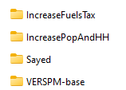

- Let’s examine how increasing fuel taxes may affect household VMT. The fuel tax (in 2005 dollars) for year 2045 is 48.4 cents per gallon. What happens if we increase that by a dollar? We change the fuel tax in 2045 from $0.484 per gallon to $1.484 per gallon for both Azones (ZNHP01 and ZNHP02) in azone_veh_use_taxes.csv.

Model name | Sayed | IncreasePopAndHH
Situation in 2045 | Fuels tax is $0.484/gallon | Fuels tax is $1.484 gallon
azone_veh_use_taxes.csv | 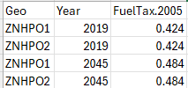 | 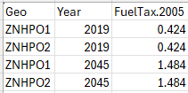
The above file is found in D:\VE2024\My_VE\models\IncreaseFuelsTax\inputs

- Let’s see how an unexpected demographic change may affect household VMT, such as the population being 10% higher than expected in 2045. This scenario is a bit trickier than the previous one in that we increase the population, but we also increase the number of households. We need to change three data files: the population in households (which is at the Azone level), the group quarters population (also at the Azone level), and the number of households (at the Bzone level). We thus change the yellow portion of three data files, increasing the values by 10%. All files are found in D:\VE2024\My_VE\models\IncreasePopAndHH\inputs.

azone_hh_pop_by_age.csv
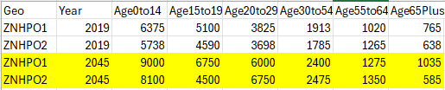
azone_gq_pop_by_age.csv
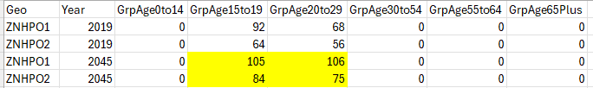
bzone_dwelling_units.csv
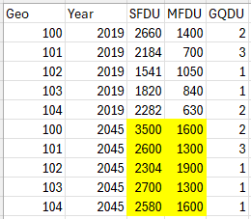
Because VE will crash if the values shown in the three above .CSV files are not integers, use the round function in Excel to ensure they are integers. For instance, if the “2580” circled above is in cell C11, then in Excel you might have a function that increases this by 10% such as =C11*1.1. Modify this function to be =Round(C11*1.1,0) to make it an integer.
Summary with the Simple 5 BZone Model
The results of executing the three scenarios are shown below. In this case, we see that the increase in fuels tax reduces emissions by about 0.8% and the increased population and housing increases emissions by about 2.9%.
Comparison of scenarios for the Simple 5 Bzone Model
Performance measure | Base scenario | Increase gas tax from $0.484/gallon to $1.484/gallon | Increase population and housing by 10%
Household VMT | 306,834 | 305,084 | 314,165
Household CO2e (grams) | 74,065 | 73,522 | 76,119
Household GGE | 5,964 | 5,918 | 6,139

Summary with the RVMPO Model
When you first installed VE, a model from the Rogue Valley MPO was placed in the models subdirectory, this model was called “VERSPM-base.” You can repeat steps 8, 9, 11, and 12 with this model. Those steps are shown below. In this case, with the RVMPO model, we see that the increase in fuels tax of $1 reduces emissions by about 1.8% (rather than 0.8% with the hypothetical 5 Bzone system) and the increase in population and housing of 10% increases emissions by about 9.5% (rather than 2.9% with the hypothetical 5 Bzone system).

Step | Modification
8 | setwd ("D:\\VE2024\\My_VE")  source ("VisionEval.R")  setwd ("D:\\VE2024\\My_VE\\models")  rspm <- openModel("VERSPM-base")  rspm$run()  results <- rspm$results()  results$export()
9 | Examine results in Household_VERSPM-base_2038.csv. Sum dvmt (column AU), DailyCO2e (column BN), and DailyGGE (column BL).
10 | Make two copies of the folder VERSPM-base.  Call them RVMPO_increase_fuels_tax and RVMPO_increase_pop_and_HH  Delete within each the “results” folder.
11 | Within the model, find azone_veh_use_taxes.csv. For instance, on my machine the pat is D:\VE2024\My_VE\models\RVMPO_increase_fuels_tax\inputs\azone_veh_use_taxes.csv. Change cell C3 from 0.484 to 1.484 such that it looks like what is shown below.  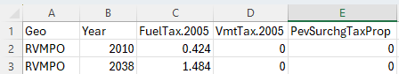
12 | Modify azone_hh_pop_by_age.csv, azone_gq_pop_by_age.csv, and bzone_dwelling_units.csv within the folder D:\VE2024\My_VE\models\RVMPO_increase_pop_and_HH\inputs

Comparison of Scenarios for the Rogue Valley MPO Model
Performance measure | Base scenario | Increase gas tax from $0.484/gallon to $1.484/gallon | Increase population and housing by 10%
Household VMT | 4,982,113 | 4,915,261 | 5,445,812
Household CO2e (grams) | 917,150 | 900,266 | 1,003,969
Household GGE | 102,356 | 100,414 | 112,056

Acknowledgments
These instructions could not have been developed without material which is available at VisionEval.org, presentations that have been shared as part of the VisionEval Pooled Fund led by Jeremy Raw, and a hypothetical data set that developed for internal testing of VisionEval as described in the VTRC report mentioned in this webinar. Any errors herein, however, are the responsibility of John Miller.

