##############################################################
# Import Data

##############################################################
# Data Cleaning and Preparation

##############################################################
# Feature Engineering

Create the 3 feature sets of interest to test with the linear regression model, see if adding demographics ____________
- Set 1: demographics plus tenure. This is your baseline, what you know about a customer from basic profile data.
- Set 2: adds Number of Services, testing whether engagement with services adds predictive power.
- Set 3: adds Contract and Payment Method, testing whether commitment and billing structure add more.
Because each set adds features to the previous one, you can attribute changes in R² to the features you added. That’s the core logic of your model comparison, and it’s worth stating in the report: “Each feature set nests the previous one, so improvements can be attributed to the added variables.”

One thing to watch: this count is built from the recoded columns, so the order matters. You recode first, then count. Also, Phone Service is in the list but Multiple Lines is not. That’s a judgment call you should document. Multiple Lines only applies to customers with phone service, so leaving it out keeps the count from double-counting the phone line. Your report should say that explicitly.

Replace “No internet Service” and “No phone service” entries in the _____ columns, with “No” so that service columns can be passed into OneHotEncoder.
‘’’
‘’’
Get total number of services

End up looping through these 3 feature sets in the churn_lin_reg

SPLIT THE DATA , random state 42 for repeatable results.

‘’’
‘’’

Standard scaler takes mean and standard deviation of each numeric column and converts them to z scores.

OIneHotEncoder learns the categories in each column.

##############################################################
# Model Assessment
##############################################################

‘’’python
from sklearn.metrics import r2_score, mean_squared_error

y_pred_train = regressor.predict(X_train)
y_pred_test = regressor.predict(X_test)

r2_train = r2_score(y_train, y_pred_train)
r2_test = r2_score(y_test, y_pred_test)
rmse_test = np.sqrt(mean_squared_error(y_test, y_pred_test))

print(feat_set)
print(f"Train R²: {r2_train:.4f}")
print(f"Test R²: {r2_test:.4f}")
print(f"Test RMSE: ${rmse_test:.2f}")
‘’’

This block measures the same model on two different datasets, and each number answers a different question.
Why R² for both train and test
Train R² tells you how well the model fits the data it learned from. Test R² tells you how well the model fits to unseen test data. The gap between them is the diagnostic:
- Train and test close together (as in your results, 0.157 vs. 0.160): the model isn't memorizing the training data. That's good, but when both are low, it means the model is underfitting. It's too simple to capture the pattern, not too complex.
- Not overfitting. The model learned noise specific to the training set.
- Test higher than train: usually just chance from the split, especially with a smaller test set. It's not a sign of anything wrong.
So the train number is a sanity check, and the test number is the one you report as your honest performance estimate.
What R² means
R² is the proportion of variance in the target that the model explains. It compares your model's errors to a baseline that always predicts the average CLTV:
- R² = 1 means perfect predictions.
- R² = 0 means the model does no better than predicting the mean.
Your test R² of 0.16 means the features explain about 16% of the variation in CLTV. The other 84% is driven by things not in the model. That's a weak fit, but for CLTV from demographics and services, it's not surprising, and it's a legitimate finding to report.
What RMSE tells you
RMSE (root mean squared error) is the typical size of a prediction error, in the same units as the target. Here it's in dollars.
- mean_squared_error averages the squared differences between predictions and actual values.
- np.sqrt takes the square root, which puts the result back in dollars.
Your RMSE of $1,075.79 means a typical prediction misses the true CLTV by about $1,076. Squaring before averaging means large misses count disproportionately, so RMSE is sensitive to outliers.
To judge whether that number is good, compare it to the spread of the target. CLTV has a standard deviation of about $1,183. An RMSE of $1,076 is close to that, which is consistent with the low R². The model is barely better than guessing the average. You can make this comparison explicit in your report by stating the RMSE next to the target's standard deviation or mean.
Two small things to fix in the code
- The from sklearn.metrics import is fine, but move it to the top of the file with your other imports. Imports inside functions work, but they're harder to scan.
- Your print(feat_set) label is useful, but consider printing the number of features too, since you're comparing three sets and the count matters when reading R².
For your write-up, a clean sentence would be: "Across feature sets, train and test R² remained close, indicating no overfitting, but the low R² values (≈0.16) and RMSE near the target's standard deviation indicate that these features alone explain little of the variation in CLTV."

LOGISTIC REGRESSION:
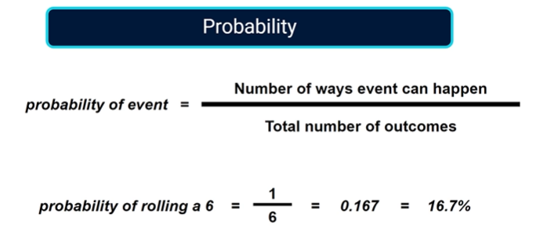

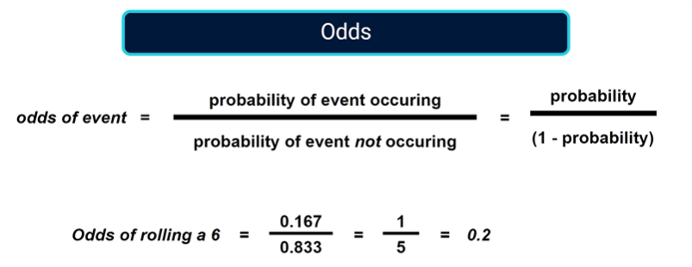

Take the log odds (values between 0 and 1)

Log odds back to probability with a sigmoid curve.

