Installation Qt Creator and the components required to buildVisual Studio

Windows version
Installed under: Microsoft Windows [Version 10.0.19041.208], now updated to: Microsoft Windows [Version 10.0.19041.630]

Installing Visual Studio Community 2019
Installed: Visual Studio Community 2019 16.6.1
When installing, I chose in Workloads: Desktop development with C ++

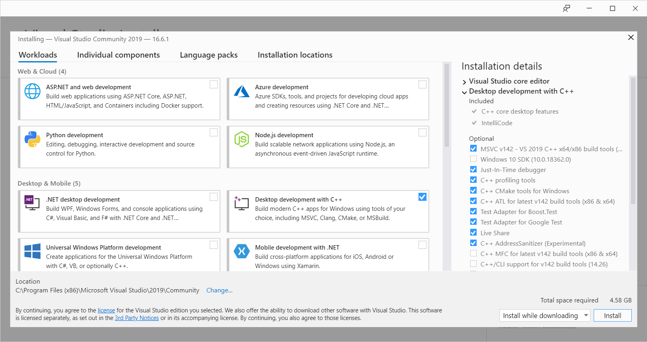

Selected: Windows SDK 10.0.19041.0

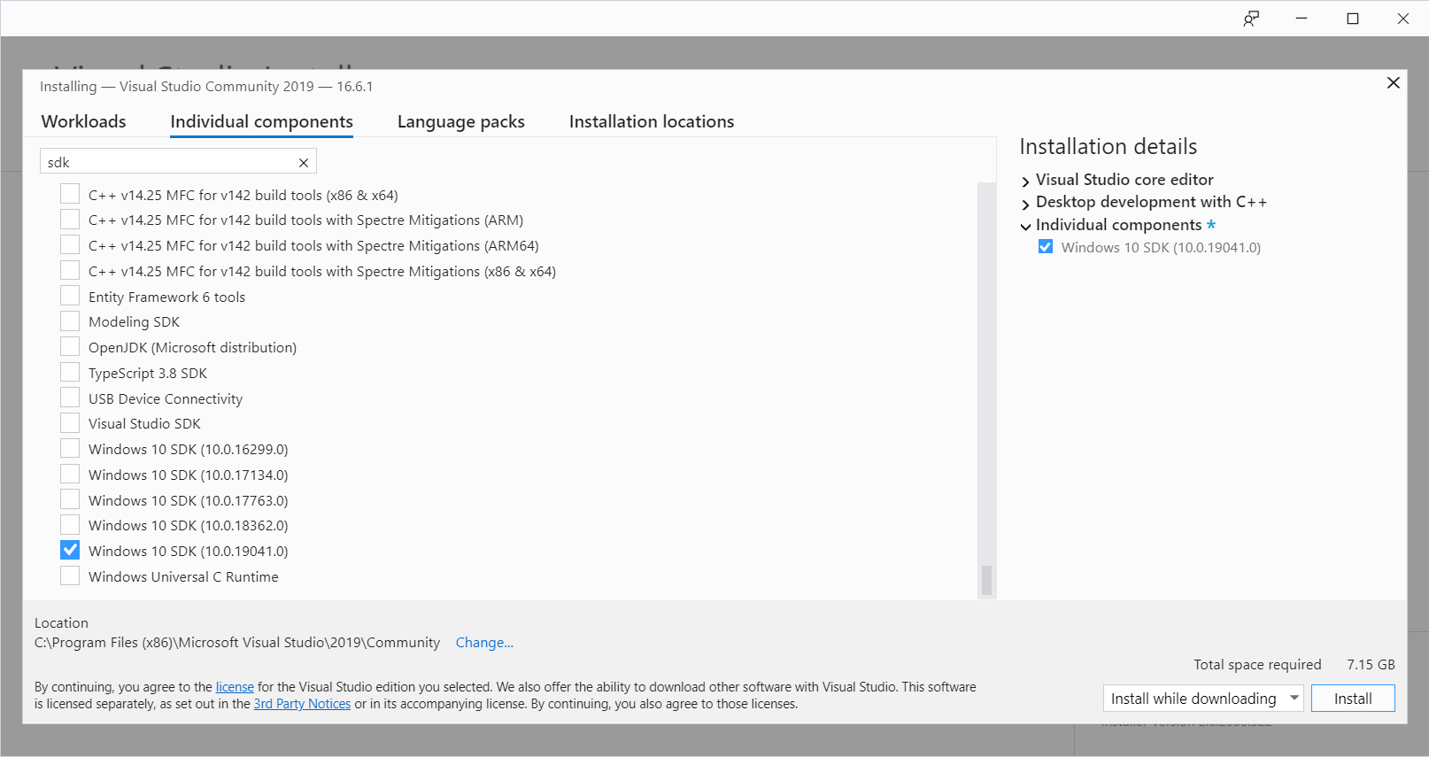

Installing Qt 5.9.5

Downloaded Qt 5.9.5 with:

https://download.qt.io/official_releases/qt/5.9/5.9.5/

Namely 2 files:
https://download.qt.io/official_releases/qt/5.9/5.9.5/qt-opensource-windows-x86-5.9.5.exe
https://download.qt.io/official_releases/qt/5.9/5.9.5/qt-opensource-windows-x86-pdb-files-desktop-5.9.5.zip

Installed Qt 5.9.5 with the following options
- msvc2015 32-bit
- msvc2015 64-bit
- msvc2017 64-bit
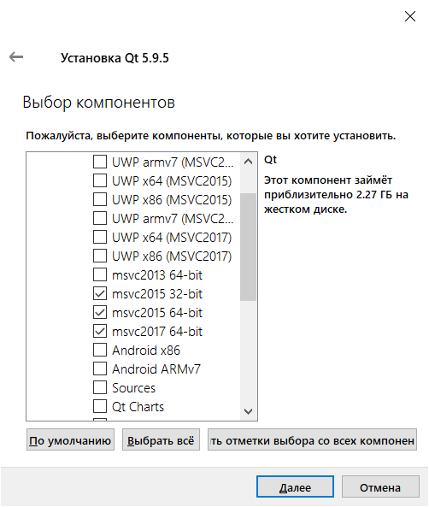

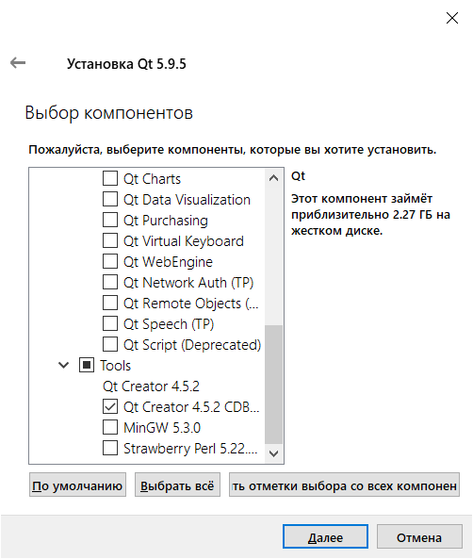

Setting the PATH environment variable
Added directories to the user's PATH environment variable:
c:\Qt\Qt5.9.5\Tools\QtCreator\bin
c:\Qt\Qt5.9.5\5.9.5\msvc2015\bin

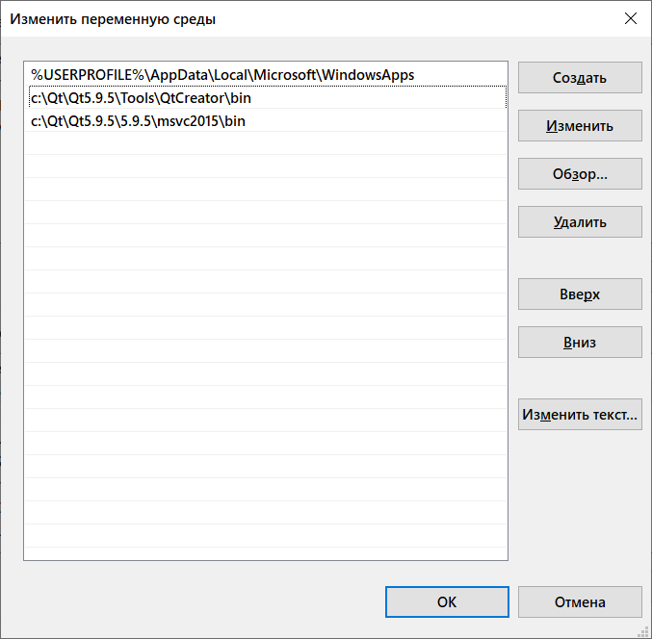

Adding PDB Files
Currently, the PDB files required for debugging are provided in a separate zip file.
This zip file contains the 7zip files, which in turn must be extracted to the correct subfolder of the Qt installation.
Without PDB files, for example, the values ​​of composite variables are not displayed in a debugger such as QString.
In the window: "Locals and Expressions" in the values ​​of these variables is displayed: <not available> or <not accessible>

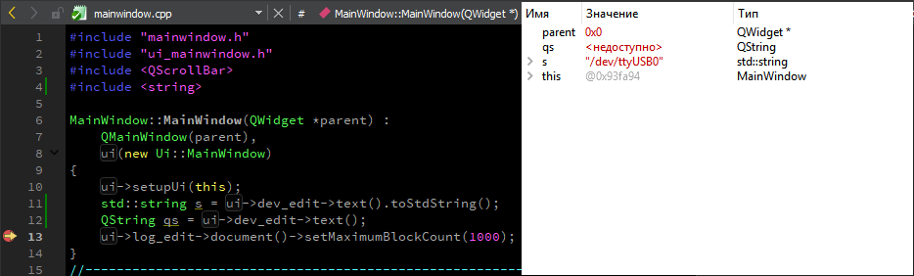

When installing the latest version of Qt through the online installer, you can choose: debug info.

For more details, see QTBUG-67587 with the resolution - Won't Do:
PDB files of windows online installer are provided in a unmanageable huge compressed folder
https://bugreports.qt.io/browse/QTBUG-67587

Well, and read how other developers relate to this:
some Qt types in debugger shown as 'not accessible'
https://bugreports.qt.io/browse/QTCREATORBUG-19797

Permalink
David Schulzadded a comment - 19 Oct '18 09:05
Unfortunately the pdb files aren't part of the offline packages anymore. Feel free to leave a vote onif this causes trouble for you.
Permalink
Permalink
David Schulzadded a comment - 22 Nov '18 06:44
Feel free to leave a vote onif this causes trouble for you. I also think this is more than uncomfortable.

Because we installed Qt from the offline installer, you need to manually copy these files.

Unzipped the previously downloaded zip file with pdb files:
http://download.qt.io/official_releases/qt/5.9/5.9.5/qt-opensource-windows-x86-pdb-files-desktop-5.9.5.zip

For MSVC2015 X86_64, do the following:
Selected .7z files by mask:
* Windows-Windows_10-MSVC2015-Windows-Windows_10-X86_64 *. *

Unzipped into one directory using Total Commander.
Allocated files.
Performed the command: Files -> Unpack ... (Alt + F9)

Copied to:
c:\Qt\Qt5.9.5\5.9.5\msvc2015_64

Likewise, for the 32-bit version, copy the corresponding PDB files to: c:\Qt\Qt5.9.5\5.9.5\msvc2015msvc2015

WebKit
In Qt 5.6.0 WebKit has been removed.
https://github.com/goldendict/goldendict#building-under-windows-with-ms-visual-studio
Building under Windows with MS Visual Studio
Note: In Qt 5.6.0 and later theWebkitmodule was removed from official release builds. You should to build it from sources to compile GoldenDict.

I didn't compile from source.
On: https://github.com/qtwebkit/qtwebkit/releases, there are compiled qtwebkit for versions only:
Qt 5.14.1, Qt 5.13, Qt 5.9
I downloaded the compiled QtWebKit for Qt 5.9:
QtWebKit 5.212.0 Alpha 2
https://github.com/qtwebkit/qtwebkit/releases/tag/qtwebkit-5.212.0-alpha2

https://github.com/qtwebkit/qtwebkit/releases/download/qtwebkit-5.212.0-alpha2/qtwebkit-5.212.0_alpha2-qt59-msvc2015-x86.zip
https://github.com/qtwebkit/qtwebkit/releases/download/qtwebkit-5.212.0-alpha2/qtwebkit-5.212.0_alpha2-qt59-msvc2015-x64.zip

MinGW is only 32-bit:
https://github.com/qtwebkit/qtwebkit/releases/download/qtwebkit-5.212.0-alpha2/qtwebkit-5.212.0_alpha2-qt59-mingw530-x86.zip

I expanded the archive into a folder:
c: \ Qt \ Qt5.9.5 \ 5.9.5 \ msvc2015
c: \ Qt \ Qt5.9.5 \ 5.9.5 \ msvc2015_64
c: \ Qt \ Qt5.9.5 \ 5.9.5 \ mingw53_32

Launching Qt Creator
Before starting Qt Creator, you need to set environment variables for VS 2015.
Run command line via shortcut:
VS2015 x64 Native Tools Command Prompt
or
VS2015 x86 Native Tools Command Prompt, respectively for 32bit,
which respectively execute the commands:
% comspec% / k "" C: \ Program Files (x86) \ Microsoft Visual Studio 14.0 \ VC \ vcvarsall.bat "" amd64
% comspec% / k "" C: \ Program Files (x86) \ Microsoft Visual Studio 14.0 \ VC \ vcvarsall.bat "" x86

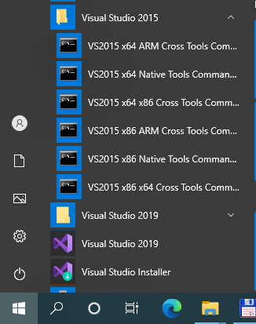

Then, in the command line that opens, run Qt Creator:
C:\Qt\Qt5.9.5\Tools\QtCreator\bin\qtcreator.exe

Debugger cdb.exe is not available
It is necessary set fields for Compiler and Debugger.
Launched Qt Creator, but Debugger cdb.exe was not available.
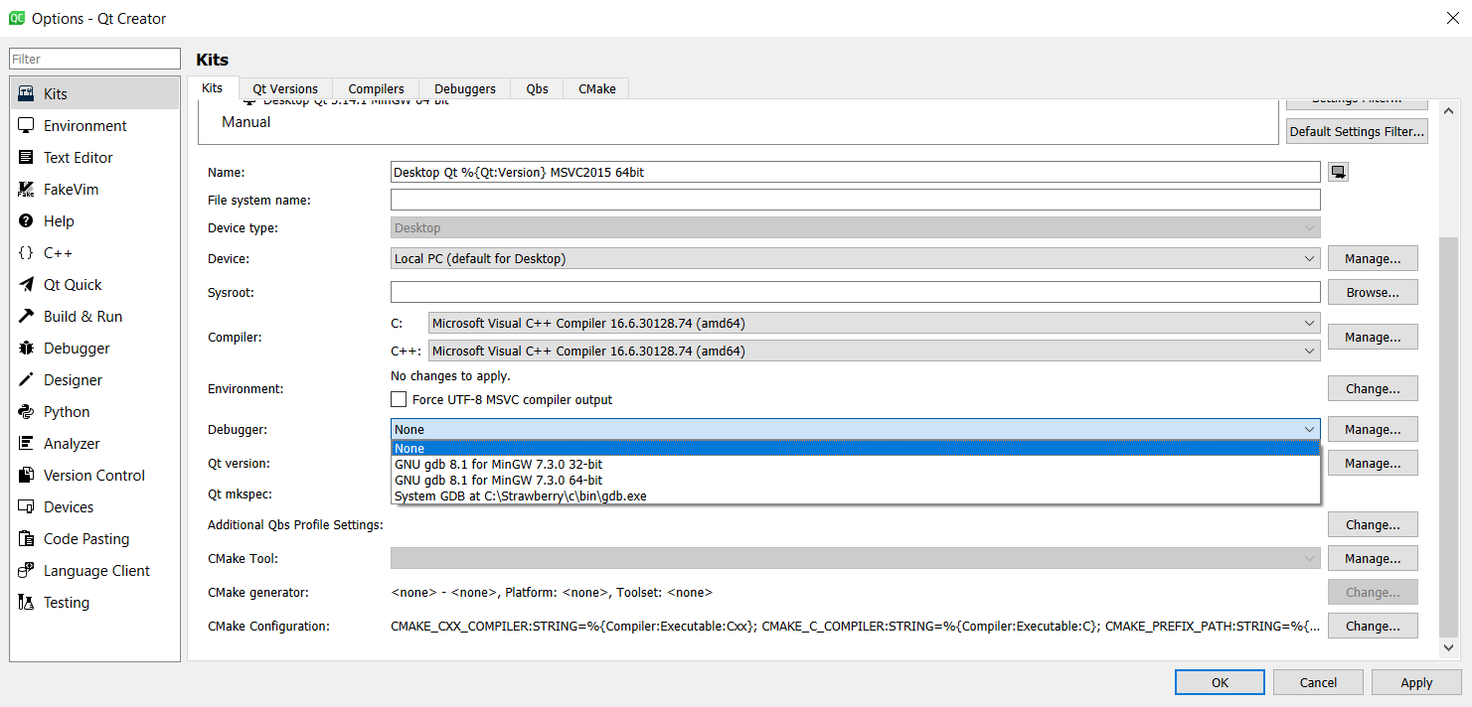

Windows 10 SDK
Downloaded Windows 10 SDK (10.0.19041.0)
https://developer.microsoft.com/ru-ru/windows/downloads/windows-10-sdk/

Installed only debuggers, from 2 msi files:
X64 Debuggers And Tools-x64_en-us.msi
X86 Debuggers And Tools-x86_en-us.msi

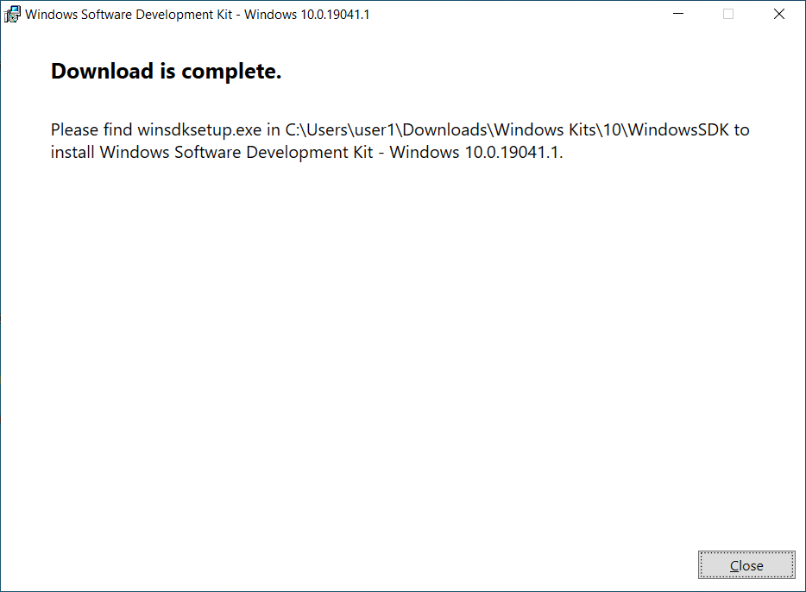

Directory: C:\Users\user1\Downloads\Windows Kits\10\WindowsSDK

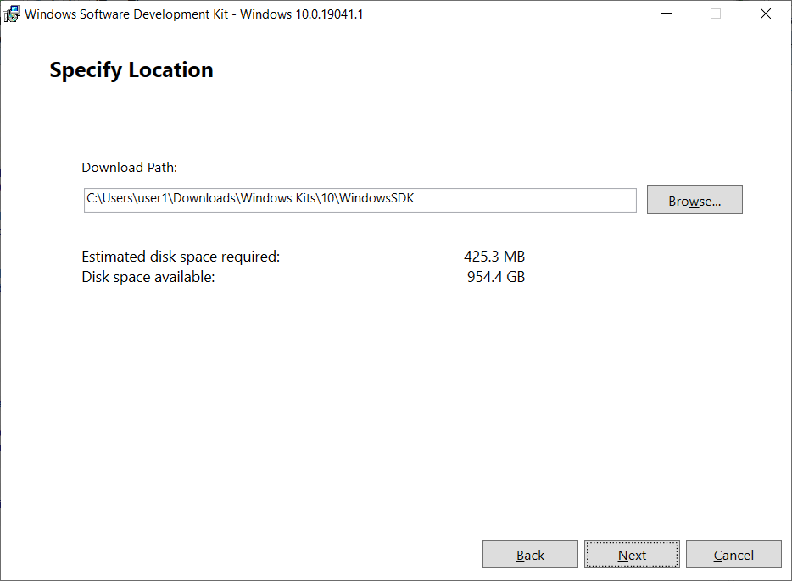

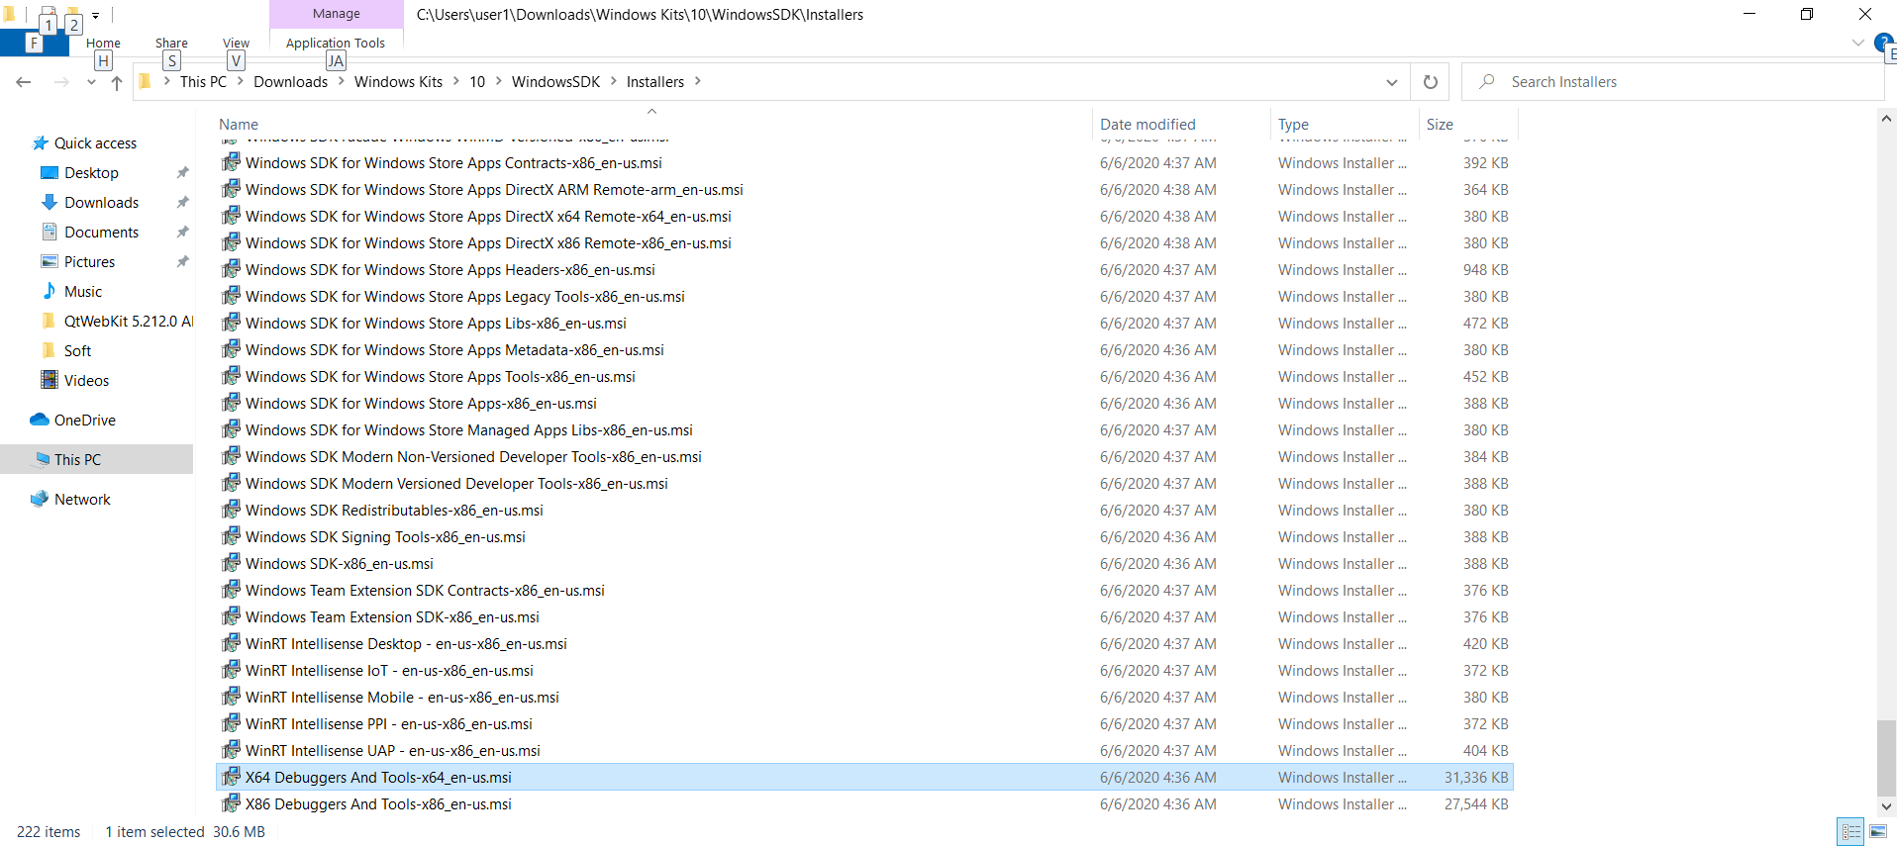

Installed:
X64 Debuggers And Tools-x64_en-us.msi

The debugger appeared:
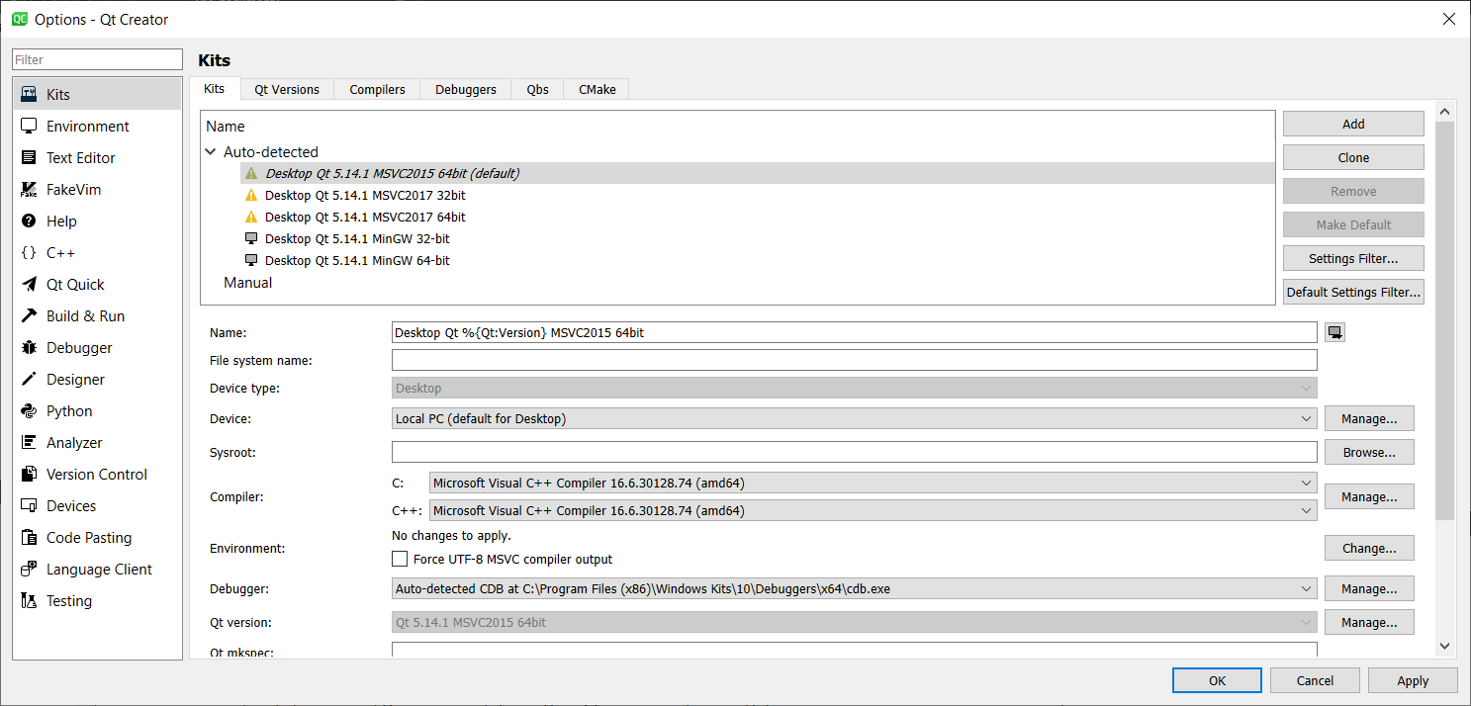

More details:
https://doc.qt.io/qtcreator/creator-debugger-engines.html#debugging-tools-for-windows

Debugging Tools for Windows
To use the CDB debugger, you must install the Debugging tools for Windows. You can download them from
Download and Install Debugging Tools for Windowsas part of the Windows SDK.

Note:Visual Studio does not include the Debugging tools needed, and therefore, you must install them separately.
In addition, you must select Qt Creator CDB Debugger Support (in Qt> Tools> Qt Creator) when you install Qt or the stand-alone Qt Creator.

AddingSymbol Server provided by Microsoft at symbol search path for Windows debuggers

Optional item.
To get debugging information for operating system libraries, for debugging Windows applications,
add the symbol server provided by Microsoft to the debugger symbol search path:

As a result of reading
https://docs.microsoft.com/en-us/windows-hardware/drivers/debugger/symbol-path
asked:
cache * C:\Users\user1\AppData\Local\Temp\QtCreator-l9Mfi9\symbolcache;srv*http: //msdl.microsoft.com/download/symbols

As in the example:
dbgcmdCopy
.sympath cache*c:\MySymbols;srv*https://msdl.microsoft.com/download/symbols

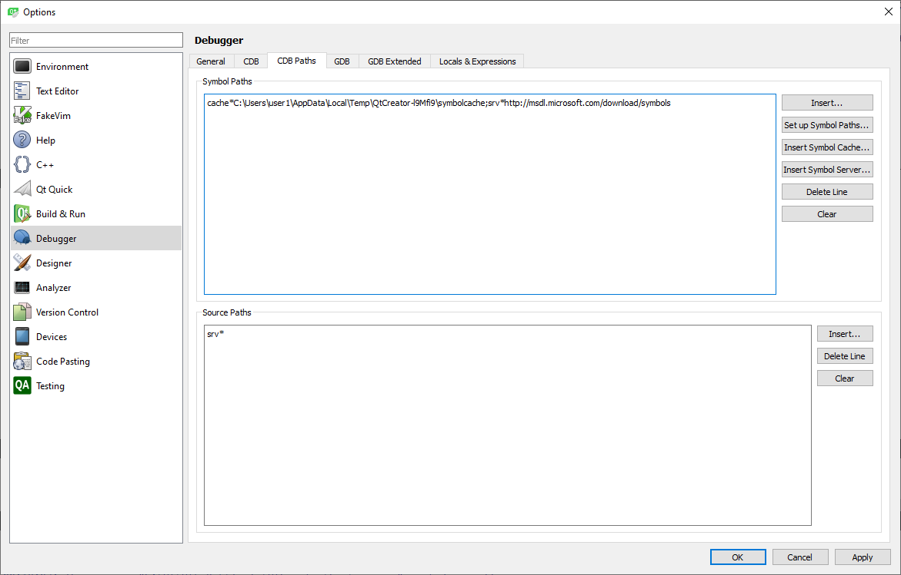

More details:
https://doc.qt.io/qtcreator/creator-debugger-engines.html#setting-cdb-paths-on-windows

Setting CDB Paths on Windows
To obtain debugging information for the operating system libraries for debugging Windows applications, add the Symbol Server provided by Microsoft to the symbol search path of the debugger:
- Select Tools> Options> Debugger> CDB Paths.
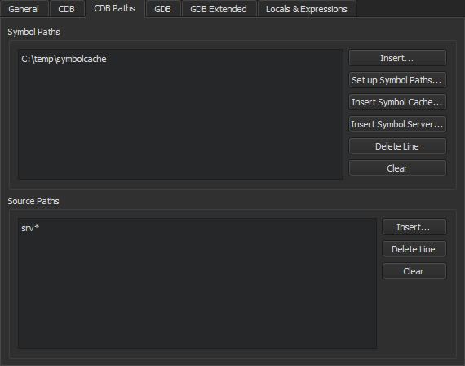
- In the Symbol Paths group, select Insert.
- Select the directory where you want to store the cached information.
Use a subfolder in a temporary directory, such asC: \ temp \ symbolcache...
- Select OK.
Note:Populating the cache might take a long time on a slow network connection.
To use the Source Server infrastructure for fetching missing source files directly from version control or the web, enter the following string in the Source Paths field:srv *...

Git
Installed Git
https://git-scm.com/download/win

