Fix encoding in Qt Creator console
If you are using a non-English version of Windows, Qt Creator has problems outputting krakozyabr.

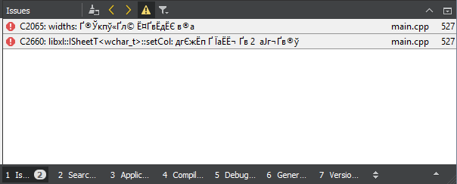

The people are exiled as they can (see links below) and one of the solutions for the Russian language is, for example, pasting the code below as is, without changes, into the pro file of the project.
The console encoding is inherited along with the console for all descendant processes.
If you specify an encoding for make, then all linker compilers should see it;
they have been writing to the console for many years, like in Unicode, just by default the encoding of the console is dosovskaya, so the transcoding into it takes place.

Trouble with Russian encoding in Qt Creator console
http://blog.mgsxx.com/?p=2979

QMAKE_EXTRA_TARGETS + = before_build makefilehook

makefilehook.target = $ (MAKEFILE)
makefilehook.depends = .beforebuild

PRE_TARGETDEPS + = .beforebuild

before_build.target = .beforebuild
before_build.depends = FORCE
before_build.commands = chcp 1251

Krakozyabry in the compiler output
https://forum.qt.io/topic/53122/krakozyabry-in-output-compiler

Build -> Run qmake
When you change the * .pro file, the collector itself will not update the files:
Makefile
Makefile.Release
Makefile.Debug

in the directory:
.. build-goldendict-Desktop_Qt_5_9_5_MSVC2015_64bit-Release

You need to run it yourself: Build -> Run qmake.

How to make qmake always rebuild a project from scratch when changing macros
https://habr.com/ru/post/182518/

Download sources

I downloaded the sources from:
https://github.com/goldendict/goldendict

git clone https://github.com/goldendict/goldendict.git

Also collected from different branches and tags. An example of an upload for the qt4x5 branch.
git clone --branch = qt4x5 https://github.com/goldendict/goldendict.git
or for example:
git checkout 1.5.0-RC2

Download libraries

Downloaded libraries from:
https://github.com/goldendict/goldendict#building-under-windows-with-ms-visual-studio

Building under Windows with MS Visual Studio
To build GoldenDict with Visual Studio take one of next library packs and unpack it to "winlibs/lib/msvc" folder in GoldenDict sources folder.
GoldenDict_libs_VS2013_x86_v4.7z- for MS Visual Studio 2013, 32 bit
GoldenDict_libs_VS2013_x64_v4.7z- for MS Visual Studio 2013, 64 bit
GoldenDict_libs_VS2015_x86_v4.7z- for MS Visual Studio 2015, 32 bit
GoldenDict_libs_VS2015_x64_v4.7z- for MS Visual Studio 2015, 64 bit

I also note that now www.mediafire.com, where these files are located, is blocked, at least by my provider in Russia, and they must be downloaded via VPN.

Launching Qt Creator
Before starting Qt Creator, you need to set environment variables for VS 2015.
Run command line via shortcut:
“VS2015 x64 Native Tools Command Prompt”
or
“VS2015 x86 Native Tools Command Prompt”, respectively for 32bit.
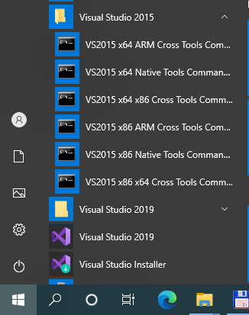
Then, in the command line that opens, run Qt Creator:
C:\Qt\Qt5.9.5\Tools\QtCreator\bin\qtcreator.exe

Errors when building the project

If you try to build from the master branch under Windows, you will have to overcome several errors.
They are listed below.
Collected under Qt 5.9 and Qt 5.14.1, no difference, here are examples for Qt 5.9.

Errors when building for MSVC2015

When building for MSVC2015, the following errors occurred.
Examples for assembly under 64 bit are given.

rc

Mistake:
'rc' is not recognized as an internal or external command

Searching for rc.exe gave the following result:
c:\Program Files (x86)\Windows Kits\10\bin\10.0.18362.0\arm64\rc.exe
c:\Program Files (x86)\Windows Kits\10\bin\10.0.18362.0\x64\rc.exe
c:\Program Files (x86)\Windows Kits\10\bin\10.0.18362.0\x86\rc.exe
c:\Program Files (x86)\Windows Kits\10\bin\10.0.19041.0\arm64\rc.exe
c:\Program Files (x86)\Windows Kits\10\bin\10.0.19041.0\x64\rc.exe

Changed Path variable to: Build Environment.

Was:
C:\Program Files (x86)\Microsoft Visual Studio 14.0\VC\BIN\amd64; C:\Windows\Microsoft.NET\Framework64\v4.0.30319; C:\Program Files (x86)\Microsoft Visual Studio 14.0\Common7\IDE; C:\Program Files (x86)\Microsoft Visual Studio 14.0\Common7\Tools; C:\Program Files (x86)\HTML Help Workshop; C:\Program Files (x86)\HTML Help Workshop; C:\Program Files (x86)\Windows Kits\10\bin\x64; C:\Program Files (x86)\Windows Kits\10\bin\x86; C:\Qt\Qt5.9.5\5.9.5\msvc2015_64\bin; C:\Program Files (x86)\Microsoft Visual Studio 14.0\VC\BIN\amd64; C:\Windows\Microsoft.NET\Framework64\v4.0.30319; C:\Program Files (x86)\Microsoft Visual Studio 14.0\Common7\IDE; C:\Program Files (x86)\Microsoft Visual Studio 14.0\Common7\Tools; C:\Program Files (x86)\HTML Help Workshop; C:\Program Files (x86)\Windows Kits\10\bin\x64; C:\Program Files (x86)\Windows Kits\10\bin\x86; C:\Windows\system32; C:\ Windows; C:\Windows\System32\Wbem; C:\Windows\System32\WindowsPowerShell\v1.0 \; C:\Windows\System32\OpenSSH \; C:\Program Files\Git\cmd; c:\Qt\Qt5.9.5\Tools\QtCreator\bin; C:\Users\user1\AppData\Local\Microsoft\WindowsApps;

Added directory:
c:\Program Files (x86)\Windows Kits\10\bin\10.0.19041.0\x64

containing:\10.0.19041.0\corresponding to my version: Microsoft Windows [Version 10.0.18363.1198],

Removed the directory:
C:\Program Files (x86)\Windows Kits\10\bin\x86;

Became:
C:\Program Files (x86)\Microsoft Visual Studio 14.0\VC\BIN\amd64; C:\Windows\Microsoft.NET\Framework64\v4.0.30319; C:\Program Files (x86)\Microsoft Visual Studio 14.0\Common7\IDE; C:\Program Files (x86)\Microsoft Visual Studio 14.0\Common7\Tools; C:\Program Files (x86)\HTML Help Workshop; C:\Program Files (x86)\HTML Help Workshop; C:\Program Files (x86)\Windows Kits\10\bin\x64; c:\Program Files (x86)\Windows Kits\10\bin\10.0.19041.0\x64; C:\Qt\Qt5.9.5\5.9.5\msvc2015_64\bin; C:\Program Files (x86)\Microsoft Visual Studio 14.0\VC\BIN\amd64; C:\Windows\Microsoft.NET\Framework64\v4.0.30319; C:\Program Files (x86)\Microsoft Visual Studio 14.0\Common7\IDE; C:\Program Files (x86)\Microsoft Visual Studio 14.0\Common7\Tools; C:\Program Files (x86)\HTML Help Workshop; C:\Windows\system32; C:\Windows; C:\Windows\System32\Wbem; C:\Windows\System32\WindowsPowerShell\v1.0 \; C:\ Windows\System32\OpenSSH \; C:\Program Files\Git\cmd; c:\Qt\Qt5.9.5\Tools\QtCreator\bin; C:\Users\user1\AppData\Local\Microsoft\WindowsApps;

For 32-bit, respectively:
C:\Program Files (x86)\Microsoft Visual Studio 14.0\Common7\IDE \; C:\Program Files (x86)\Microsoft Visual Studio 14.0\VC\BIN; C:\Program Files (x86)\Microsoft Visual Studio 14.0\Common7\Tools; C:\Windows\Microsoft.NET\Framework\v4.0.30319; C:\Program Files (x86)\HTML Help Workshop; C:\Program Files (x86)\HTML Help Workshop; C:\Program Files (x86)\Windows Kits\10\bin\x86; c:\Program Files (x86)\Windows Kits\10\bin\10.0.19041.0\x86; C:\Qt\Qt5.9.5\5.9.5\msvc2015\bin; C:\Program Files (x86)\Microsoft Visual Studio 14.0\VC\BIN; C:\Program Files (x86)\Microsoft Visual Studio 14.0\Common7\IDE \; C:\Program Files (x86)\Microsoft Visual Studio 14.0\VC\BIN; C:\Program Files (x86)\Microsoft Visual Studio 14.0\Common7\Tools; C:\Windows\Microsoft.NET\Framework\v4.0.30319; C:\Program Files (x86)\HTML Help Workshop; C:\Windows\system32; C:\Windows; C:\Windows\System32\Wbem; C:\ Windows\System32\WindowsPowerShell\v1.0 \; C:\Windows\System32\OpenSSH \; C:\Program Files\Git\cmd; c:\Qt\Qt5.9.5\Tools\QtCreator\bin; C:\Users\user1\AppData\Local\Microsoft\WindowsApps;

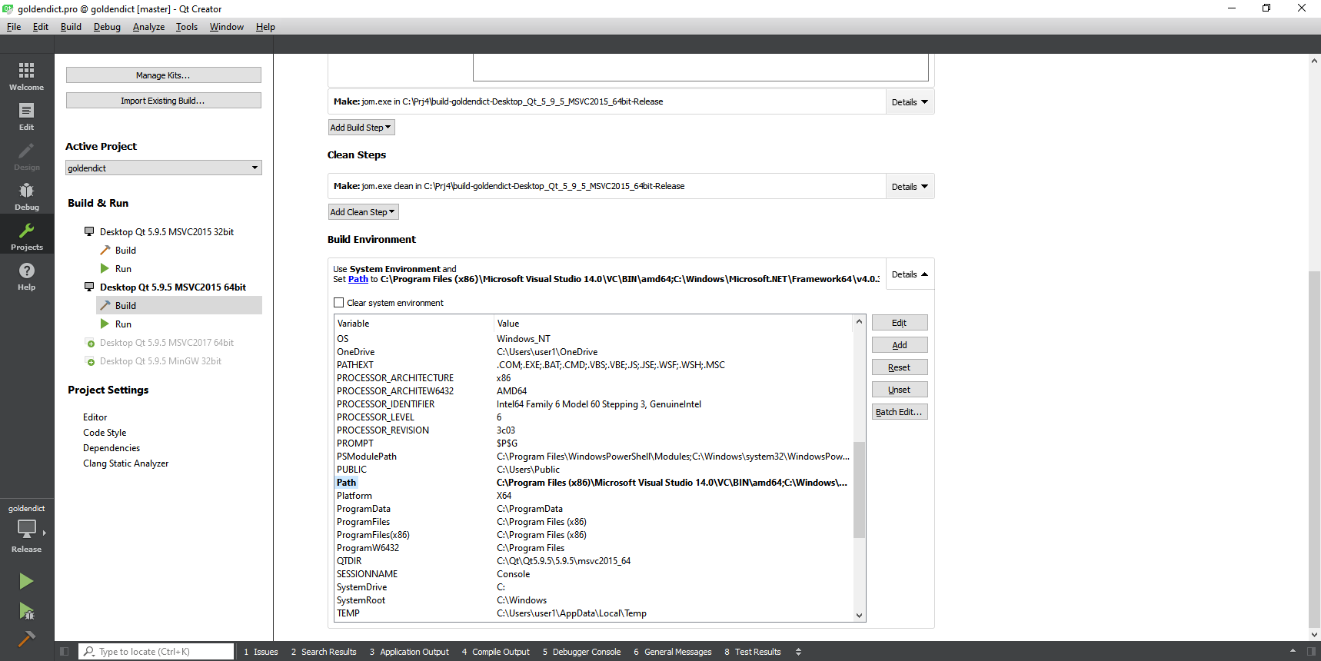

zstd

Mistake:
LINK: fatal error LNK1181: cannot open input file 'C:\Prj4orig\goldendict\winlibs\lib\msvc_2015\x64\zstd.lib'

File: zstd.lib, not included in: GoldenDict_libs_VS2015_x64_v4.7z, and other library files.

The answer to this error, Abs62, is below:

https://github.com/goldendict/goldendict/issues/1266
Abs62commentedon Jun 5
For build with MSVC just take static zstd library from https://github.com/facebook/zstd/releases(rename libzstd_static.lib to zstd.lib).

Those. can be downloaded fromhttps://github.com/facebook/zstd/releasesbinary library and rename libzstd_static.lib to zstd.lib.

But if, for example, download this version:

Zstd v1.4.5 Release Notes
zstd-v1.4.5-win32.zip1.28 MB
zstd-v1.4.5-win64.zip1.38 MB

then error messages are issued during assembly:
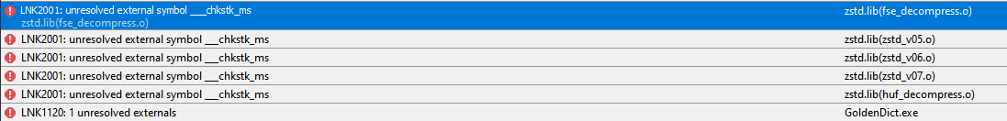

zstd.lib (fse_decompress.o): error LNK2001: unresolved external symbol ___chkstk_ms
zstd.lib (zstd_v05.o): error LNK2001: unresolved external symbol ___chkstk_ms
zstd.lib (zstd_v06.o): error LNK2001: unresolved external symbol ___chkstk_ms
zstd.lib (zstd_v07.o): error LNK2001: unresolved external symbol ___chkstk_ms
zstd.lib (huf_decompress.o): error LNK2001: unresolved external symbol ___chkstk_ms
release\GoldenDict.exe: fatal error LNK1120: 1 unresolved externals
jom: C:\Prj4\build-goldendict-Desktop_Qt_5_9_5_MSVC2015_64bit-Release\Makefile.Release [release\GoldenDict.exe] Error 1120
jom: C:\Prj4\build-goldendict-Desktop_Qt_5_9_5_MSVC2015_64bit-Release\Makefile [release] Error 2
22:35:10: The process "C:\Qt\Qt5.9.5\Tools\QtCreator\bin\jom.exe" exited with code 2.
Error while building / deploying project goldendict (kit: Desktop Qt 5.9.5 MSVC2015 64bit)
When executing step "Make"

I had to rebuild zstd myself from the source, and rename the resulting libzstd_static.lib to zstd.lib
In the MinGW version of the library, the lib prefix is ​​added to the library name, i.e .: libzstd.a

Another option is to drop support for the zim format.
Those. instead, you can remove: CONFIG + = zim_support in: goldendict.pro, which will disable support for dictionaries of this type, but remove the dependency on this library.

CONFIG (zim_support) {
DEFINES + = MAKE_ZIM_SUPPORT
LIBS + = -llzma -lzstd
}

no_ffmpeg_player

Mistake:
LNK1181: cannot open input file 'swresample-gd.lib'

or:
ffmpegaudio.obj: error LNK2019: reference to unresolved external symbol avcodec_parameters_to_context in function "public: bool __cdecl Ffmpeg :: DecoderContext :: openCodec (class QString &)" ( ? openCodec @ DecoderContext @ Ffmpeg @ @ QEAA )
ffmpegaudio.obj: error LNK2019: reference to unresolved external symbol avcodec_send_packet in function "public: bool __cdecl Ffmpeg :: DecoderContext :: play (class QString &)" ( ? play @ DecoderContext @ Ffmpeg @ @ QEAA_NAEAVQString )
ffmpegaudio.obj: error LNK2019: unresolved external reference to the symbol in the function avcodec_receive_frame "the public: bool __cdecl Ffmpeg DecoderContext :: ::-play (class a QString &)" ( -play DecoderContext @? @ Ffmpeg @ @ QEAA_NAEAVQString @ @@ the Z)
debug\GoldenDict.exe: fatal error LNK1120: Unresolved External Items: 3

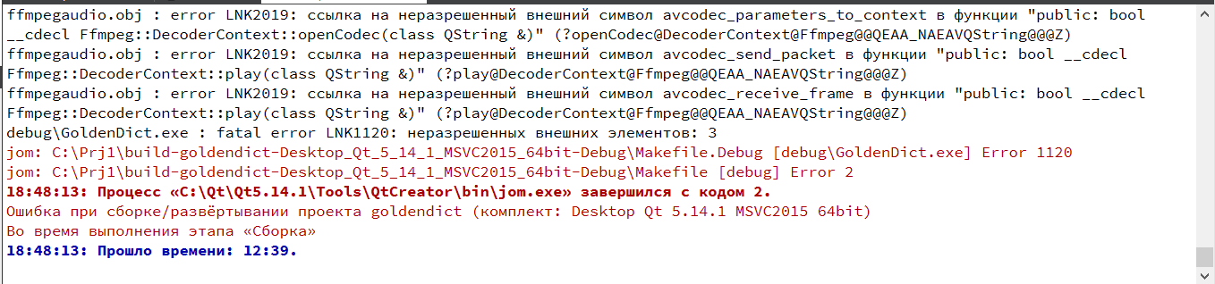

I have disabled support for ffmpeg player:
"CONFIG + = no_ffmpeg_player"
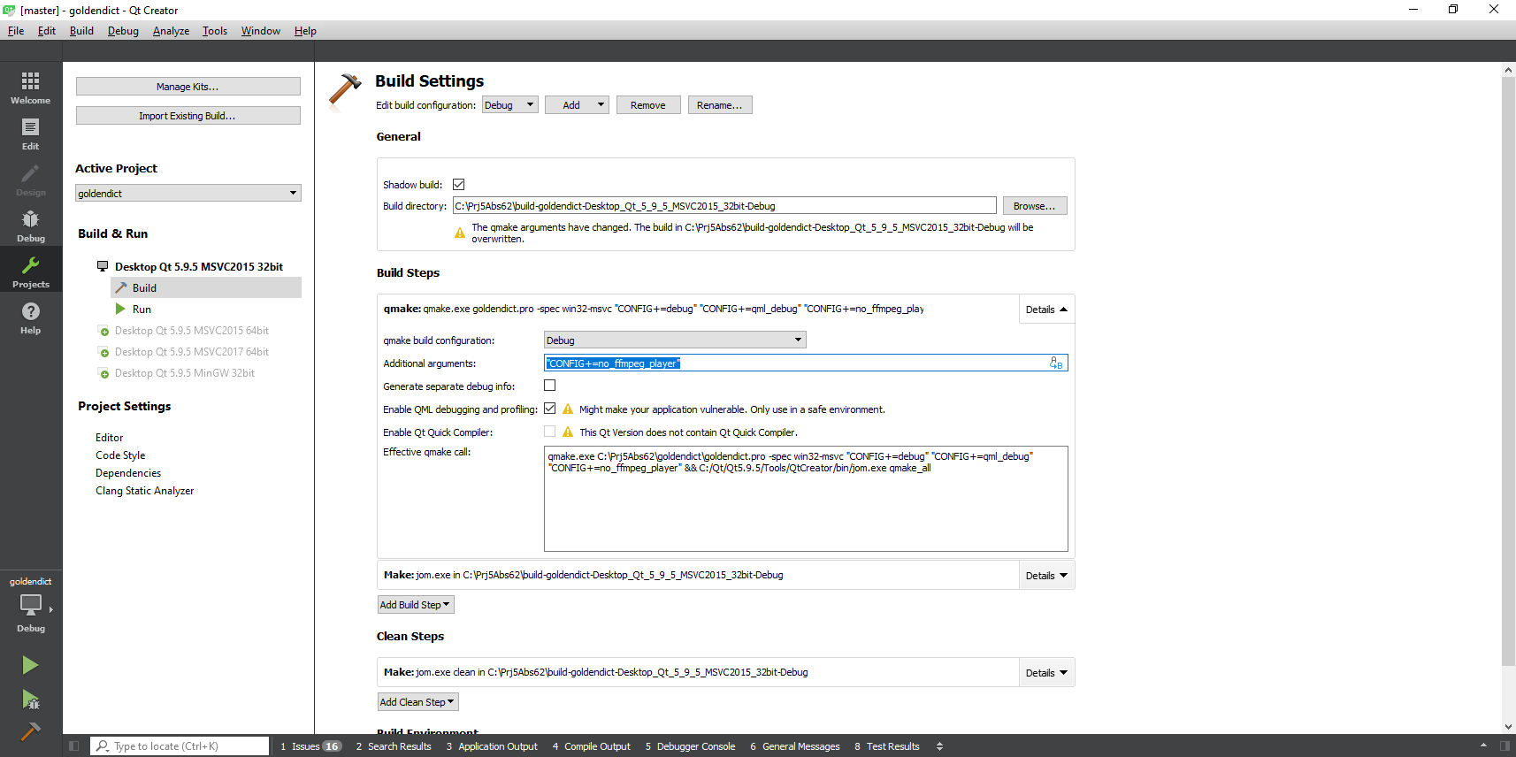

Abs62's answer to this error is below.
http://forum.ru-board.com/topic.cgi?forum=5&active=&topic=49149&start=2180
Quote:
How can ffmpeg be added?
Replace the ffmpeg header files in "winlibs\include" with the ones from ffmpeg 3.0.1, then the existing libraries should be fine. Or build ffmpeg 4.2.1 yourself under msvc.

Downloaded: FFmpeg 3.0.12 "Einstein" from:
https://ffmpeg.org/olddownload.html
https://ffmpeg.org/releases/ffmpeg-3.0.12.tar.gz
Moved the following old directories to another directory and copied the new ones from the downloaded archive to "winlibs\include":
libavcodec
libavformat
libavutil
libswresample

An error occurred during assembly:
ffmpegaudio.cc
c:\prj4orig\goldendict\winlibs\include\libavutil\common.h (45): fatal error C1083: Cannot open include file: 'libavutil/avconfig.h': No such file or directory
jom: C:\Prj4orig\build-goldendict-Desktop_Qt_5_9_5_MSVC2015_64bit-Release\Makefile.Release [build\ffmpegaudio.obj] Error 2

Copied the file: ..\winlibs\include\libavutil\avconfig.h, from the old directory.

But the assembly again gave an error:
LINK: fatal error LNK1181: cannot open input file 'swresample-gd.lib'

Those. advice: “Replace the ffmpeg header files in" winlibs\include "with similar ones from ffmpeg 3.0.1, then the existing libraries should work.”, did not help me.

"Or build ffmpeg 4.2.1 yourself for msvc"
I didn't compile ffmpeg 4.2.1 for Windows. the sound still works through Qt Multimedia.
But this, apparently, can be done according to the instructions:
https://trac.ffmpeg.org/wiki/CompilationGuide/MinGW
https://www.cyberforum.ru/cpp-beginners/thread2039983.html

Errors when building under MinGW
The assembly was carried out under MinGW 32-bit.
I managed to collect by adding flags: "CONFIG + = old_hunspell" "CONFIG + = no_chinese_conversion_support"
Without them, the following errors were issued.

old_hunspell

Mistake:
./build\hunspell.o: In function `run ':
C:\Prj4orig\build-goldendict-Desktop_Qt_5_9_5_MinGW_32bit-Debug /../ goldendict / hunspell.cc: 274: undefined reference to `Hunspell :: spell (std :: __ cxx11 :: basic_string <char, std :: char_traits <char> , std :: allocator <char>> const &, int *, std :: __ cxx11 :: basic_string <char, std :: char_traits <char>, std :: allocator <char>> *) '
C:\Prj4orig\build-goldendict-Desktop_Qt_5_9_5_MinGW_32bit-Debug /../ goldendict / hunspell.cc: 286: undefined reference to `Hunspell :: suggest (std :: __ cxx11 :: basic_string <char, std :: char_traits <char> , std :: allocator <char>> const &) '
./build\hunspell.o: In function `suggest ':
C:\Prj4orig\build-goldendict-Desktop_Qt_5_9_5_MinGW_32bit-Debug /../ goldendict / hunspell.cc: 508: undefined reference to `Hunspell :: analyze (std :: __ cxx11 :: basic_string <char, std :: char_traits <char> , std :: allocator <char>> const &) '
./build\hunspell.o: In function `run ':
C:\Prj4orig\build-goldendict-Desktop_Qt_5_9_5_MinGW_32bit-Debug /../ goldendict / hunspell.cc: 668: undefined reference to `Hunspell :: spell (std :: __ cxx11 :: basic_string <char, std :: char_traits <char> , std :: allocator <char>> const &, int *, std :: __ cxx11 :: basic_string <char, std :: char_traits <char>, std :: allocator <char>> *) '
collect2.exe: error: ld returned 1 exit status

Added by:
"CONFIG + = old_hunspell"
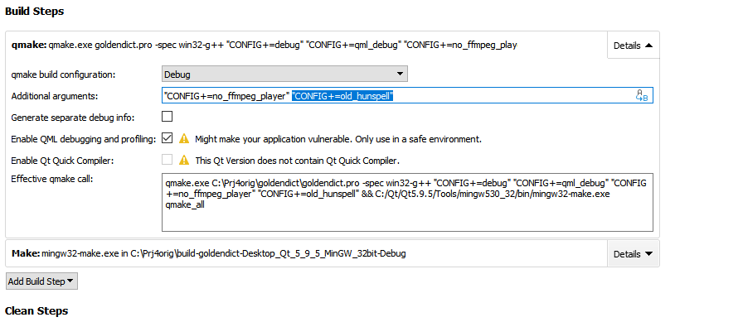

no_chinese_conversion_support
Mistake:
.../build\chinese.o: In function `ZN7Chinese29CharacterConversionDictionaryC2ERKNSt7__cxx1112basic_stringIcSt11char_traitsIcESaIcEEES8_5QIconRK7QString ':
C:\Prj4orig\build-goldendict-Desktop_Qt_5_9_5_MinGW_32bit-Debug /../ goldendict / chinese.cc: 53: undefined reference to `_imp___ZN6opencc15SimpleConverterC1ERKNSt7__cxx1112basic_stringIcEEcEEcES
./build\chinese.o: In function `ZN7Chinese29CharacterConversionDictionary20getAlternateWritingsERKNSt7__cxx1112basic_stringIjSt11char_traitsIjESaIjEEE ':
C:\Prj4orig\build-goldendict-Desktop_Qt_5_9_5_MinGW_32bit-Debug /../ goldendict / chinese.cc: 97: undefined reference to `_imp___ZNK6opencc15SimpleConverter7ConvertERKNSt7__cxx1112basic_stringIcES '
collect2.exe: error: ld returned 1 exit status

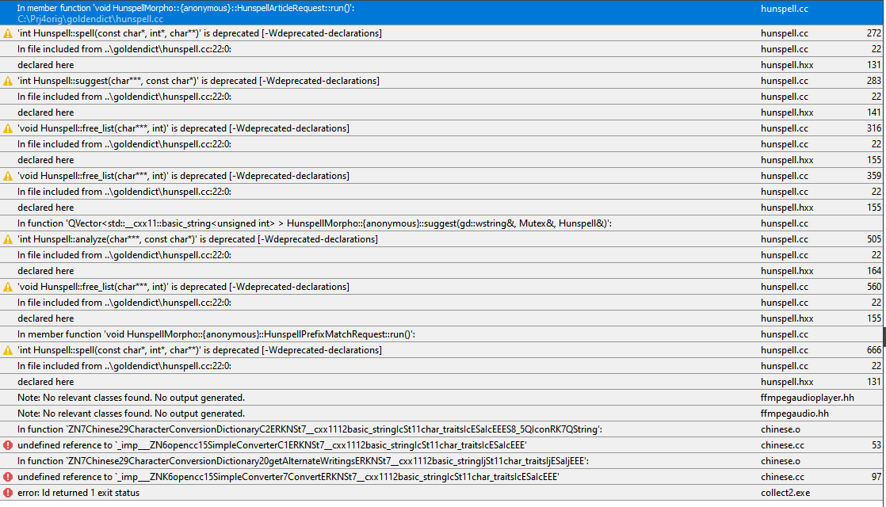

After adding: "CONFIG + = no_chinese_conversion_support" and Rebuild, everything is assembled.
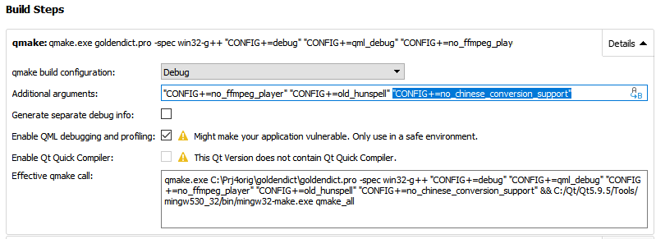

In this assembly, DSL dictionaries are indexed at startup.

Build dependencies
To run GoldenDict outside of Qt Creator, you need to collect all the libraries necessary for its operation.

First we pull the libraries using windeployqt.

Go to the directory with GoldenDict.exe.
We execute the command:

windeployqtGoldenDict.exe

After that, copy the GoldenDict libraries from:
..\winlibs\lib\msvc

Copy the libraries that windeployqt did not pull:
c:\Program Files (x86)\Windows Kits\10\bin\10.0.19041.0\x64\ucrt\ucrtbased.dll
c:\Qt\Qt5.9.5\5.9.5\msvc2015_64\bin\libxml2.dll
c:\Qt\Qt5.9.5\5.9.5\msvc2015_64\bin\libxslt.dll

You can enable the output of messages to the log file using: --log-to-file.

The error logging mode is enabled by running GoldenDict with the "--log-to-file" switch. In this case GoldenDict creates a file "gd_log.txt" in its configuration folder,
which will record various warnings, debug messages and error messages.
If such a key is not specified, messages will be output to the console (under Linux and MacOS) or ignored (under Windows).

Startup errors

Errors with MDX dictionaries
When launching Goldendict from 32bit version, an error message is displayed:
Vector <T> too long

MdictParser: open C:\GoldenDict\GoldenDict_Dicts\En-En\Longman\En-En-Longman_DOCE6\longman_dictionary_of_contemporary_english_6th_edition.mdx

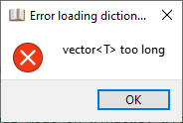

When starting from the 64bit version, another error message is displayed:
bad allocation.

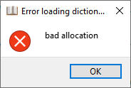

The following messages are displayed in the console:
MDict: Building the index for dictionary: C:\GoldenDict\En-En-Longman_DOCE6\longman_dictionary_of_contemporary_english_6th_edition.mdx
MdictParser: open C:\GoldenDict\En-En-Longman_DOCE6\longman_dictionary_of_contemporary_english_6th_edition.mdx

In the version from nonwill there are 2 more messages:
MDict: Building the index for dictionary: C:\GoldenDict\En-En-Longman_DOCE6\longman_dictionary_of_contemporary_english_6th_edition.mdx
MdictParser: open C:\GoldenDict\En-En-Longman_DOCE6\longman_dictionary_of_contemporary_english_6th_edition.mdx
87220 entires made
Building a tree of 296 elements

As a result, a window appears with an error: bad allocation, and Issues displays:
f:\dd\vctools\crt\vcstartup\src\heap\throw_bad_alloc.cpp: 34: warning: Debugger encountered an exception: Exception at 0x7ffdfdd83e49, code: 0xe06d7363: C ++ exception, flags = 0x1 (execution cannot be continued) (first chance)

For some reason, in the 32bit version this message is not displayed in Issues.

Errors with DSL dictionaries in the nonwill version
Examples of errors issued by Goldendict compiled from the nonwill repository when running under debug - Build configuration: Debug.
DSL and MDX dictionaries are not indexed, but at least they connect and work at startup.
True, at the same time, various errors are poured:

For some reason, when the project is built under Build configuration: Release, everything works.

main.cc:243
Debugging starts
mincore\com\oleaut32\dispatch\ups.cpp (2122)\OLEAUT32.dll! 00007FFE001A95F6: (caller: 00007FFE001A8A09) ReturnHr (1) tid (298c) 8002801D Library not registered.
mincore\com\oleaut32\dispatch\ups.cpp (2122)\OLEAUT32.dll! 00007FFE001A95F6: (caller: 00007FFE001A8A09) ReturnHr (2) tid (298c) 8002801D Library not registered.

Exception at 0x7ffdfdd83e49, code: 0xe06d7363: C ++ exception, flags = 0x1 (execution cannot be continued) (first chance) at c:\prj3\goldendict_nonwill_1.5.0-2019\main.cc: 243

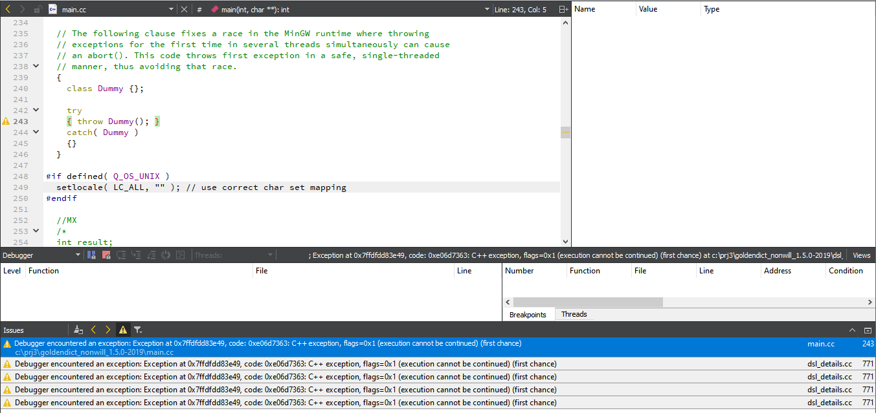

dsl_details.cc:771

Exception at 0x7ffdfdd83e49, code: 0xe06d7363: C ++ exception, flags = 0x1 (execution cannot be continued) (first chance) at c:\prj3\goldendict_nonwill_1.5.0-2019\dsl_details.cc: 771

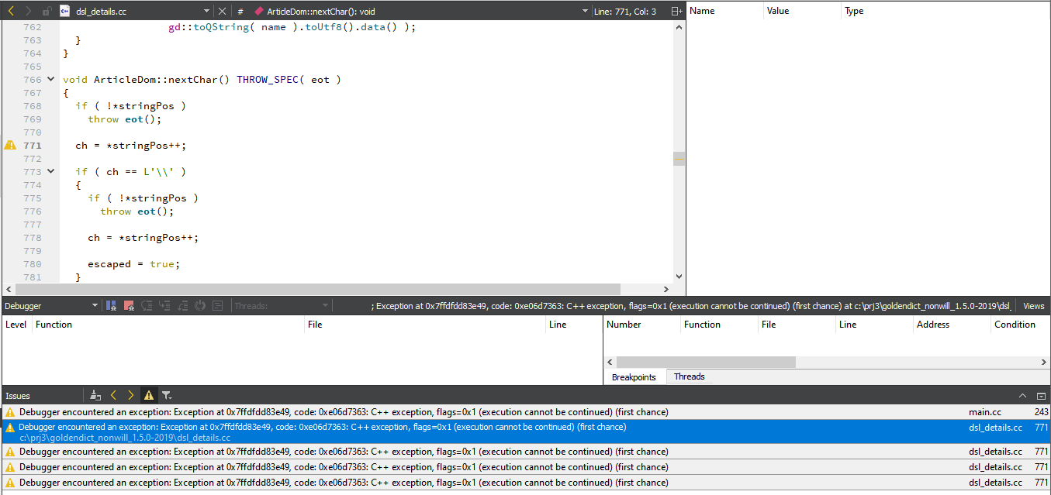

Errors in English Wikipedia, when displaying a dictionary entry

English Wikipedia returns an error when displaying a dictionary entry:
Query error: XML parse error: unexpected end of file at 1,1

Well, the following messages are also issued. I don't know what they can influence.

LINK: warning LNK4098

LINK: warning LNK4098: defaultlib 'MSVCRT' conflicts with use of other libs; use / NODEFAULTLIB: library
LINK: warning LNK4098: defaultlib 'LIBCMT' conflicts with use of other libs; use / NODEFAULTLIB: library

How to fix this warning?

OLEAUT32.dll! 00007FFE001A95F6
Debugging starts
mincore\com\oleaut32\dispatch\ups.cpp (2122)\OLEAUT32.dll! 00007FFE001A95F6: (caller: 00007FFE001A8A09) ReturnHr (1) tid (ddc) 8002801D Library not registered.
mincore\com\oleaut32\dispatch\ups.cpp (2122)\OLEAUT32.dll! 00007FFE001A95F6: (caller: 00007FFE001A8A09) ReturnHr (2) tid (ddc) 8002801D Library not registered.

Perhaps these messages are related to a bug:
https://bugreports.qt.io/browse/QTBUG-63789

Is there any way to fix this problem?

