**HOME**

……….is an online platform to sell your Trash, helping the society to recycle more of their waste by enabling the informal recycle sector.

Do you want to earn some cash/donate for a cause by selling all your Trash through online? If yes you’re at the right place. We want to use resources more sustainably for a healthy, clean community and to bring more dignity to the recycling profession.

At ……………. you can sell your trash and other unused materials in just a few clicks and get handsome money, coupons or donate for a cause by selling your trash that other kabadiwala cannot offer you.

…………….. ensure that the trash remain properly segregated and don’t ends up in landfills.If you have collected paper, books & magazines, plastics, cardboards or household items in your house, offices or any corporate houses. Then you don’t need to strain yourself in search of kabadiwala to sell your trash or unused stuff.

You can do it from your home/office in an easy and convenient way. Sell your trash and other unused items directly from our website.

**SCHEDULE PICKUP**

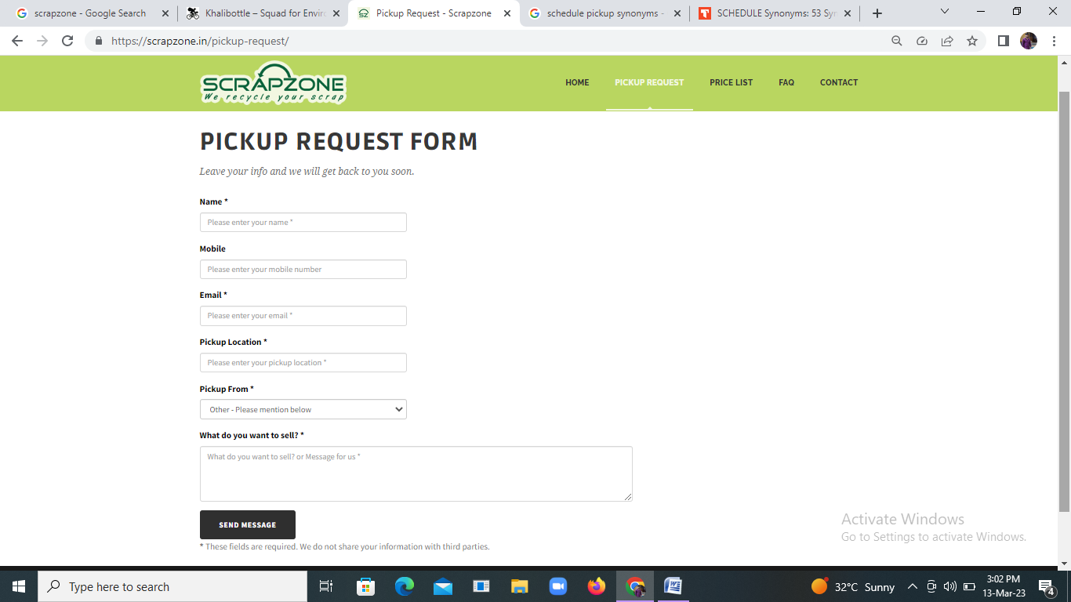

**PRICE LIST**

<https://scrapzone.in/price-list/>

**CONTACT**

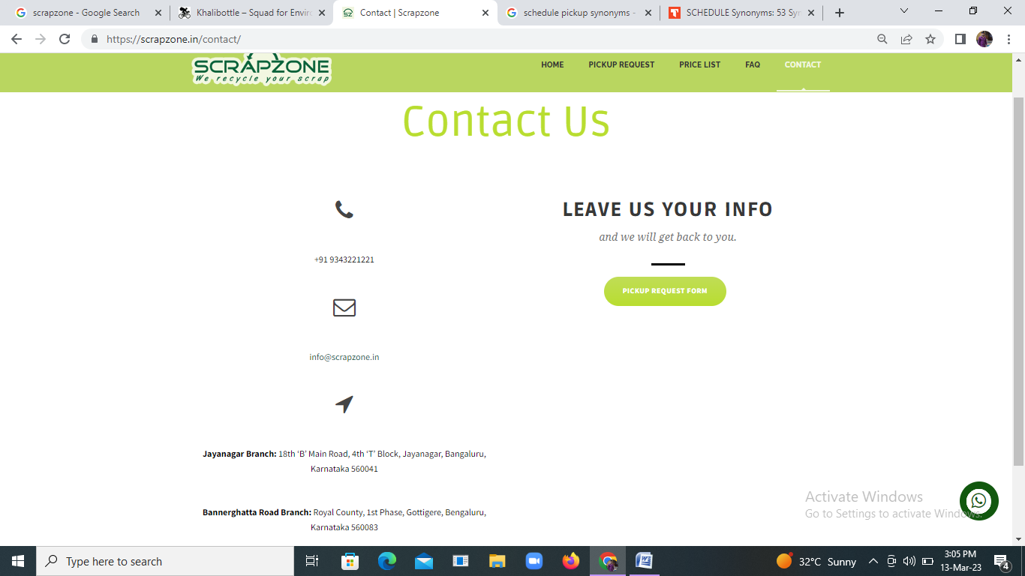

REFER THE FOLLOWING WEBSITE FOR FURTHER

<https://khalibottle.net/>

<https://scrapzone.in/>