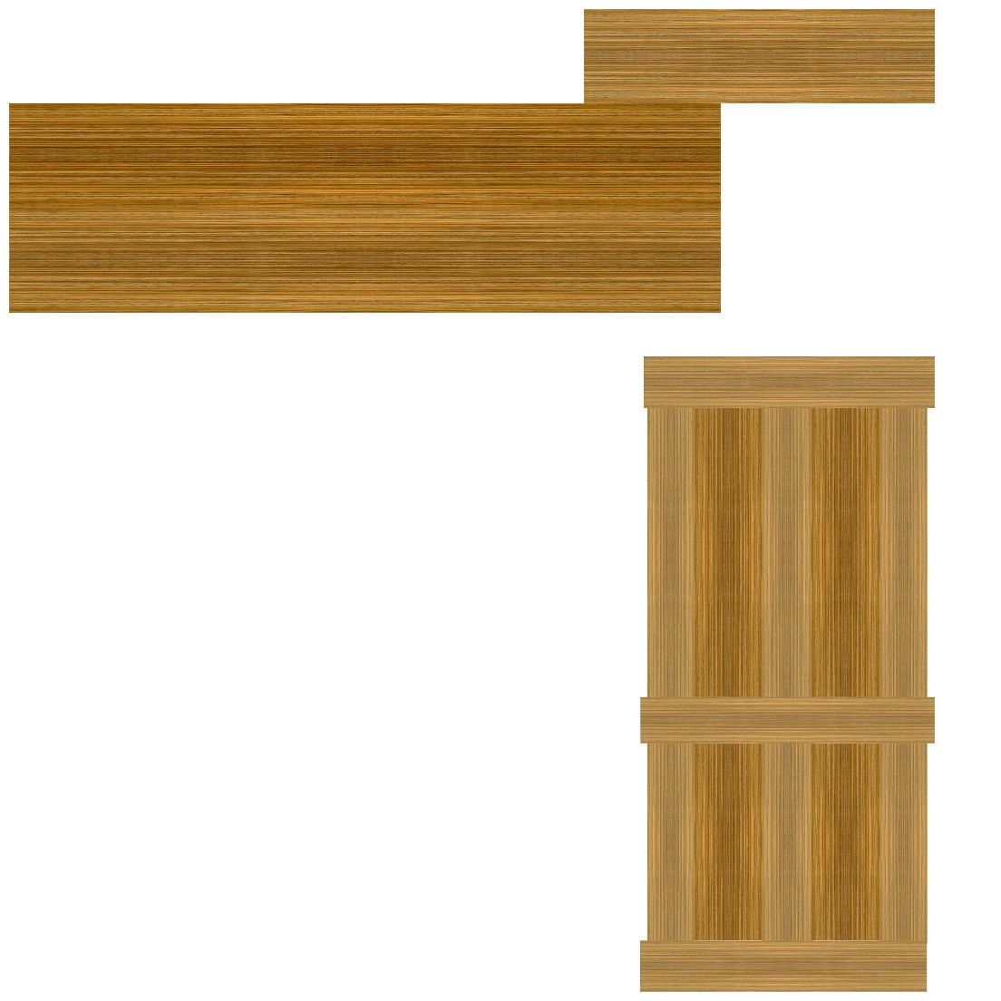The wood effect used on the doors was originally an image from a google search for “Zebrano Wood” and was on the web page ‘woodworkingnetwork.com’ tiled by four with two lines of symmetry and added to the UVout.png for my door model, and varied in colour by changing the values in levels to starting (dark) values of 56, 41 and 0, from lightest to darkest. All processes mentioned done using Photoshop.

I could use improvement on my skills with photoshop among other apps in the adobe creative suite.

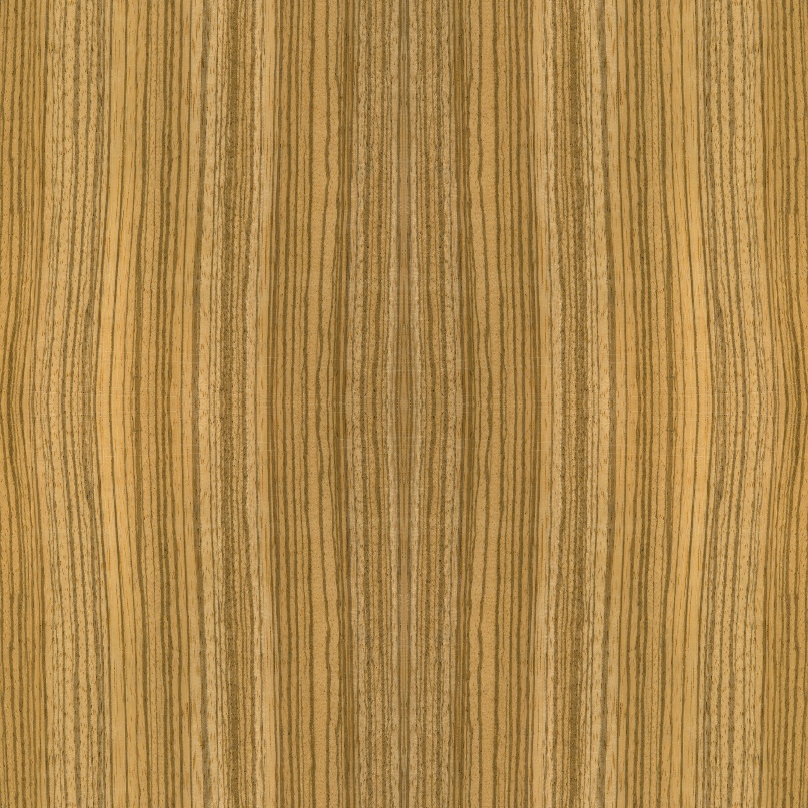

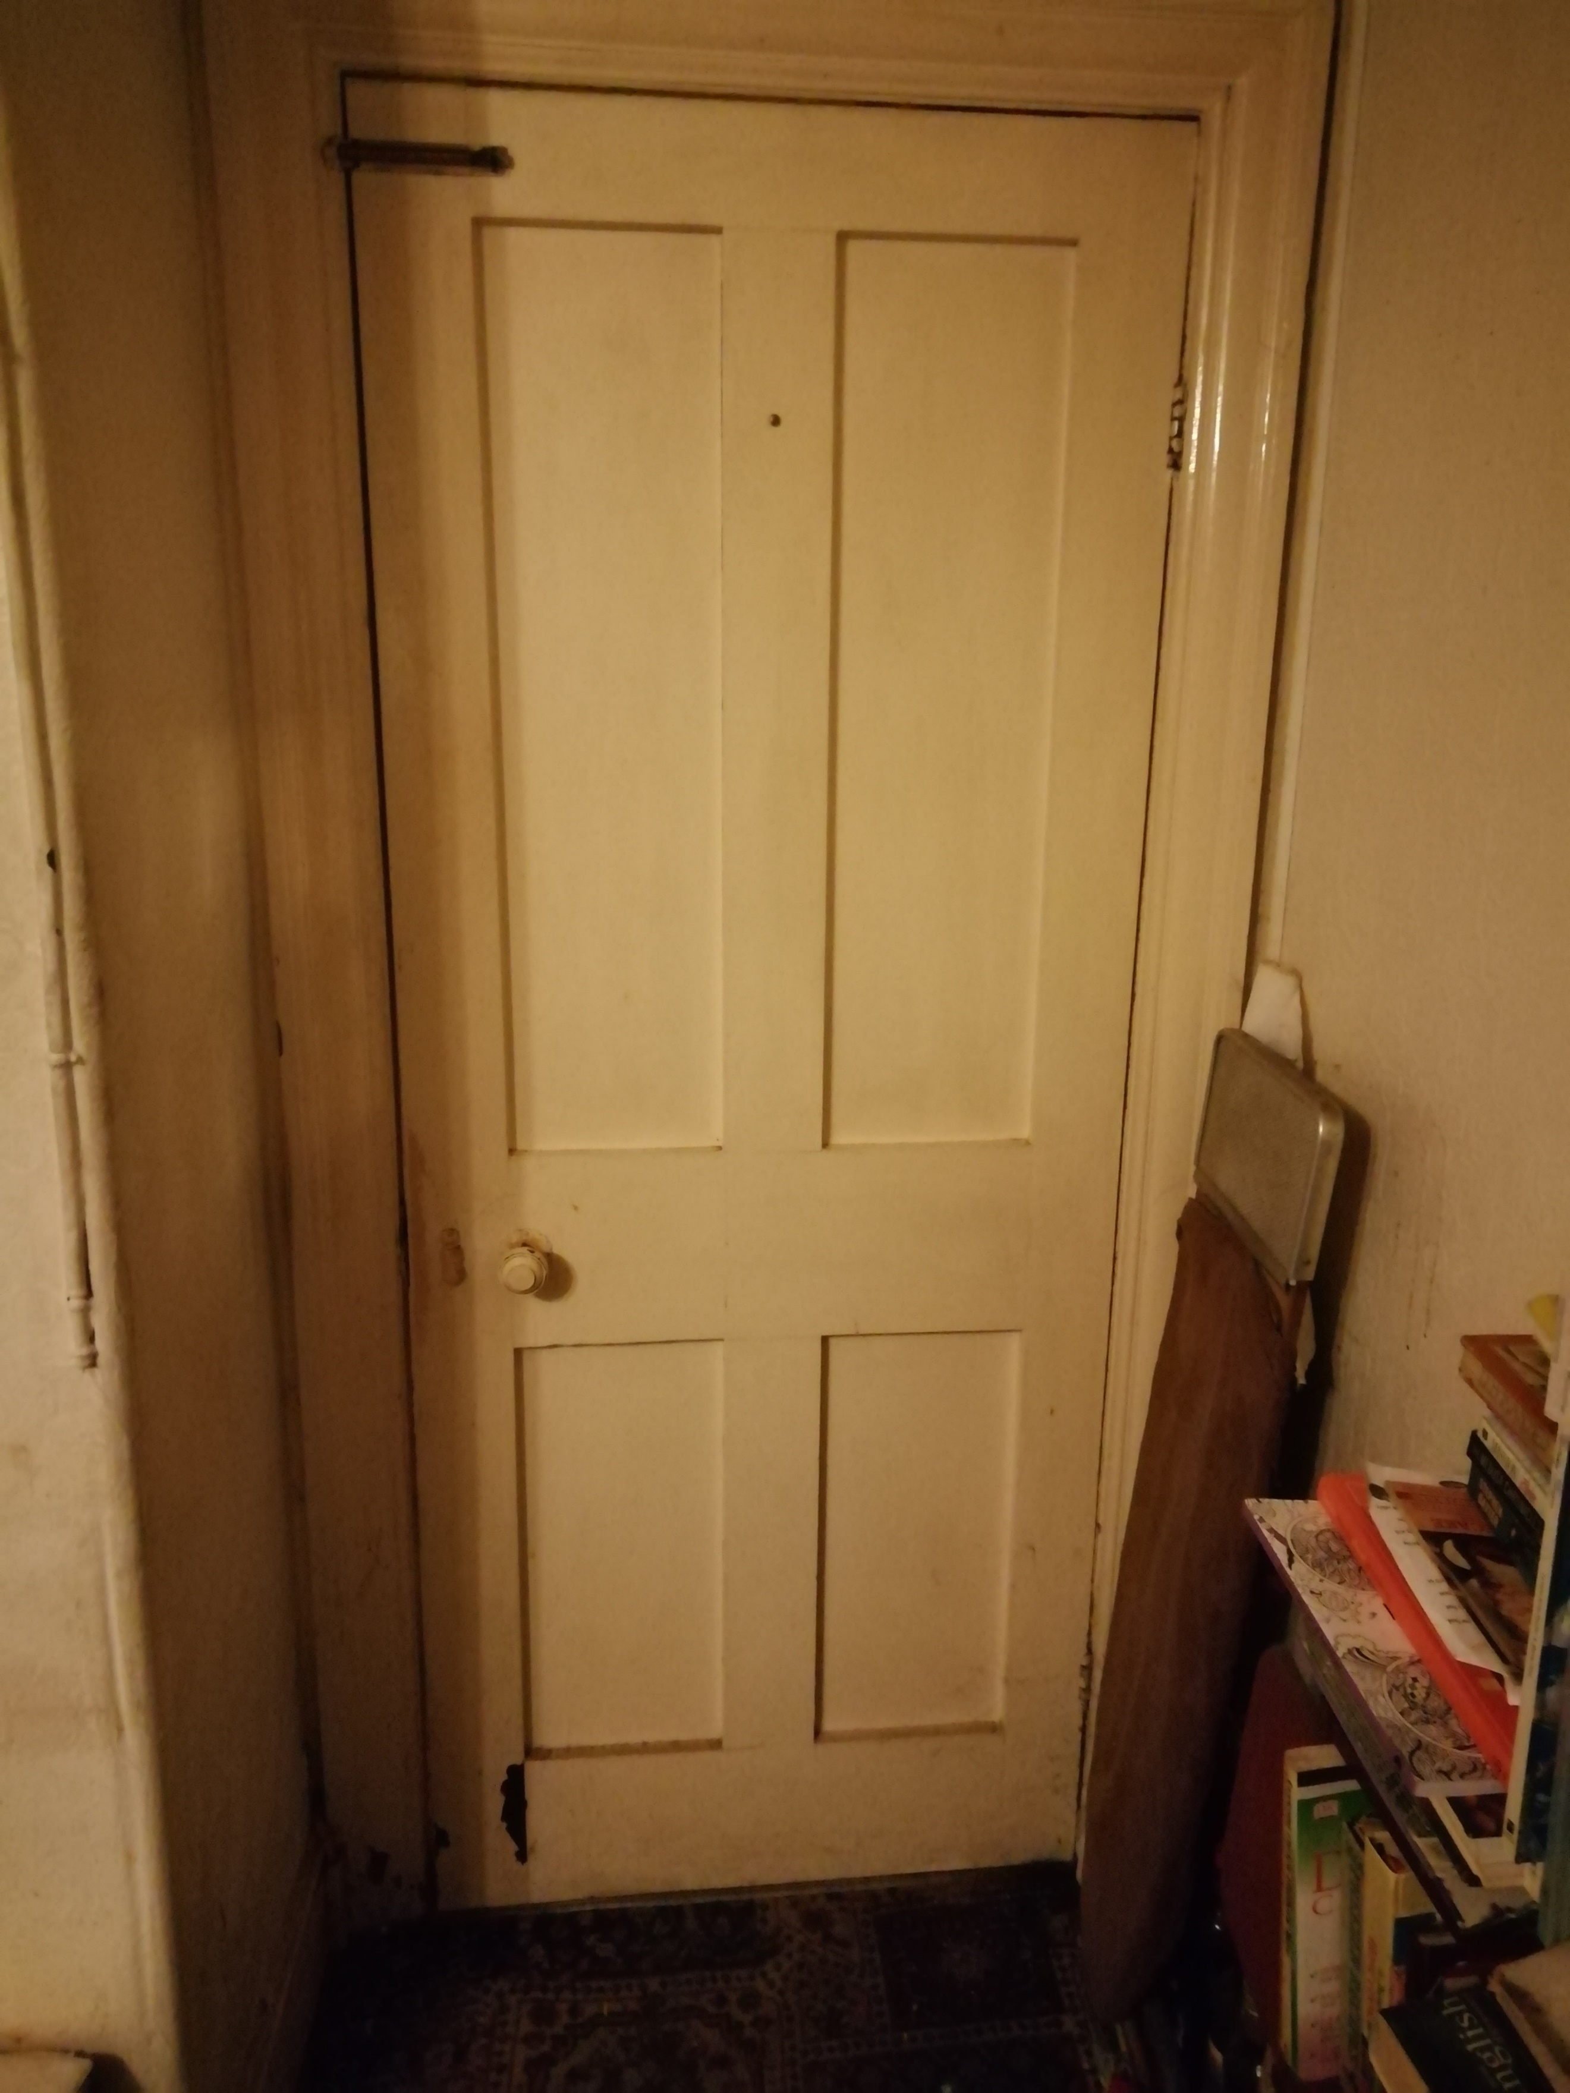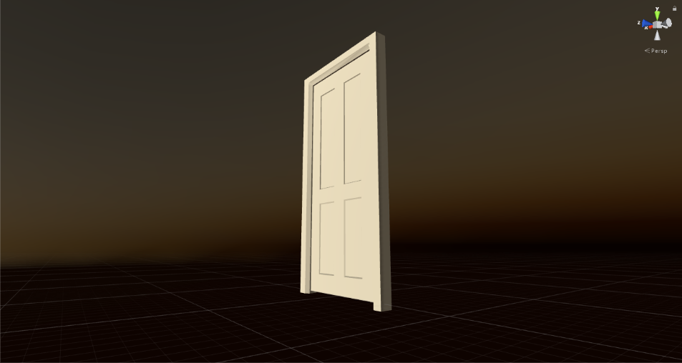The model (below, right) and UV Guide for the door were created in Maya on the University macs. References from google on old Victorian-style Panel Doors was used, as well as images of doors in my home (below left). I found the Modelling of the Door fairly easy, but UV creation is something that I will improve on as I continue this course.