MMAN2300 – T2 2022

Vibration Individual Laboratory Assignment

ASSIGNMENT DUE: Friday 5 August, 5pm (Sydney time)
MOTIVATIONS AND AIM OF THE ASSIGNMENT
This assignment simulates (despite a series of necessary simplifications) a vibration case study in which you need to apply the vibration engineering knowledge that you have acquired so far in the course. In particular, the virtual lab simulates a case study in which you have to use your:
- SDOF-free-vibration knowledge to identify key system parameters (system identification)
- SDOF-forced-vibration knowledge to analyse vibration caused by rotating unbalance
This assignment is authentic in the sense that the report you have to write mimics (with some simplifications) tasks found in real vibration-analysis applications.
The key takeaways of this assignment are:
- Learn how to use impulsive tests and constant-speed tests to analyse the vibratory characteristics of a rotating machine
- Relate free-vibration tests with forced-vibration responses on the same machine, understanding which aspects show across all tests and allow validating observations done on each singularly
- Understand how important quantities are extracted from vibration signals
- Understand how vibration measurements relate to theoretical diagrams in time/frequency domain

STUDENT DETAILS

Steven Watts
z5204987
GENERAL INSTRUCTIONS
To complete this assignment:

- Read the detailed description of the case study and the tasks outlined in the next pages of this document.
- Run the virtual lab program “MMAN2300_2022T2_Lab2” to obtain the data you need.
- Complete your report using the template available in this document.
- Save your completed assignment as a pdf and submit it using the provided link on Moodle.

When using the Matlab pcode simulator “MMAN2300_2022T2_Lab2” to obtain your data. You must use your zID to run the simulated experiments.
This report template can be completed in handwriting or typing. All parts must be completed to achieve full mark. Use the space provided in the boxes of this document to report your answers (try not to exceed the space). If you are typing, an 11 points Times New Roman font is suggested. If you are handwriting your answer, it is your responsibility to ensure their legibility. Illegible answers will receive zero marks, whereas untidy works will result in a reduced mark. For diagrams, you can use any software you like (e.g. Matlab or Excel), or draw the diagrams by hand, but always ensuring high quality diagrams including correct scaling.

SITUATION DESCRIPTION
You work for the vibration-analysis department of a large company, who serves a series of production sites. This is your first assignment after your training and apprenticeship and you are now tasked with an independent analysis. The following is the email you have received from the chief of your department.

EMAIL RECEIVED FROM THE CHIEF OF YOUR DEPARTMENT
From: Chief – Vibration analysis department
Subject: Urgent vibration analysis
Hi,
As I mentioned to you earlier on the phone, you need to complete part of a vibratory analysis of a newly installed wind turbine. They need a green light from us and I must have a full report using the form attached (below) before they can start normal operation. You are tasked with the analysis of the lateral vibration of the turbine.
Under the assumption of imbalance forces with a frequency below 20 r.p.m., the system can be modelled as SDOF. The turbine can only operate within the range 5-20 r.p.m. and our modelling group suspect the possibility of a resonance in this range. A significant residual unbalance in the rotor is likely. The system’s equivalent mass for such SDOF model is estimated at about 350 tonnes (metric tons).
Unfortunately, due to the remoteness of the site, we are unable to send you or anyone from our department to take the measurements and we must rely on the local operators. You are able to communicate with the crew on site via email to request the execution of impact tests or constant speed acquisitions. The local crew will try to execute the tests you request as well as possible, but remember that they are not vibration experts. Make sure that you analyse all the results forwarded to you from the site carefully, before drawing your conclusions and providing your recommendations.
I know it’s your first independent task, but I am confident you can do a fantastic job!
Best regards
Chief

REPORT TEMPLATE
Part 1. Free-vibration and system identification
Based on an impulsive test, estimate the damping ratio and undamped natural frequency of the system. Report a screenshot of your decay, with annotations indicating all the quantities you have extracted from the graph. Also, report all the calculation steps to obtain the final answers and write a justification for any choice you have taken in your methodology.
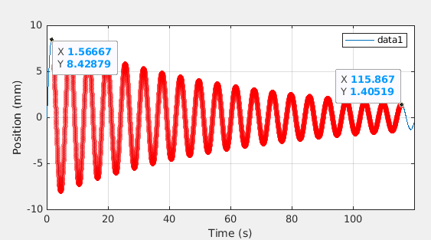
Calculations here  19 Oscillations, N = 19  y_1 = 8.429 mm  y_20 = 1.405 mm  t_1 = 1.567 s  t_20 = 115.9 s  write equations properly here  delta = 0.09429  1.044 rad/s | Discussion of any choice here
Undamped natural frequency = 1.044 rad/s | Damping ratio = 0.01500 (1.5%)

Part 2. Forced vibration analysis and comparison with free-vibration
Obtain a series of 6 steady-state responses for different speeds. In your choice of the nominal angular speeds, consider that you want to verify the steady-state vibration amplitude of your system in the relevant frequency range, i.e. validate information you have obtained in Part 1. Keep in mind that the nominal speed you input is sent to the speed controller of the turbine, but the speed controller could be subject to small but non-negligible errors, thus the actual speed might be different from the requested nominal value. Also, discuss your choice of speeds, based on what you have observed in Part 1.

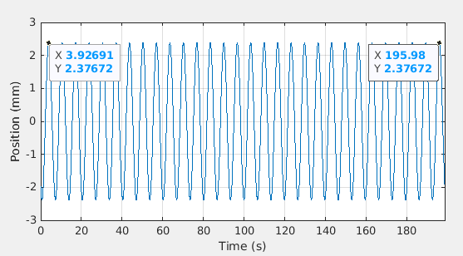
Part 2A. Report your time domain screenshots for steady-state responses and annotate the graphs, identifying as many relevant quantities as possible.
Angular speed = 5 RPM

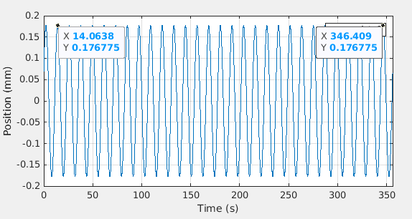
Angular speed = 9 RPM
Angular speed = 11 RPM

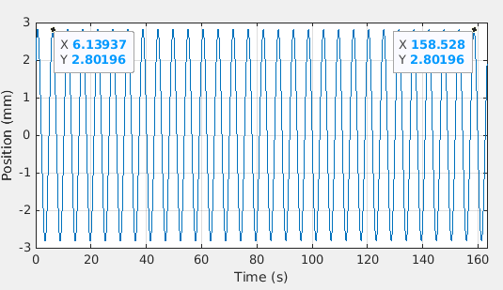
Angular speed = 15 RPM

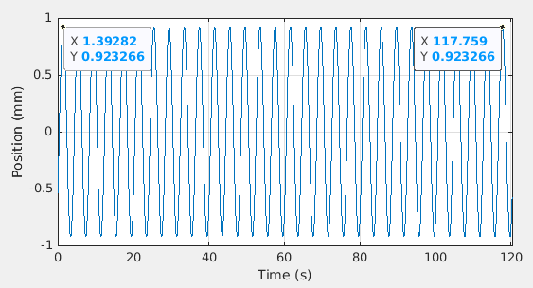

Angular speed = 18 RPM

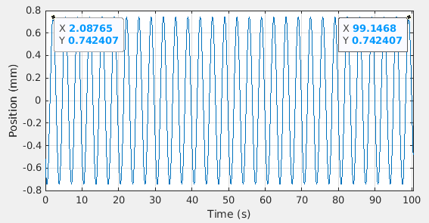

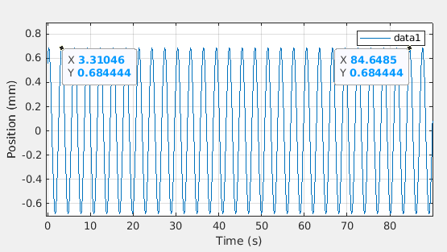
Angular speed = 20 RPM
Part 2A (continued) Place the discussion justifying your choice of angular speeds and any supporting calculations here

Part 2B. Briefly discuss the agreement/disagreement of what you have found in Part 2A and Part 1
Note that no data could be found for RPM = 9.2400 – 10.9277, as operator said “The system started vibrating really too much”

this is consistent with derivation from impact test which gave a omegaD of 1.044 rad/s = 9.969 RPM
Part 2C. Based on:
- The values of natural frequency and damping ratio found in Part 1 and
- the steady-state vibration signals of Part 2A
- the estimate of the mass given by the chief
estimate the value of the unbalance for this system. Discuss any choice which you have taken in your methodology.

Calculations here

mass = 350 tonnes = 350000 kg
Final result: = …
Discussion of any choice here

Part 2D. Draw the analytical steady-state vibration displacement amplitude as a function of frequency for this system, using all the system parameters you have estimated so far. Also compare it to the experimental results obtained in Part 2A. Choose an effective graphical representation for the comparison. In addition, briefly discuss agreement/disagreement.
Graph showing the estimated analytical steady-state vibration amplitude in comparison to experimental results
Brief discussion of agreement/disagreement

Part 3. Recommendations
Provide a quantitative recommendation on the (vibrationally) safe operating speed ranges, considering that the maximum recommended vibration amplitude is 3 mm. Report all justifications and calculations you have used to develop your recommendation.
Recommendations (with justifications and calculations)

End of the template

This case-study is inspired by a practical case, but this is simplified and adapted to suit the needs of this class. As such, this problem and its solution are not to be intended as “good-practices” for specific practical applications, but rather as an exercise to learn MMAN2300 fundamentals.

