No. | Issue | Description & Ref. | Solution | Snapshot of Results
1 | Hardcoded password  Severity: High | - Android application uses a hardcoded password. This application stores passwords in the Android application's source code.  - A hardcoded password is nothing but a plaintext password stored in the android application source code.  - Hardcoded password can be easily retrieved through reverse engineering | - Do not store the password as plaintext in the Android application source code. Instead store sensitive data like passwords as environment variables. This way, passwords are not committed to the codebase. | 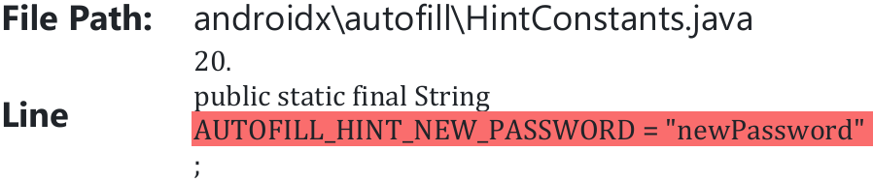
2 | Data Stored as plain text  Severity: High | - Data collected in the field and stored offline is not encrypted. This means that if the device is compromised, lost, or stolen, sensitive data could be accessed by unauthorized parties. | - To mitigate this risk, consider implementing encryption for offline data storage. This would ensure that even if the device is compromised, the data remains protected.
3 | Use of insufficiently random values  Severity: Medium | - The application used to generate random numbers in java is java.util.Random.  - Usage of java.util.Random class makes the random number generation cryptographically weak. | - Use java.security.SecureRandom class for random number generation | 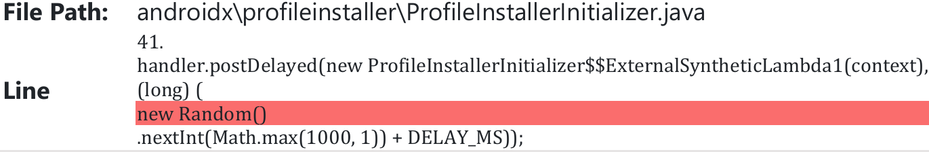
4 | Android backup vulnerability  Severity: Medium | - There is an Android backup vulnerability in the androidmanifest.xml file.  - The property android:allowBackup='true' exists on the application tag in the androidmanifest.xml file, which means the application users can back up the app's internal data, which resides under /data/data/ | - To avoid Android backup vulnerability, set android:allowBackup=false within the androidmanifest.xml file, unless If the app only handles non-sensitive data
5 | External storage  Severity: Medium | - The application uses an Android external storage application. External storage also stores Android application data.  - There is no security enforced on the saved file in external storage. Files created on external storage, such as SD cards, are globally readable and writable because external storage can be removed and modified by the user.  - It is not an issue if the developer does not store sensitive information on external storage. | - Use internal storage to write sensitive information. If the user wants to store data externally, encryption is required. | 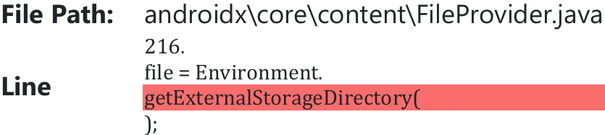
6 | Credentials stored as tokens  Severity: Medium | - Credentials are stored as tokens to enable offline use of the application.  - Offline access can increase the risk of data tampering or manipulation if the token is compromised.  - Token expiration challenges: Managing token expiration and refresh can be complex, especially in offline scenarios.  - When the user reconnects, syncing data can lead to conflicts or data loss if not handled properly. | - There is need to encrypt the tokens and data on the local device to protect it from unauthorised access and tampering.  - Implement token expiration of at least 24 hours or a timeline that synchronises with the period that users can be anticipated to be working offline.

