As you can see in Excel graph, the incremental value of “Manzil Halal Investing” and “Traditional Investing” for the Traditional Savings is very small when the “Payment Type” is Weekly.  
Therefore, the span of every price in the graph is not well recognized.

Payment Type = Monthly Payment

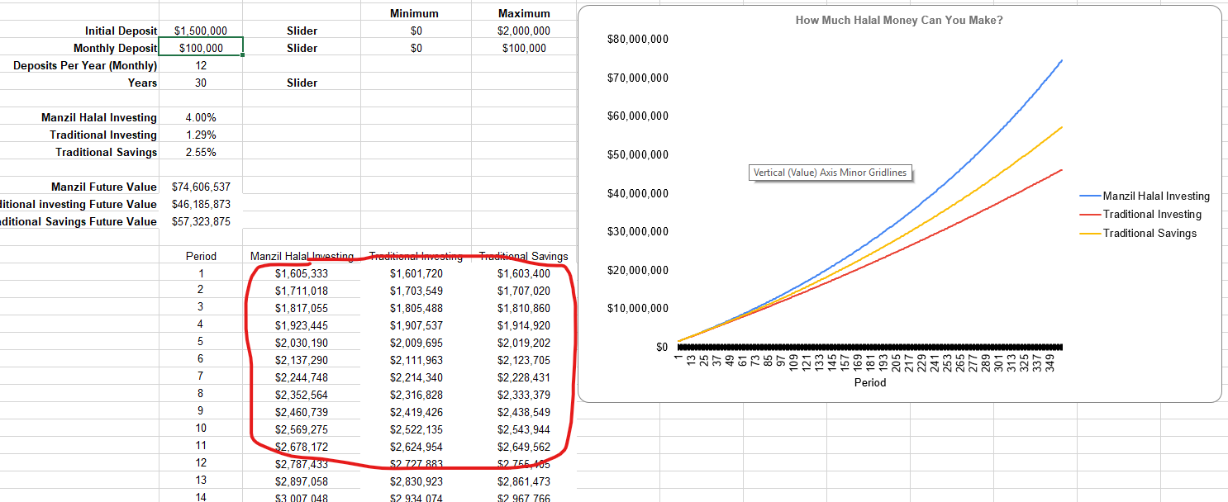

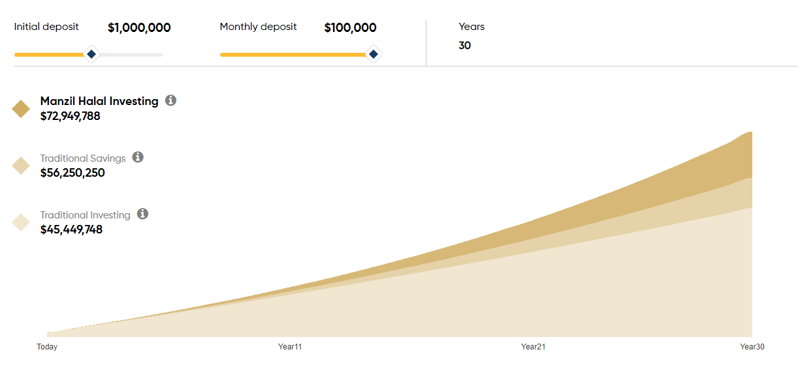

Payment Type = Semi Monthly

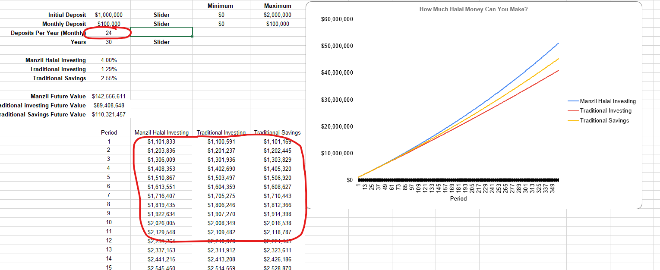

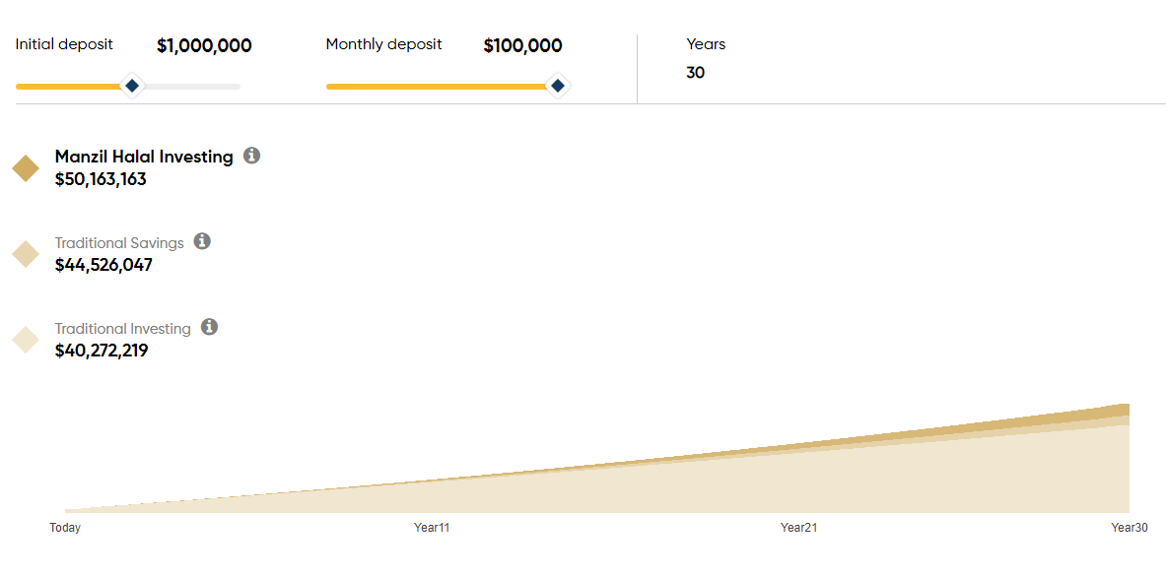

Payment Type = Weekly

