**Machine Learning Engineer Nanodegree**

**Capstone Project**

Santosh Narayan  
May 13th, 2018

**Report**

**I. Definition**

**Overview/Domain Background**

**This project is aimed at predicting house prices. The Ames Housing dataset was compiled by Dean De Cock.**

<https://www.kaggle.com/c/house-prices-advanced-regression-techniques>

The Ames Housing data set has about 80 variables that directly relate to property sales. This dataset focuses on both quantitative variables and qualitative variables of the project. The variables are the perfect representation of the questions any typical buyer would ask before buying a house/property. Example include: When was the house built? Does it have a basement? How many bathrooms does the house have? The dataset has information that can answer a typical buyers question. The datset represents the sale of individual residential property in Ames, Iowa from 2006 to 2010. 10. The data set contains 2930 observations and a large number of explanatory variables (23 nominal, 23 ordinal, 14 discrete, and 20 continuous) involved in assessing home values.

Property/Real Estate is a very widely used measure of a person’s wealth. A home is the probably the biggest investment anyone makes. It is a field with relatively low barriers to entry, anyone can participate at a level of the purchasing power they have. Flipping houses has become an occupation for quite a few. By knowing the true market value, one can help arbitrage and earn significant profits.

Hence, I have selected the Ames, Iowa dataset of housing sales prices to analyze and develop a model to predict housing prices. The project is taken from Kaggle competition. In the future, using this model as a base, I would like to be able to predict at my local area.

I would also like to cite the following research paper: <https://smartech.gatech.edu/bitstream/handle/.../Corsini_Kenneth_R_200912_mast.pdf> which discusses the housing prices in relation to other external factors such as employment rate, interest rates, New construction, Consumer Price Index etc.

**Problem Statement**

<https://en.wikipedia.org/wiki/Kaggle>

I plan to use regression techniques such as random forest and gradient boosting.

Inputs are the 79 variables and out put is to predict the price of the house.

The opportunity involves in using the data set provided to predict the housing price. The goal is to predict the sale price variable of each house. There are so many different variables in the dataset that come into play when predicting a house price. Every solution and analysis can be unique depending upon the user. I look forward to using my skills and knowledge in this domain to come up with a prediction.

<https://ww2.amstat.org/publications/jse/v19n3/decock.pdf>

**Datasets and Inputs**

The dataset is provided on Kaggle competition website. They are available to download by everyone.

<https://www.kaggle.com/c/house-prices-advanced-regression-techniques/data>

Data set contains information from the Ames Assessor’s Office used in computing assessed values for individual residential properties sold in Ames, IA from 2006 to 2010

The data set given contains 1460 observation in the train file and 1459 on the test file and a large number of explanatory variables (23 nominal, 23 ordinal, 14 discrete, and 20 continuous) involved in assessing home values. The 14 discrete variables typically quantify the number of items occurring within the house. Most are specifically focused on the number of kitchens, bedrooms, and bathrooms (full and half) located in the basement and above grade (ground) living areas of the home. Additionally, the garage capacity and construction/remodeling dates are also recorded. There are a large number of categorical variables (23 nominal, 23 ordinal) associated with this data set. They range from 2 to 28 classes with the smallest being STREET (gravel or paved) and the largest being NEIGHBORHOOD (areas within the Ames city limits). The nominal variables typically identify various types of dwellings, garages, materials, and environmental conditions while the ordinal variables typically rate various items within the property.

data_description.txt provides the detailed description of the data.

Here's a brief version of what you'll find in the data description file. The below variables are the list provided on Kaggle by the data provider.

* SalePrice - the property's sale price in dollars. This is the target variable that you're trying to predict.
* MSSubClass: The building class
* MSZoning: The general zoning classification
* LotFrontage: Linear feet of street connected to property
* LotArea: Lot size in square feet
* Street: Type of road access
* Alley: Type of alley access
* LotShape: General shape of property
* LandContour: Flatness of the property
* Utilities: Type of utilities available
* LotConfig: Lot configuration
* LandSlope: Slope of property
* Neighborhood: Physical locations within Ames city limits
* Condition1: Proximity to main road or railroad
* Condition2: Proximity to main road or railroad (if a second is present)
* BldgType: Type of dwelling
* HouseStyle: Style of dwelling
* OverallQual: Overall material and finish quality
* OverallCond: Overall condition rating
* YearBuilt: Original construction date
* YearRemodAdd: Remodel date
* RoofStyle: Type of roof
* RoofMatl: Roof material
* Exterior1st: Exterior covering on house
* Exterior2nd: Exterior covering on house (if more than one material)
* MasVnrType: Masonry veneer type
* MasVnrArea: Masonry veneer area in square feet
* ExterQual: Exterior material quality
* ExterCond: Present condition of the material on the exterior
* Foundation: Type of foundation
* BsmtQual: Height of the basement
* BsmtCond: General condition of the basement
* BsmtExposure: Walkout or garden level basement walls
* BsmtFinType1: Quality of basement finished area
* BsmtFinSF1: Type 1 finished square feet
* BsmtFinType2: Quality of second finished area (if present)
* BsmtFinSF2: Type 2 finished square feet
* BsmtUnfSF: Unfinished square feet of basement area
* TotalBsmtSF: Total square feet of basement area
* Heating: Type of heating
* HeatingQC: Heating quality and condition
* CentralAir: Central air conditioning
* Electrical: Electrical system
* 1stFlrSF: First Floor square feet
* 2ndFlrSF: Second floor square feet
* LowQualFinSF: Low quality finished square feet (all floors)
* GrLivArea: Above grade (ground) living area square feet
* BsmtFullBath: Basement full bathrooms
* BsmtHalfBath: Basement half bathrooms
* FullBath: Full bathrooms above grade
* HalfBath: Half baths above grade
* Bedroom: Number of bedrooms above basement level
* Kitchen: Number of kitchens
* KitchenQual: Kitchen quality
* TotRmsAbvGrd: Total rooms above grade (does not include bathrooms)
* Functional: Home functionality rating
* Fireplaces: Number of fireplaces
* FireplaceQu: Fireplace quality
* GarageType: Garage location
* GarageYrBlt: Year garage was built
* GarageFinish: Interior finish of the garage
* GarageCars: Size of garage in car capacity
* GarageArea: Size of garage in square feet
* GarageQual: Garage quality
* GarageCond: Garage condition
* PavedDrive: Paved driveway
* WoodDeckSF: Wood deck area in square feet
* OpenPorchSF: Open porch area in square feet
* EnclosedPorch: Enclosed porch area in square feet
* 3SsnPorch: Three season porch area in square feet
* ScreenPorch: Screen porch area in square feet
* PoolArea: Pool area in square feet
* PoolQC: Pool quality
* Fence: Fence quality
* MiscFeature: Miscellaneous feature not covered in other categories
* MiscVal: $Value of miscellaneous feature
* MoSold: Month Sold
* YrSold: Year Sold
* SaleType: Type of sale
* SaleCondition: Condition of sale

**Metrics**

This is a regression problem where the Target variable (SalePrice) has to be predicted for a given set of features. A training dataset has been provided which has the given features and the actual Saleprice. This data can be fit to a model. The accuracy of the model is given by the ‘score’, i.e given a set of features how accurately the model is able to predict the target valuesn as compared to the actual values.

Hence after training, I would obtain the ‘score’ with the Train dataset. The higher the score and closer to 1 would mean a better trained model. Then I would obtain the score with the test dataset.

**II. Analysis**

**Data Exploration**

The data analysis on the housing data showed the following:

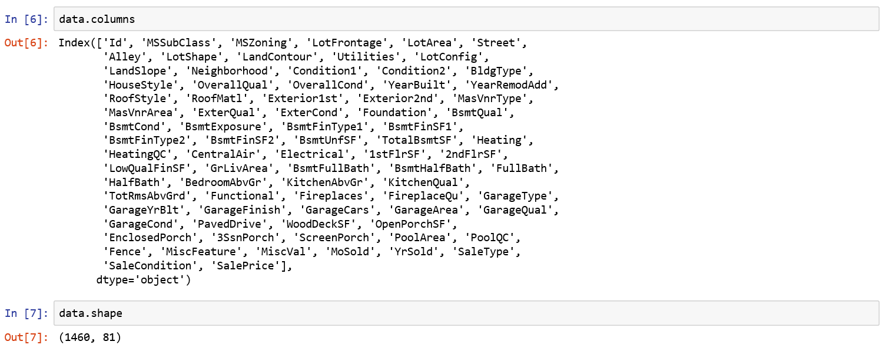

There are 1460 housing data points provided in the Training dataset.

A plot of the target variable, SalePrice shows the distribution. Most of the houses are priced between $150,000 and $200,000.

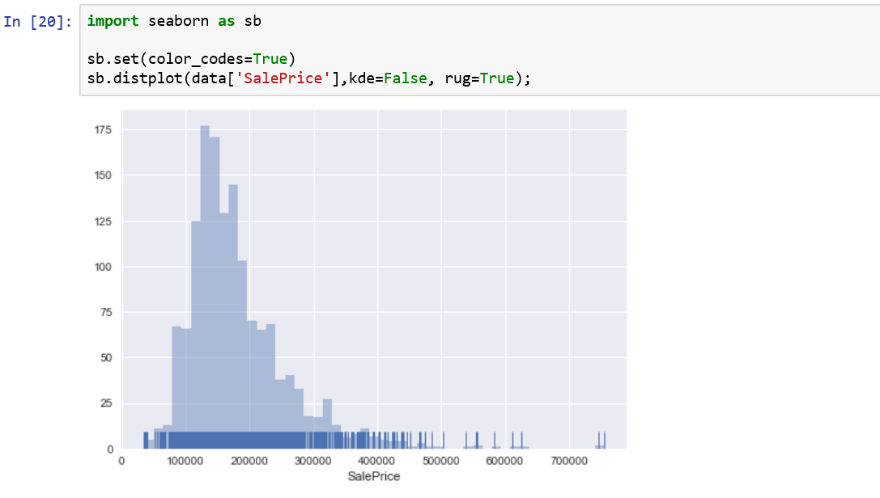

On a hunch, I wanted to look at the box plot which interested me, the distribution of SalePrice with respect to number of FullBath, LivingArea and TotalBasement sqarefeet.

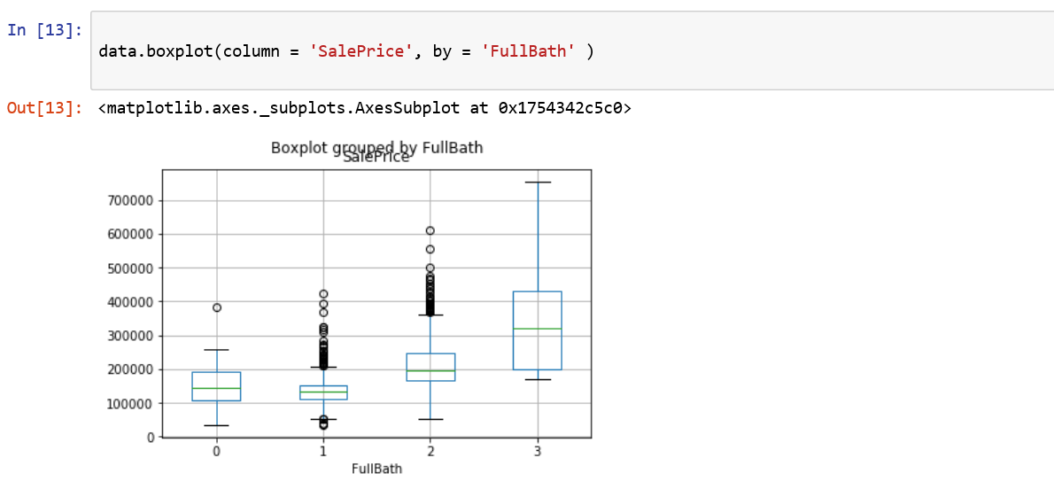

It can be seen that most of the houses have 1 or 2 Fulbaths and the SalePrice are generally proportional to the number of FullBaths. There are a low number of outliers with 0 (some lowcost houses which have only half baths and probably the shower is separate) and 3 full baths(probably indipendent houses outside the communities).

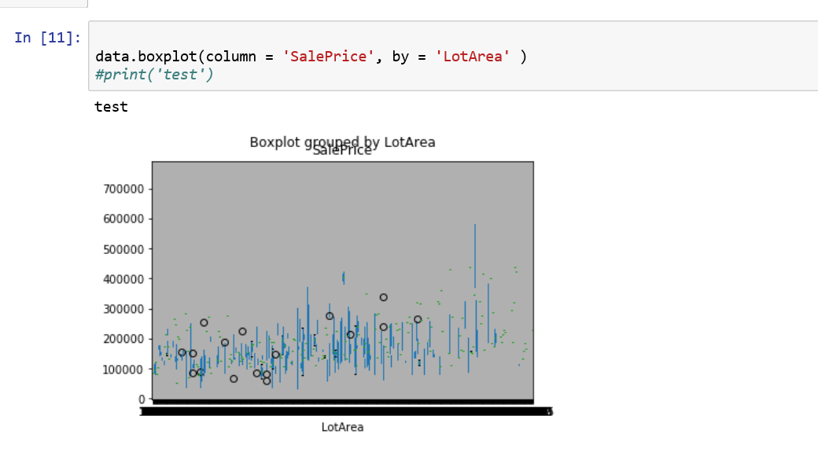

The lot area is spread all the way from 1300 sq ft to 215,000 sq ft. This is a wide spread with no concrete clusters. Also, we note that the price does not dramatically increase depending on the lot size. This might be due to even though the lot size is huge, they might be located on the outskirts of the city and may be thinly populated.

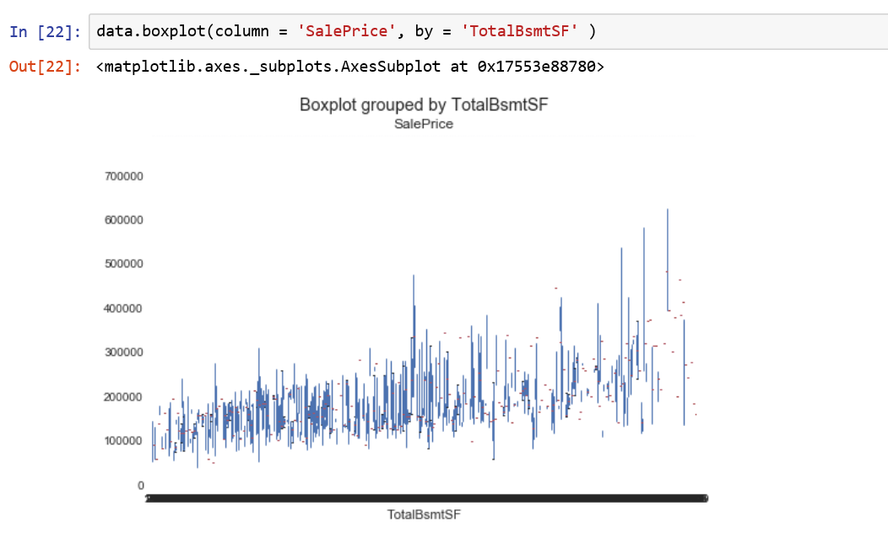

The reason I was interested to the relation to basement area is because, in many areas basement is not available, and the presence of basement would have caused and immediate jump in prices. But I don’t see that by looking at the above boxplot. The Basement area is actually well spread out, this probably indicates that most of the houses have some basement area. In fact, looking at the file there are only 37 houses with no basement.

**Exploratory Visualization**

Next, the below graphs are analysis of numerical values that provide good insights.

The 1stFloor sqftt follows a bell shape as expected.

Most of the houses do not have 2nd Floor as the sq Ft is zero.

There is no house with 3 season Porch.

About half of the houses have 3 bedrooms.

Over a third of the houses don’t have finished basement.

While a third have a FullBath in the basement.

Most of the houses have some area of unfinished basement.

The older homes may not have had the garage, so most of the garages were built in 1990’s and 2000’s.

None of them houses have LowQualFin area.

About 40% don’t have an Open Porch.

OverallCond and OverallQuality are pretty high, showing a good enforcement of buuilding codes and neighborhoods built by reputable builders.

Most of the houses have two car garages.

About equal number of houses has a no or single fireplace, with a few having 2 or more.

The summer month May, Jun, Jul are the months with maximum homes sold.

None of the houses have a screen Porch

Most of the houses have 5-7 rooms above ground.

Over half the houses don’t have a wood deck.

The number of houses sold year over year is fairly consistent above 300, but in 2010, there was a dip by over 30%. This is possibly due to the recession.

There is a surge in remodeling activity after the year 2000.

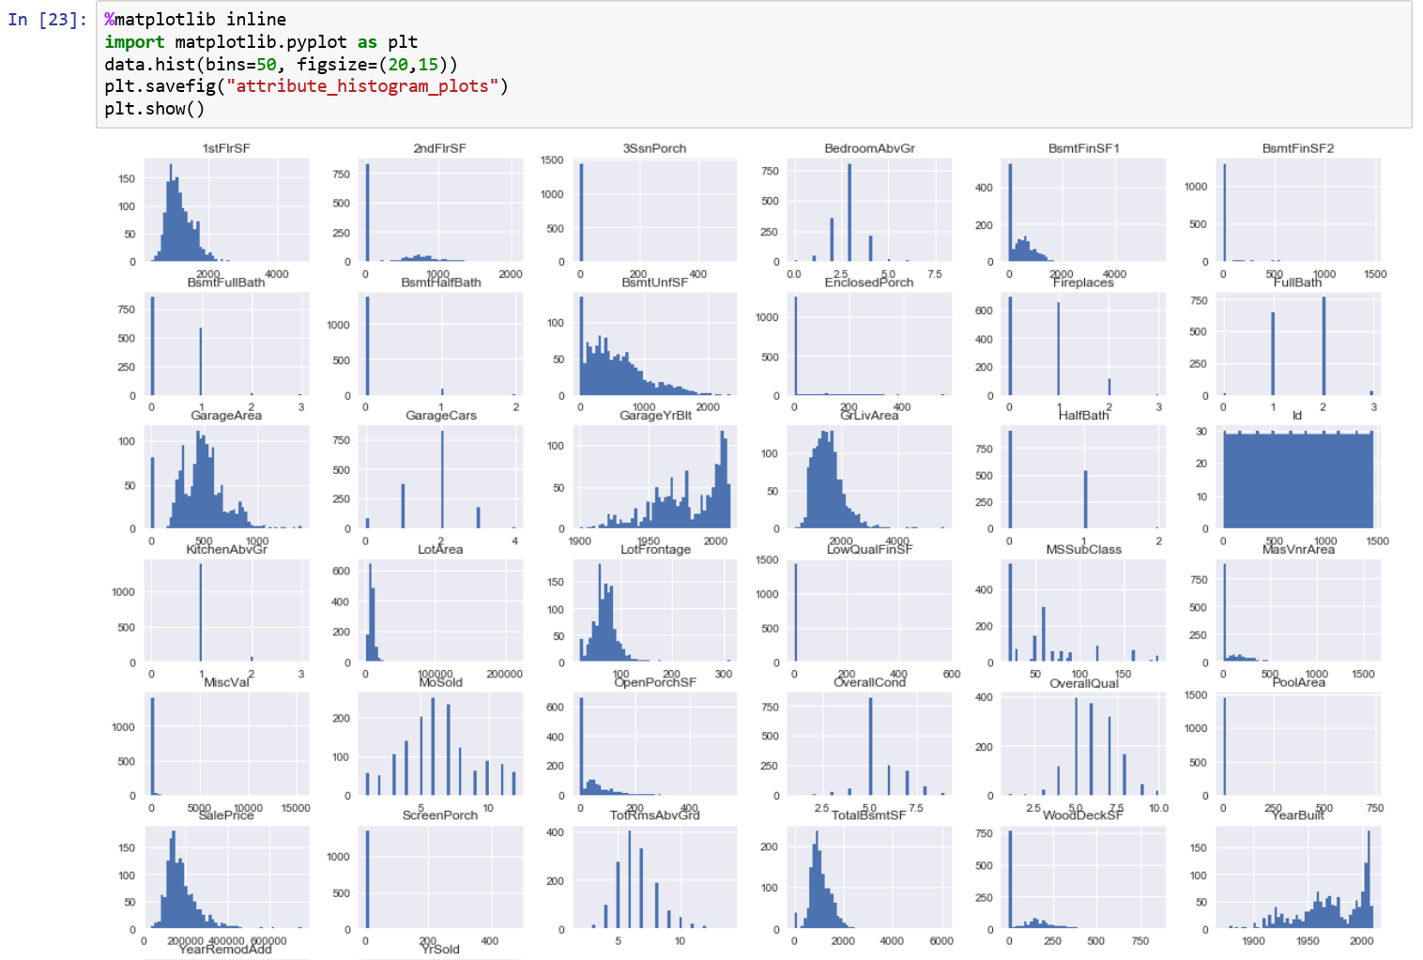

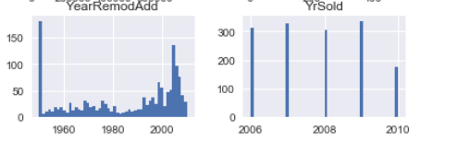

Next, with such a large number of available features, it would be good to see correlation of each related to the SalePrice, so that we can identify which ones to focus on.

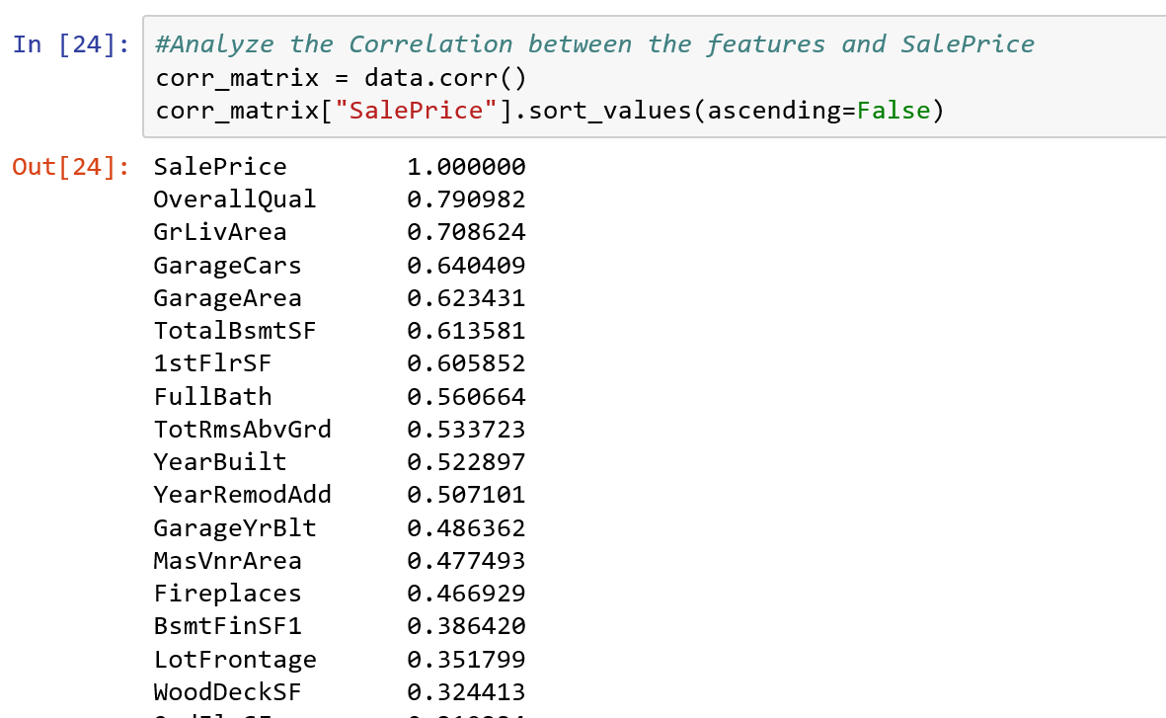

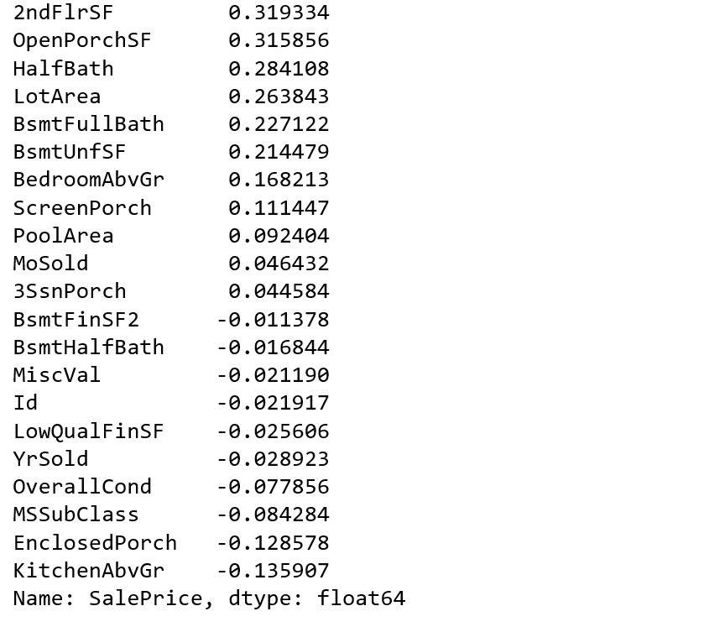

Next, Looked at the plots of the top 9 corelated features vs the SalePrice as these all have correlation >0.5.

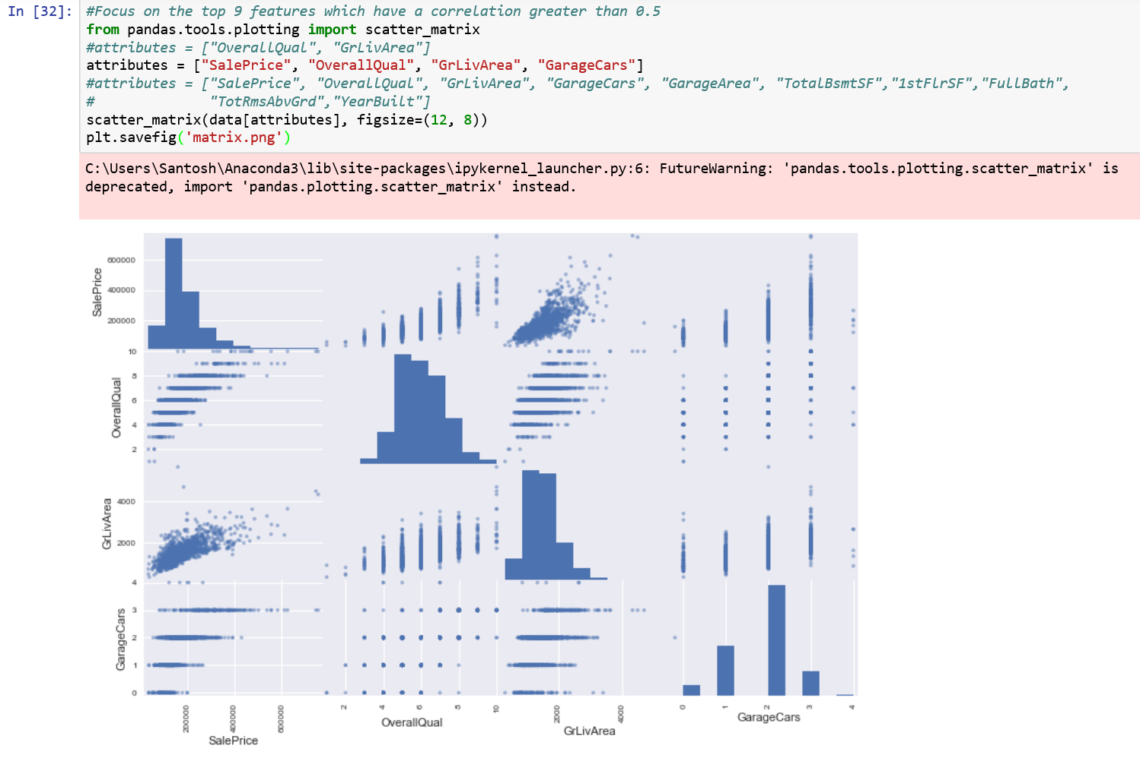

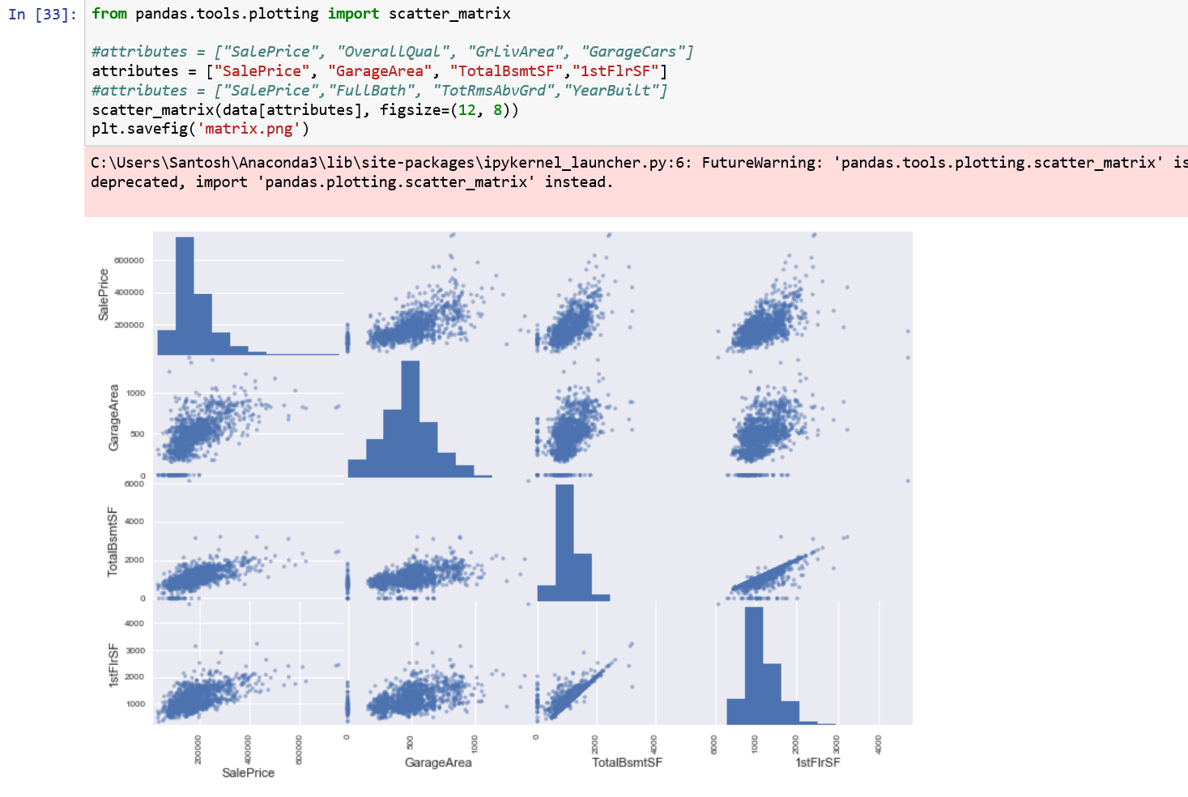

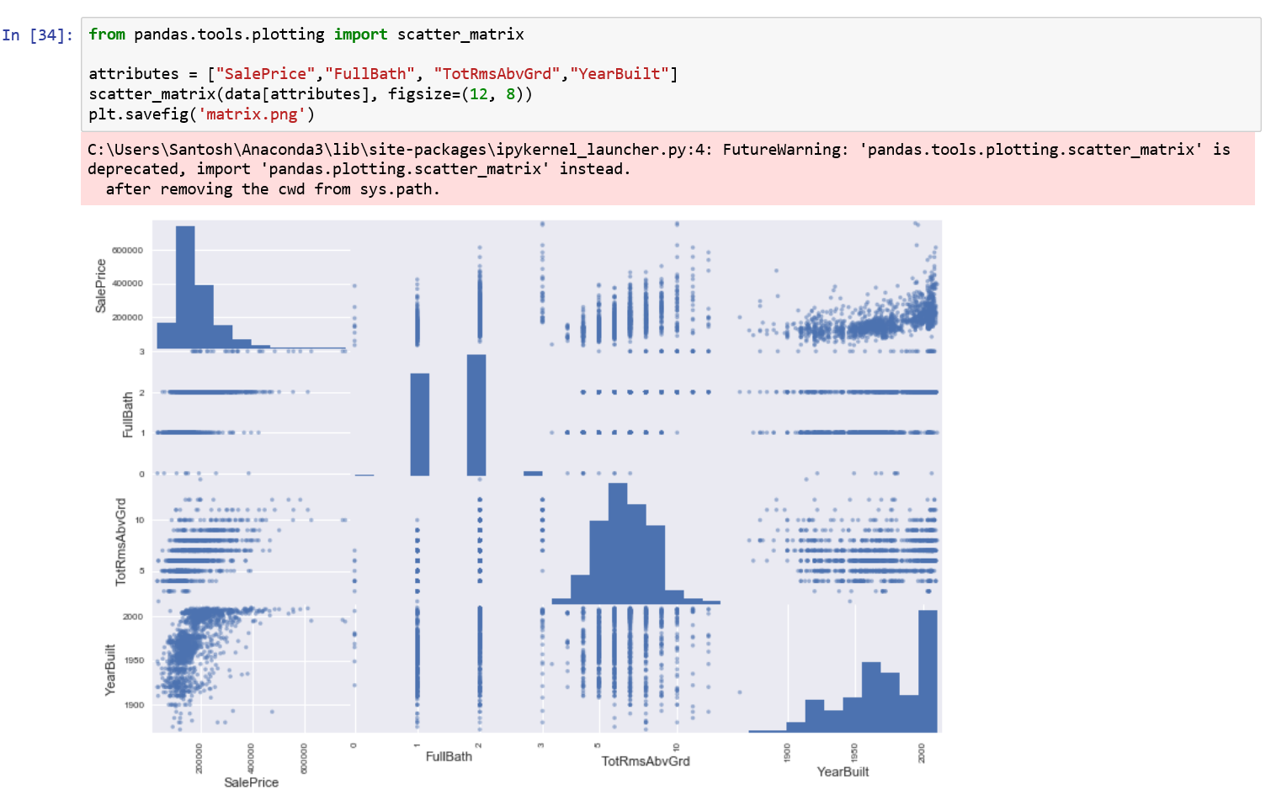

BoxPlot review of the top 9 features.

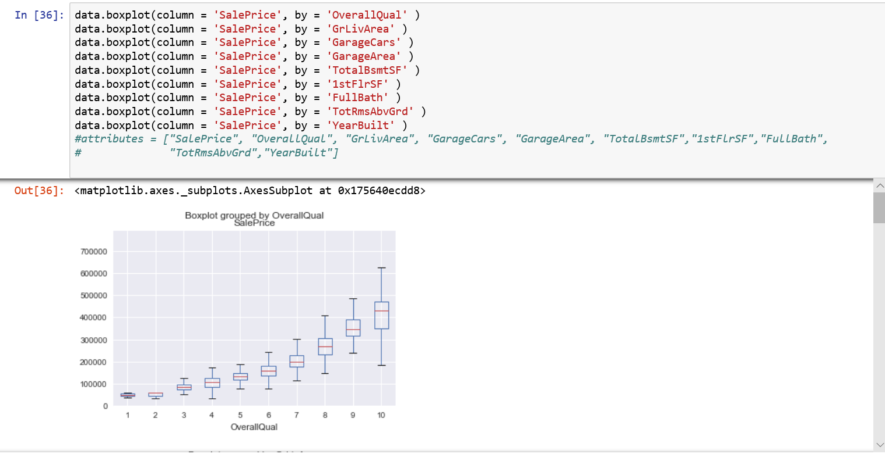

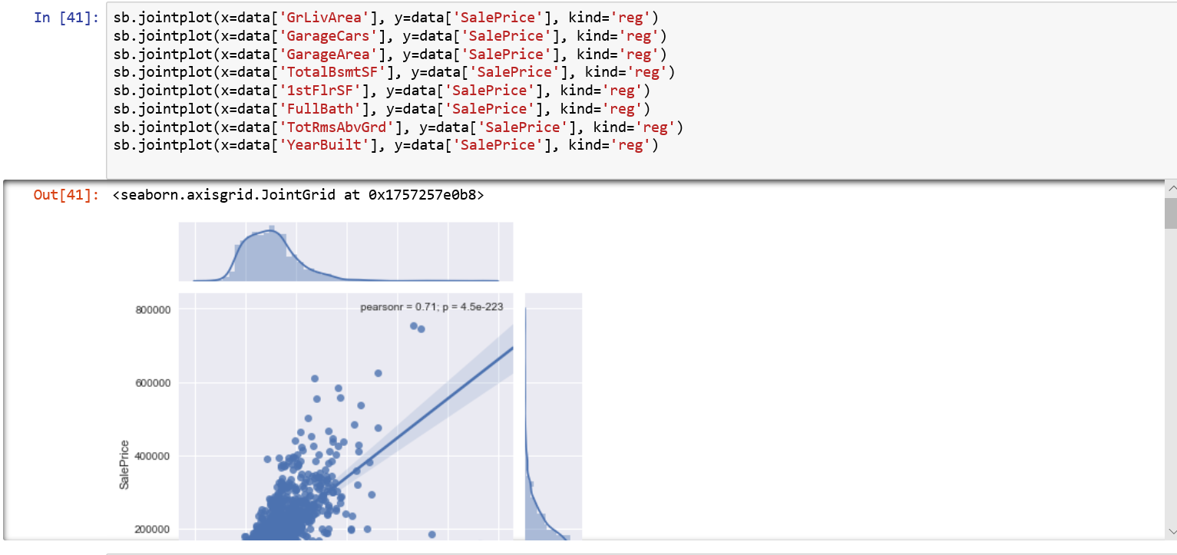

**Algorithms and Techniques**

To Benchmark the results, the model was run for three features. The model was then trained used random forest. The Random forest and XGB provided the below accuracy score. SVC was also run on the data set, it provided.

I plan to use Random Forest and XGBoost algorithms to develop model.

Ensemble methods use multiple learning models to gain better predictive results

Random Forest :

Random forests, also known as random decision forests, are a popular ensemble method that can be used to build [predictive models](https://www.datascience.com/resources/white-papers/executives-guide-to-predictive-data-modeling) for both classification and regression problems. Random forest model creates an entire forest of random uncorrelated decision trees to arrive at the best possible answer.

Decision trees are simple but intuitive models that utilize a top-down approach in which the root node creates binary splits until a certain criteria is met. This binary splitting of nodes provides a predicted value based on the interior nodes leading to the terminal (final) nodes.

XGBoost stands for eXtreme Gradient Boosting. XGBoost is vary popular because of Execution speed and Model Performance. It dominates structured or tabular datasets on classification and regression predictive modeling problems.

Boosting is an ensemble technique where new models are added to correct the errors made by existing models. Models are added sequentially until no further improvements can be made.

Gradient boosting is an approach where new models are created that predict the residuals or errors of prior models and then added together to make the final prediction. It is called gradient boosting because it uses a gradient descent algorithm to minimize the loss when adding new models.

<https://www.datascience.com/resources/notebooks/random-forest-intro>

https://machinelearningmastery.com/gentle-introduction-xgboost-applied-machine-learning/

**Benchmark Model**

To Benchmark the results, the model was run for three features. The model was then trained used random forest. The Random forest and XGB provided the below accuracy score. SVC was also run on the data set, it provided very poor results and hence is not considered for further modeling.

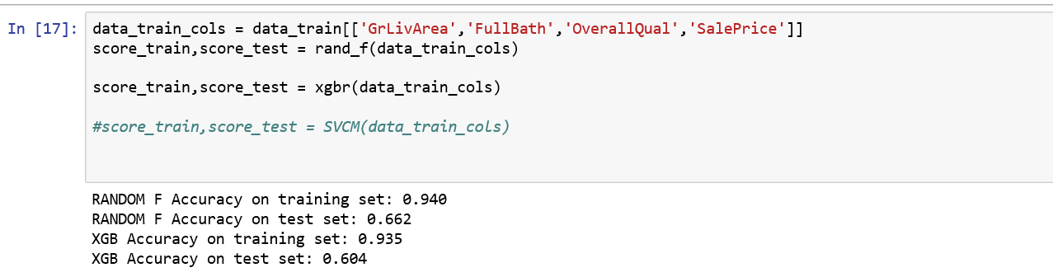



**Data Preprocessing Step**

The preprocessing that needed to take place before the data could be trained were:

* Locate and clean the Null values
* The POOLQC column had Nulls, these were filled with None.
* MiscFeature, Alley, Fence, FireplaceQu were al filled with None
* LotFrontage was filled with the median of the frontage of the Neighborhood
* 'GarageType', 'GarageFinish', 'GarageQual', 'GarageCond' were filled with None
* GarageYrBlt', 'GarageArea', 'GarageCars' were filled with 0
* 'BsmtFinSF1', 'BsmtFinSF2', 'BsmtUnfSF','TotalBsmtSF', 'BsmtFullBath', 'BsmtHalfBath' were filled with 0
* 'BsmtQual', 'BsmtCond', 'BsmtExposure', 'BsmtFinType1', 'BsmtFinType2' were filled with None
* MasVnrType was filled with none
* MasVnrArea was filled with 0.
* MSZoning was filled with the Mode of the values
* Functional was filled with Typ
* Electrical, KitchenQual, Exterior1st, Exterior2nd, SaleType were filled with mode.
* MSSubClass was filed with None

**Implementation**

The data set was then trained on a Random forest model and a benchmark score was obtained. The data was then preprocessed by treating for basic null values. Due to a large number of columns and the potential redundant features, the top nine correlated columns to the target variable were selected. This processed data was fed into Random Forest, XGBoost and SVM.

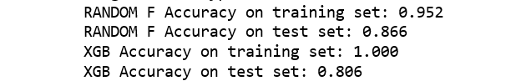

**Results**

It can be seen from the benchmark and the models that the scoring is higher in both cases than the benchmark model.

|  |  |
| --- | --- |
| **MODEL** | **Score** |
| Benchmark – Random Forest | 0.713 |
| Tuned - XGB | 0.806 |
| Tuned – Random Forest Best Score | 0.866 |

**Conclusion**

The model has been trained using 1460 rows of housing prices data. The model has the max of 86% accuracy. Pre-processing steps have been applied as necessary to maximize the use of the available data for training. There are some refinements that could be done to improve the model accuracy. I considered the top nine corelated features for prediction, and it received reasonable accuracy., with some minimal data pre-processing. We can further analyze each feature and remove outliers and also incorporate other features into the model.

**References:**

http://scikit-learn.org/stable/modules/generated/sklearn.ensemble.RandomForestClassifier.html

https://www.kaggle.com/mchatham/ames-housing-regression/code

https://www.kaggle.com/surya635/house-price-prediction/code

https://www.fabienplisson.com/random-forest-and-grid-search/

<https://www.kaggle.com/gchshin/house-price-prediction-challenge/code>