Tempo & beat analysis

Introduction:
Beat: sequence of impulsive phenomena also cut out that define the tempo
Difference between polyphonic complexity and rhythmic complexity: some music is more complex in textures and timbres (several instruments, several melodies) but has a relatively simple rhythmic part. Other music is less complex from a texture point of view, but is more difficult to understand and describe rhythmically.

Previous approaches
Povel and Essens (1985) propose an algorithm which gives a set of periods between two notes. This based on the internal clock and the temporal note detection. Their work results from the perception of temporal paternal signals and not exclusively musical signals.
Model perfected by Parncutt in 1994 to again include, thanks to the internal clock, new information on the signal structure
Desain and Homing (1992) create a model which still relies on the different beats between 2 notes but associates with a rhythm which comes from the different note deviations. The addition of the different rhythmic profile of the signal gives an overall representation of the rhythm of the complex signal. This model algorithm is made possible by decomposing the signal beforehand, much like a human brain would.
Large and kolean have meanwhile created a model that relies on nonlinear oscillators therefore more complex convoluted with the different start of notes. He assumes that neural interactions are also non-linear. This model is even closer to the human brain.
Longet-Higgins and lee's written work on the rhythmic interpretation of monophonic music but the detection of tempo is only underlying their model.
This kind of model like that of Rosenthal and Brown relies on very precise note detection which limits their applications this makes this model difficult to achieve because the note detection of multitimbral, polyphonic music is not obvious.
Often, rhythm detection on acoustic signals can count on upstream processing of the signal and on already existing detection models. Indeed, this technique determines the rhythm through percussion. This method allows direct or parallel interpretation of the signal.
Todd meanwhile creates an algorithm that detects the notes but only under certain conditions of timbres paired with a very simple model allows the creation of a rhythmogram representative of the beats.
All this work has been done on signals before processing computer, then an algorithm that loads the rhythm of the music isolated. But melodies or too complex signals are still impossible to process simultaneously.

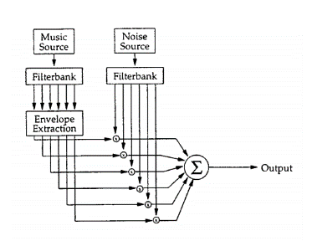

I. PSYCHOACOUSTIC SIMPLIFICATION

Difficulty groups the harmonics to recreate a note and determine its moment of appearance, even after isolating the different components it is still difficult to identify the beginning and the end of the note. On the other hand, there is a model which applies a white noise modeling of the signal which makes it possible to keep the pulse of the signal intact.
This modulation is possible by sequencing the signal in different frequency ranges. We modulate

II. DESCRIPTION OF ALGORITHM
Principle of the Large and Kolen algorithm: use a network of "resonators" to make a phase-locked loop with the beat of the signal and determine the frequency of the pulse. In our algorithm, the resonators are simplified, and there is more pre-processing and post-processing of the signal to precisely extract the desired information, as the model operates on acoustic data rather than a stream of events.

A rhythmic pulse is described in terms of frequency and phase component, just like a periodic sound waveform; the frequency of the pulse in a rhythmic musical signal is the tempo or the frequency of the rhythm, and the phase of the pulse indicates when the “downbeat” of the rhythm occurs. Thus, the times when a pulse takes place can be defined as having a phase of 0, and the time between each pulse has a phase of π.

Principle of the algorithm: an input signal, which enters a bank of filters which divides the signal into 6 frequency bands.
For each frequency band, the amplitude of the envelope is calculated as well as its derivative. Each derivative is passed through another bank of comb filters (which are tuned resonators). In each filter bank, the one whose resonant frequency matches the periodic modulation rate of the envelope derivative will participate in the phase locked loop.

A. Frequency analysis and envelope extraction

The filter bank has 6 bands: 1 low pass filter (fc = 200Hz), 4 band pass filters (f2 = [200 - 400 Hz], f3 = [400 - 800Hz], f4 = [800 - 1600 Hz] , f5 = [1600 - 3200 Hz]), 1 high pass filter (fc = 3200 Hz).
Each filter has 3dB ripple in the passband, very sharp cuts (40 dB rejection in the stopband) and covers about an octave:

The envelope of each sub-band of the filter is extracted. The outputs of the filter bank are convolved with a half-Hann window to smooth the envelope. Thus, we obtain the rectified envelope signal, which will be examined for periodic modulation.

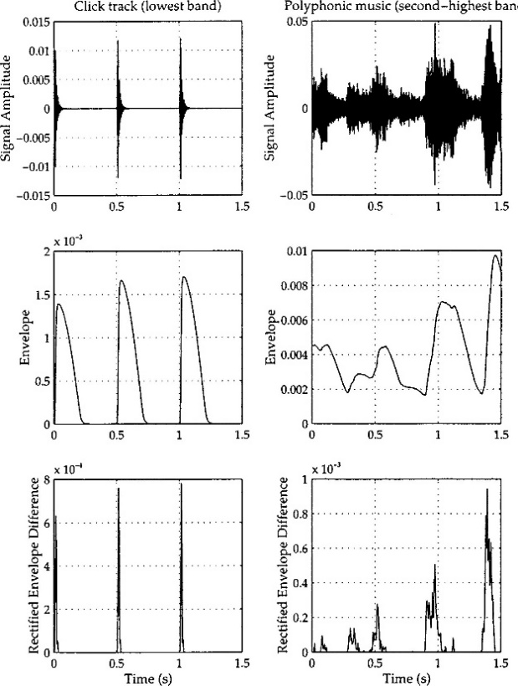

B. Resonators and tempo analysis

After the envelope has been extracted and processed for each channel, a bank of comb filters (resonators) is used to determine the tempo of the signal. Thanks to the Fourier theorem, we know that the points of interest in the frequency domain are those at which a periodic signal of period T has energy. Thus, a resonator with a delay T will respond more strongly to a signal of period T than any other, since the response peaks in the filter align with the frequency distribution of the energy in the signal.
Each envelope is therefore filtered with different resonators of different delays, and the output of this filtering is added to the frequency sub-bands. By examining the energy of each resonator (each summed filter bank), we can determine the periodic component of the strongest signal. Thus, the frequency of the resonator which has the greatest energy is selected as the tempo of the signal.

Here we see the energies at the output of the resonators, for the click signal and for the polyphonic music signal (therefore more difficult to analyze). We see that for the first signal, we have a peak at 120 bpm. Indeed, on the envelope extractions, we saw that for this signal we had a period of 0.5s, therefore 1 / 0.5 = 2Hz. This value corresponds to the frequency of the resonator returning the greatest energy. So 2Hz * 60 = 120 beats per minute.
For the second signal, there are 2 bumps at around 150 and 75 bpm. Indeed, on the extraction envelope, we had about 0.4s of period, so 1 / 0.4 = 2.5Hz so 2.5 * 60 = 150 bpm

C. Determination phase

Once the tempo is known, one can determine the phase quite simply by looking directly at the output of the resonators or by examining the delays of these resonator filters.

Indeed, the vector w of the delays of the filters of a resonator can be interpreted as the “expected output” of this resonator, that is to say the n following envelope output samples that the filter would generate in response ( at zero input).

The goal is to examine the sum of the delay vectors of the resonators corresponding to the determined tempo over the different frequency ranges. The peak of this prediction vector is the estimate of when the next beat will arrive as input.
The ratio ꙍ = 2π * (tn-t) / T is the phase ꙍ of the followed tempo (tn = the estimated time of the next beat, t = the current time, and T = the period of the resonator).
The phase analysis takes place every 25 ms, and each analysis result will be useful to confirm the current prediction and adjust it if necessary.

Figure 7 shows the phase peaks for 2 Hz clicks and for an example of polyphonic music. In the upper graph, since the analyzed tempo is 120 bpm, the x-axis covers the next half second of time (120/60 = 2 and ½ = 0.5s), and for the lower trace, the estimated tempo is of 149 bpm, so a period is about 400 ms (149/60 = 2.48, 1 / 2.48≈0.4).

The x-axis in each case covers the next full period of the resonator following the tempo, and the peak of the curve shows where the next beat is expected: about 210 ms in the future for the first signal, and 290 ms for the second.

III. IMPLEMENTATION AND COMPLEXITY

You can use the code described above from audio files and also via a live microphone.
We are going to talk here about the parameters to act on the speed and the precision of the program.

A. Program parameters

The program works in real time and on a computer.
The different parameters were tested for sampling rates from 8KHz to 44.1KHz.
4 different parameters tested but only 3 implemented.

1. Frequency filterbank
You can choose the bank of filters to break down the incoming audio signal quite widely, no need to be really precise.
The speed of the system will vary with the complexity of the filters.
We have a complete resonant filter bank implemented.
On the other hand, the performance of the beat-tracking program using banks of filters, other than those with 6 channels of order 6 mentioned previously has not been tested.

2. Envelope sampling rate
The rate of decimation of the track envelope will affect the speed and performance of the system as well.

1: There are going to be many resonator frequencies that cannot be accurately represented with integer delays in comb filters.
2: the extraction phase will only be done if the precision is equal to the sampling rate of the envelope.

So, using a fast-sampling rate for the envelopes will require a lot of filtering work with the combs.

Empirically, envelopes should be sampled at at least 100Hz for the best possible performance.

3. Number of resonators per frequency channel

The amount of computation incorporated into the monitoring and analysis of comb resonator filters varies with their number.
If we use too few resonators, as the resonator will try to lock in phase with a particular frequency, so not over a range of frequencies. So if there is no resonator tuned close to the tempo of a particular signal, the signal cannot be tracked accurately.

The frequency range of the resonator to follow will also have an impact, the greater the range of tempi, the more the fixed number of resonators will be distributed according to this range.

The best recorded results have used a bank of 150 resonators for each channel which will cover a logarithmically spaced range of 60bpm to 240bpm.

4. Analysis frame rate

We examine the phase of the resonator for each frame analysis, which will suggest the next locations of the beats.
We can combine the suggestions with the other frame analyzes and when several frames are fixed on a point we will associate it with a beat.
The frequency with which the examination and sum of outputs procedure will have a big effect on the speed and accuracy of the program.
The best results have been obtained at at least 15Hz.
On the other hand, for the real-time performance, we cannot use these parameter values, it is possible to use the live performance but with parameters that will make the detection less precise, and some music tests do not the sequel also not worked.

B. Behavior tuning

You can therefore control the trade-off between speed and precision, but the program can also be adjusted with the alpha parameter of the comb filters.
We can consider them as controlling if we consider the beat extracted so far but also the incoming envelopes.
The larger the alpha, so close to 1, the more the algo will tend to lock onto a beat and follow that tempo without considering the new input envelopes.
But the smaller the alpha, the beat tracking can be easily disturbed by changing the periodicity of the input signal.
So, we can use this parameter for different ways of using the algo, if we listen to rock or pop for example, there is a very stable tempo so a large alpha value will be more suitable. On the other hand, a piece of classical music or other music which has a tempo that changes more often, a small value of alpha will be more appropriate

