**Use of Bit Bucket and Source Tree as a Version Control**

Here, In this assignment the data from the machine that calculates the heart rate, speed, time duration etc. is loaded and the data is showed in the data grid view and graph is also created according to the data grid view. The different version is saved using source tree and bit bucket. Some of the screenshots of using bit bucket is shown below.

1. **Overview**

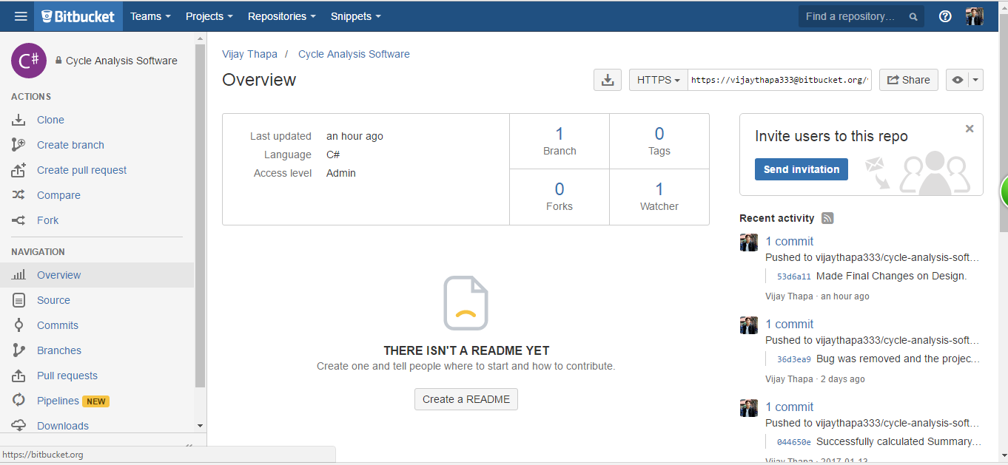

Fig: Overview of Bit Bucket Repository

1. **Total Commits**

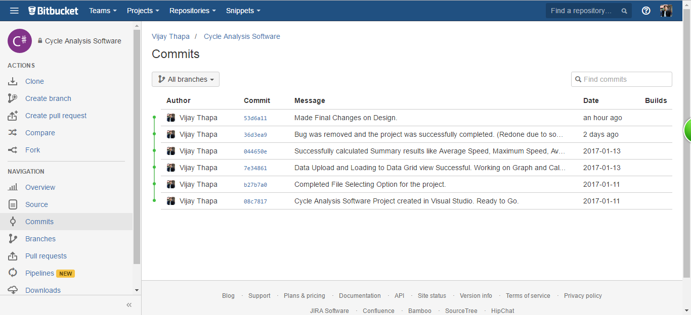

Fig: Total Commits

1. **First Commit**

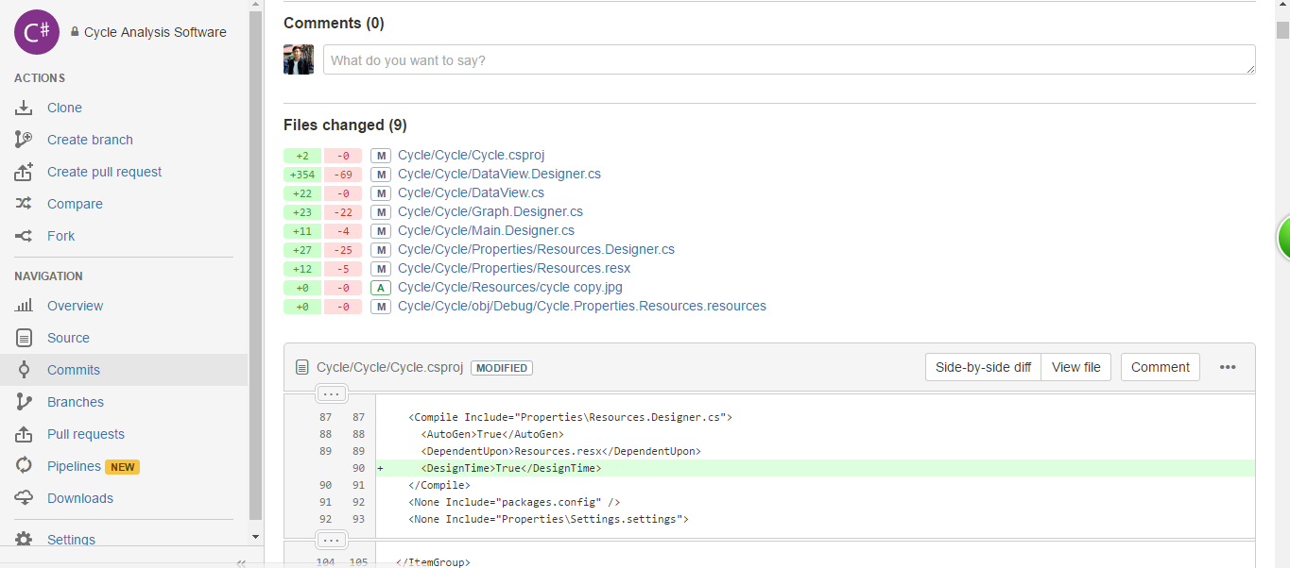

Fig: First Commit

1. **Second Commit**

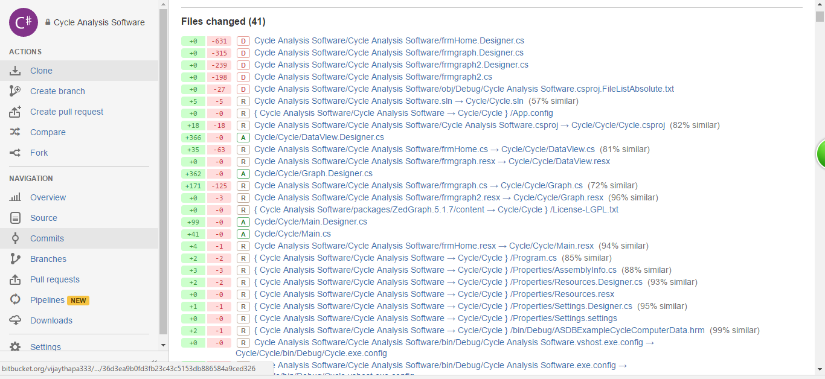

Fig: Second Commit

1. **Third Commit**

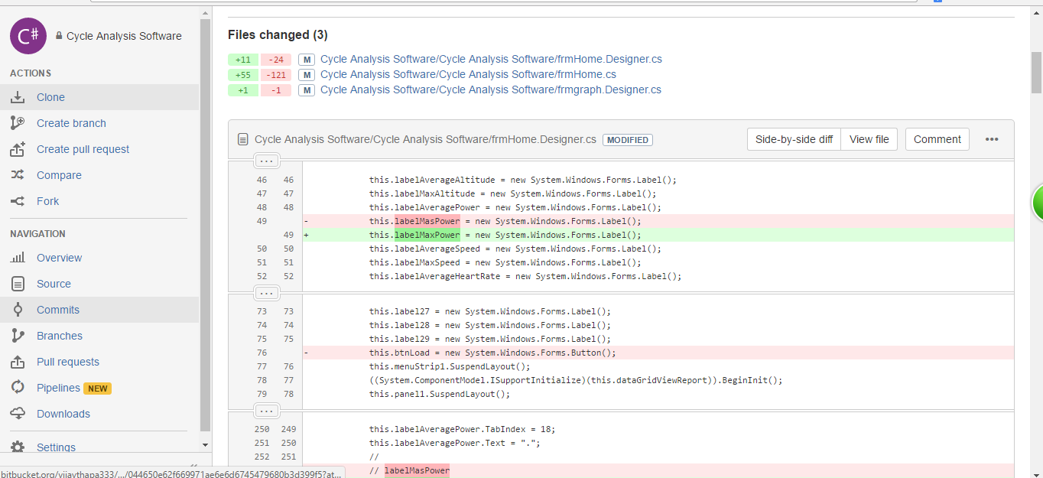

Fig: Third Commit

1. **Fourth Commit**

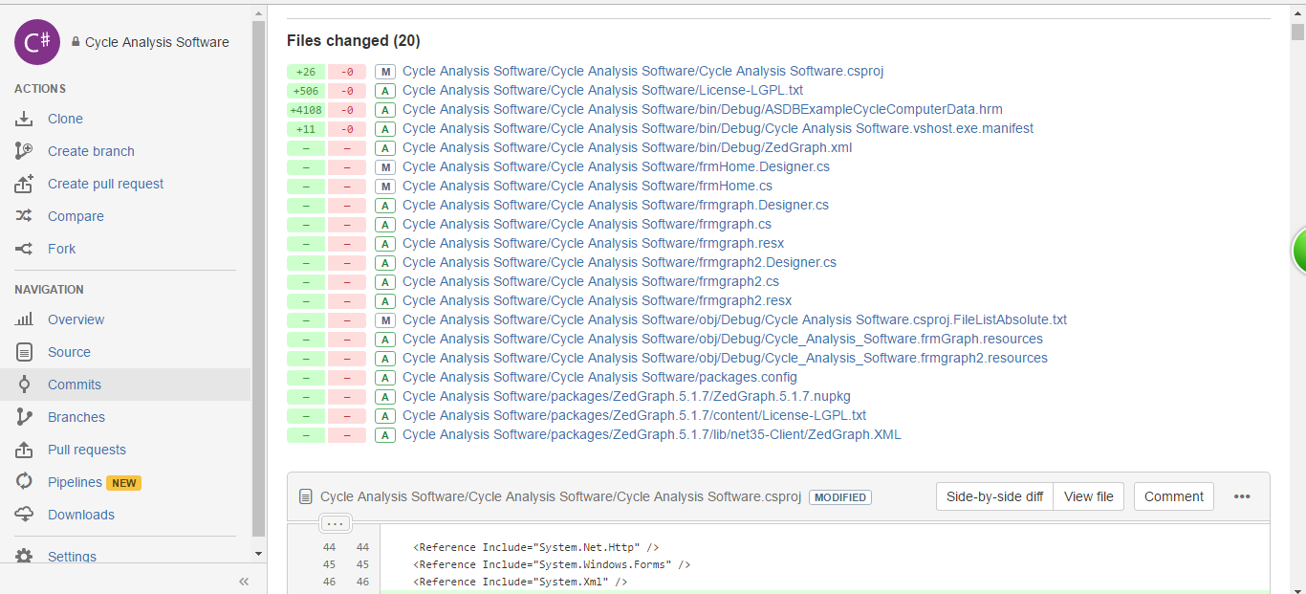

Fig: Fourth Commit

1. **Fifth Commit**

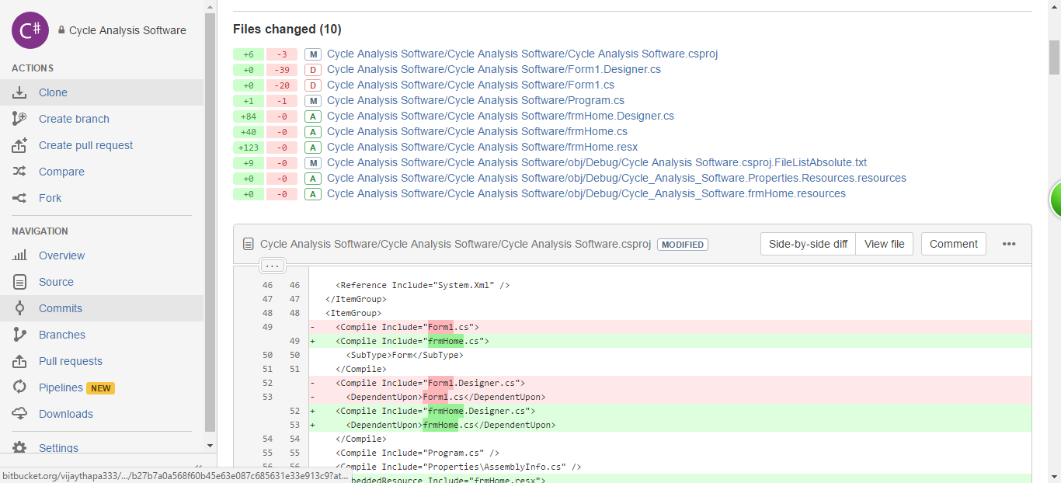

Fifth Commit

1. **Sixth Commit**

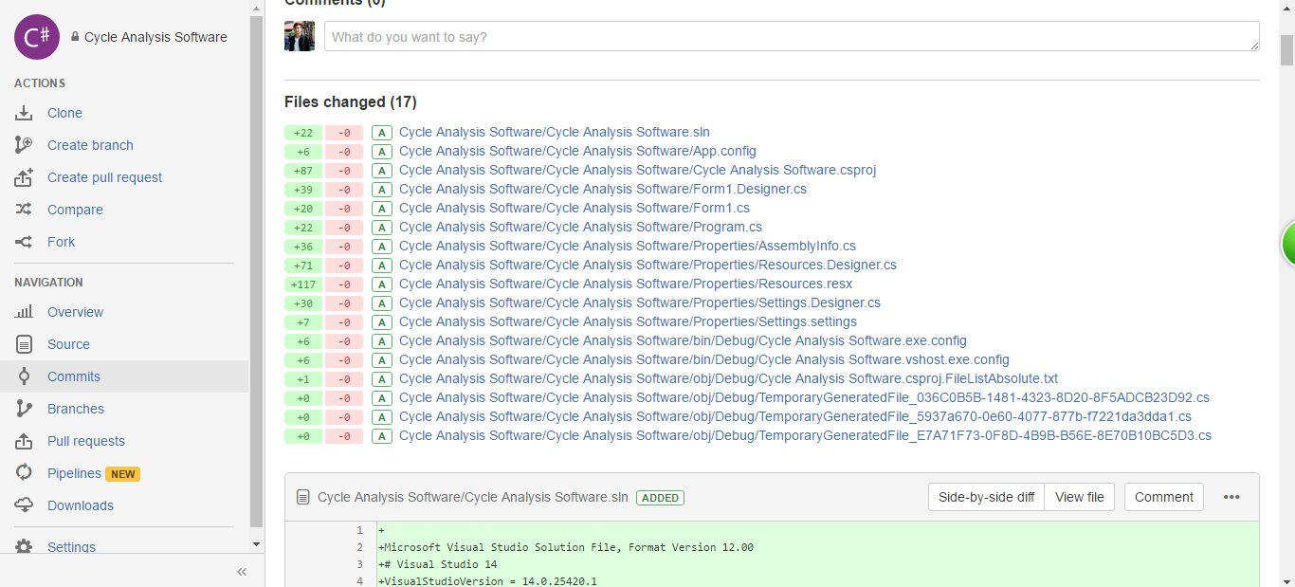

Fig: Sixth Commit