**CMSC 113: Computer Science I**

**Lab #7: Reading Files**

1. Write a program that reads from a file that contains a location (an *x*- and a *y­*-coordinate) and a name. It should then make a label saying *Hello,* and that name.

Consider a file containing the following text:

20 50

Priscilla

The program reading from this file would make a label saying *Hello, Priscilla* at the location (20, 50).

1. Write a program that draws three rectangles of different colors on the applet. The locations and colors of the rectangles will be written in a file. Here is a sample file:

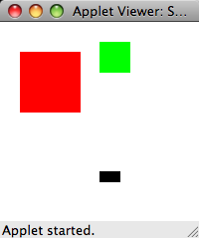

20 30 60 60 255 0 0

100 20 30 30 0 255 0

100 150 20 10 0 0 0

This would produce one rectangle with its upper-left corner at (20, 30), width and height of 60, and colored red. (The color numbers are 255, 0, and 0.) The next rectangle would be at location (100, 20), it would be 30 by 30, and colored green. The last rectangle would be at location (100, 150), it would be 20 pixels wide and 10 pixels tall, and it would be colored black.

1. Change your program in problem above to allow an arbitrary number of rectangles. You may assume that the file contains only complete descriptions of rectangles. (That is, the number of numbers in the file is a multiple of 7.)