**The Fish Passage Extension (FIPEX) for ArcGIS 10.0**

**User Manual**



Acknowledgements 4

DISCLAIMER 5

Preface 6

1. General Timeline of Development 7

2. FIPEX overview 8

Who is the Typical User of FIPEX? 10

3. The Geometric Network Model 11

4. Tool Installation 12

License 12

Software Requirements 12

Hardware Requirements 12

Prerequisites 12

Installing FIPEX 12

Installing the R Statistical software for Windows 13

Configuring FIPEX - Network Build and Options Config Walkthrough 17

Network Creation 17

Quality Control 21

Set up the FIPEX Options 22

Run a One-Click (One Barrier) analysis 23

Uninstalling FIPEX 25

5. Overview of FIPEX Toolset 27

Basic Features 27

Analysis Types 28

Classes 30

Exclusions 30

Polygon Inclusion 30

Advanced Features 32

"Order" of analysis 32

Analysis Direction 33

Output to DBF Tables 33

DCI Calculation 33

6. FIPEX Tools and Commands 35

A. Place / Remove Flag Tool 35

B. Place / Remove Barrier Tool 35

C. Place Flags on Selected 35

D. Place Barriers on Selected 35

E. The FIPEX Menu 36

E1 FIPEX Options 36

E2 Display Arrows 42

E3 Properties 43

E4 Clear Results 43

E5 Clear Barriers 43

E6 Clear Flags 43

F. One-Click Analysis Tool 44

G. Advanced Analysis Command 44

H. Batch Snap Barriers to Points 44

FIPEX Output Form 44

FIPEX Output Tables 46

The Habitat Table 47

The Metrics Table 47

7. A 'One-Click Analysis' Walkthrough 48

8. An 'Advanced Analysis' Walkthrough 51

9. A DCI Calculation Walkthrough 55

10. Getting Started -- Network Building Tips 60

Use a 'File Geodatabase' 61

'Clean' the Dataset Prior to Building the Network 61

Use a Temporary Network to Help 'Clean' the Dataset 62

Problem Lines or Points may Cause Other Features to be Disconnected 64

Check the table of Network Build Errors for Error Codes 64

Deal with 'Loops' or 'Braids' on a Case-by-Case Basis 65

Thoroughly Check for Duplicate (i.e. stacked) Barriers 66

Check with the Data Provider for Hydrographic Specifications 67

Create a separate 'Sinks' layer 67

Create a single sink for multiple watersheds 67

# Acknowledgements

Created by

**Fisheries and Oceans Canada, Habitat Management, Maritimes Region**

Additional Development by

**Parks Canada - DCI Integration and Upgrade from FIPEX version 2.3.x (for ArcGIS) 9.x to FiPEX version 10.x for (ArcGIS 10.x)**

**Greig Oldford - further refinement, development, and support**

Thanks to

**David Longard**

**Donald Sam**

**Peter Rodger**

**David Cote**

**Dan Kehler**

**Koreen Millard**

**Peter Duinker**

**Ken Meade**

**Eldon Gunn**

**Phil Greyson**

**Sebastian Harder**

**Dalhousie University**

**Parks Canada**

**Natural Sciences & Engineering Research Council of Canada**

**Nova Scotia Power Inc.**

Documentation created and updated by:

**Greig Oldford**

**Donald Sam**

This document was last updated Aug 30, 2013

by Greig Oldford

For support contact Greig Oldford at [gr336681@dal.ca](mailto:gr336681@dal.ca)

FIPEX is distributed under a CREATIVE COMMONS License (Attribution 2.5 Canada)

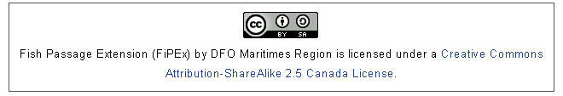

http://creativecommons.org/licenses/by/2.5/ca/

# DISCLAIMER

**Herein, the "AUTHORS" shall refer to any and all contributing authors to the Fish Passage Extension for ArcGIS™ (FIPEX) including but not limited to the individuals, organizations and institutions responsible for funding and development of this product.**

**Herein, the "SOFTWARE PRODUCT" refers to the Fish Passage Extension (FIPEX) "add-in" / extension for the ESRI™ ArcGIS™ Desktop™ Software Suite.**

**The AUTHORS are in no way responsible for the use or misuse of the SOFTWARE PRODUCT. Although all efforts have been made to ensure the proper functioning of the associated SOFTWARE PRODUCT, it is provided by the AUTHORS "as is" and "with all faults." The AUTHORS makes no representations or warranties of any kind concerning the safety, suitability, inaccuracies, typographical errors, or other harmful components of this SOFTWARE PRODUCT. The AUTHORS will not be liable for any damages you may suffer in connection with using, modifying, or distributing this SOFTWARE PRODUCT. In no event, unless required by applicable law or agreed to in writing, shall the AUTHORS or any person be liable for any loss, expense or damage, of any type or nature arising out of the use of, or inability to use the SOFTWARE PRODUCT.**

**PLEASE ADHERE TO THE CREATIVE COMMONS LICENSE (http://creativecommons.org/licenses/by/2.5/ca/) AND ATTRIBUTE THE ORIGINAL AUTHOR. THE ATTRIBUTION CAN BE AS FOLLOWS:**

**Fisheries and Oceans Canada (2011). The Fish Passage Extension (FIPEX). Halifax, Nova Scotia: Fisheries and Oceans Canada, Habitat Management, Maritimes Region.**

# Preface

{ Back to Top }

The extensive fragmentation of river systems due to damming, road construction, and other development is a problem that many governments, communities, and environmental groups are trying to solve. On the path to recovery of longitudinal connectivity (i.e., connectivity from headwaters to ocean / outflow) of river systems many questions arise, including:

*How fragmented is a river system?*

*How much of the fragmentation is due to anthropogenic barriers?*

*How much does each barrier contribute to local fragmentation?*

*How much does each barrier contribute to system-wide fragmentation?*

*How much habitat will be restored or reconnected by a given project?*

*What kind of habitat will be made available?*

*How can limited funds be used most effectively?*

River systems present unique challenges when attempting to assess the impacts of barriers and costs/benefits of habitat restoration and connectivity projects, making answering the above questions difficult, time consuming, or both.  The Fish Passage Extension (FIPEX) is designed to help address these challenging questions. The toolset is designed as an integrated 'Add-in' to the Geographic Information System (GIS) software ArcGIS Desktop™ by ESRI™. It provides basic and advanced tools for assessing river systems with respect to their longitudinal connectivity and can assess individual and cumulative impacts of barriers to fish passage such as dams, weirs, and culverts. FIPEX can be differentiated from other toolsets for river / watershed network analysis in that it leverages the *geometric network* model provided with the ESRI ArcGIS Desktop™ suite.

FIPEX is made freely available courtesy of Fisheries and Oceans Canada and Parks Canada via the ESRI Code Gallery and www.thefishpassageextension.net (pending).

# 1. General Timeline of Development

{ Back to Top }

**2007 - 2008**

* Project Initiated by Fisheries & Oceans Canada, Habitat Management (formerly Habitat Protection and Sustainable Development Division), Maritimes Region under Project Leader David Longard.

**2009**

* A sharealike[1] / attribution agreement is reached between Fisheries & Oceans Canada and Dalhousie University (Masters research of Greig Oldford)

**2009**

* Useability of toolset refined (funded by Fisheries & Oceans Canada)

**2010**

* A sharealike / attribution agreement is reached between Fisheries & Oceans Canada, Parks Canada, and Dalhousie University (Masters research of Greig Oldford).
* Funding contribution from National Science and Engineering Research Council of Canada (NSERC) for Masters research using FIPEX.
* Nova Scotia Power Incorporated extends data sharing agreement for testing and refinement of toolset.
* Parks Canada funds further development.
* The DFO American Eel Decision Support Toolset is renamed the Fish Passage Extension (FIPEX).

**2011**

* Parks Canada funds further development.
* A Creative Commons Canada 2.5 (attribution) license is approved by Parks Canada and Fisheries and Oceans Canada.
* Free distribution of FIPEX software and source code over the web and via the ESRI Code Gallery is approved by Fisheries and Oceans Canada.

**2012**

* Parks Canada funds the upgrade of FIPEX to be compatible with ArcGIS 10.x, the integration of Dendritic Connectivity Index calculation, and refinement of system-level analyses.
* Logo redesign by Sebastian Harder (Sebazistan.com) - donation of service
* Refinement of additional tools for river analysis by Greig Oldford: 'distance to source', 'distance to sink', output table refinement (database normalization), options menu overhaul, 'visualize network' tool, code optimization and main algorithm overhaul.
* Parks Canada approves distribution via standalone website, thefishpassageextension.net

# 2. FIPEX overview

{ Back to Top }

The Fish Passage Extension for ArcGIS (FIPEX) is a GIS toolset for assessing the effects of watercourse obstacles on the ability of fish to travel within a watershed, and the connectivity of a river system as a whole. The toolset was developed at Fisheries and Oceans Canada (Maritimes Region) by the Habitat Protection and Sustainable Development Division as a decision support tool to assist in the process of identifying sites where habitat restoration actions would provide the most benefit to eels and other fish species of concern.  See

for further details.

FIPEX offers the ability to quantitatively assess the effects of real or anticipated barriers. The following main features are provided:

1. Summarize habitat quantity affected by one or many barriers, with *habitat affected* defined as one or all of:
2. habitat immediately upstream of a barrier (until the next barrier or headwaters)
3. habitat immediately downstream of a barrier (until the next barrier or headwaters)
4. total habitat upstream of a barrier (ignoring all other barriers)
5. total habitat downstream of a barrier (with the flow of the system, until the ocean / sink)
6. total habitat downstream of a barrier (ignoring the flow of the system)
7. Define *habitat quantity* in one or many ways:
8. As linear network (e.g., metres)
9. As polygonal / area network (e.g., hectares)
10. Including all features
11. Excluding certain features (e.g., stillwater, wetland, lake 'spines')
12. Sub-categorize network using user-defined classes (e.g., lakes, river, wetland, urban area).
13. Exclude certain barriers (e.g., waterfalls) from analysis without a network rebuild.
14. Assess the contribution of one or many barriers to overall systemic connectivity using the Dendritic Connectivity Index (DCI).
15. Assess a whole watershed / river system for systemic connectivity using the Dendritic Connectivity Index (DCI).

## Who is the Typical User of FIPEX?

{ Back to Top }

Ultimately, the goal of FIPEX is to provide the everyday user with a decision support tool for fish passage and riverine connectivity assessment. However, as of version 10.1, FIPEX is suited for the intermediate to advanced user of ArcGIS™. Typically, the user of FIPEX is a GIS technician or GIS specialist. Familiarity with the geometric network model (usage of the Utility Network Analyst toolbar) is an asset. After a river network is created, barriers are organized and labelled, quality assurance on the data is done, FIPEX is installed, options are set, and preliminary tests are done, a relatively unskilled user can conduct analyses using FIPEX. However, the flexibility offered by the toolset and advanced options such as coupling with the statistical software, 'R', mean that the typical user should have experience with ArcGIS and technical knowledge of windows-based software and operating systems.

# 3. The Geometric Network Model

{ Back to Top }

FIPEX can be used with a hydrological dataset which is registered and modified as a *geometric network* by the ESRI ArcGIS™ program*.* As such,FIPEX requires the creation of a geometric network using the *Build Geometric Network Wizard* provided in the ArcCatalog™ program (a part of the ArcGIS Desktop™ suite). The geometric network is used for 'tree' or dendritic networks -- for example, water distribution, power distribution, or river networks. The *Utility Network Analyst Extension* / Toolbar is provided with the most basic ArcGIS Desktop™ license and contains many tools to perform simple tasks such as network tracing and connectivity troubleshooting. The geometric network model is *not* the same as the network model provided by ArcGIS™ for use with the *Network Analyst™* extension which is used primarily for road network analysis and routing (an upgrade / add-in requiring an additional purchase from ESRI).

To create a geometric network requires a second-tier ArcGIS™ license:

" Although geometric networks can be both created and edited in ArcGIS for Desktop Advanced and Standard, they are read-only in Basic." -- ESRI ArcGIS Resources Website, 2012

For more information on geometric network creation, editing, and troubleshooting:

http://resources.arcgis.com/en/help/main/10.1/index.html#//002r00000008000000

http://resources.arcgis.com/en/help/main/10.1/index.html#//00170000015t000000

# 4. Tool Installation

{ Back to Top }

## License

Prior to installation please read and accept the disclaimer and license. The FIPEX toolset is provided as is, where is (see DISCLAIMER)

When redistributing this software, leveraging it, or presenting results based on the usage of this software we request that you adhere to Creative Commons license and provide attribution to:

**Fisheries and Oceans Canada (2011). The Fish Passage Extension for ArcGIS (FIPEX). Fisheries and Oceans Canada, Habitat Management, Maritimes Region.**

## Software Requirements

* Windows XP or Windows 7 Operating System (Windows Vista may work, but is untested)
* ArcGIS 10.x Desktop™ Installed (Standard level license preferred)
* The Microsoft .NET framework 3.5+ installed.

## Hardware Requirements

* A PC Computer with 1Gb+ RAM
* 2.4Gb+ disk space (requirement for operation of ArcGIS)
* CPU Speed 2.2Ghz+

## Prerequisites

Prior to installation, ensure that the following requirements are met:

* ESRI™ ArcGIS™ 10.x is installed
* ArcMap™, ArcCatalog™ and all other ArcGIS™ products are not running.
* You have Administrator level privileges on your computer.

## Installing FIPEX

{ Back to 4: Tool Installation }

(If there is a version of FIPEX already installed on your desktop computer, to remove previous version see Part 3.)

1. If you have downloaded a ZIP (compressed) file containing FIPEX, extract it to a secure directory on your local machine.

2. Navigate to that directory and double click the file with the esriAddIn file extension.

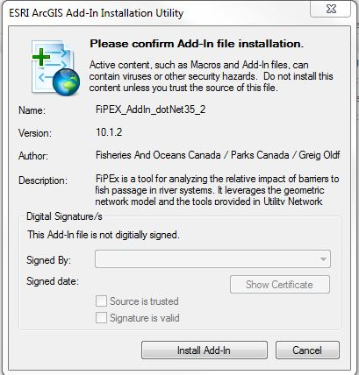

3. If you wish to calculate the **Dendritic Connectivity Index** (DCI), install the 'R' program (version 2.11.1) that is bundled and distributed with FIPEX follow these instructions, otherwise skip to step 4.

### Installing the R Statistical software for Windows

{ Back to 4: Tool Installation }

NOTE: FIPEX and R do not work well together at ArcGIS version 10.1 and above. To date, only ArcGIS version 10.0 works with R. Other functions of FIPEX are known to work beyond ArcGIS 10.0, but calculations of the DCI will not.

a) Double-click the **R-2.11.1-win32.exe** (do not install the 64bit version - ArcGIS is 32bit and will not be able to call a 64bit program).

b) Install the required **RBGL** and **Graph** packages -->

c) Launch the **'RGui'** Program (In the **'Start Menu'** under '**R**', you should see the program R.2.11.1 - run this).

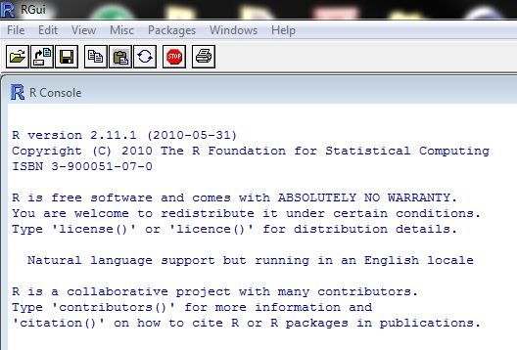

d) Go to the **'Packages'** Menu -> **'Set Cran Mirror'**

e) Select a server nearby and click **OK**

f) Go to **'Packages'** -> **'Install Packages**...'

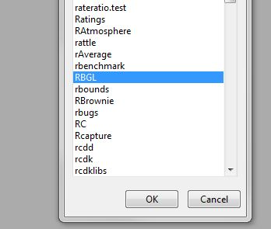

g) Select **RBGL** and click **OK**

h) Go to **'Packages'** -> **'Install Packages**...'

i) Select **'Graph'** and click **OK**

NOTE: FIPEX requires R version 2.11.1 (not a more recent version) and an error will result if a later version is installed. If you do not see these packages, check that you have R version 2.11.1 Installed. If not, you will need to install this version.

j) To test package install click the menu **'Packages'** -> **'Load Package'** and select **RBGL** and click **OK**. Repeat with **'Graph**.' This should not raise an error.

k) **Important**: Cut and paste the entire ***DCI Model Files Directory*** to a permanent local directory in which you have 'write' permissions (e.g., /My Documents)

4. Open **ArcMap**

5. Go to the **'Customize'** Menu -> **'Add-In Manager'**

6. You should now see FIPEX in the manager (ignore digital signature warning)

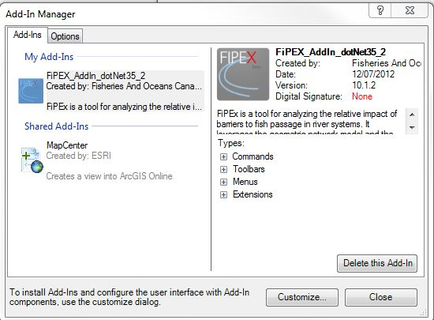

7. Look at second tab **'Options'**: check that **'load all add-ins without restrictions'** is checked.

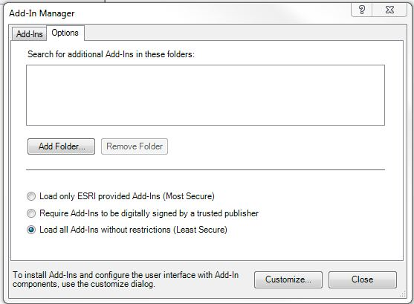

8. Go to **'Customize'** -> **'Extensions'** and check *The Fish Passage Extension Add-In for ArcMap.*

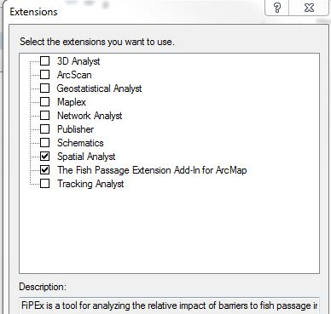

9. Go to **'Customize'** -> **'Toolbars'**

10. Check that the ***FIPEX*** Toolbar is activated. Also activate the ***Utility Network Analyst Toolbar***.

11. The FIPEX Toolbar should now be present but inactive. It will remain inactive until it detects a layer that is a member of a geometric network is present in the map document.

InactiveToolbar.JPG

## Configuring FIPEX - Network Build and Options Config Walkthrough

{ Back to 4: Tool Installation }

A demo dataset has been provided to help explain and configure FIPEX. In the directory that FIPEX was downloaded you should find an .MXD file (ArcMap document) and a geodatabase. This brief walkthrough will help set up the FIPEX 'Options' , demonstrate the construction of a simple geometric network (a requirement in order to set FIPEX Options), and do a simple analysis. Prior to opening this MXD, follow the instructions below for Network Creation.

1. Close **ArcMap**

2. Open **ArcCatalog** (note: the full version, not from within ArcMap)

3. Navigate to the FIPEX install directory and into the demo geodatabase (named similar to *'FIPEX_DemoDataVer10_Dec1212.gdb'*)

4. Inside you should see the **'ForDemo'** dataset.

5. Inside the **'ForDemo'** dataset you should find three layers: **'RiverLines'**, **'RiverDams'**, and **'RiverSinks'**

### Network Creation

{ Back to 4: Tool Installation }

6. We will create a geometric network. You must have appropriate Standard-level ArcGIS Desktop™ License activated to continue. If you are unable to create a geometric network following the instructions here, it may be due to license restrictions.

7. Right-click anywhere in the **'Contents'** view of the ***'ForDemo'*** dataset (not on a layer)

8. Go to **'New'** -> **'Geometric Network'**. You should see the Wizard Screen.

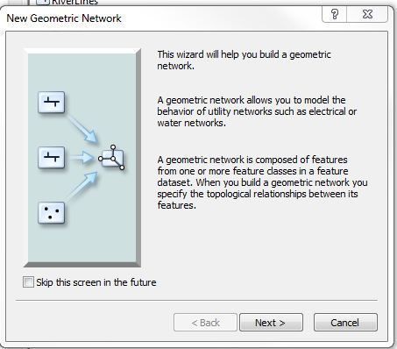

9. Click **Next** (accept defaults; FIPEX uses SIMPLE networks only, not COMPLEX).

10. Check all three layers.

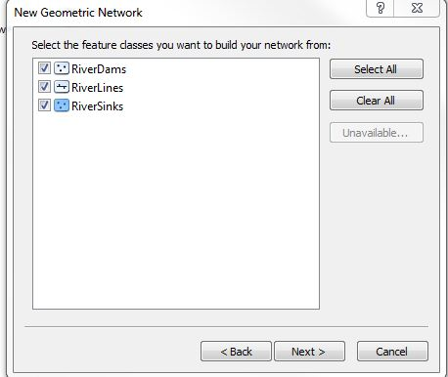

11. Click **Next**

12. Click **Next** (accept defaults)

13. Set the **'RiverSinks'** layer as **'Sinks'**=Yes

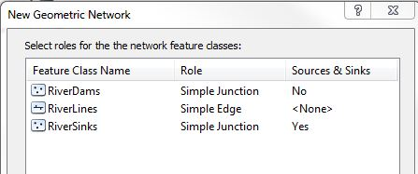

NOTE: FIPEX only uses SIMPLE junctions and edges. Do not use complex junctions and edges.

14. Click **Next**

15. Click **Next** (FIPEX does not use Network Weights)

16. Click **Finish**. The network should built. Notice that the geometric network wizard has built two additional layers: the 'junctions' layer, and a pseudo-layer called 'ForDemo_Net_Junctions.

NOTE:

1. A geometric network cannot include layers from more than one dataset.
2. There may only be one geometric network per dataset.
3. One layer may not participate in more than one geometric network.
4. Networks cannot have layers added to them after they are built - they must be rebuilt (deleted and rebuilt).
5. In network creation, points can be snapped to lines and vice versa, using topological rules set for the dataset -- but this is not recommended; it is recommended the data are 'cleaned' beforehand.
6. Geometric Networks must be created within a Feature Dataset within a geodatabase ('File' geodatabase is preferred).

For more information on geometric networks visit

http://resources.arcgis.com/en/help/main/10.1/index.html#//002r00000008000000

http://resources.arcgis.com/en/help/main/10.1/index.html#//00170000015t000000

17. Open **ArcMap**. Open the FIPEX_InstallDoc.mxd document.

18. You should see the three layers: RiverSinks, RiverDams, RiverLines. These layers now participate in the geometric network, 'ForDemo_Net_Junctions', so the FIPEX Toolbar is now active. The Utility Network Analyst Toolbar should also should the 'ForDemo_Net' network active.

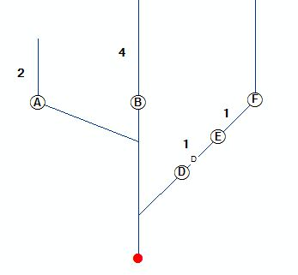

19. Go to the FIPEX toolbar, **'Menu'** -> **'Display Arrows'**. Notice black circles positioned mid-line denote indeterminate flow. In a newly created geometric network this is normal.

20. Set the 'flow direction' of the geometric network. You will have to start an edit session to do this. In the 'List by Drawing Order' view of the Table of Contents, right-click any one of the layers and click **'Edit Features'** -> **'Start Editing'**

21. The **'flow direction'** is set using the **Utility Network Analyst Toolbar**. The **'Set Flow Direction**' button should now be active. Click this button.

setlow.JPG

22. The circles should now change to arrows.

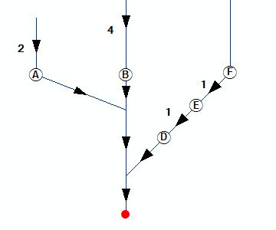

NOTE: FIPEX determines flow direction based on NETWORK TOPOLOGY. It is not set based on elevation or digitized direction. If there are loops / braids in network, this can cause 'indeterminate flow' which is represented by circles.

23. **Save Edits** and **Close Edit Session**. Note that barriers A thru F should be visible and labeled. The RiverDams layer contains these barriers. During network creation, these barriers would have 'broken' the river lines which they fall upon. The number labels represent line length (used next).

### Quality Control

{ Back to 4: Tool Installation }

24. Do a quick quality control analysis with the Utility Network Analyst tools. Place a flag on the sink (colored red). Do this by clicking on the **'Add Junction Flag Tool'** (there is a similar tool in FIPEX, but use this one for now).

PlaceFlagtool.JPG

25. A green box (called the 'flag') should appear. This is a the analysis 'start point'. A number of options are now available in the Utility Network Analyst toolbar. Select **'Find Connected'**.

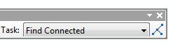

26. Click the **'Solve'** button next to it. All network elements connected to the flag will be highlighted red.

set prior to analysis.

NOTE: The trace functions of the geometric network will not 'see' barriers unless they are set active by placing barriers on the network.

27. Clear the results. You can use the FIPEX menu to do this. Click **'Menu'** -> **'Clear** **results'**

28. Clear the flags. You can use the FIPEX menu to do this. Click **'Menu'** -> **'Clear Flags'**

29. With the **'Set Junction Flag'** tool, flags can only be set, they cannot be cleared. They also remain unlabeled. The FIPEX **'Place / Remove Flag'** tool can alternatively be used, which can set, remove, and label the flag. Set the flag using this tool on the sink again.

flags.JPG

30. Place a single barrier (red 'X') on barrier D using the FIPEX **'Place/Remove Barrier'** tool. This effectively turns barrier D 'On'. (turn off **'display arrows'** in the FIPEX dropdown menu)

NOTE: The Utility Network Analyst functions, 'Find Connected' and 'Find Disconnected' are especially useful in troubleshooting disconnected network elements during network creation and quality control.

NOTE: FIPEX can only 'see' Junction barriers - barriers and flags must be placed on existing nodes or barriers, and not on line edges.

31. Do a second quick quality control test, again using the Utility Network Analyst toolbar trace 'Find Connected'. Select **'Find Connected'** and click **'Solve'**. All network 'beyond' barrier D should now be inaccessible and therefore not connected.

### Set up the FIPEX Options

{ Back to 4: Tool Installation }

32. Click **'Menu'** -> **'Options'** on the FIPEX toolbar.

33. You will see four tabs. The menu is described in more detail in later sections. For now the **General Tab** settings determines which habitat layers are used in the analysis, and the **'Barriers Tab** contains settings for barriers used in the analysis.

34. In the **General Tab**, click the checkbox next to River Lines. Highlighting this layer will activate the **'Change'** button.

NOTE: Lines will only appear in the 'Line Layers' box if they participate in a geometric network.

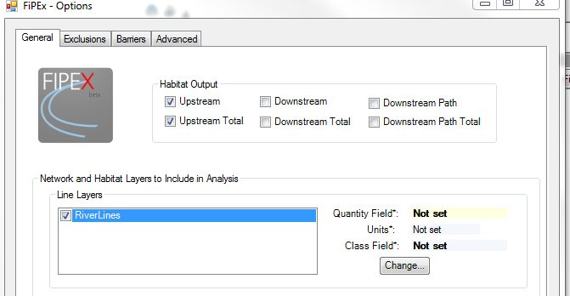

35. Click the **'Change'** button. Select *'LengthPrio_Demo'* as the **'Quantity'** -- this determines what field in the layer attribute table will be used to summarize habitat quantity. The simplest option is length. Select '*<none>*' for the **'class'** field. Select **'Metres'** for the **Units**. Click **'Save'**

36. Click the **'Barriers'** Tab. Check **'RiverDams'** as a barriers layer.

37. Select a field to use to uniquely identify barriers in analysis output. Click **'Change ID Field**' and select the field ***'Label'*** and click **'Save'**.

NOTE: all settings are saved with the MXD file. Most settings will only have to be set once for given river system.

38. Click 'Save Settings'

### Run a One-Click (One Barrier) analysis

39. The FIPEX **'One Click Analysis'** tool is meant for a quick assessment of a barriers. Select this tool from the toolbar.

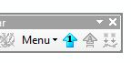

40. Click on a barrier in the network. You should see a brief analysis run followed by a FIPEX Results Summary Form.

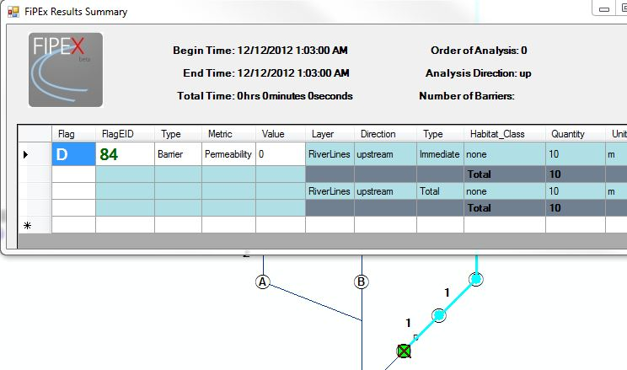

NOTE: The results returned (direction and type) are determined by the settings in the 'General' Tab

This was a first and general introduction to some of the FIPEX functionality and tools. Advanced analysis, multi-barrier analysis, Dendritic Connectivity Index calculation, and other analyses are discussed later.

ADDITIONAL NOTES:

-- FIPEX is not well-equipped to handle more than one geometric network in a given ArcMap data frame. It is recommended that layers included in the data frame only participate in a maximum of one geometric network and that network be common among all participating layers.

-- Avoid using 'group layers' for layers that participate in geometric networks -- they have been known to cause issues.

-- Web layers, such as those found on ArcGIS Online, have been known to cause problems with FIPEX, though not always. If you encounter errors, try removing these from the map.

## Uninstalling FIPEX

{ Back to 4: Tool Installation }

1. FIPEX can be removed by opening ArcMap, clicking **'Customize'** -> **'Add-In Manager'**.

2. Under **'My Add-Ins'** select FIPEX_AddIN_dotNet35_2 (or similar) and click **'Delete this Add-In'**

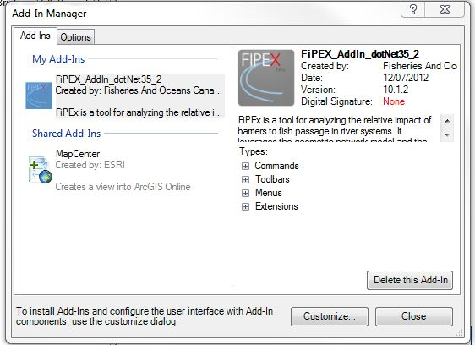

3. Prior to closing ArcMap, click **'Customize'** -> **'Extensions'** and uncheck the Fish Passage Extension for ArcMap.

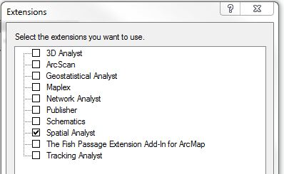

# 5. Overview of FIPEX Toolset

{ Back to Top }

FIPEX is provided as a toolbar for ArcGIS. This toolbar contains a number of tools, scripts, menus, and commands which makes analysis of river systems with respect to their *longitudinal connectivity* easier.

**FIPEXTOols.JPG**

## Basic Features

{ Back to 5: Overview of FIPEX Toolset }

Basically, FIPEX automates and 'batches' commands and analyses that are possible in ArcGIS without FIPEX but would take a long time. There are also other, more advanced features.

For example, if you wish to know what network lines are upstream of a barrier, grouped by feature type (from a code assigned to each line feature), *without* FIPEX you would need to:

(assuming a geometric network is built)

1. Place a flag on the barrier
2. Perform a **'Trace Upstream**' analyis with results returned as selection using the Utility Network Analyst.
3. Run a **'Summarize'** analysis on the feature type field in the attribute table.

*With* FIPEX you would:

(assuming FIPEX options are set)

1. Click on the barrier with the **One-Click Analysis** tool.

Another example: setting barriers 'on' in the geometric network. If you had 100 barriers, *without* FIPEX you would need to:

1. Click on the barrier with the **'Junction Barrier**' tool.
2. Repeat this 100 times.
3. Repeat this each time the map is opened

*With* FIPEX you would:

(assuming FIPEX options are set)

1. Select all barriers you wish set.
2. Click the **'Barriers on Selected'** button **barriersselected.JPG**
3. Save the map (barriers are saved in the MXD and do not need to be reset next time)

### Analysis Types

FIPEX will perform analysis for a single barrier, presenting results in an output form and in non-spatial database tables. The standard metrics on each barrier are:

* **immediate upstream** **network,** until the next upstream barrier(s):

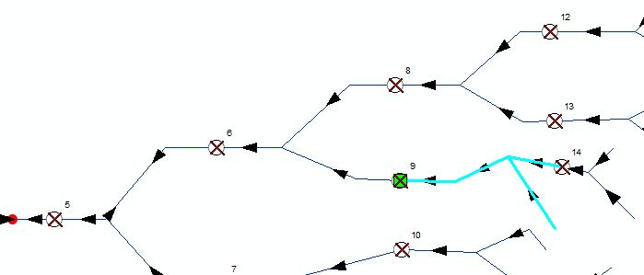

* **total upstream** **network,** ignoring all upstream barrier(s):

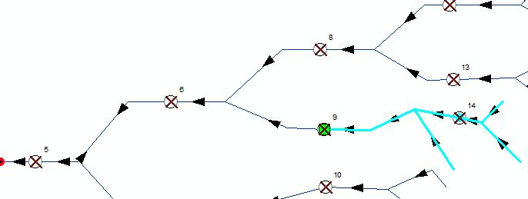

* **immediate downstream** **network** **with network flow**, until the next downstream barrier:

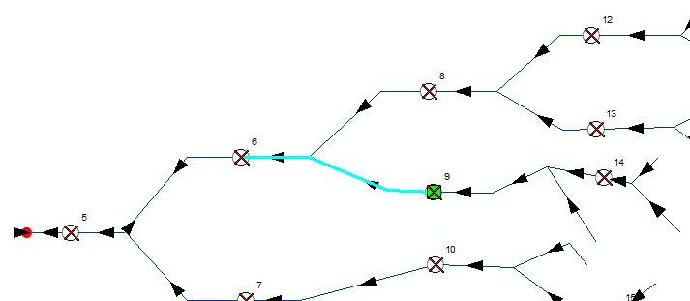

* **total downstream** **network** **with network flow**, ignoring the next downstream barrier:

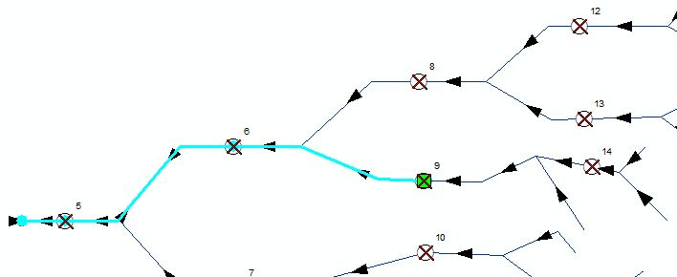

* **immediate network** **downstream**, **ignoring network flow**, until the next barrier(s):

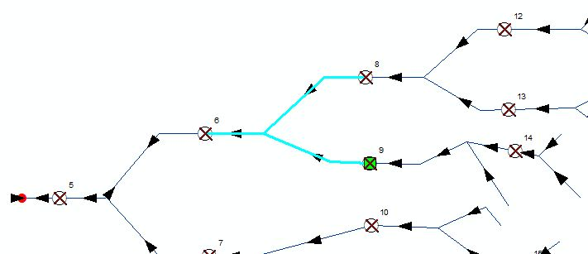

* **total network downstream**, **ignoring network flow,** ignoring the next barrier(s) encountered:

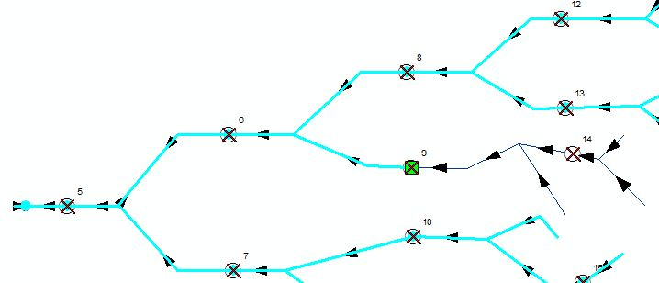

### Classes

FIPEX offers the ability to define 'classes' for the output. This effectively summarizes network returned from the analysis. For example, river network may be summarized by 'large river', 'small river', or 'stream'. Alternatively, river network may be summarized by 'Stream order = 1', 'Stream order = 2', 'Stream order = 3' , etc.

### Exclusions

Certain features may be excluded from analysis. For example, a common exclusion are lines features that run through waterbodies such as lakes. These are sometimes referred to as 'lake spines' and are unrepresentative of stream or river length. If they have been identified by a unique code in the layer's attribute table, then they may be excluded from the analysis.

### Polygon Inclusion

Geometric networks are not able to accommodate inclusion of polygons -- they maintain only node-edge topology. FIPEX can optionally include polygonal layers and features into the analysis by 'intersecting' them with the lines features of the geometric network. For example, lakes may be included by setting this in the FIPEX options menu:

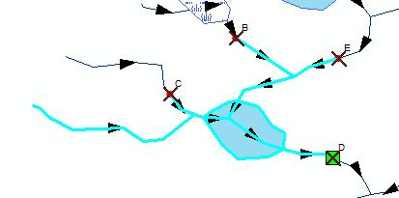

Resulting analyses will summarize lake surface area in the output:

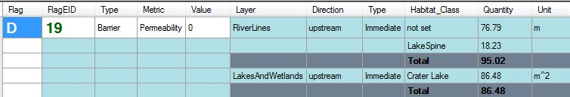

NOTE: A powerful combination is the polygon inclusion with line exclusion. If a line runs through a polygon, exclude that length but include the polygon total. As such, a river system can be analyzed returning only network area rather than length (if the area data are available.

## Advanced Features

{ Back to 5: Overview of FIPEX Toolset }

The most common 'Advanced' feature used with FIPEX is iteration of basic analyses like those described in the 'Basic Features' section. Typically, this is for a large number of barriers or an entire river system. By setting one flag on the 'sink' of the network, a user can run an **'Advanced Analysis'** on all barriers encountered on that river system (avoiding repetitive analysis of one barrier at a time).

The Advanced analysis button: advancedanalysisbutton.JPG

The Advanced Analysis Options Tab in the FIPEX Options menu:

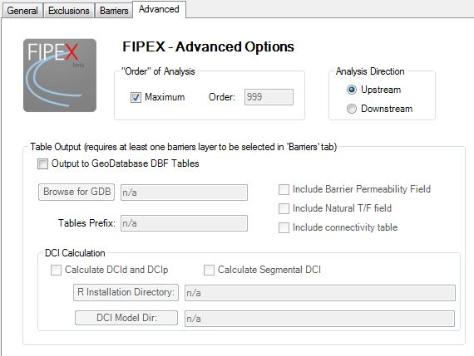

### "Order" of analysis

The "**Order**" of analysis is the limit of number of sibling barriers in the direction of analysis that the FIPEX algorithm will iterate in an 'Advanced Analysis.' In the image below, the orders of the barriers (red circles) with respect to the system sink (green square) are labeled.

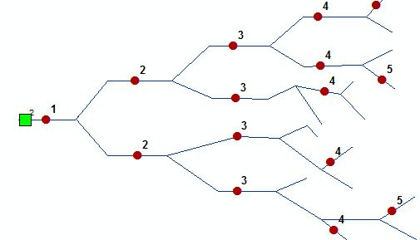

### Analysis Direction

Determines which direction from the flag the analysis iterates. For example, if the user was interested in how many barriers were between a barrier in the upper reaches of a watershed and the ocean, they may choose an iterative downstream analysis.

### Output to DBF Tables

DBF Tables are non-spatial tables compatible with Microsoft Excel, stored here in an output geodatabase. Optionally, three tables are created: Connectivity, Habitat, and Metrics. These tables are designed to be relational (to each other or to barrier layers) and can be used for further analysis.

### DCI Calculation

The Dendritic Connectivity Index (DCI) is a scaled index of connectivity (Cote et al., 2009[2]). It measures the likelihood that a fish can move from a point in the river system to any other point in the river system. There are three measures: the DCI for diadromous fish movement (movement between the river system and the ocean), the DCI for potadromous movement (for within the system only), and the segmental DCI (for the connectivity of individual reaches of river).

The DCI requires the R Statistical software program (http://www.r-project.org/). If R is installed on the local machine (see Installing the R Statistical software for Windows for details) then FIPEX can call upon R to calculate these statistics during the Advanced Analysis. The resulting DCI statistics are output to a form and to the Metrics table.

# 6. FIPEX Tools and Commands

{ Back to Top }

FIPEXTOols.JPG

**A B C D E F G H**

## A. Place / Remove Flag Tool

{ Back to 6: FIPEX Tools and Commands }

Places or removes a single junction flag on a point in the network. Also labels or removes the label for that flag. Labels are set based on the 'Barrier ID' selected in FIPEX Options.

NOTE: Only existing network points can be used as flags (start points) with FIPEX.

## B. Place / Remove Barrier Tool

{ Back to 6: FIPEX Tools and Commands }

Places or removes a single junction barrier on a point in the network. Also labels or removes the label for that barrier. Labels are based on the 'Barrier ID' selected in FIPEX Options.

NOTE: Only existing network points can be used as barriers with FIPEX.

## C. Place Flags on Selected

{ Back to 6: FIPEX Tools and Commands }

Places flags on all selected junctions / points that participate in the geometric network. Also labels flags. Labels are based on the 'Barrier ID' selected in FIPEX Options.

NOTE: Only existing network points can be used as flags (start points) with FIPEX.

## D. Place Barriers on Selected

{ Back to 6: FIPEX Tools and Commands }

Places barriers on all selected junctions / points that participate in the geometric network. Also labels barriers. Labels are based on the 'Barrier ID' selected in FIPEX Options.

NOTE: Only existing network points can be used as barriers with FIPEX.

NOTE: Labels are applied by creating a label 'class' in the layer(s) properties. The layer class is called "BarrierOrFlagID" with particular features selected using a custom SQL Query.

## E. The FIPEX Menu

{ Back to 6: FIPEX Tools and Commands }

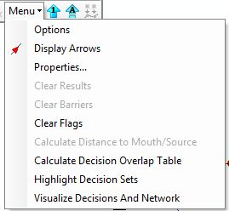

E1

E2

E3

E4

E5

E6

### E1 FIPEX Options

The FIPEX Options Menu contains four tabs: General, Exclusions, Barriers, Advanced.

**NOTE:** The settings in this menu are stored with the FIPEX Extension properties and are ultimately stored in the MXD document. This means that for a particular network or configuration, many of the settings in this menu will need to be set only once.

#### The General Tab

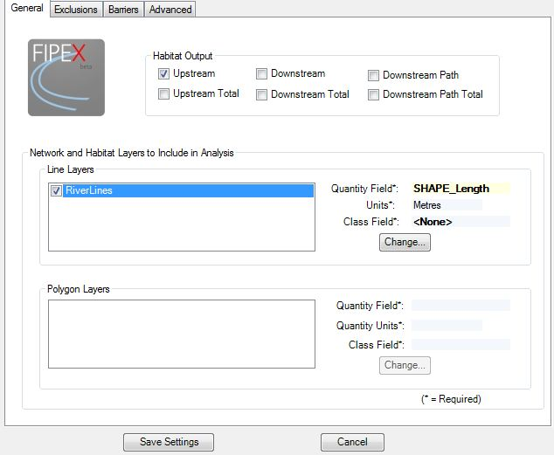

The settings in the FIPEX General Tab are essential to set prior to running any analysis. The ***Habitat Output*** checkboxes dictate the type(s) of traces performed in both the *One-Click Analysis* and the *Advanced Analysis*. For an explanation of each trace type see Analysis Types.

The ***Network and Habitat Layers to Include in the Analysis***determines which layers will be used in the analysis to generate results. The '***Change****..'.* button will provide a pop-up window to select:

1. ***Quantity Field:*** The field used to total network quantity (this field should be of type 'Integer' or 'Double')
2. ***Units:*** This field specifies the units of the quantity field.
3. ***Class:*** The class field is used to separate and summarize output results. For example, this field may represent Stream Order or feature type (e.g., lake, stream, river).

#### The Exclusions Tab

The Exclusions Tab is used to set which features within the participating feature layers for the analysis will be excluded from the results. These settings apply to both the *One-Click Analysis* and the Advanced Analysis.

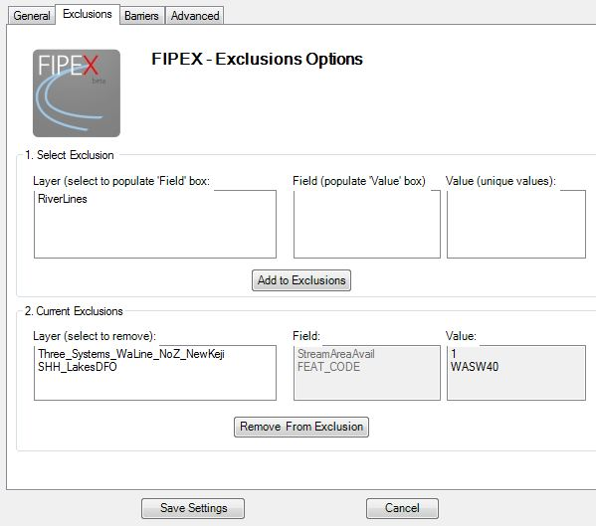

The ***Select Exclusion*** section is where the particular feature code can be selected. To set an exclusion:

1. Select the layer in the ***Layer*** box of section 1.
2. Select the field in the ***Field*** box of section 1.
3. Select the unique value from that field in the ***Value*** box of section 1.
4. Click ***'Add to Exclusions'*** .
5. Click 'Save Settings'.

To remove an exclusion:

1. Click the layer in the **Layer** box of section 2. Corresponding Field and Value should highlight.
2. Click **'Remove From Exclusion'**
3. Click **'Save Settings'.**

#### The Barriers Tab

The Barriers Tab is used to determine which barriers get reported in the results. It is also used to select the 'Barrier ID' (used for labels and output identification), the 'Permeability' field (used in *Advanced Analysis*), and the 'Natural T/F' field (used in *Advanced Analysis*).

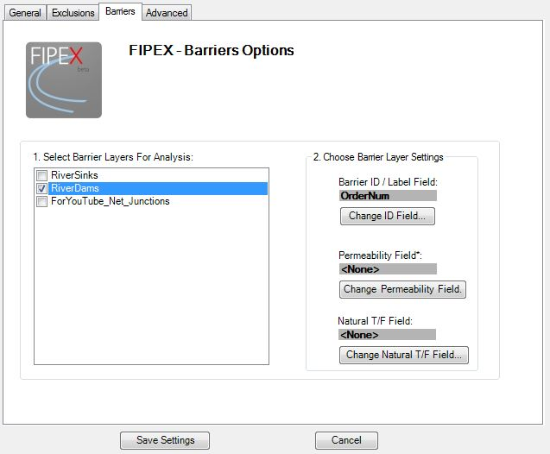

To select the 'Barrier ID', 'Permeability', and 'Natural T/F', buttons that provide a pop-up form that allow you to select from the available fields in the attribute table of the layer selected in ***Select Barrier Layers For Analysis*** section.

**NOTE:** The Barrier ID refers to the user-readable output ID. FIPEX will also report an ID called the 'EID'. This refers to the 'Element ID' of the feature in the geometric network. The 'EID' is used to avoid problems due to barriers with duplicate user-specified ID's. Take note that while the user-set Barrier ID will stay consistent, the EID of barriers may change with any edit to the geometric network.

**NOTE:** Barrier ***permeability*** refers to the degree of impairment a barrier presents to fish passage or longitudinal connectivity of the river system. It is used in various analyses as a 'weight' to help assess the relative impacts of barriers.

The ***Natural T/F*** field is a boolean (i.e. true/false) field that specifies whether a barrier is naturally occurring (as opposed to anthropocentric). Some analyses exclude these types of barriers.

#### The Advanced Tab

The Advanced Tab sets options that are only used in the *Advanced Analysis* of FIPEX.



The ***"Order" of Analysis*** section sets the maximum number of iterations in the direction of the analysis (set in the *Analysis Direction* section) that the FIPEX *Advanced Analysis* algorithm will proceed.



In the image above, the order of the barriers (red circles) upstream of the sink (green square) are labeled. If the ***Maximum*** checkbox is checked, the traces in the analysis direction will proceed until the end(s) of the network are reached.

The ***Analysis Direction*** is the direction from the flag(s) (i.e. start point(s)) that the Advanced Analysis algorithm will proceed. This direction is based solely on flow direction as set in the geometric network.

**NOTE:** The ***Analysis Direction*** is different from the ***Habitat Output*** trace types found in the General Tab.

An example: If all six ***Habitat Output*** trace types are checked in the General Tab and the ***Analysis Direction*** is set to 'Upstream' in the Advanced Tab, the FIPEX ***Advanced Analysis*** will perform all six trace types for a given barrier and then proceed to perform all six trace types for the ***next barrier(s) encountered upstream****.* It will continue to do this until the ***'Order' of Analysis*** is exceeded or the end(s) of the network is reached.

The ***Table Output*** section sets parameters for the output from FIPEX *Advanced Analysis* to non-spatial geodatabase tables.

* ***Output to Geodatabase DBF Tables*** checkbox: Determines whether these tables will be generated.
* ***'Browse for GDB'*** button: Provides a pop-up window to select the output geodatabase. ***'Tables Prefix'***: the user-determined prefix for the output table names.
* ***Include Barrier Permeability Field***: determines whether output tables will include the barrier permeability which must be specified in the Barriers Tab.
* ***Include Natural T/F Field***: determines whether this parameter will be included in the output tables.
* ***Include Connectivity Table***: determines whether a table containing the connectivity of barriers on the network will be generated.

**NOTE:** Barrier ***permeability*** refers to the degree of impairment a barrier presents to fish passage or longitudinal connectivity of the river system. It is used in various analyses as a 'weight' to help assess the relative impacts of barriers.

The ***Natural T/F*** field is a boolean (i.e. true/false) field that specifies whether a barrier is naturally occurring (as opposed to anthropocentric). Some analyses exclude these types of barriers.

The ***DCI Calculation Section*** determines whether the Dendritic Connectivity Index (DCI; Cote et al., 2009) will be calculated and output. The R Statistical Software (See **Installing the R Statistical software for Windows)** must be installed on the computer in order to calculate the DCI. The three checkboxes in the above section (for Barrier Permeability, Natural T/F Field, and Connectivity table) must also be checked to enable this section.

In brief, the DCId and DCIp are measures of the longitudinal connectivity of the system. The DCI Segmental is a measure of the relative connectivity of segments within the system. The statistics are provided as an index from 0 - 100 with 100 being 100% connected. For an explanation and walkthrough see 9. A DCI Calculation Walkthrough.

The ***R Installation Directory*** button sets the location of the R program on the local system. As is specified in the **Installing the R Statistical software for Windows** Section the current version used for DCI Calculation is R 2.11.1. The button provides a pop-up window to navigate to the R installation directory. Select this directory.

**NOTE:** FIPEX looks for the DCI Program rterm.exe in the /bin directory of the R Installation directory you provide.

The ***DCI Model Directory*** button provides a pop-up browse window to locate the directory of the DCI Model files provided with FIPEX. *You must have read/write access to this directory.*

### E2 Display Arrows

The Display Arrows button will toggle display of network flow arrows. This button is identicle to the one provided with the Utility Network Analyst toolbar.

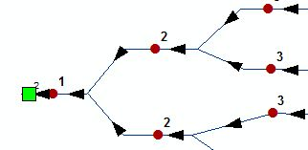

### E3 Properties

The **Properties** menu in the FIPEX dropdown menu allows you to set the style of the network flow arrows. This menu is identical to the one provided in the Flow dropdown menu of the Utility Network Analyst toolbar.

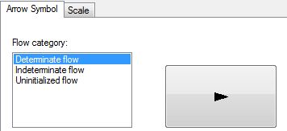

### E4 Clear Results

The Clear Results button in the FIPEX dropdown menu will clear all highlighted results returned by an analysis. This button is identical to the one on the Utility Network Analyst Toolbar.

### E5 Clear Barriers

The Clear Barriers button will clear all network barriers. It also clears the labels for the barriers.

### E6 Clear Flags

The Clear Flags button will clear all network flags. It also clears the labels for the flags.

## F. One-Click Analysis Tool

{ Back to 6: FIPEX Tools and Commands }

With the ***One-Click Analysis*** tool a quick analysis can be done for a single barrier or non-barrier junction on the network. This tool uses the settings found in the General tab, the Barriers tab, and the Exclusions tab of the FIPEX Options Menu. It does not use the settings in the Advanced tab. See A 'One-Click Analysis' Walkthroughfor a walkthrough of a One-Click Analysis.

## G. Advanced Analysis Command

{ Back to 6: FIPEX Tools and Commands }

The ***Advanced Analysis*** command will start an iterative analysis for multiple barriers and multiple flags. This command uses the settings from the Advanced Tab of the FIPEX Options (see **The Advanced Tab**). Output will be optionally sent to non-spatial geodatabase tables (for an explanation of table output see FIPEX Output Tables). The DCIp, DCId, and DCI segmental will optionally be calculated (DCI Calculation).

## H. Batch Snap Barriers to Points

{ Back to 6: FIPEX Tools and Commands }

The **'Batch Snap Barriers to Points'** button will snap points to lines based on snapping settings in ArcMap. This command operates using an active edit session, a selection of point features, and the settings in the **Snapping Window** of the **General Editing Options**. See **'Clean' the Dataset Prior to Building the Network** for a description and walkthrough.

## FIPEX Output Form

{ Back to 6: FIPEX Tools and Commands }

The FIPEX Output form is created after both the **'One Click Analysis'** or '**Advanced Analysis**' is run. The form creates a 'datagrid' similar to an excel worksheet that varies in length and width depending on the options selected.

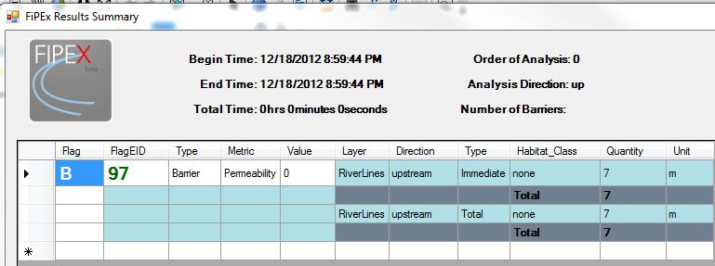

Figure 1: The summary output from a One-Click Analysis.

**The output columns:**

***Flag*** - The flag ID (user-set)

***FlagEID*** - The unique geometric network element ID (hidden from attribute tables)

***Type*** - Can be 'Sink', 'Barrier', or 'Flag - Node'. In a One-Click Analysis this will refer to the node which the user clicks (may or may not have a barrier marker on it). In an Advanced Analysis, this will identify the flag(s) of the analysis.

***Metric*** - contains barrier or flag specific metrics such as permeability, DCIp and DCId (for an Advanced Analysis. System-wide metrics; available for flags only), or DCI segmental (For an Advanced Analysis. Barrier-specific).

***Value*** - the value of the specific metric

***Layer*** - the participating layer name

***Direction*** - the direction of trace used in analysis on the layer in the 'Layer' column. Can be 'upstream' or 'downstream'. Determined in the FIPEX Options General Tab.

***Type*** - the type of trace used in analysis on the layer in the 'Layer' column in the direction specified in the 'Direction' column. Can be 'Immediate', 'total', or 'path'. Determined in the FIPEX Options General Tab.

***Habitat******Class*** - the unique class, if specified in FIPEX options, that the results in the 'Quantity' column belong to (specific for the Layer, Direction, and Type)

***Quantity*** - the total amount of habitat for this analysis class, type, direction, layer, and barrier.

***Unit*** - the unit of the quantity reported.

In the FIPEX results from an Advanced Analysis the horizontal shading will alternate for each barrier or flag (see below image).

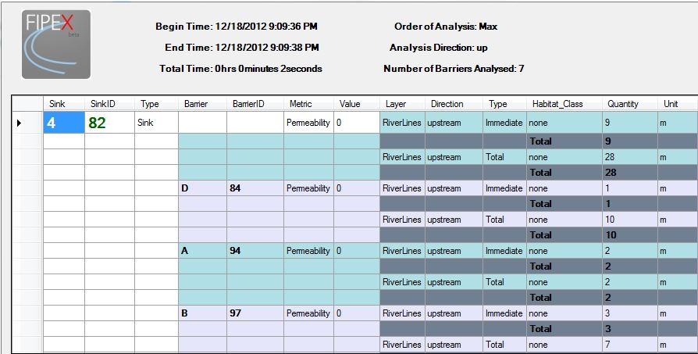

Figure 2: The summary output from an Advanced Analysis.

**NOTE:** Sometimes the output form will be pushed beneath ArcMap or other visible forms.

## FIPEX Output Tables

{ Back to 6: FIPEX Tools and Commands }

Optionally, an Advanced Analysis will output to non-spatial geodatabase tables. These tables are easily exported to XLS, CSV, DBF or other common formats. The tables are designed to be joined or related (either with each other or with spatial layers).

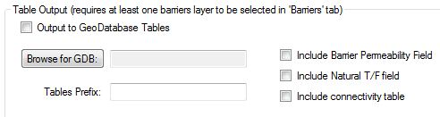

Figure 3: The table output section in the Advanced Tab

The following tables can be created: Connectivity, Habitat, and Metrics tables. These tables will be output to the geodatabase specified in the FIPEX Options Advanced Tab.

**NOTE:** A unique, random five character code will be generated and used as a suffix for tables generated by an Advanced Analysis. This is to help identify tables associated with a single analysis.

### The Habitat Table

The Habitat table contains network quantity results returned for each barrier and sink used in the Advanced Analysis. The following fields are used

***ObjectID***- Unique object ID for each row in the table.

***Sink ID*** - The unique ID of the flag / sink. The ID field used is set to the ObjectID in the sink layer.

***Sink EID*** - The unique 'Element ID' of the sink. The EID is a hidden ID created and used by the geometric network.

***bID (Barrier ID)*** - The barrier ID set by the user in FIPEX Options Barriers Tab.

***barrEID (Barrier EID)*** - The unique 'Element ID' of the barrier. The EID is a hidden ID created and used by the geometric network.

***Node Type*** - Determined by the presence / absence of a barrier marker. Can be 'Barrier', 'Sink', or 'Flag - Node.'

***Habitat Layer***- The layer of the output quantity for this row in the table.

***Direction*** - The direction of the trace for this row. Can be 'upstream' or 'downstream'. Determined in the FIPEX Options General Tab.

***Trace Type*** - The type of trace for this row. Can be 'Immediate', 'total', or 'path'. Determined in the FIPEX Options General Tab.

***Habitat Class*** - the unique class, if specified in (FIPEX Options General Tab), that the results in the row belong to (specific to the Layer, Direction, and Type).

***Habitat Class Field*** - reports the field used for the layer in this row (if specified in FIPEX Options General Tab) for the unique class designation.

***Habitat Quantity Field*** - reports the quantity of network for this sink/barrier, layer, direction, trace type, class (optional).

***Unit Measure*** - the unit of measure for the ***Habitat Quantity Field***.

### The Metrics Table

{ Back to 6: FIPEX Tools and Commands }

The Metrics table contains one or many metrics for the sinks / barriers encountered during an Advanced Analysis. The following fields are used:

***ObjectID***- Unique object ID for each row in the table.

***Sink ID*** - The unique ID of the flag / sink. The ID field used is set to the ObjectID in the sink layer.

***Sink EID*** - The unique 'Element ID' of the sink. The EID is a hidden ID created and used by the geometric network.

***bID (Barrier ID)*** - The barrier ID set by the user in FIPEX Options Barriers Tab.

***barrEID (Barrier EID)*** - The unique 'Element ID' of the barrier. The EID is a hidden ID created and used by the geometric network.

***Node Type*** - Determined by the presence / absence of a barrier marker. Can be 'Barrier', 'Sink', or 'Flag - Node.'

**Metric Name** - The name of the metric for this row (currently limited to 'permeability', 'DCIp', 'DCId', and 'DCI Segmental'.

**Metric** - The metric value (type 'double').

**The Connectivity Table**

The connectivity table contains the barrier-barrier topology of the network, as analyzed by FIPEX. This table can be useful in troubleshooting network connectivity; it should help ensure that any given barrier has only one downstream barrier (maintaining dendritic topology). The columns include:

***ObjectID***- Unique object ID for each row in the table.

**BarrierFlagID** - The unique 'Element ID' of the barrier. The EID is a hidden ID created and used by the geometric network.

**Downstream Barrier/Sink** - The unique 'Element ID' of the immediately downstream barrier.

# 7. A 'One-Click Analysis' Walkthrough

{ Back to 6: FIPEX Tools and Commands }

This walkthrough will lead you through conducting a **One-Click Analysis** with FIPEX. Prior to this walkthrough you should have a geometric network created (see Network Creation) using the MXD and dataset provided.

The One-Click Analysis

1. For a simple **One-Click Analysis** using network lines (no classes):

2. Open **FIPEX** **Options** (Menu -> Options)

3. In the **General Tab**, under **Habitat Output** check **'Upstream'**.

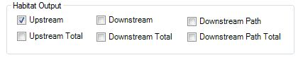

4. In the **Network and Habitat Layers** **to Include in Analysis** section check **'RiverLines'**.

5. Use the **'Change**...' button to set the **Habitat Quantity Field** for *RiverLines* to the *Length_PrioDemo* field. Set the **Units** to Metres and the **Habitat Class Field** to <None>.

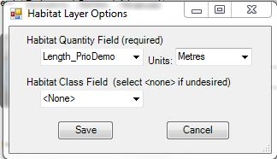

6. Go the **Barriers Tab**. Check *'RiverDams'*.

7. Use the '**Change ID Field'** button to select the *Label* field as the ID field. This specifies which field will be used in output ID's (i.e., the 'user set ID'). Leave the **Permeability** **Field** and the **Natural T/F** Field not set.

8. Click **'Save Settings'**

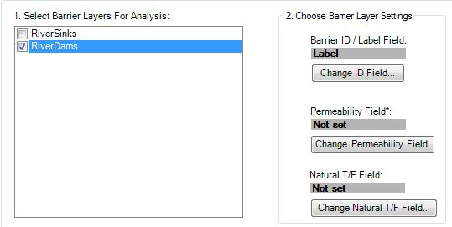

9. Add barrier markers to all barriers in the network. This can be done with the **'Set Barriers on Selected'** or the **'Place / Remove Barrier'** tool. To use **'Set Barriers on Selected'**, go to the **'List by Selection'** Tab of the Table of Contents in ArcMap.

ListbySelected.JPG

10. Right-click the **'RiverDams'** layer and click **'Make this the only selectable layer'**

Use the **'Select Features by Rectangle'** tool to select all barriers.

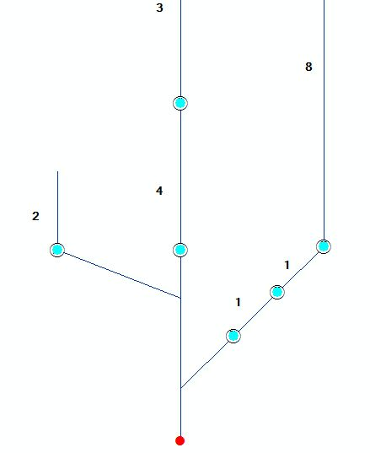

11. Click the **'Set Barriers on Selected'** button. setbarriers.JPG

12. Barriers should be set and labeled on barriers A, B, C, D, E, & F.

13. Use the **One-Click Analysis** tool to perform a quick analysis starting at any barrier or the flag. At any barrier results should appear similar to this: one click.JPG

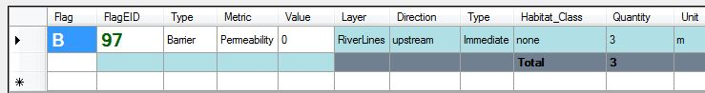

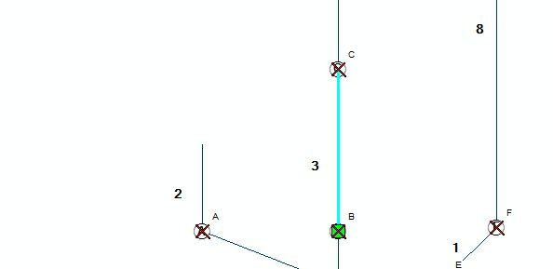

Notice if you click the network sink, the 'Type' in the results changes to 'Sink.'

**NOTE:** In a One-Click Analysis, results are returned as a selection AND highlighted red. The selection can be used for further analysis or operations. Only the last operation (determined by the checkboxes in the General Tab, reading left to right) is returned as selection.

# 8. An 'Advanced Analysis' Walkthrough

{ Back to Top }

This walkthrough will lead you through conducting an **Advanced Analysis** with FIPEX. Prior to this walkthrough you should have a geometric network created (see Network Creation) using the MXD (*FIPEX_InstallDemo.mxd*) and dataset provided. You should also have completed the One-Click Analysis Walkthrough (A 'One-Click Analysis' Walkthrough).

An Advanced Analysis is used to analyze one or many barriers on a given network. It is triggered by clicking the Advanced Analysis button on the FIPEX toolbar advanced.JPG .

**NOTE:** The Advanced Analysis will only be activated on the FIPEX toolbar if there is a geometric network present in the active data frame and there is a flag set on the network.

The Advanced Analysis uses the settings in the Advanced Tab of the FIPEX Options menu (as well as the settings in the General, Exclusions, and Barriers).

1. Open the **FIPEX Options** menu. Make sure the **General Tab** looks like this (check 'Upstream', 'Downstream', 'Downstream Total' and / or any other Habitat Output you wish):

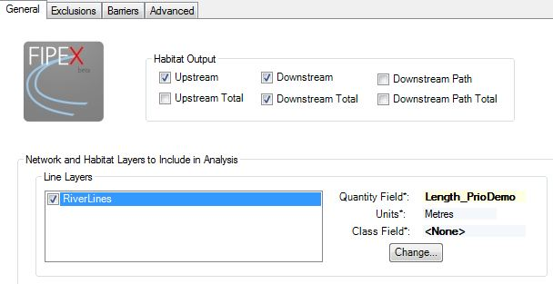

2. In the **Barriers Tab**, highlight **'RiverDams**.' For the **Barrier ID / Label Field**, select the *Label* field using the **'Change ID Field...**' button. Choose the 'Permeability Field', setting it to the *pass* field using the 'Change Permeability Field' button. Make sure the **Barriers Tab** looks like this:

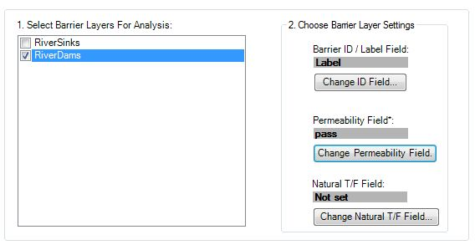 3. In the **Advanced** **Tab**, in the **"Order" of Analysis**, check "**Maximum**." This setting ensures the analysis will iterate through all barriers encountered between the flag and the end(s) of the network in the Analysis Direction.

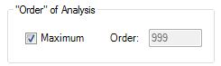

4. Set the **Analysis Direction** to '**Upstream**.'

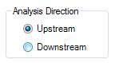

**NOTE:** The ***Analysis Direction*** is different from the ***Habitat Output*** trace types found in the General Tab.

An example: If all six ***Habitat Output*** trace types are checked in the General Tab and the ***Analysis Direction*** is set to 'Upstream' in the Advanced Tab, the FIPEX ***Advanced Analysis*** will perform all six trace types for a given barrier and then proceed to perform all six trace types for the ***next barrier(s) encountered upstream****.* It will continue to do this until the ***'Order' of Analysis*** is exceeded or the end(s) of the network is reached.

5. Check **'Output to GeoDatabase Tables'**.

6. Click **'Browse for GDB'** and select a geodatabase for output (File Geodatabase preferred). You may choose to use the geodatabase provided with FIPEX (*FIPEX_DemoDataver10_[date].gdb*).

7. In tables prefix enter **'demo'** (or another prefix of your choosing).

8. Check **'Include Barrier Permeability Field'**, **'Include Natural T/F field'**, and **'Include Connectivity Table'**. Make sure your Advanced Tab looks generally like this:

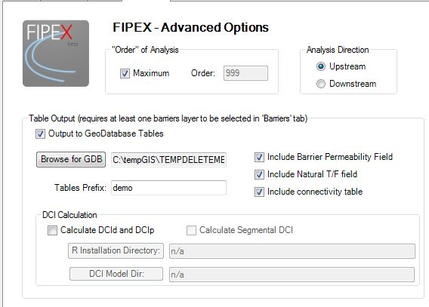

9. Click **'Save Settings'**.

10. In the *FIPEX_InstallDemo.mxd* in ArcMap, place a flag on the sink of the network (use the **Place/Remove Flag tool**), place barrier markers on barriers **A,B,C,D,E, & F** (if you have not used the **'Set Barriers on Selected'** tool see steps 9 thru 12 of the **One Click Analysis Walkthrough)**. Make sure your network looks like this:

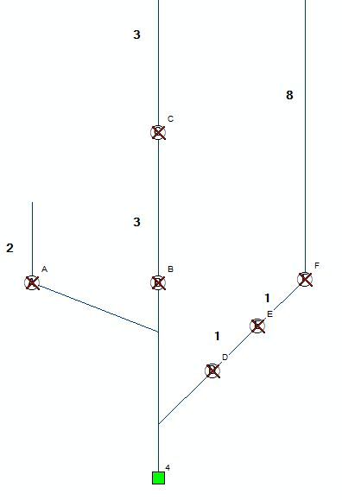

11. Click the **Advanced Analysis** button advancedanalysis1.JPG. This will pop-up the FIPEX Options menu (for review). Click **'Run'**.

12. The output should look similar to this:

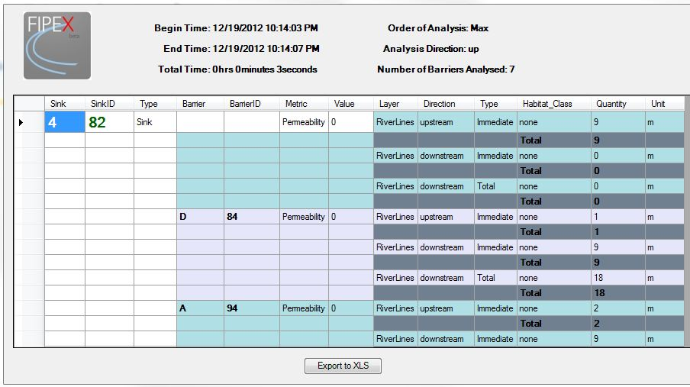

You should also see three tables output in the Table of Contents (the 'List Layers by Source' view should now be active).

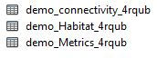

Notice in the output form the highlighting alternates between barriers. The first result listed is for the network found immediately accessible to the sink. Subsequent results (barriers D and A in the image) are reported next. The Permeability Metric is included for each. The Total is specific for each layer, each direction, and each trace type. There is only one item summed for each 'total' in this case because we have no habitat 'classes' specified.

For an explanation of the output tables see FIPEX Output Tables.

**NOTE:** It is possible to run a single Advanced Analysis for multiple flags. That is, multiple river systems or sections of river systems can be analyzed and reports generated. In the output form, the results for multiple flags are separated by the row for each sink (partially highlighted white).

# 9. A DCI Calculation Walkthrough

{ Back to Top }

This walkthrough will lead you through conducting an **Advanced Analysis** with Dendritic Connectivity Index (DCI) output. Prior to this walkthrough you should:

1. Have a geometric network created (see Network Creation) using the MXD (*FIPEX_InstallDemo.mxd*) and dataset provided.
2. Have completed the One-Click Analysis Walkthrough (A 'One-Click Analysis' Walkthrough).
3. The setup for the FIPEX Options is similar to that of the Advanced Analysis Walkthrough (**An 'Advanced Analysis' Walkthrough**). Performing that is recommended.
4. The 'R' Statistical software is needed during the analysis and so steps 3a - 3k of Installing the R Statistical software for Windows should be done.

NOTE: FIPEX requires R version 2.11.1 (not a more recent version; some older versions may work) and an error will result if a newer version is installed. If you do not see these packages, check that you have R version 2.11.1 Installed. If not, you will need to install this version.

The DCI analyses calculate metrics of connectivity for a river system or segments of a river system. The DCId characterizes *diadromous* connectivity, that is, the connectivity of the ocean / sink to the river system and vice versa. This metric may be used to characterize the system's accessibility for diadromous migratory fish such as salmon or the American Eel, for example. The DCIp characterizes potadromous connectivity -- the connectivity between sections of a river system and other sections of a river system. The DCIp characterizes the ease with which resident fish may move within the system. The DCI segmental is specific for individual reaches of river and is a measure of the connectivity of that segment (or 'reach') to the other reaches of river. At a basic level, the DCI metrics reflect the probability that a fish may move through the system. The DCI is given on a 0-100 index, with a DCI=100 being 100% connected.[3]

The DCI metrics rely on a parameter called permeability (*p;* sometimes referred to as *passability* or *passage efficiency*) of barriers. This parameter is the degree to which a barrier impedes passage or connectivity. In FIPEX analyses, permeability is a 0-1 index, with *p*=1 being 100% passable. The permeability of a barrier reflects *the probability that a fish will successfully pass a barrier*. Another way to define permeability is: *the proportion of a given fish population that will successfully pass a barrier.*

**NOTE:** There are numerous studies and specialized and unspecialized software available to help estimate permeability. Here is a study assessing the

- Anderson, G. B., Freeman, M. C., Freeman, B. J., Straight, C. A., Hagler, M. M., & Peterson, J. T. (2012). [Dealing With Uncertainty When Assessing Fish Passage Through Culvert Road Crossings](http://link.springer.com/article/10.1007%2Fs00267-012-9886-6?LI=true#page-1). Environmental management, 1-16.

A common software to use to assess passability is Fish Xing:

- Washington Department of Fish and Wildlife [WDFW] (2006) [Fish Xing User Manual and Reference Version 3](http://stream.fs.fed.us/fishxing/).

For FIPEX to calculate the DCI's, a *permeability* field must be chosen for each barrier layer included in the analysis. This can be found in the FIPEX Options Barriers Tab.

**NOTE:** The permeability does not need to be calculated to calculate DCI's. Barriers can be set, as in the example in this walkthrough to a permeability of zero, thus assuming all barriers to be completely impassable.

To set the permeability field open the FIPEX Options menu and go to the Barriers Tab.

1. Highlight the RiverDams layer.

2. Click the **'Change Permeability Field'** button. Choose the *pass* field. Click **'Save'** to close the pop-up. The settings should look like this:

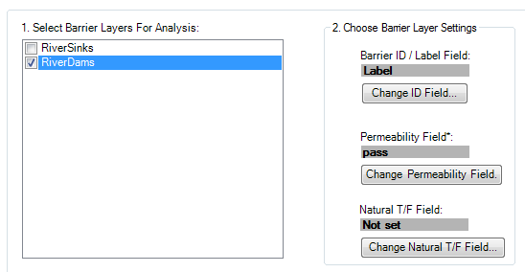

**NOTE:** The DCI can accept a parameter that identifies barriers as anthropocentric or natural. This is the 'Natural T/F Field'. This field can remain unset and a FIPEX will assume all barriers are manmade.

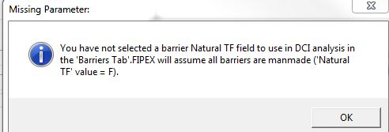

3. Go to **FIPEX Options Advanced Tab**. Check **'Include Barrier Permeability Field'**, **'Include Natural T/F Field'**, and **'Include Connectivity Table'**. The DCI Calculation section should now be visible.

4. Check **'Calculate DCId and DCIp'** and '**Calculate Segmental DCI'**.

5. Click '**R Installation Directory'**. Navigate to the location of the R Statistical Software. Select the directory and click **'OK**.'

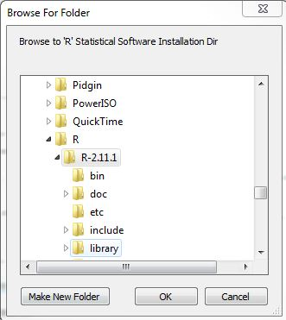

**NOTE:** FIPEX checks for the bin/rterm.exe program. In subsequent versions of R, rterm is not located in the same bin/ directory.

6. Click the '**DCI Model Dir'** button. Navigate to and select the directory provided with the FIPEX add-in. The name will be similar to: *DCI Model Files Mar 14*. **You must have read / write permissions to this directory.**

**NOTE:** FIPEX will attempt to read / write a temporary file to this directory upon declaring the directory in the Advanced Options. This process will usually detect whether you have read / write access. Usually a safe directory to place the DCI Model Files directory is the My Documents folder.

Make sure that the final setup looks similar to this:

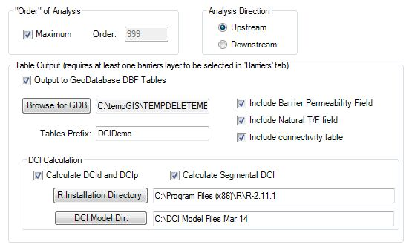

7. Click '**Save Settings'**.

8. Review the network. You should be using the demo MXD provided with FIPEX. There should be barrier markers on each of the network barriers. A green flag should be on the sink of the network.

9. Click the Advanced Analysis button. advancedanalysis1.JPGNotice the FIPEX Options appears again. This is provided to double-check settings. Click the **'Run'** button.

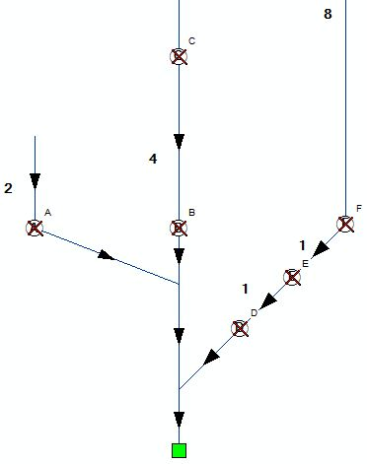

10. Results returned should look similar to:

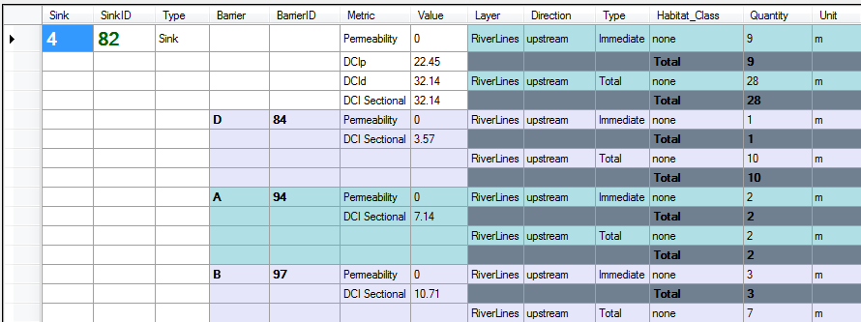

Notice the DCIp and DCId are reported only in the row associated with the sink / flag. This is because these metrics are associated with the entire river system. The DCI Sectional is reported for each barrier (and the sink). The 'Section' referred to is the immediately upstream section of river from the barrier to the next barrier(s) in the network. The DCI Sectional is also given for the segment immediately upstream from the sink / flag which will always match the DCId (somewhat redundant).

There is an extra table created and visible now in the Table of Contents. This is titled 'DCI', prefixed with the characters you chose in the FIPEX Options and suffixed with a random five character code. This table contains exactly what was sent to the R Model to calculate DCI.

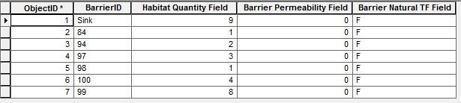

This completes the walkthrough

# 10. Getting Started -- Network Building Tips

{ Back to Top }

Building geometric networks and conducting quality assurance can be time consuming. Here are a few pointers and tips to help.

## Use a 'File Geodatabase'

{ Back to 10: Getting Started -- Network Building Tips }

With FIPEX, a File Geodatabase as opposed to a Personal Geodatabase is more extensively tested. Choosing a File Geodatabase to store and work with data is recommended.

## 'Clean' the Dataset Prior to Building the Network

{ Back to 10: Getting Started -- Network Building Tips }

The Build GeometricNetwork Wizard has a 'snapping' feature, but it rarely worked as expected. ESRI recommends 'cleaning' the dataset prior to geometric network creation. In this case, 'cleaning' the dataset means that barrier points fall exactly on top (are coincident with) river network lines. ESRI recommends using Topology rules in the geodatabase to achieve this:

http://help.arcgis.com/en/arcgisdesktop/10.0/help/index.html#//002r00000008000000

http://gis.stackexchange.com/questions/35270/arcgis-10-sp-3-geometric-network-which-features-are-moved

There are a number of ways to do this, and topology can be complicated. If you choose not to use topology, FIPEX contains a tool called 'Batch Snap Points to Lines.'

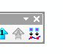

This tool operates using an active edit session, a selection of point features, and the settings in the Snapping Window of the General Editing Options. It will snap points to lines based on snapping settings in ArcMap.

NOTE: You may need to turn on 'Classic Snapping' in the General Editing Options of ArcMap. Click on the Editor Toolbar (with an active edit session), 'Editor' -> 'Options' -> General Tab, click 'Use classic snapping'. Then snapping options can be set via'Editor'-> 'Snapping'-> 'Snapping Window'.

Don't forget to set the Snapping tolerance! 'Editor' -> 'Snapping' -> 'Options...'

**To Snap Points to Lines**

1. Select all point features you wish to have snapped to lines. The **'Batch Snap Points to Lines**' command should now activate on the FIPEX Toolbar.

2. Click on the **'Batch Snap Points'** command.

NOTE: Always have a backup of your data prior to editing.

3. Click **OK**.

4. Results should be reported.

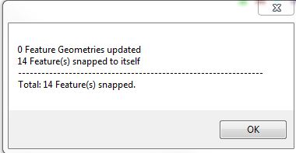

5. Save Edits: **'Editor'** -> **'Save Edits'**. Do not end the edit session.

6. The changes in the barrier locations must now be registered with the geometric network. Use the **Geometric Network Editing Toolbar** to do this. Click the **'Connect'** button on the toolbar.

geometricnetowrkeditortoolbar.JPG

**IMPORTANT: Use the 'Connect' button on the Geometric Network Editing Toolbar (built-in with ArcMap) to register your snapping changes with the geometric network.**

geometricnetowrkeditortoolbar.JPG

7. **Save Edits**, **End Edit Session**.

## Use a Temporary Network to Help 'Clean' the Dataset

{ Back to 10: Getting Started -- Network Building Tips }

Creating a geometric network with points and lines as they are (imperfect) will be useful because the tools provided with the Utility Network Analyst Toolbar provide means to troubleshoot the network. After troubleshooting and editing, the network can be deleted and rebuilt (if need be).

Specific tools provided with the Utility Network Analyst Toolbar that can be used to help troubleshoot a network are:

* **Find Connected**
* **Find Disconnected**
* **Find Loops**

By setting the Analysis Options on the Utility Network Analyst Toolbar to return results as a selection, using Find Disconnected can be useful in identifying which barriers are not currently participating in the network. A useful process is combining this functionality with the 'Bulk Snap Points to Barriers' command provided with FIPEX. The general process is:

1. Start an edit session by right-clicking the barrier features you wish to snap in the Table of Contents. **'Edit Features'** -> **'Start Editing'**

2. Set a junction or edge flag using the **Utility Network Analyst** tools

3. Set the Analysis Options (**'Analysis'**->**'Options'**) to trace on all features and trace indeterminate flow: **General Tab**, check **'Directed trace tasks include edges with indeterminate and uninitialized flow'**.

4. Set the results to return a selection: **Results Tab**, **'Selection'** radio button.

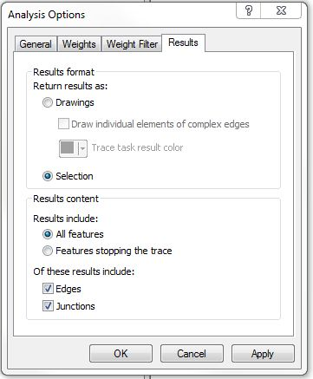

4. In the **'List by Selection**' tab of ArcMap's **Table of Contents**, right click your barrier(s) layer and click **'Make This the Only Selectable Layer'**.

5. Select a Trace Task in the dropdown of the **Utility Network Analyst Toolbar**.

6. Click the **'Solve'** button. Only disconnected barrier features should be returned.

7. Click the **'Bulk Snap Points to Barriers'** button (be sure to follow instructions from earlier on setting Snap Tolerances). The barriers should snap to lines.

**IMPORTANT: Use the 'Connect' button on the Geometric Network Editing Toolbar (built-in with ArcMap) to register your snapping changes with the geometric network.**

geometricnetowrkeditortoolbar.JPG

8. (see above note) Click **'Connect'** on the **Geometric Network Editing Toolbar**.

9. Save your edits. **'Editor'** -> **'Save Edits'**

10. Re-run trace results and see what barriers are still unconnected.

## Problem Lines or Points may Cause Other Features to be Disconnected

{ Back to 10: Getting Started -- Network Building Tips }

If a **'Find Disconnected'** trace reveals lines or points to be unexpectedly disconnected from the geometric network a select few of these lines or points may be causing the others to remain disconnected -- fixing these few may fix the others.

TIP: When first building and troubleshooting a network, simply selecting points and lines and clicking the 'connect' button on the Geometric Network Editing toolbar (with an edit session started) may fix some of these errors.

## Check the table of Network Build Errors for Error Codes

{ Back to 10: Getting Started -- Network Building Tips }

During network creation, a number of build errors may occur. The Geometric Network Editing Toolbar can help identify the problem features. In an edit session you can use the Network Build Errors command of this toolbar to highlight problem features. For more information, see:

http://help.arcgis.com/en/arcgisdesktop/10.0/help/index.html#//002r0000000z000000

The build errors are also stored in a table identified as the geometric network's name appended with _BUILDERR. The table is found in the root of the geodatbase. As of December, 2012, the codes refer to:

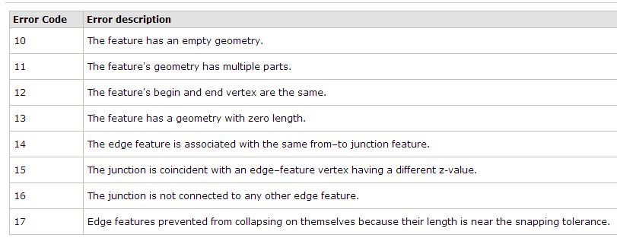

-- from http://help.arcgis.com/en/arcgisdesktop/10.0/help/index.html#//002r00000006000000

## Deal with 'Loops' or 'Braids' on a Case-by-Case Basis

{ Back to 10: Getting Started -- Network Building Tips }

The geometric network determines flow direction based on the 'tree' structure of a river network. When that structure is broken - as is the case with segments of river that are braided or in a river delta - the direction of flow as seen by the network is categorized as 'indeterminate'.

NOTE: FIPEX is able to handle areas of indeterminate flow but only if no barriers are situated on a segment with indeterminate flow -- if there are two possible routes from headwaters to sink of a system past a barrier, then this may cause errors.

Currently, the only way to handle 'Loops' and 'Braids' is on a case-by-case basis. In the case of smaller braids with no barrier present on any of the braids, they may be ignored. In the case of braids over large areas of network or in braids that contain a barrier, a decision will have to be made. If it is decided that the flow and subsequent FIPEX analyses should be forced 'through' the barrier, network line elements may be 'disabled' in the attribute table.

'Disabling' a network element means that network traces may not pass through the element. To 'disable' a network element:

1. Start an edit session for the layer containing the network element (line, usually) you wish to disable.

2. Go to the '***Enabled***' field and change the value for that feature to ***'false'***.

3. Click **'Connect'** on the **Geometric Network Editing Toolbar'**.

4**. Save Edits. End Edit Session**

The 'enabled' or 'disabled' setting is saved in the attribute table of the network layer. This is useful if the network needs to be rebuilt, as the state of the feature is saved.

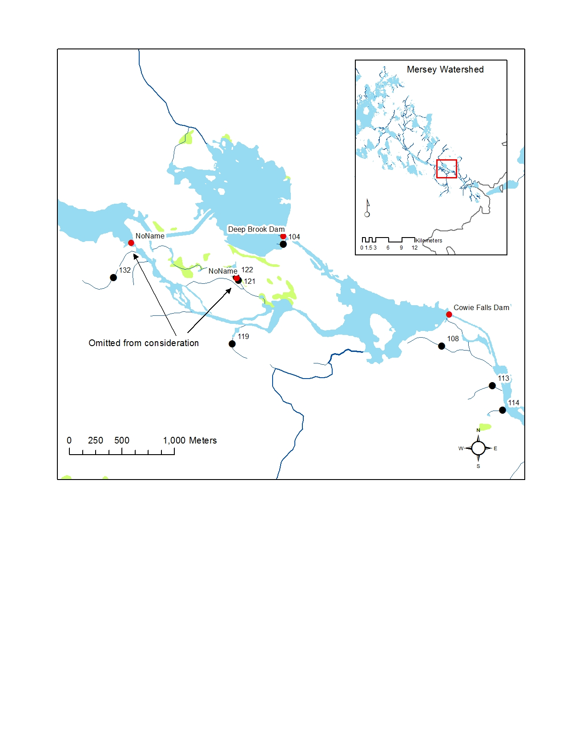

Figure 4: In the case of a braided section of this river, the barrier features titled 'NoName' were disabled, forcing analysis traces through Deep Brook Dam.

## Thoroughly Check for Duplicate (i.e. stacked) Barriers

{ Back to 10: Getting Started -- Network Building Tips }

In many circumstances, barriers can be 'stacked' on top of each other. This can cause problems when 'setting' these barriers.

NOTE: If barriers continue to show up as 'disconnected' from the geometric network, it may be due to multiple barriers stacked on top of each other.

Currently, there is no easy way to clean these duplicate barriers. Scripts may be available with other extensions or on the Internet. Alternatively, manually check for duplicates after all other checks have been done. A 'Find Disconnected' search with Utility Network Analyst will help identify potential problems.

## Check with the Data Provider for Hydrographic Specifications

{ Back to 10: Getting Started -- Network Building Tips }

Most regions have a government authority who manages spatial data including a hydrographic dataset. These datasets are increasingly maintained with adherence so some basic hydrographic standards. One key standard, for example, is the continuance of river network lines through lakes and large water bodies to maintain network connectivity throughout. Knowledge of what standards your data already meet will be helpful during network analysis with FIPEX.

## Create a separate 'Sinks' layer

{ Back to 10: Getting Started -- Network Building Tips }

A sink represents the outflow of a river system. The function of the sink is to determine network flow in the geometric network -- everything connected to the sink flows towards it. A separate sinks layer is a good idea and it is recommended for using FIPEX (in FIPEX Options you will choose a layer to be used as a 'barriers' layer by FIPEX. Combining a 'sinks' layer with a 'barriers' layer may have unintended consequences.).

NOTE: You can also declare 'sources'. Network 'sources' and 'sinks' can be combined into one layer. After creating a 'source' or 'sink' feature it must be declared as a source or sink in the attribute table of that layer. To apply this change, the network flow must be recalculated using the Utility Network Analyst toolbar.

## Create a single sink for multiple watersheds

{ Back to 10: Getting Started -- Network Building Tips }

To minimize time spent locating and creating sinks for many river systems, you can create a single sink for multiple networks by editing network lines to connect multiple river systems. These lines are unrepresentative of actual river network and therefore serve a function similar to lake 'spines,' for example. In similar practice, an attribute can be assigned to these features to use in the Exclusions tab of the FIPEX Options menu.

It is possible to use a coastline layer of a region to intersect with rivers. Using a tool like Hawth's Tools "Intersect Lines (Make Points) Tool" (http://www.spatialecology.com/htools/tooldesc.php) you can create points at the intersection of two lines layers. This method does not always yield the desired results because large coastal rivers often are segmented by tributaries (see example below) and therefore a custom generalized coastline layer often must be created to properly place a sink along large rivers.

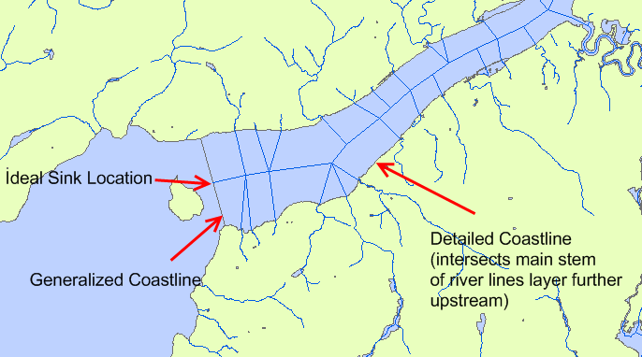

1. Sharealike - all work shared freely between all parties involved; similar to Creative Commons terminology.
2. Cote, D;, Kehler, D.G.; Bourne, C.; Wiersma, Y.F.. (2009) A new measure of longitudinal connectivity for stream networks. *Landscape Ecology* **24**:1, 101-113
3. The DCI's are semi-structural, in that they incorporate some biological data  in determining barrier passabilities, but do not consider other biological aspects, such as movement motivation.