Question

You are required to create a Customer Relationship Management web application, where you

will be developing CRUD(Create Read Update Delete) functionality.

Note the following points while developing the application

→ The main page will display all the customers present in the database.

→ Customers will have following attributes

a) First Name

b) Last Name

c) Email

→ You are required to provide action buttons(update and delete)

→ There should be an add customer button that will redirect to a new page which will consist

of a form to add the customer details.

Solution and Technologies Used:-

Spring Boot, Data Jpa with h2 Database

Submitted by Rajat Joshi

Add New Record Page

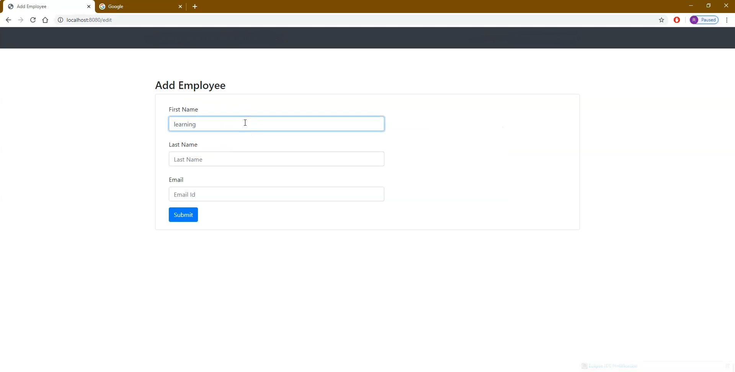

All Record Page

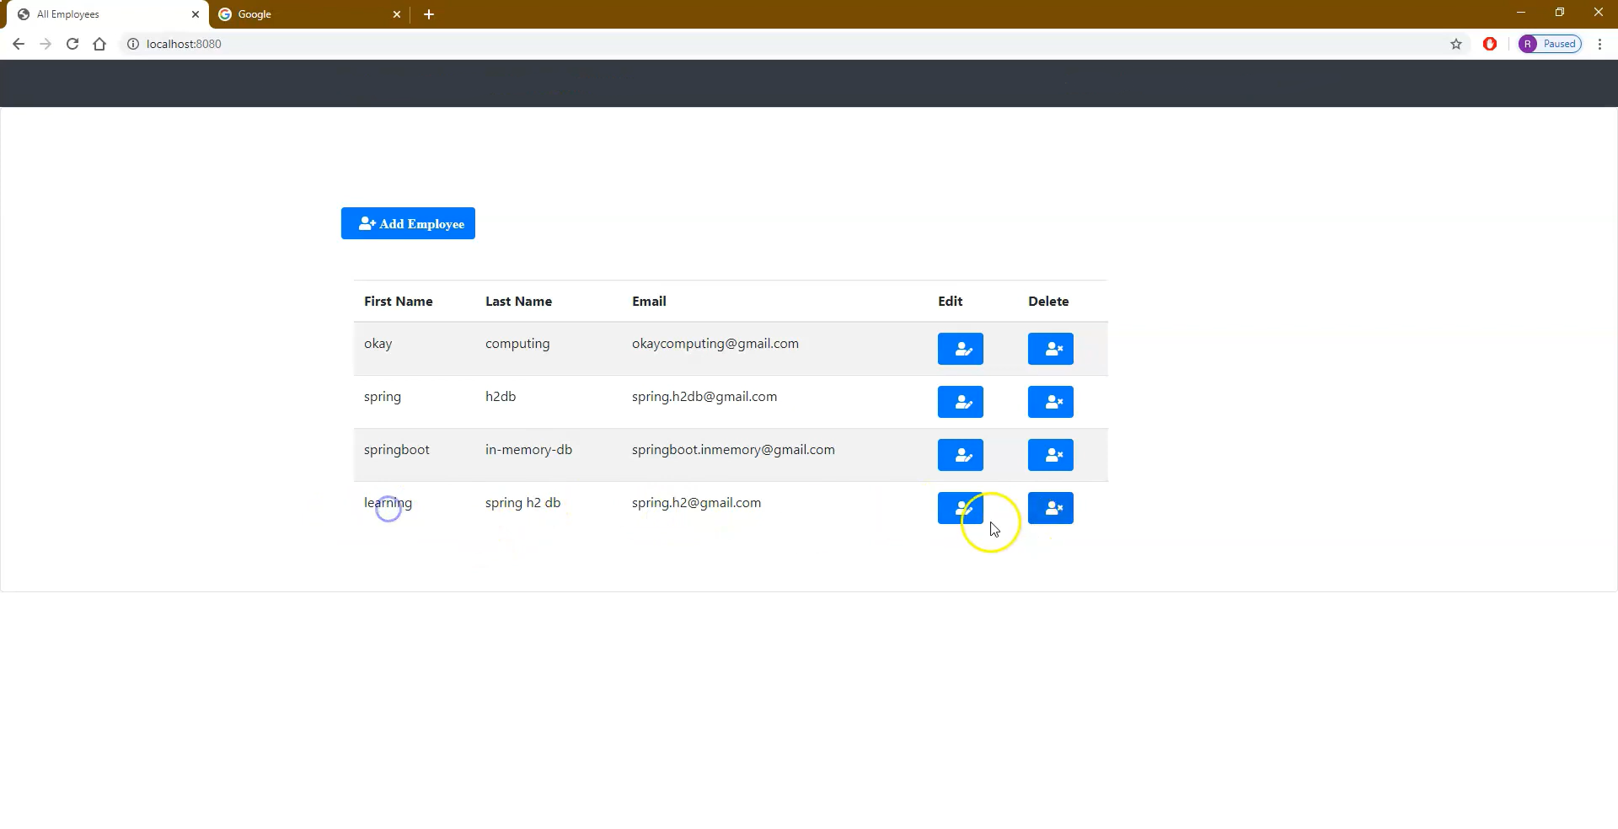

All Record Page

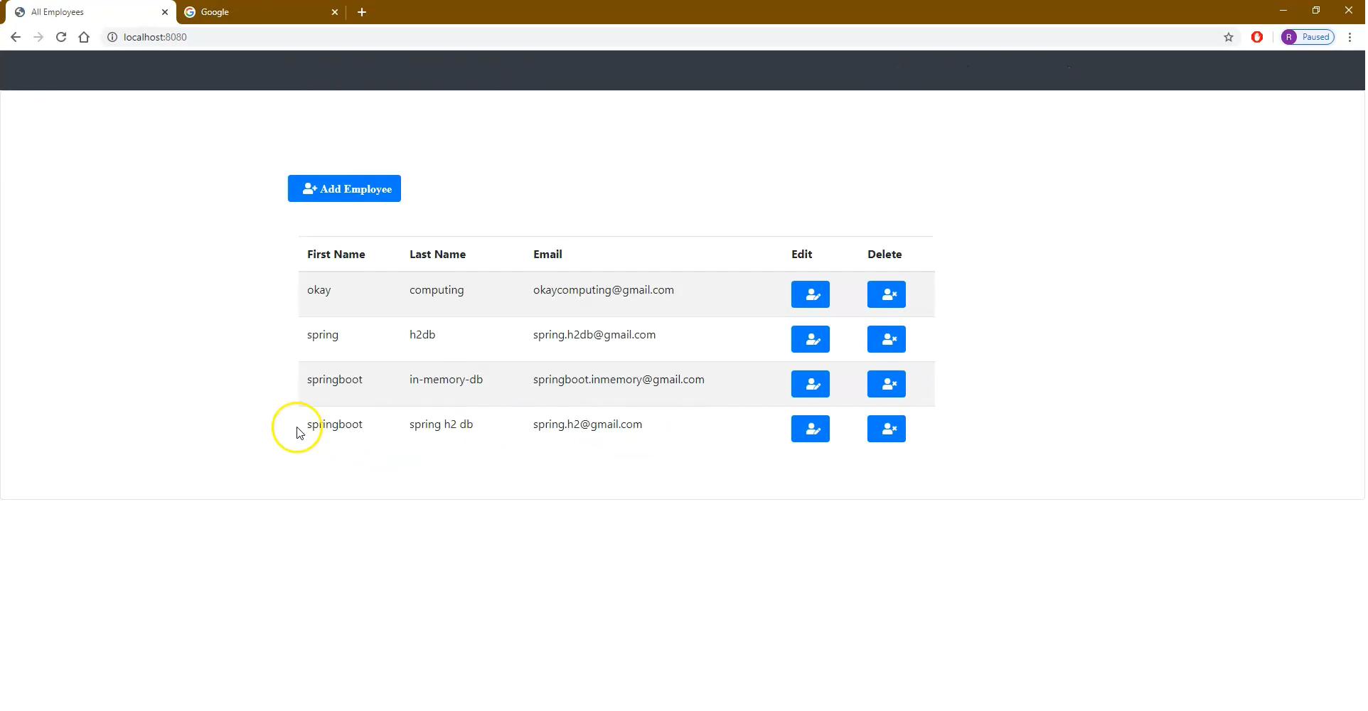

After Deleting last record

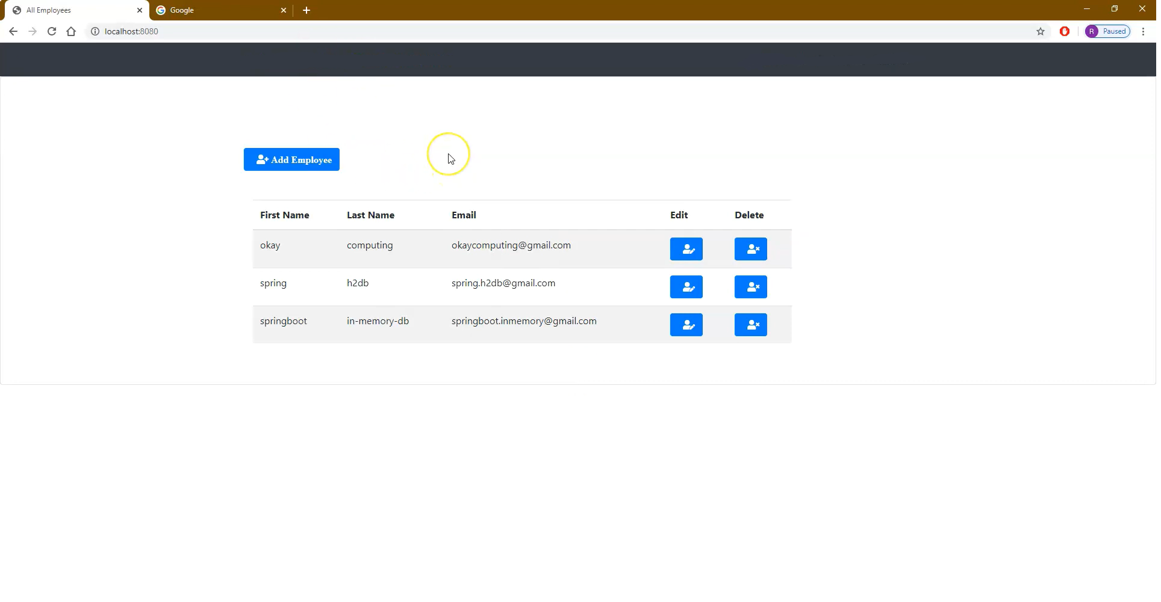

H2 Database Login

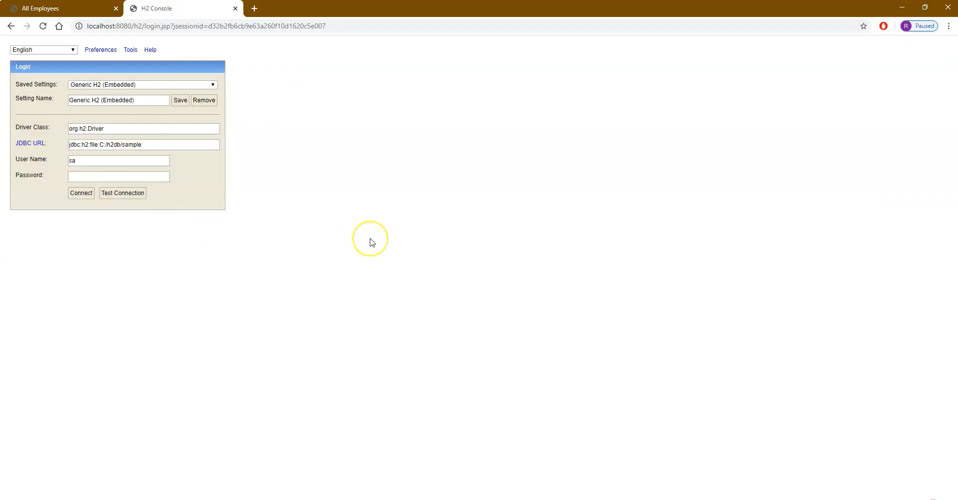

Printing all Records

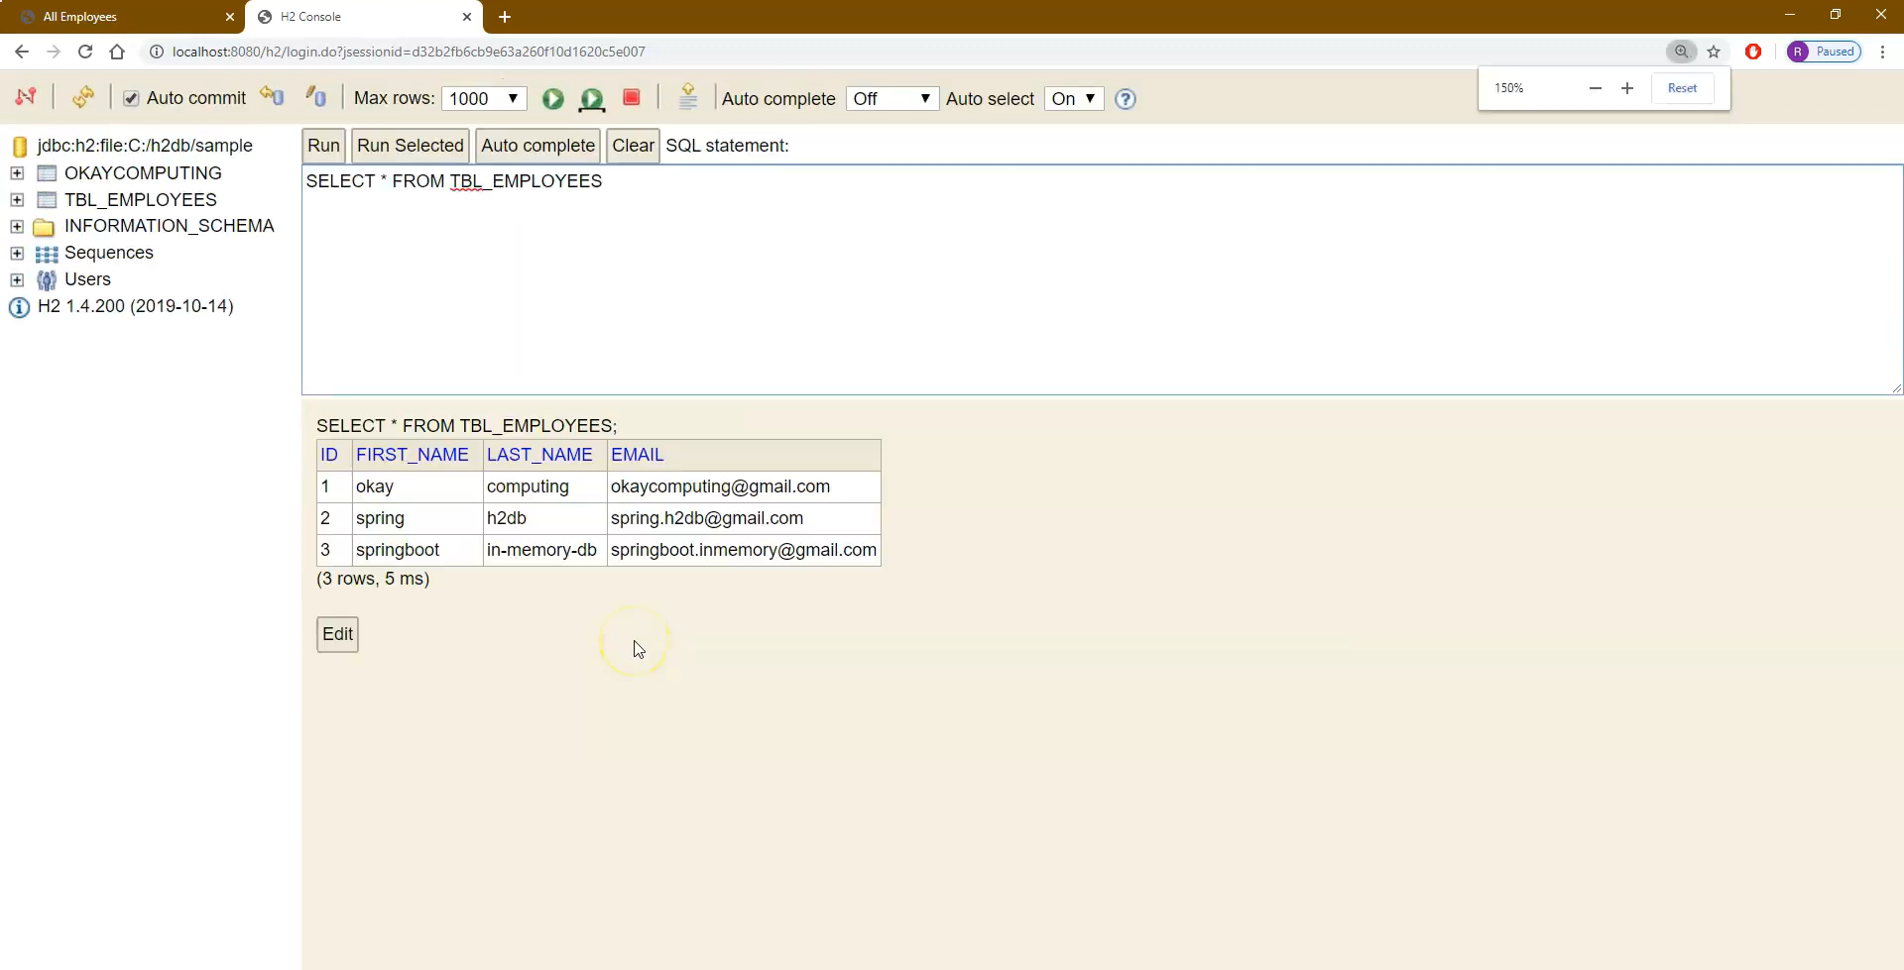

Adding New Record

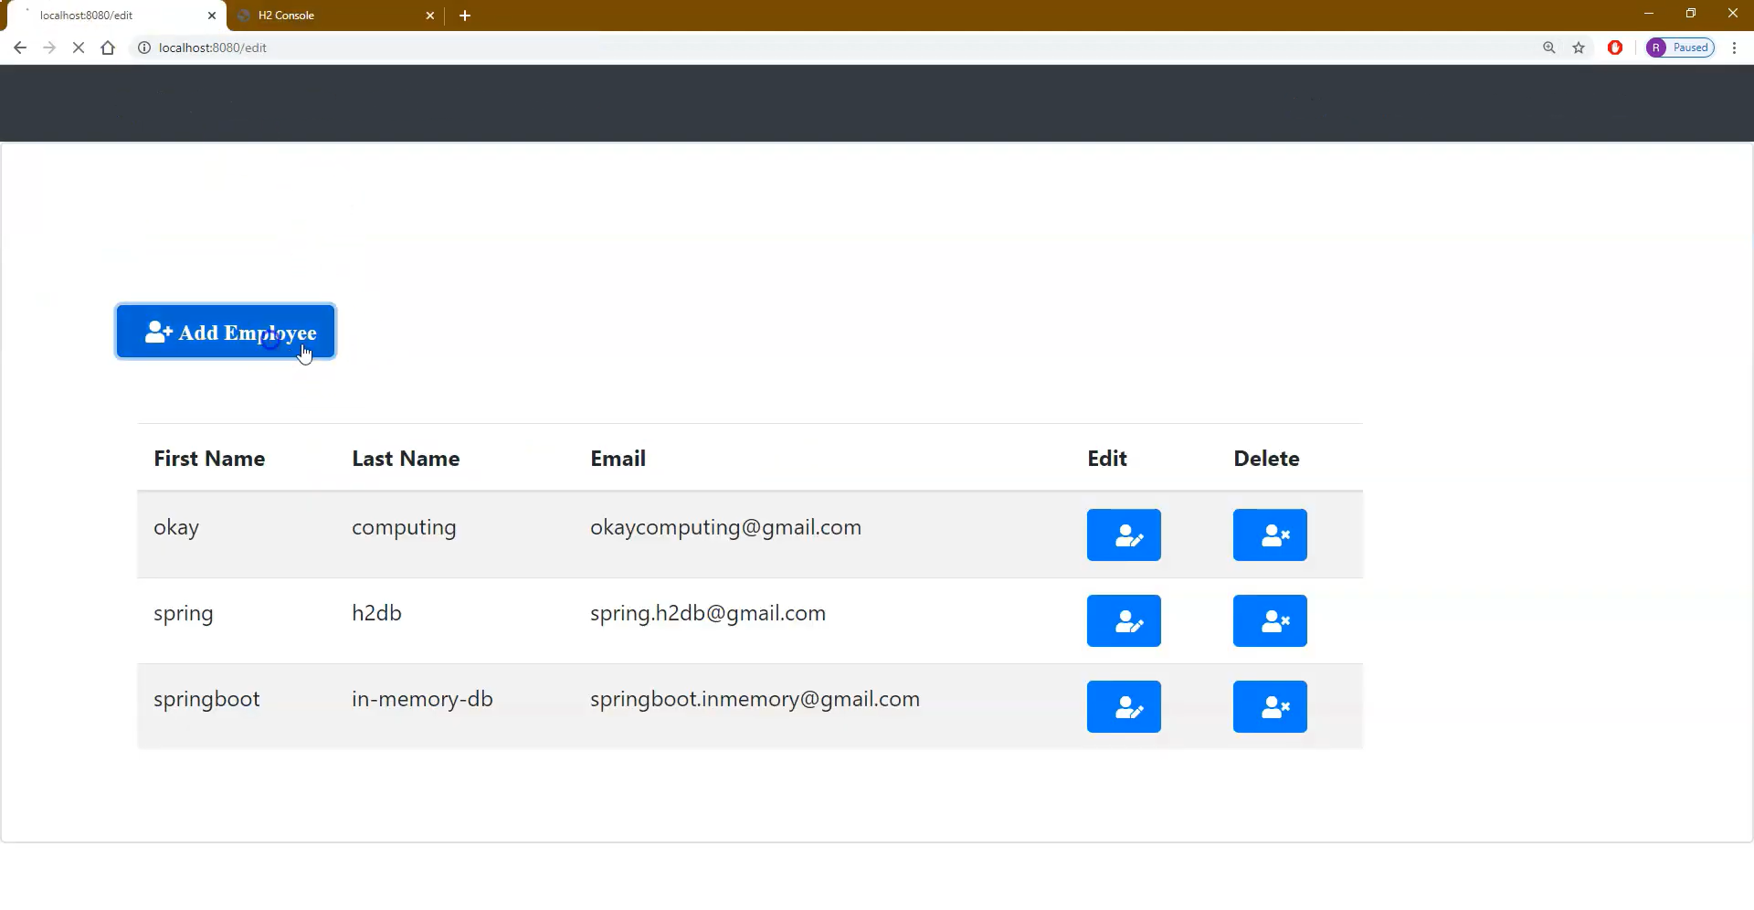

Added

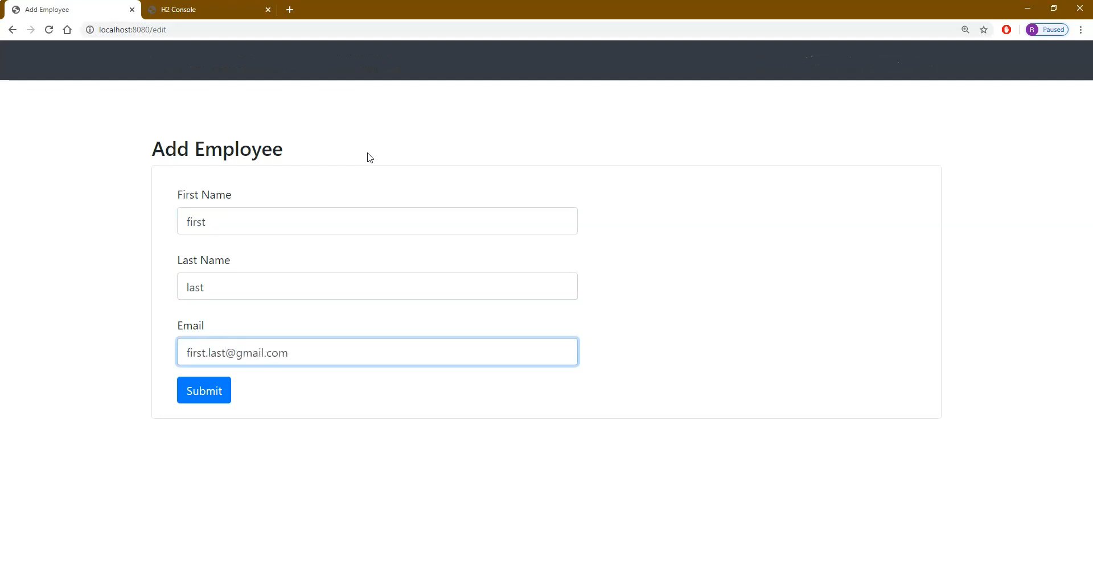

Printing that Newly added Record

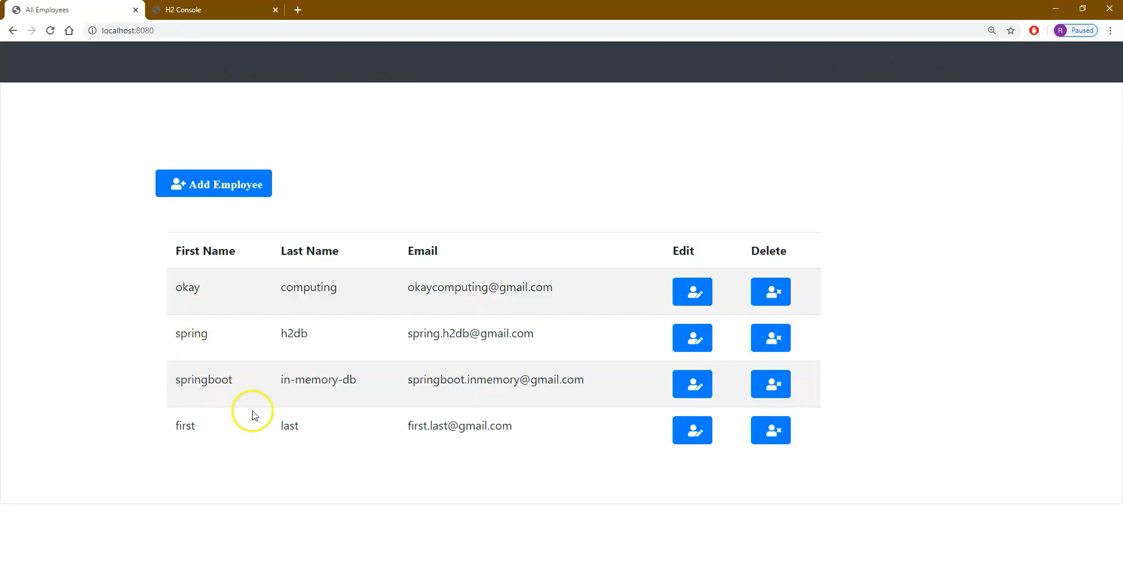

Now Watching that newly added record in h2 database

