# Using pandoc for scientific markdown

This is a little tutorial I wrote for myself to help me get started with using markdown for scientific documents and as a resource for when I forget how to do stuff. I’ve stuck it here in case it turns out to be useful for anyone else, but I’m not promising anything.

As ever, this is a collection of things I found out by frantic googling, so this tutorial is indebted to all the tutorials and stack overflow questions already out there.

## Code

Code can be specified inline using backticks like this: `some code`, which renders this: some code. Code blocks can be rendered by tab indenting a paragraph, so this:

a code block

is rendered as this:

acodeblock

To do an *indented* code block use two tabs, and so on.

## Equations

Equations can be specified using LaTeX code like this:

$\pi^2$

which renders as $π^{2}$.

Equations can be numbered too, by adding a reference in the text and an anchor to the maths like this:

equation (@first): (@first) $\pi^2 + 2 - 3^n$

which renders as:

equation (1):

$π^{2}+2−3^{n}$

## Figures

Figures can be included similarly to urls using the format:

![Figure caption][/path/to/figure.fig]

or alternatively with a reference and the path at the end, like this:

![Figure caption][id] ... [id]: path/to/figure.fig

For example, the following line of code

![**Fig. 1**: a bunch of points or something][points]

(with the file path at the end of the doc, referenced by [points]) returns this figure and caption:

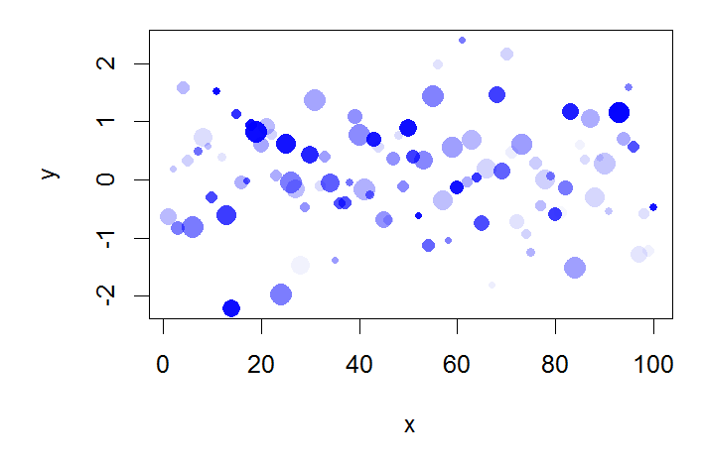

**Fig. 1**: a bunch of points or something

Unfortunately, the filepaths go a bit funny if outputting to docx and the filepath is anywhere other than in the same directory as the output file or below.

Also, LaTeX adds the ‘Figure $n$’ bits in itself, so the above will have that repeated in the pdf.

## Figure referencing

Unfortunately, explicitly referencing figures by number is harder. If we’re rendering to pdf we can use LaTeX references of the form \ref{id} in the text and \label{id} in the figure caption. This doesn’t work for formats like html and docx though.

So markdown like this:

Figure \ref{bar} is great. ![**Figure 2**: some pretty bars \label{bar}][bars]

(again with the filepath at the end) renders correctly in pdf, but not so well in html or docx:

Figure is great.

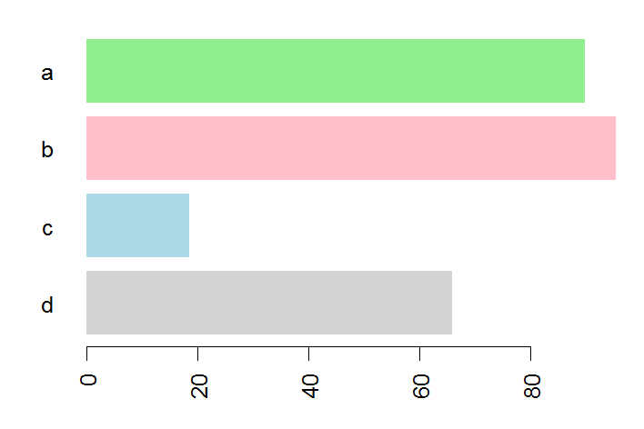

**Figure 2**: some pretty bars

## Citations

Citations are specified by citekeys in the format @Ward2009, which is rendered as: Ward et al. (2009).

To fill in the citations and add a bibliography (at the end of the document, pandoc needs us to specify a bibtex bibliography file. We can also change the citation style by specifying a .csl file. These are both covered in the ‘pandoc’ section below.

## pandoc

Assuming pandoc is installed and in the system path, rendering the file is as simple as running the following from the command line:

pandoc file.md -o file.html

To get all the useful scientific features working, we need a bunch of other options:

* building a standalone file (-s)
* using smart quotes (-S)
* rendering the file using pandoc-flavoured markdown (-c pandoc.css)
* specifying a .bib file to render citations (--bibliography=file.bibtex)
* specifying a .csl file to set the citation style (--csl=file.csl)

giving us something like this:

pandoc -s -S -c pandoc.css --bibliography=file.bibtex --csl=file.csl file.md -o file.html

or

pandoc -s -S -c pandoc.css --bibliography=file.bibtex --csl=file.csl file.md -o file.docx

So to render this file I used

pandoc -s -S -c pandoc.css --bibliography=library.bib --csl=mee.csl test.md -o test.html pandoc -s -S -c pandoc.css --bibliography=library.bib --csl=mee.csl test.md -o test.docx pandoc -s -S -c pandoc.css --bibliography=library.bib --csl=mee.csl test.md -o test.pdf

## References

Ward, G., Hastie, T., Barry, S., Elith, J. & Leathwick, J.R. (2009). Presence-only data and the em algorithm. *Biometrics*, **65**, 554–63. Retrieved from <http://www.ncbi.nlm.nih.gov/pubmed/18759851>