1. Open the Payslip.sln in Visual Studio 2022.
2. There are 2 projects, reactapp is the front-end web page, webapi is the back-end.
3. Set both projects as the Startup Projects

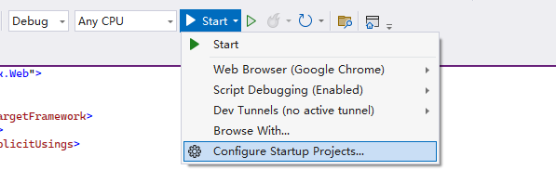

1. Click start there will be a web page for inputs, make sure back-end Swagger UI is running too.

1. Provide the inputs and click “Calculate” button, the result will be displayed in the table below.

That’s all.