We will be working with Visual Studio for this workshop. Please make sure you have Visual studio installed and the environment ready for this workshop.

Installing Visual Studio Community 2022

Download visual studio using this [link](https://visualstudio.microsoft.com/downloads/). You can install visual studio with default configurations for this workshop. If you decide to make changes later, you can use the visual studio installer where you can modify your copy. **Complete the following steps to set up your environment.**

Once installed, create a new project.

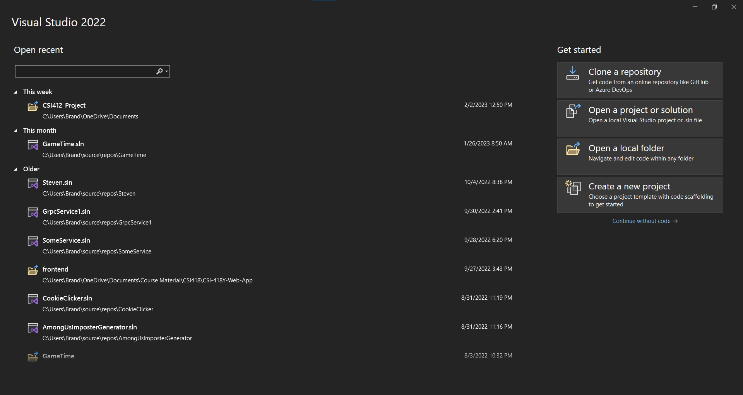

Select the **C# Console App** template. There are other console app templates, we only want the one for C#!

Search Console

Name the project whatever you want, same thing for the solution. Note: Solution and project names are not the same. The solution name will be the name of the .sln file that is generated. One named make sure to select **.NET 6.0** as the framework you are working with. Once created you will be given some default files.

Right click your project name (in this case for me DiscordBotWorkshop) and select Manage NuGet Packages.

Make sure to select the “Browse” tab and search “DSharpPlus”. Install the indicated packages below. **MAKE SURE TO SWITCH THE VERSION TO LASTEST STABLE!!!!**

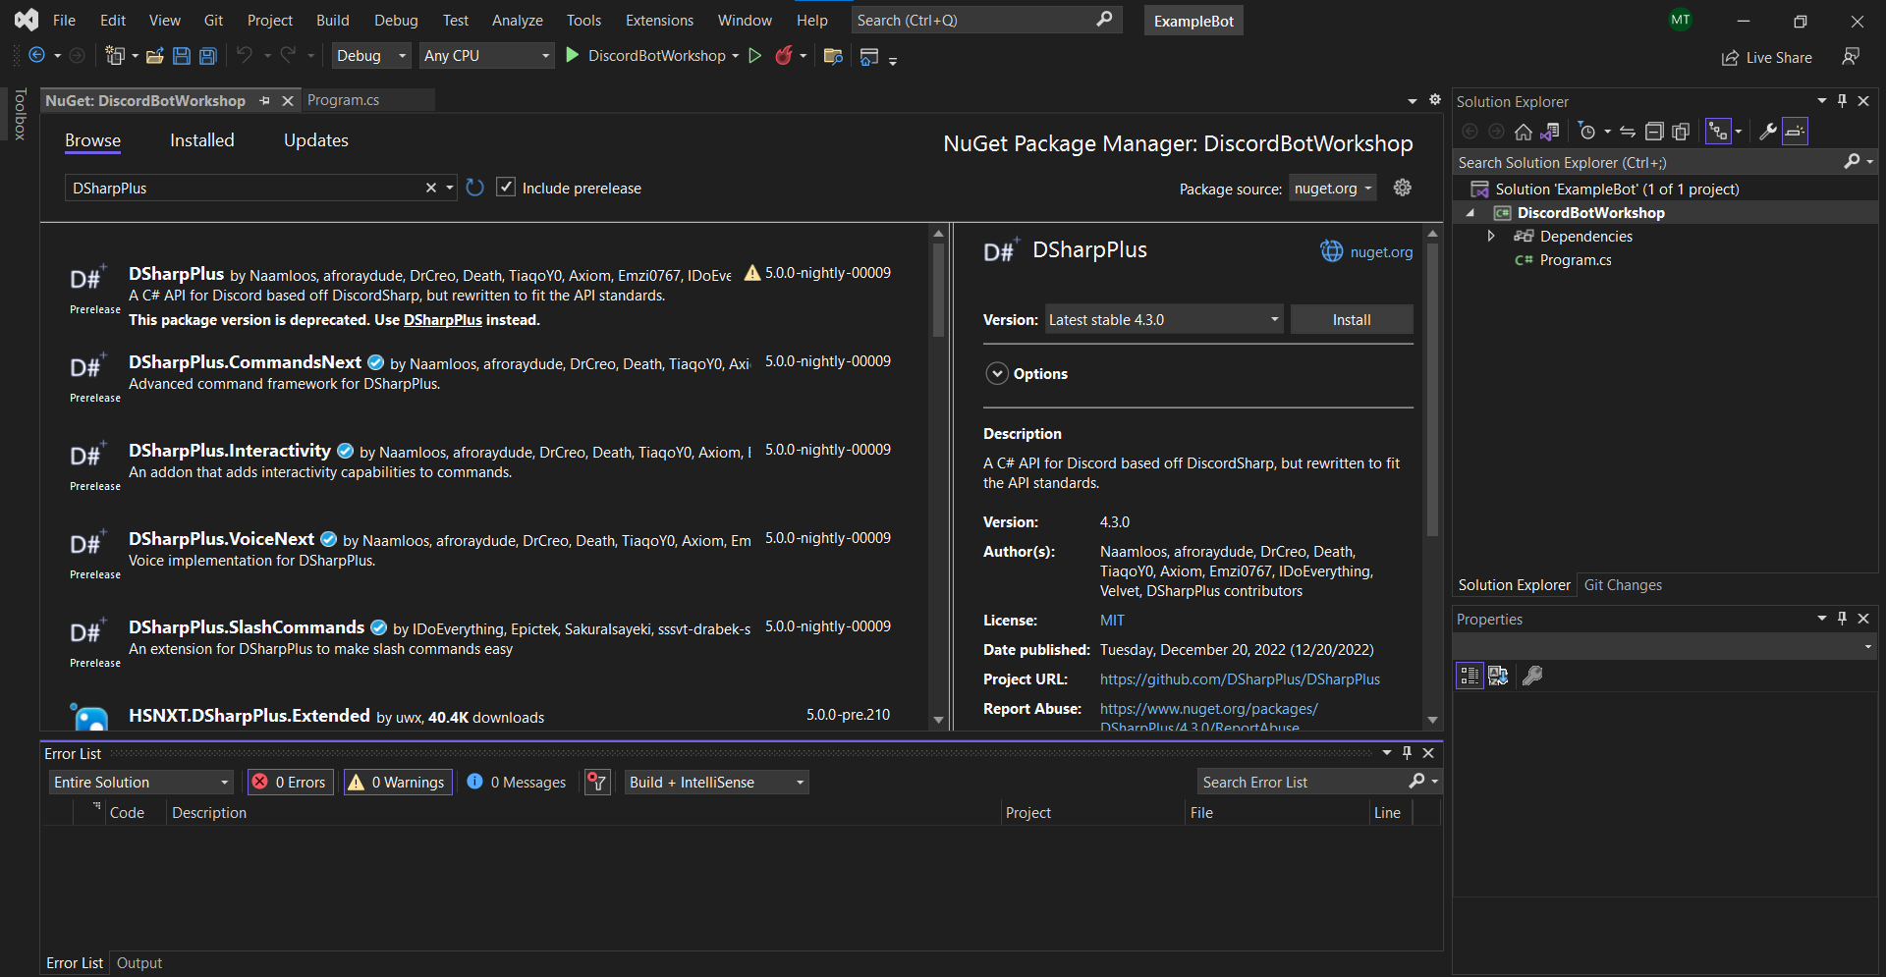

After installing those packages, you should be able to switch back to the install tab and see these 3 packages there. You are now ready for the upcoming workshop. See you there!

If you run into any problems please reach out to me [btiev@albany.edu](mailto:btiev@albany.edu) or over in our discord server!