**NHL Database Project Description**

For our project, we took inspiration from Professor Riccardi’s example from class. As Sport Analytic majors, we wanted to create a database for a sport, and we chose to do the NHL. The goal of the project was to create a database with tables such as players, teams, games, and most importantly, player and team stats from games. With this database, we aimed to create an interactive dashboard to display some key statistics relevant to the sport of hockey in an easy to use, easy to understand way for the end user.

We started by outlining our entities and relationships in a conceptual model:

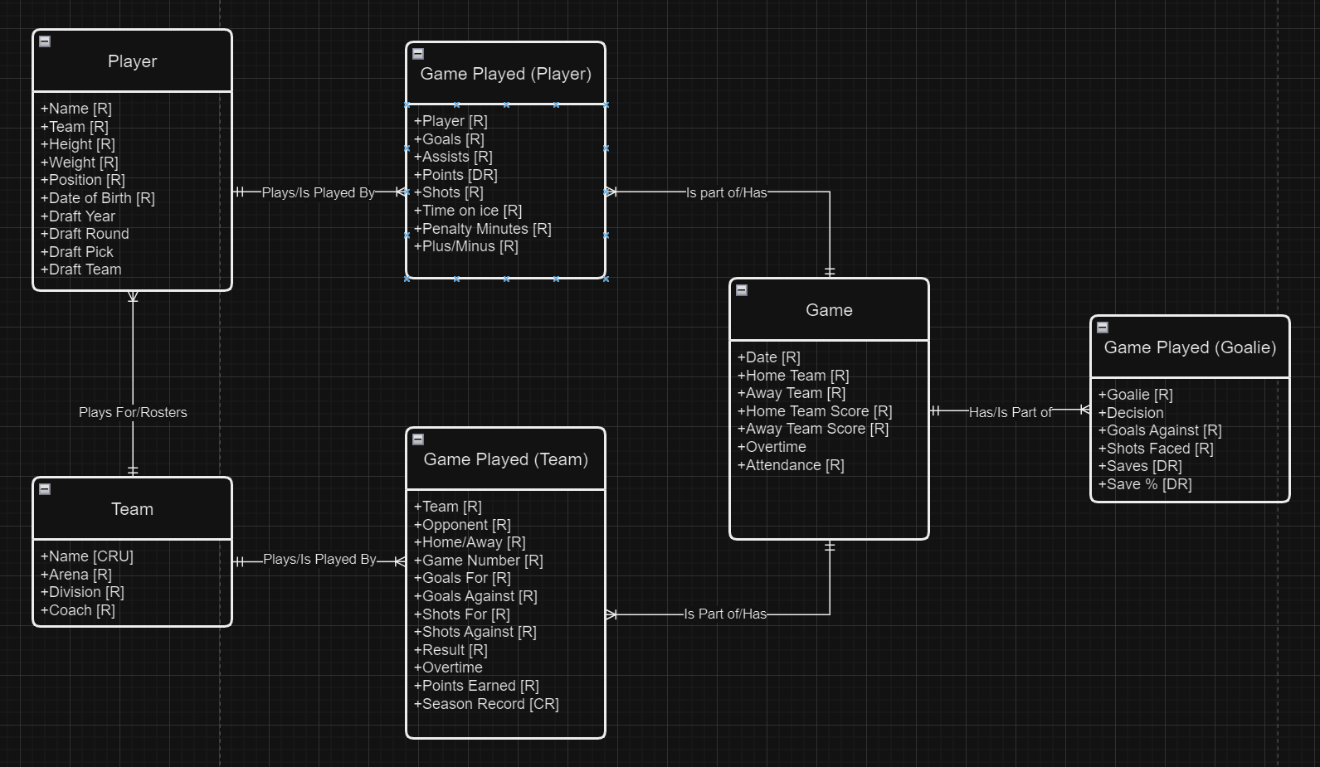

Next, we planned out our internal model with a logical data model:

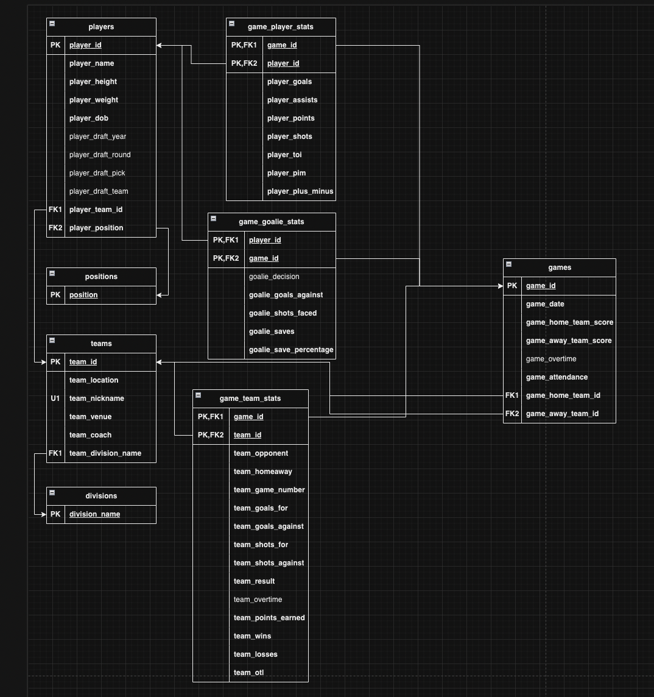

After implementing the internal model, we retrieved data from hockeyreference.com to insert data into the database. We then determined the following user stories that we wanted to implement into the external model and the dashboard:

* I can view the current standings in each division to see which teams are likely going to make the playoffs
* I can see which players have the most points overall
* I can see which positions have the best plus/minus
* I can see which teams have the most points by players
* I can see all of the above but filtered by player draft year and team division

With this data, there are many more potential user stories, including some with the goalie data. However, these were the ones we wanted to focus on for our dashboard. Here’s the link to watch a video of the working dashboard:

<https://youtu.be/FBd5sF35Kls>