Auroras

# Solar wind

“[S]olar wind is a stream of plasma released from the upper atmosphere of the sun”1 and is responsible for exciting atoms in the earth’s atmosphere. These atoms, in turn, release energy in form of photons, or light waves, and thus create polar lights. But how is solar wind formed in the first place? And how does it get to the earth’s poles?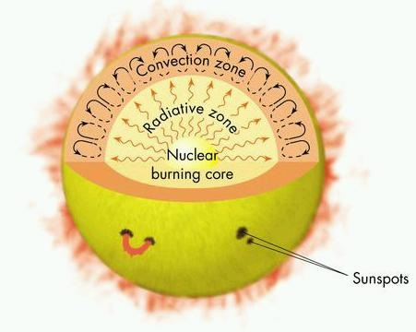

When Hydrogen atoms collide with high velocity and immense energy inside the sun’s core, at a temperature of more than 15 million degrees Celsius, nuclear reactions take place to form Helium. These reactions produce energy which radiates from the sun’s core towards the sun’s outermost layer, the convection zone, where it is subsequently stored in “convection cells”. These convection cells produce electrical currents as well as magnetic fields which interact with the plasma (ionized gas) in the sun’s upper atmosphere, also known as “corona”. Usually the gravitational force of the sun prevents this plasma from leaving its atmosphere, however, occasional bursts of energy from the sun’s core may create strong enough magnetic fields in and around the convection cells to overpower the sun’s gravity and transport the plasma out of the corona and into space. These bursts of plasma leaving the sun are what we call “solar wind”.

When solar wind moves towards the earth, it does not impact it directly or without any resistance. Rather, it interacts with the earth’s **magnetosphere**. The magnetosphere is the area of space where charged particles are controlled by the earth’s magnetic field. As the plasma hits the magnetosphere, part of it is deflected towards the two poles and pulled into the earth’s atmosphere.

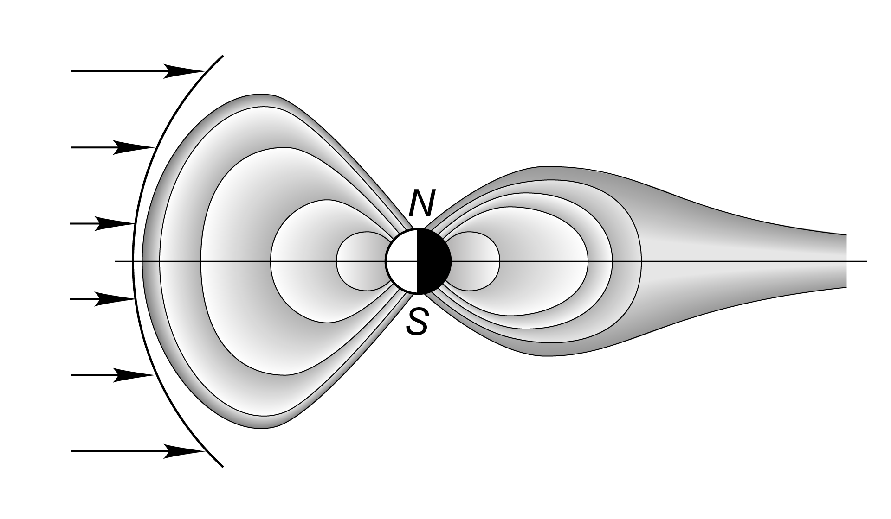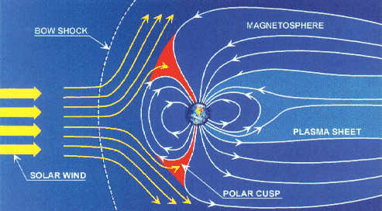

# Auroral lights

When solar wind enters the earth’s atmosphere (80km above sea level and higher) its charged particles collide with the oxygen and nitrogen atoms in the air. These collision excite the atoms and thereafter lead to the emission of light waves (photons) when electrons inside the excited atoms jump back to the ground state from their excited states. The colors of the emitted light waves depend on the atoms involved and the altitude of the collisions.

Oxygen emits:

1. Red light at around 240km above sea level and higher. This color is very rare, as it takes up to two minutes for an oxygen atom to emit red light. During this relatively long period of time the chance of another atom colliding and thus transferring new energy is very high, therefore red light is not emitted that often. If an emission does happen, though, this usually happens at higher altitudes as the atmospheric density and abundance of oxygen is lower with increasing altitude, thus reducing the chance of collision. However, decreased abundance of oxygen at high altitudes also means that there are fewer atoms available to emit light.
2. Green light at altitudes up to 240 km above sea level. It takes oxygen approximately three quarters of a second to emit green light. Therefore, the chance of a green light photon to be emitted is a lot higher than for red light, making green the most common color seen in polar lights.

Nitrogen emits:

1. Blue light at altitude levels of 100km and less. This color is emitted when an ionized nitrogen atom regains an electron. This color is very common during high levels of solar activity.
2. Dark red light at 100km above sea level and higher.

Other colors such as yellow or pink are usually mixtures of the above.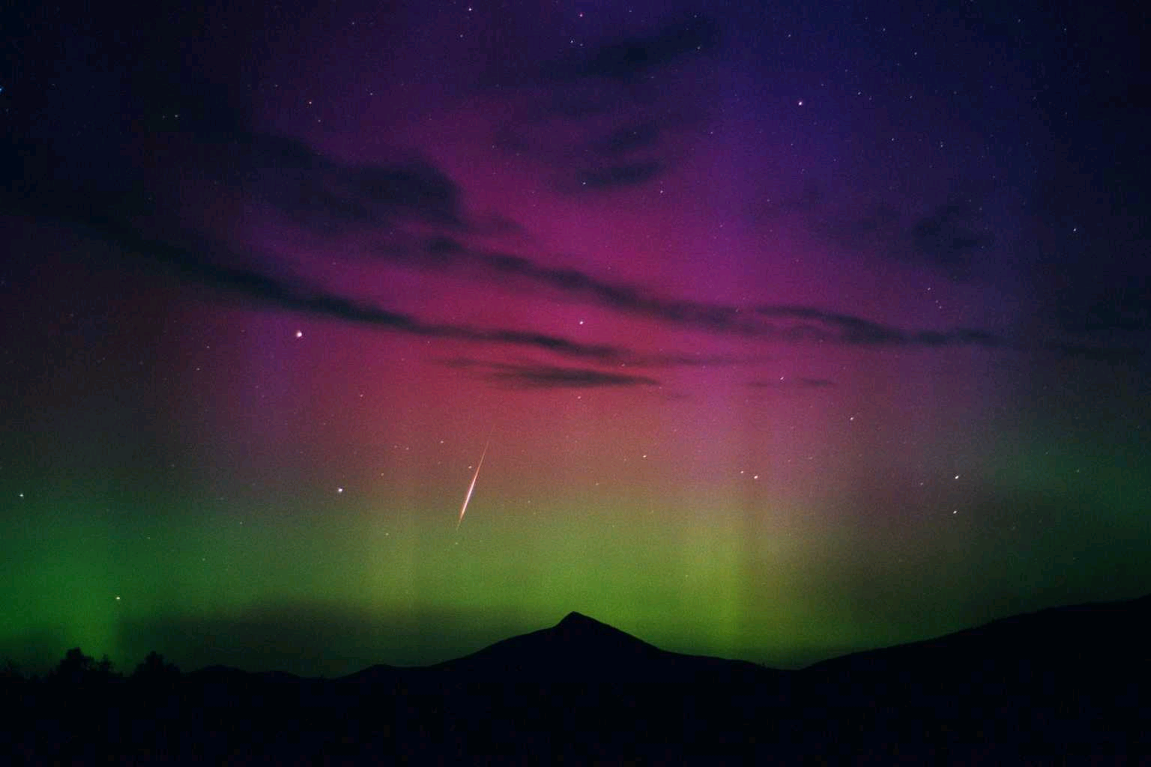

# Forms & Magnetism

Auroras are never the same, they evolve and change constantly. It may appear as a diffuse glow or “curtains”, which consist of many parallel rays, each lined up with the local direction of Earth’s magnetic field lines. In the late 19th century, is was established that the aurora appears mainly in the so-called “auroral zone”, a ring-shaped region with a radius of approximately 2500 km around Earth’s magnetic pole. Surprisingly, it was hardly ever seen around Earth’s geographic pole, which is about 2000 km away from the magnetic pole. Auroras are best observed at magnetic midnight, a time of the day when the North or South Magnetic pole is exactly in between the Sun and an observer on Earth’s surface. Later in the 1970s, is was finally discovered that auroras are caused by interaction between Earth’s magnetosphere and the magnetic field of the solar wind.

# Sounds associated with Auroras

Abbildung 2 : Earth's magnetic field and bow shock

Folktales and traveler’s tales say that auroras have been heard to generate noise such as claps, crackles and static sound. For a long time it was dismissed as a myth, until in 2012 a study from the Aalto University in Finland was published saying that they recorded “clapping sounds” correlated to the sightings of auroras, and that the sound was produced approximately 70 m above the ground. However, hearing auroral noise so extremely rare that is it considered a “once-in-a-lifetime-experience”, only possible during maximum auroral activity on windless nights away from other noise sources.

# On other planets

Planets such as Jupiter and Saturn have much stronger magnetic fields than the Earth, and have both large radiation belts. Auroras have been observed on both planets, and also on Uranus and Neptune. Most of these auroras occur due to the solar wind, but, in Jupiter’s case, Jupiter’s moons, especially Io, are another powerful source of auroras on the planet. Auroras have also been observed on the surfaces of Io, Europe and Ganymede. These auroras have also been seen on Venus and Mars. As Venus has no magnetic field, its auroras appear as bright and diffuse patches of different shape and intensity, sometimes distributed across the whole planet.

# Sources

1. <http://en.wikipedia.org/wiki/Solar_wind>
2. [en.wikipedia.org/wiki/Magnetosphere](http://en.wikipedia.org/wiki/Magnetosphere)
3. [en.wikipedia.org/wiki/Aurora](http://en.wikipedia.org/wiki/Aurora)
4. [www.northernlightscentre.ca/northernlights.html](http://www.northernlightscentre.ca/northernlights.html)
5. [science.howstuffworks.com/nature/climate-weather/atmospheric/question471.htm](http://science.howstuffworks.com/nature/climate-weather/atmospheric/question471.htm)
6. [youtu.be/1DXHE4kt3Fw?t=54s](http://youtu.be/1DXHE4kt3Fw?t=54s)
7. [youtu.be/czMh3BnHFHQ](http://youtu.be/czMh3BnHFHQ)
8. <https://www.youtube.com/watch?v=NRZfKqhs6rM>
9. <https://www.youtube.com/watch?v=Zcef943eoiQ>