Temasek Polytechnic

School of Informatics and IT

**Diploma in Information Technology (IT)**

Software Requirement Specifications (SRS)

**Project Particulars**

|  |  |
| --- | --- |
| **Tutor** | Mr Goh |
| **Class** | P03 |
| **Project Title** | Delonix Regia Hotel Management System |

**Project Team’s Particulars**

|  |  |
| --- | --- |
| **Matric Number** | **Student Name** |
| 1505447A | Kenji Leong |
| 1502784J | Goh Mao Cheng |
| 1505081H | Koh Jia Cheng |

Revision History

|  |  |  |  |
| --- | --- | --- | --- |
| **Date** | **Version** | **Description** | **Author** |
| 19/05/17 | 1.1 | Re-edited 2.2, 2.3, 2.6, 2.7 | Goh Mao Cheng |
| 19/05/17 | 1.2 | Re-edited 2.1, 2.4, 2.5, 2.8 | Koh Jia Cheng |
| 21/05/17 | 1.3 | Re-revise all 1, 2, 3, 4, 5 after Agile Daily SCRUM | Goh Mao Cheng  Koh Jia Cheng  Kenji Leong |
| 22/05/17 | 1.4 | Re-revised all the assumptions and added many more | Koh Jia Cheng |
| 21/5/17 | 1.5 | Re-edited the user requirements | Kenji Leong |

**Table of Contents**

**1. DISTRIBUTION OF WORKLOAD 4**

**2. OVERVIEW OF REQUIREMENTS 4**

2.1 System Functions 4

2.2 User Characteristics 5

2.3 General Constraints 6

2.4 Functional Requirements 6

2.5 Data Requirements 6

2.6 User Interface Requirements 7

2.7 Interface with Other Systems 13

2.8 Assumptions 13

**3 OPERATIONAL AND QUALITY REQUIREMENTS** 14

3.1 Operating Environment 14

3.2 Development Constraints 14

3.3 Performance 14

3.4 Availability 15

3.5 Security and Access Control Requirements 15

**4 SPECIAL REQUIREMENTS 16**

**5 REFERENCES 16**

# 1. DISTRIBUTION OF WORKLOAD

|  |  |
| --- | --- |
| **Requirement Gathering** | **Members** |
| 1, 2, 3, 4, 5 | Goh Mao Cheng |
| 1, 2, 3, 4, 5 | Koh Jia Cheng |
| 1, 2, 3, 4, 5 | Kenji Leong |

# 2. OVERVIEW OF REQUIREMENTS

## **2.1** **System Functions**

**Room availability and Booking Module**

This function will show the availability of the hotel room online to the guests so that they will be able to know the status of all the rooms in terms of vacancy. As a result, if the room they know the room they want to book is vacant then they can book it.  
  
**Housekeeping and Staff Management Module**

Firstly, it is to allow Mr Wang to keep record of the staff details such as the name, date of birth and home address. Also, the duty types of each staff that they were assigned to which includes general, room, estate and security maintenance.  
  
**Reporting Module**

**Room Status Report**

It will list all the room records with their room statuses (Vacant, Occupied, Vacant and Scheduled for Cleaning).

**Single Room Occupancy Report**

It will list all the occupants in that particular room at any given instance currently.

**All Room Occupant Report**

It will list all the occupants in all the rooms at any data. For example, all the Customers that are in the hotel in their rooms on the 21st January).

**Room Occupancy Report**

It is a report generated statistically at intervals of Daily, Weekly, Monthly, Yearly basis of the room occupancy. This report is only available to Management and Administrator.

**Housekeeping Report**

Lists the duties such as general, estate, room and security maintenance that the staffs have been allocated. This allows Mr Wang to generate the Housekeeping Schedule on a Weekly, Daily and Monthly basis. This report is only available to Management and Administrator.

**Additional Features of Reporting Module**

**Preview report**

This feature can help Mr Wang and the staffs to check for any errors before sending it to print at the printer.

**Export to excel**

This feature will allow Mr Wang to be able to generate a spreadsheet since he can add numerical figure.

**Method of Payment**

This function will records details of the credit card such as card number, expiry date and cardholder name and this allow the guest to be able to pay for the hotel room online that they have booked through the use of credit cards such as Visa or MasterCard. There are also method of payment through cash.

**Check in and check out**

This function will record the check in and check out details such as the date or name of the guest and it also allow the guest to be able to check in into the system so that they will be able to book the hotel room, including number of occupants, desired check out time etc

**Feedback/Remarks**

This function will allow the guest to be able to give review or comment of the hotel such as what they need to improve on and also whether they would need to change the size of the bed if required. Basically act as a feedback to Mr Wang to see if there are possible enhancement to be done, or damages to be fixed, so they could further improve their services to future customers.

**Updating the data in the system**

This function will allow Mr Wang and the receptionist to change data of the customer. The customer might be request for a room change and hence will have their room changed. There might be changes to the occupancy as well, so there is also a need for that to be accessible to updates made by Mr Wang and the receptionists.

## **2.2** **User Characteristics**

There are 3 different Level of Users using the System. Dividing them into 3 Levels, we have:

* 1st Level of Users are the Receptionist, they are allowed to access parts of the reporting module, full access to room availability and booking module.
* 2nd Level of Users are the Management users, which they have access to all the modules (Room Availability and Booking, Housekeeping and staff management, and Reporting Module)
* 3rd Level of Users are the Hotel Administrators, access to all parts of the system including all the three modules and in addition, the User Account and Login Creation Module

## **2.3** **General Constraints**

There are constraints like Single Computer which means only 1 point of entry for the customer. Adding on, the old PC means that the processing speed will be slow which would not facilitate the flow during Peak Hours.

Additionally, there are also budget constraints to come up with a well-designed systems for only $70,000. To elaborate, depending on the design and architecture, there are costs in manpower, labour, purchases of system and technologies.

Other than that, there is also a very tight deadline for this project with many different requirements.

For more information, the general constraints could be reviewed at the References.

## **2.4** **Functional Requirements**

This system will basically allow the receptionist to enter guest data to allow them to stay in the hotel. They will capture a few mandatory details of the guest to allow their stay. Adding on, the system will also allow any modification to be done by the receptionist and Mr Wang. It will also store data regarding staff and guest information which will be updated periodically. At different intervals, it should also generate different types of report to let Mr Wang understand the situation of his hotel. This means that the system will also need to send the data report to a printer to be printed.

## **2.5** **Data Requirements**

Staff:  
 - Staff First name  
 - Staff Last name  
 - Date of Birth  
 - Bank account number  
 - Home address  
 - Phone number  
 - Duty Types the staff can do:  
 - General Maintenance

- Room Maintenance

- Estate Maintenance

- Security Maintenance

Customer:

- Last name

- First name

- Number of Adult and Children occupants

- Phone number

- Email address

- Home address (Block number, House number, Postal Code, Country)

- Method of Payment (i.e. Cash, Credit)

- Credit card would require Credit Card Number, Credit Card holder’s name, expiration date of the card

- Check in Details

- Check in date

- Check in time

- Desired check out date

- Desired check out time

- Customer remarks (Feedback)

- Late checkout for customer or not

## **2.6** **User Interface Requirements**

**Guest**

**Homepage**

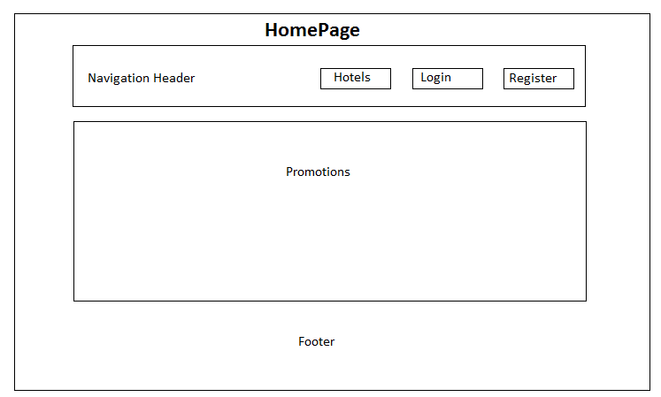

On the homepage, for the navigation header, it should include a button for hotels where after clicking it, it should show all the rooms for the different types of hotel. Also, a login and register page is required if the guest wants to book a room. Lastly, the promotion section should show all the hotels that have the best deals and the footer is used for better navigability.

**Login for Guest, Receptionist, Management and Admin**

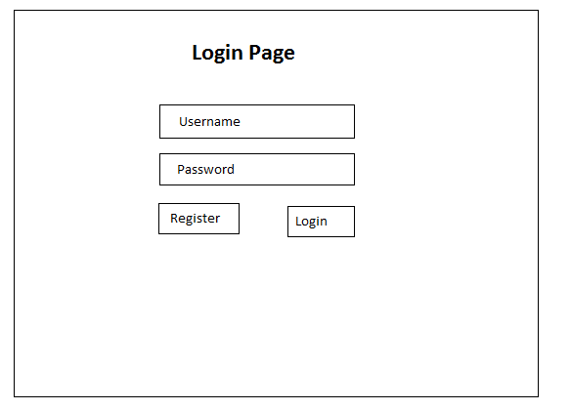

This is the login page for all the users in the system. As shown above, all users can login through their username and a password, which must contains at least one uppercase letter and a number is also required to be entered by the user.

**Register Page for Guest**

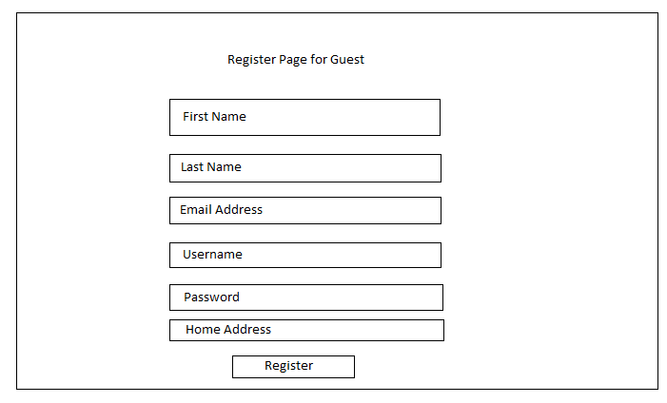

The guest would need to go to the register page if they have not created the account, which includes first name, last name, email address, username, password and home address.

**Hotels List Page for Guest**

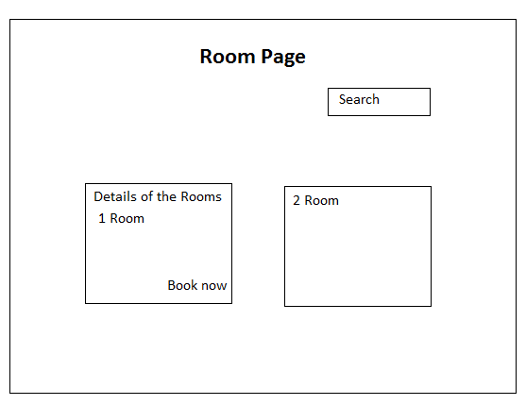

After the guest click on the type of hotel they prefer, they would then be navigated to the Room Page where it will show a list of the room details such as the types of room, price, description and ratings. Besides, the guest can also search for a specific room. Lastly, after deciding on the room the guest then can click on the book button that they want.

**Check Out Page for Guest**

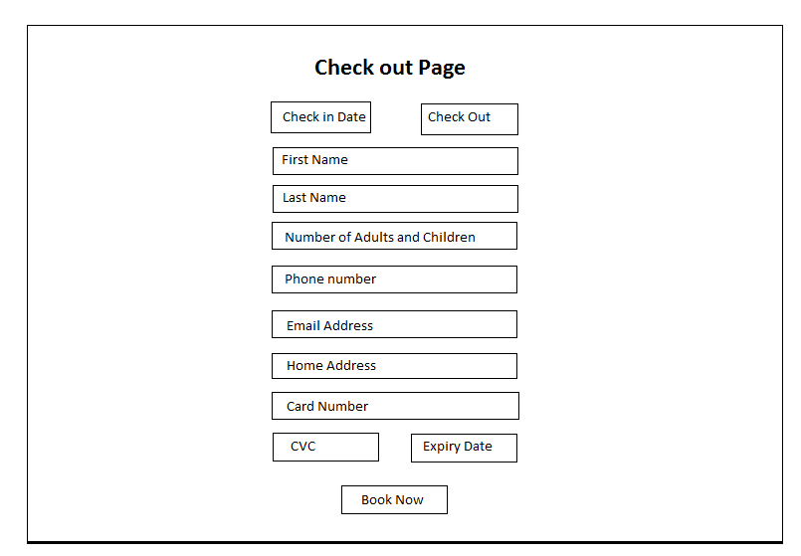

This is the page where the guest will enter all their particular and payment details which include credit card number, expiry date and CVC code for processing.

**Receptionist**

**Room Availability and Booking Module**

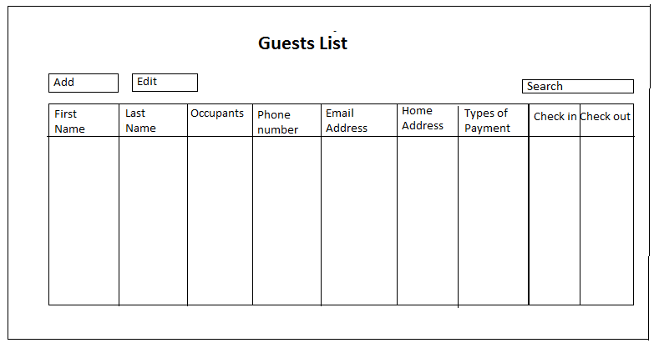

The guest list will show all the details of the guest that they have entered in the checkout page. Besides, when the receptionist clicks on the check in button it will redirect them to the checkout page and the receptionist can also edit the details of the guest by clicking on the edit button.

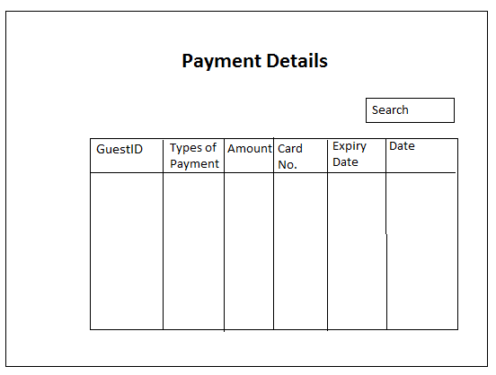

Lastly, when the receptionist clicks on the types of payment, they will be redirected to payment details page as shown below, where it will show credit cards details such as the card number, expiry date, date of transaction and the amount of money transacted for each guest based on their id.

**Reporting Modules**

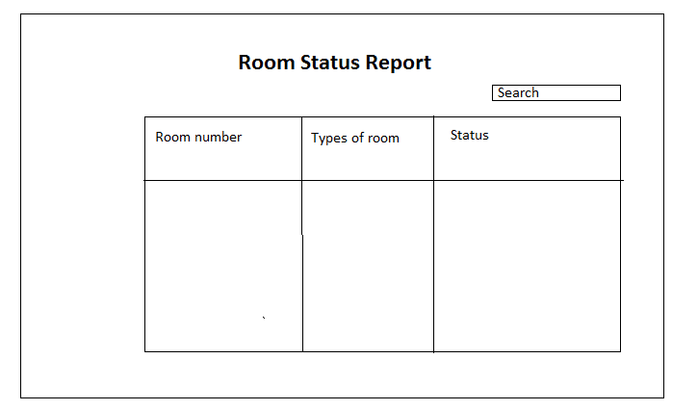

This room status report will allow the receptionist to see whether which room are available based on the status such as whether it is vacant, occupied or vacant and scheduled for cleaning. Also, they can also search for the room number.

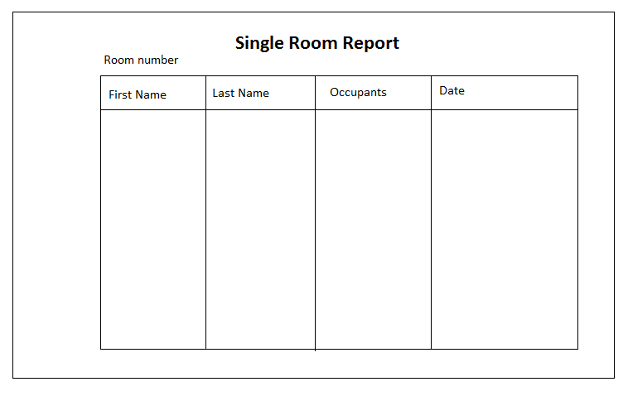

For the single report, when the receptionist clicks on the room they will be able to see the number of occupants in the room in terms of number of adults and children and their details such as their first and last name and the date that the room is booked.

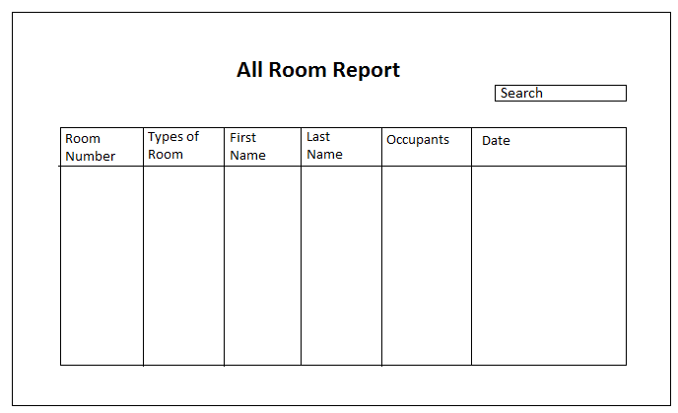

For the all room report, it will list all guests for all the room at any date. Similarly, to the single room report, it will show similar details of all the guest in a specific room at any given point in time.

**Management**

Management team has accessed to all three modules.

**Housekeeping and staff management Modules**

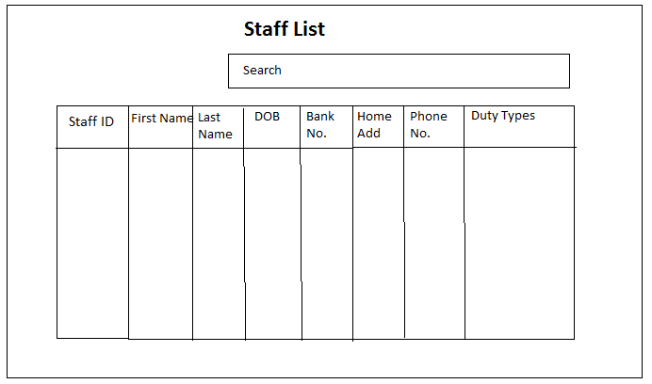

This is to show the details of all the staff in the system such as their staff ID, name and duty types.

**Reporting Modules**

As shown below, these are the two other reports that the Management Team can access.

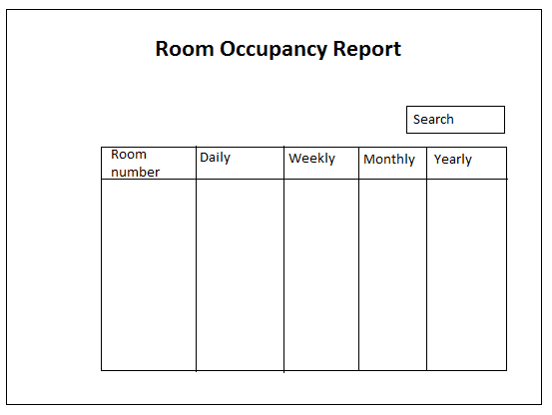

For the room occupant report, it is available only to the management and administrator and this report will show them details such as the the room number, types and the daily, weekly, monthly and yearly statistic of each room.

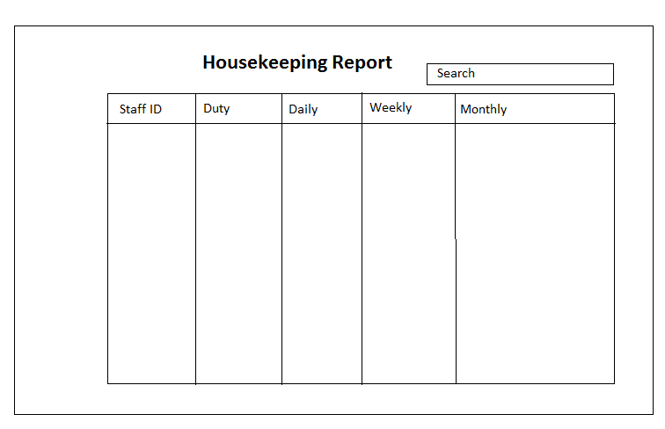

For the housekeeping report, it is used to show the duty that each staff was assigned to and this can be assigned based on their staff id.

**Administrator**

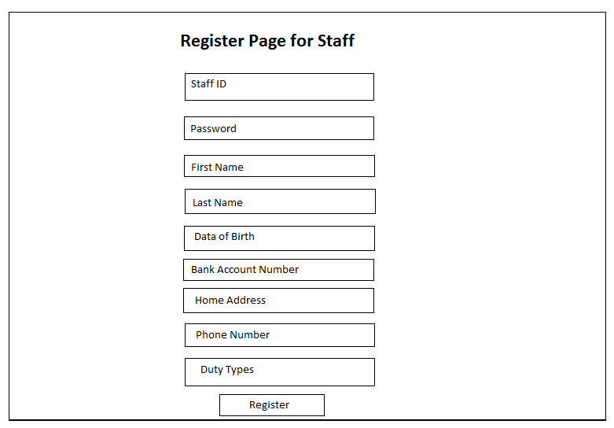

Other than accessing all three modules, the admin can also access the user account where they have the privileges to perform CRUD operation such as adding staff and guest. Besides, they can also see all the users inside the system which are the guest and staff list and also perform the same operation.

## **2.7** **Interface with Other Systems**

Firstly, in order to communicate with other critical component such as the Hotel Property Management system, it would requires data such as the guest identity, status and room number to be exchange between them. As a result, this can allow them to identify the guest details when needed. For example, whether if the guest is a VIP or normal guest.

Besides, when transferring data between systems, it is important to ensure the data is encrypted before it is send. On the other hand, if this is not done, a third party can easily attack and retrieve confidential information such as the credit card number of the guest. Thus, it is important to always to encrypt data before any data transfer.

## **2.8** **Assumptions**

* The budget will actually be enough for the entire process.
* The deadline will actually be enough time for us to implement the system.
* The backup records will actually be safe to delete after 5 years.
* The computer will be able to run the software with such low end specifications.
* There will be no issue with reliability of the system. I.e. Customer checking out late.
* There will be no issues with 1 point of customer entry.
* Only Administrator can create account for the staffs.
* Mr Wang can use Administrator to make different modification to the system’s data when needed.
* More staff information are actually required, instead of just name as mentioned by Mr Wang.
* The response time of the system also has to be fast enough so that it can provide better performance. As a result, the staff and guests will then be satisfied with the system.

# 3 OPERATIONAL AND QUALITY REQUIREMENTS

## **3.1** **Operating Environment**

The system as shown below might not be solid as it is Pentium 5. The broadband internet connectivity might also be slow.

- Single computer at the reception staff area

- Computer Specs  
 - Pentium 4 PC

- Windows XP support package 2  
 - 1 GB RAM  
 - 160 GB Hard disk   
 - Connected to internet via broadband connection   
- The broadband connection is also used to maintain the blog site

## **3.2** **Development Constraints**

Firstly, meeting the deadline for each task is definitely be an issue since the level of technical for all of us is different. As a result, if one of the task they were assigned is too tough for them, we would need either more members to do the same task or extend the deadline of the task.

Also, the members also have their own personal schedule they prefer to follow such as setting their own time to complete. Thus, the task that we are assigned is able to fit the members personal schedule so that we finish the task on time.

Lastly, another constraint is to deploy the system onto different platforms such as mobile. This is because due to the time constraint and limited skills on mobile development, it will requires more time as we need to research on how to code the different features that is required. Also, after our system is completed we also want to deploy it on Microsoft Azure but we have not done it before so more time is definitely required.

## **3.3** **Performance**

**Acceptable Response Time during *Non-Peak Hour***

Room Availability: 2 - 6s

Feedback/Remarks: 2 - 8s

Generate Reporting Modules: 2 - 10s

Housekeeping and Staff management List: 2 - 10s

Booking/Payment: 30s – 1mins

Updating Data in the System: 10s ~ 15s

Add Guest or Staff: 10s ~ 15s

Firstly, the average response time for non-peak hour for features such as room availability, feedback and generating the reporting module should around 2 to 10 seconds because it would require time for the system to load or retrieve the data from the server.

Besides, for booking which includes payment for checking in, the average time should be around 30secong to 1 minute because, the system would check the validity of the user and it is important to ensure that the data match with the bank. As a result, more time should be required went processing the payment.

Lastly, the average time for updating or adding guest into the system should be around 10 to 15 seconds because since a three tier model is used. Thus, it would require more time to check the validity of the data before it is entered into the system.

**Acceptable Response Time during *Peak Hour (*11am - 12pm)**

On the other hand, since there is an increase in traffic during peak hour. As a result, the average response time of the system for all the features mention should increase by about 20 seconds because of the increase traffic.

## **3.4** **Availability**

Since the hotel operates at 24 hours a day and 7 days a week. As a result, the system is required to run 24/7 in order to accommodate with the hotel operating hours and the peak hour for the hotel is between 11AM to 12PM because this is the stipulated and recommended check out time for the hotel.

Besides, the system should have a downtime for maintenance and data backup once every month, on the first Sunday of the month, from 2AM to 3AM because this is the time period that has the least amount of guest since they are sleeping. As a result, the traffic will decrease and this is the best time to back up the data.

## **3.5** **Security and Access Control Requirements**

This standalone software as proposed by Mr Wang, will have the Receptionist to Login first to start her/his daily working schedule of basically entering customer information and get it sent to the database. Such information will also be logged into the system which would be generated into a report later on. They would also have to Log out later on.

For more advance control, the management and the administrator as well as Mr Wang have all the access and modification privilege for any facilitation. However, any modification or use of such actions will be logged into the system to prevent any abuse of authority as well as wrongful adjustment of data. The users of the management will have to login first to verify their identity.

Regarding the guest’s card data, since Mr Wang wants it to be stored in their database instead of just using a payment gateway (Recent payment gateways would not need payer’s information to be stored anywhere but with the bank through their API systems), doing so could be dangerous in the case of any data breaching. So it will be encrypted through Salt Hashing.

# 4 SPECIAL REQUIREMENTS

The backup data will be safely discarded from the system after 5 years and this is because all these data can be used to see statistics such as which type of room are the most popular and based on the feedback how it can further improve the hotel management system.

# 5 REFERENCES

**Video 1: ///Functions**  
- Room availability and Booking module  
- Housekeeping and Staff management module  
- Reporting module

**Video 2: ///Users**

- 1st Level of Users are the Receptionist, they are allowed to access parts of the reporting module, full access to room availability and booking module

- 2nd Level of Users are the Management users, which they have access to all the modules (Room Availability and Booking, Housekeeping and staff management, and Reporting Module)

- 3rd Level of Users are the Hotel Administrators, access to all parts of the system including all the three modules and in addition, the User Account and Login Creation Module

**Video 3: /// Room Availability and Booking Module**

- Data to be capture are

- Last name

- First name

- Number of Adult and Children occupants

- Phone number

- Email address

- Home address (Block number, House number, Postal Code, Country)

- Method of Payment (i.e. Cash, Credit)

- Credit card would require Credit Card Number, Credit Card holder’s name, expiration date of the card

- Check in Details

- Check in date

- Check in time

- Desired check out date

- Desired check out time

- Customer remarks (Feedback)

- Late checkout for customer or not

**Video 4: /// Process Flow when hotel guest checks out**

- Guest will start checking out from 11am to 12pm

- Guest will bring their baggage to the reception area

- Guest will pass room key to reception staff

- Guest will be asked by the reception staff whether or not they had consumed any items from the room or whether they took any item out from the mini bar

- Cleaning staff will check the item list the following day to see whether the previous guest had taken any item out from the mini bar

- A payment invoice will be generated which calculates

- Number of days the guest had stayed

- Whether they had consumed any items from the mini bar

- The payment invoice will indicates

- Guest details

- Check-in date

- Check-out date

- Number of nights the guest stayed

- Room rates

- Any additional cost

- Mode of payment

- The guest will check the invoice and then proceed to make the actual payment

**Video 5: ///Additional Features**

- Modification of the Guest Records privilege for Mr Wang and the Receptionist upon customer’s demand (i.e. if they change the room as they are unhappy, new occupants etc)

**Video 6: ///Housekeeping and Staff Management Module**

- Two key features  
- Keeping records of the staff  
 - Staff name (Might Need further details of the Staff like ID)  
 - Date of Birth  
 - Bank account number  
 - Home address  
 - Phone number  
 - Duty Types the staff can do

**Video 7: /// Staff Duties**

- General Maintenance

- Room Maintenance

- Estate Maintenance

- Security Maintenance

**Video 8: ///Reports required in the Report Modules**

- Room Status Report

- It will list all the room records with their room statuses (Vacant, Occupied, Vacan and Scheduled for Cleaning)

- Single Room Occupancy Report

- It will list all the occupants in that particular room at any given instance currently

- All Room Occupant Report

- It will list all the occupants in all the rooms at any data. For example, all the Customers that are in the hotel in their rooms on the 21st January)

- Room Occupancy Report

- It is a report generated statistically at intervals of Daily, Weekly, Monthly, Yearly basis of the room occupancy. This report is only available to Management and Administrator

- Housekeeping Report

- Lists the duty the staff have been allocated. This allows Mr Wang to generate the Housekeeping Schedule on a Weekly, Daily and Monthly basis. This report is only available to Management and Administrator.

**Video 9: ///Additional features for Reporting Module**

- The ability to preview the report before sending into printer

**Video 10: ///Budget for the system**

- $70,000

**Video 11: ///Where will software be installed in**

- Single computer at the reception staff area

- Computer Specs  
 - Pentium 4 PC

- Windows XP support package 2  
 - 1 GB RAM  
 - 160 GB Hard disk   
 - Connected to internet via broadband connection   
- The connection is also used to maintain the blog site

**Video 12: ///Integration into Existing System (NOT OF PRIORITY)**

- Allowing Customer to enquire about Room Availability Online (As of right now, Mr Wang have to manually access Emails sent by Customers asking about room availability)

- Exporting the Reports (The 5 different reports) so that Mr Wang can have statistical analysis in the future in Spreadsheet Format

**Video 13: ///Backups for the System and Peak hours of hotel**  
- Backup timings

- 2-3am

- Once a month

- First Sunday of every month

- Backup record to be kept in the system for 5 years before they can be safely discarded

- Peak Hours  
 - Around 12pm which is the stipulated check-out time for hotel guests

**Video 14: ///Deadline**

- 31 March for system to be done

- 7 April for system to be fully deployable

*Sourced from:   
Interview with Mr. Wang (Assignment 2);

<https://studenttpedu-my.sharepoint.com/personal/antonioq_tp_edu_sg/_layouts/15/onedrive.aspx?id=%2Fpersonal%2Fantonioq%5Ftp%5Fedu%5Fsg%2FDocuments%2FSWEN%20Videos%20%2D%20HMS&FolderCTID=0x01200041E9132373CE2745981755123F8DEDAE>