Site url : dev.aflix.tv

# User Permission

Right now the user permission are hardcoded

We want make an admin panel to manage the user access control

|  |  |
| --- | --- |
| User/Content | Description |
| Public Users | Any users that are visiting the site by directly typing in [www.Aflix.tv](http://www.aflix.tv) or coming via search engine results |
| Public Content | any content that could be viewed by public users without any registration, these content are static pages like About Us page, Contact us page etc |
| Free Registered users | Users required to register by providing all the information required in 2.4, Once registered a confirmation email will be sent. Users not required to click for conformation |
| Registered Content | The content classified as for “Registered Users Content” any “Free Registered Users” can watch this content by logging in using email and password |
| Paid Subscribers | Users that registered with information required in 2.4 and pay a subscription fee of USD1 per month or USD10 per year. |
| Paid Subscribers content | The content classified as “Paid subscribers content” |
| Corporate Admin | A special admin that could only be created by the superadmin, This admin is created to manage the users for a group or organization that signup to Aflix. Corporate admin have permission to create corporate users and upload the corporate users via csv. |
| Corporate Content | Corporate contents are the content allowed for the corporate users. Basically all registered content are allowed for the corporate users because all the corporate users are a registered users as well. Super admin can assign some content from the paid subscribers content to the corporate users due the corporate agreement with Aflix |
| Corporate Users | The Aflix members who have a special collaboration with Aflix. All Corporate users are considered as a free registered users. Corporate users will be able to watch some special paid subscriber’s content that assigned by the superadmin. The special paid subscriber videos are differ from an organization to organization. The organization can be a large company, school, kindergarten or association. |
| Contributor | Contributor is a type of user who can contribute their videos to be distributed via Aflix platform. Contributor can contribute video either in Registered Content, Paid Subscriber Content and Premium Content. The revenue will be discussed in the Contributor section later. Contributor can be organization or individual |
| Premium VOD Content | Premium Contents are the video content that made available to all the subscribers via various prices. Once users pay for the premium content they can continue to watch if for 30 days from the date of payment. |
| Superadmin | Superadmin is a superuser that have full access to create users, upload content, and approve content, view revenue and more. Will be discussed in detail in superadmin section |

# Paypal complete payment cycle

### User (Free Registered User, Paid Subscriber) Clicking the Paid VOD



System will automatically check that user is login or not if user is a new user or not login yet then system will show prompt login screen

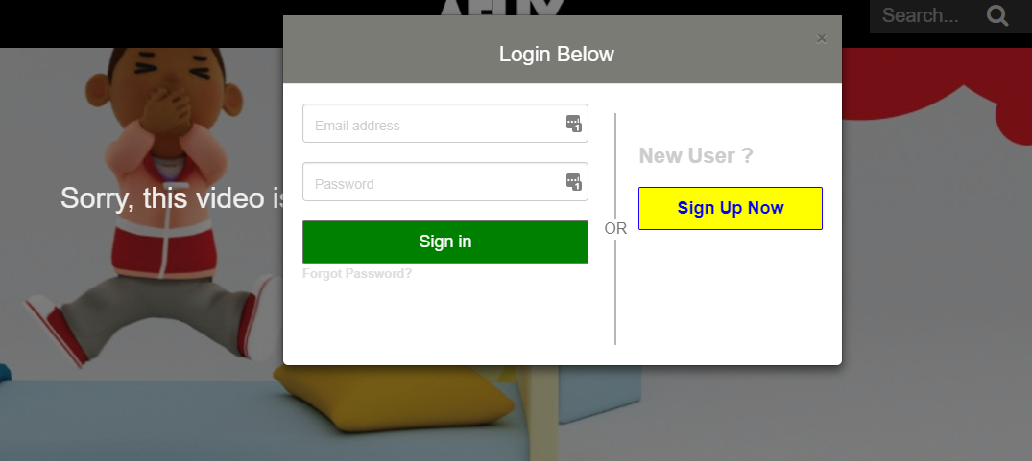

If user is already registered on this website then simply login to the system if not then register to website and then login. Once login, the price of the video will be displayed, then click “Purchase Now”



Price will be shown

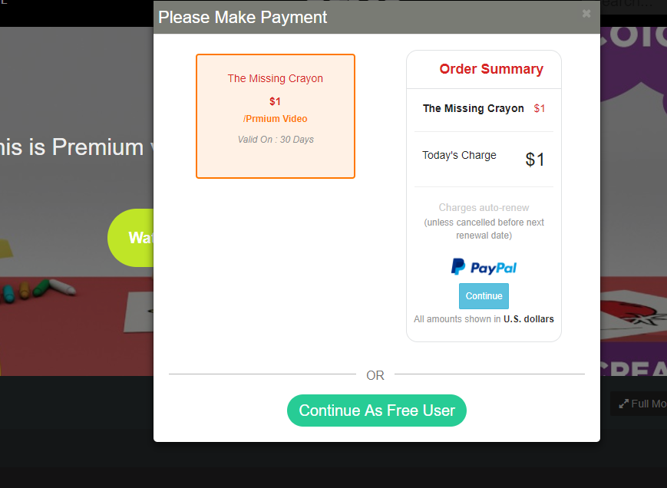

Continue to make payment and watch the video for 30 days

Right now its stuck afte registration

# Mobile version when click signup , the form shown for a while and disappeared

Need to make sure the mobile signup working properly