MIVA OPEN UNIVERSITY, ABUJA, NIGERIA
SCHOOL OF COMPUTING
DEPARTMENT OF DATA SCIENCE
CREDIT RISK ANALYSIS AND LOAN DEFAULT PREDICTION USING MACHINE LEARNING MODEL AND DATA VISUALIZATION
BY:
MBAEGBU CHINEDUM GRACE
MATRICULATION NUMBER: 2025/A/DSC/0058
A PROJECT SUBMITTED TO THE DEPARTMENT OF DATA SCIENCE, SCHOOL OF COMPUTING, MIVA OPEN UNIVERSITY ABUJA, NIGERIA.
IN PARTIAL FULFILLMENT OF THE REQUIREMENTS FOR THE AWARD OF THE BACHELOR OF SCIENCE (HONOURS) DEGREE IN DATA SCIENCE
AUGUST, 2026

CHAPTER ONE: INTRODUCTION
1.1 Background of the Study
Credit risk refers to the possibility that a borrower may fail to meet agreed financial obligations. It remains one of the major sources of risk for retail and commercial lending institutions worldwide (Basel Committee on Banking Supervision [BCBS], 2000).
Traditionally, financial institutions have assessed credit risk through manual underwriting, expert judgment, and statistical models. These methods include the 5 Cs of Credit, namely Character, Capacity, Capital, Collateral, and Conditions, as well as statistical techniques such as Logistic Regression, Discriminant Analysis, and Altman’s Z-Score (Altman, 1968; Thomas et al., 2002; Mestiri, 2024; Bello, 2023).
Although these traditional methods are relatively easy to understand and interpret, they have some limitations. For example, conventional linear scoring models may struggle to capture complex relationships between variables, patterns in borrower behaviour, and changes in economic conditions. These limitations can affect their ability to assess credit risk accurately, particularly when borrower characteristics and lending conditions become more complex (Mestiri, 2024).
Relevance in Modern Computing and Data Science
Advances in computing, big data, and machine learning have changed how financial institutions assess credit risk. These technologies make it possible to process large amounts of data, identify patterns in borrower behaviour, and make lending decisions more efficiently.
- Processing Large Volumes of Data: Modern computing infrastructure allows financial institutions to process large amounts of transactional records, credit histories, and other borrower information. This helps them analyse a wider range of factors when assessing creditworthiness (Suhadolnik et al., 2023; Bello, 2023).
- Identifying Complex Patterns: Machine learning models such as XGBoost, LightGBM, and Random Forest can identify complex relationships between borrower characteristics and loan repayment outcomes. Unlike traditional linear models, these algorithms can capture non-linear relationships without requiring all such relationships to be specified manually (Chen & Guestrin, 2016; Suhadolnik et al., 2023).
- Faster Loan Decisions: Machine learning can automate parts of the loan assessment process and help financial institutions make decisions more quickly. This is particularly useful for digital banks and financial technology companies that process large numbers of loan applications (Bello, 2023).
- Understanding Model Predictions: Although machine learning models can make accurate predictions, some are difficult to interpret. This can be a concern in credit risk assessment, where financial institutions need to understand the factors influencing lending decisions. Methods such as SHAP (SHapley Additive exPlanations) and LIME (Local Interpretable Model Agnostic Explanations) help explain individual predictions by showing how different features contribute to a model's output (Lundberg & Lee, 2017; Bussmann et al., 2021).
1.2 Problem Statement
Despite improvements in credit scoring models, financial institutions continue to face the challenge of predicting which borrowers are likely to default on their loans. Loan defaults can lead to financial losses and affect the stability of lending institutions. Two major challenges make credit risk prediction difficult.
The first challenge is class imbalance. In many credit datasets, borrowers who default make up a smaller proportion of the total number of borrowers. When a model is trained on such data, it may favour the majority class, which consists of borrowers who repay their loans. As a result, the model may fail to identify applicants who are likely to default, leading to high-risk loans being approved (Chawla et al., 2002).
The second challenge is model interpretability. Machine learning models such as XGBoost and neural networks can identify complex patterns in credit data, but their predictions may be difficult to explain. Financial institutions need to understand the factors behind lending decisions, particularly when an application is rejected. This creates a challenge when using complex models, as their predictive performance must be balanced with the need to explain their decisions. Methods such as SHAP can help explain model predictions and provide insight into the factors influencing credit risk assessments (Bussmann et al., 2021).
Changes in economic conditions and borrower behaviour make credit risk prediction even more challenging. These issues highlight the need for models that can identify potential loan defaults while providing reliable performance measures and explanations that are easy to understand. This study therefore focuses on addressing class imbalance and model interpretability in credit risk prediction.
1.3 Research Aim and Objectives
Research Aim
The aim of this study is to develop and evaluate an interpretable machine learning framework for credit risk assessment and loan default prediction using credit data from Sterling Bank Nigeria. The study will focus on addressing class imbalance and using Explainable Artificial Intelligence (XAI) to make model predictions easier to understand.
Research Objectives
The specific objectives of the study are:
- To explore and preprocess Sterling Bank’s personal and retail loan data and apply synthetic resampling techniques to address class imbalance.
- To develop an ensemble machine learning model, such as XGBoost, and compare its performance with traditional statistical models using suitable credit risk evaluation metrics.
- To apply a SHAP-based Explainable Artificial Intelligence framework to explain model predictions and examine how these explanations can support transparent and auditable credit risk assessments in line with relevant Central Bank of Nigeria (CBN) guidelines.
1.4 Research Questions
To achieve the stated objectives, this study seeks to answer the following research questions:
- RQ1: How effectively can data preprocessing and synthetic resampling techniques, such as SMOTE, address class imbalance and help identify important risk factors in Sterling Bank’s personal and retail loan data?
- RQ2: How does the performance of an ensemble machine learning model, such as XGBoost, compare with traditional statistical models in predicting loan defaults when assessed using appropriate credit risk evaluation metrics?
- RQ3: How can a SHAP-based Explainable Artificial Intelligence framework help explain loan default predictions and support transparent and auditable credit risk assessments in the context of relevant CBN guidelines?
1.5 Significance of the Study
Significance to Sterling Bank Nigeria and Commercial Lenders
The study may help Sterling Bank Nigeria understand how machine learning can be used to improve credit risk assessment. By comparing an ensemble model with traditional statistical models, the research will examine whether machine learning can identify borrowers who are more likely to default. This could support loan assessment and risk management by providing additional information for lending decisions. The findings may also help the bank assess whether these methods could improve the efficiency of its credit assessment process (Suhadolnik et al., 2023).
Significance to Regulatory Oversight and Policy
The use of complex machine learning models in credit assessment can make it difficult to explain why a borrower has been classified as high risk. This can create challenges for transparency, auditing, and the review of lending decisions. This study will examine how SHAP (SHapley Additive exPlanations) can be used to explain the factors that influence model predictions. These explanations may help risk analysts, compliance officers, and auditors better understand the model's outputs. The study will also consider the relevance of these explanations to applicable Central Bank of Nigeria (CBN) guidelines and the need for transparent credit assessment (Lundberg & Lee, 2017; Bussmann et al., 2021).
Significance to Applied Data Science and Financial Computing
This study will contribute to the application of machine learning in credit risk prediction by examining two key challenges: class imbalance and model interpretability. It will explore the use of synthetic resampling techniques, such as SMOTE, and evaluate an ensemble model, such as XGBoost, against traditional statistical approaches. The results may provide useful information for data scientists and researchers working on credit risk models, particularly when dealing with imbalanced financial datasets. The study may also serve as a reference for future research on the application of machine learning to credit assessment in Nigeria and other African banking markets (Chawla et al., 2002; Chen & Guestrin, 2016).
1.6 Scope of the Study
Institutional Focus
The study focuses on Sterling Bank Nigeria, specifically its personal and retail lending operations. The analysis will use available historical loan data to examine factors associated with loan default and assess the performance of selected credit risk prediction models.
Data Analysis and Model Development
The study covers the main stages of the data science process, including exploratory data analysis, data cleaning, feature engineering, and the treatment of class imbalance. Synthetic resampling techniques, such as SMOTE, will be considered alongside cost sensitive methods where appropriate. The study will compare Logistic Regression with machine learning models such as Random Forest, XGBoost, and LightGBM to evaluate their performance in predicting loan defaults (Chawla et al., 2002; Chen & Guestrin, 2016; Suhadolnik et al., 2023).
Model Interpretability and Visualization
The study will use SHAP (SHapley Additive exPlanations) to examine the factors influencing model predictions at both the overall and individual borrower levels. It will also include an interactive dashboard prototype to present model performance, important risk factors, and prediction explanations. The explanations will be considered in relation to the need for transparent and auditable credit risk assessments and relevant Central Bank of Nigeria (CBN) guidelines (Lundberg & Lee, 2017; Bussmann et al., 2021).
1.7 Limitations of the Study
- Historical Data and Economic Changes: The study relies on historical loan data, which may not fully reflect sudden changes in Nigeria’s economic conditions, such as exchange rate fluctuations or increases in inflation. Unless relevant macroeconomic variables are available and included in the analysis, the models may not account for the effects of these changes on borrowers’ ability to repay their loans.
- Limited Real-Time Testing: The models will be evaluated using historical data, appropriate training and testing procedures, and cross-validation where applicable. Testing the models in Sterling Bank’s live production environment, integrating them with real-time data streams, and conducting A/B testing are outside the scope of this study.
- Limitations of Synthetic Resampling: Synthetic resampling techniques, such as SMOTE, can help address class imbalance by generating additional examples of the minority class. However, these synthetic examples are created from patterns in the available data and may not fully represent the behaviour of actual borrowers. Their use therefore requires careful evaluation to avoid overfitting or misleading performance estimates (Chawla et al., 2002).
1.8 Definition of Key Terms
- Credit Risk: The potential that a bank borrower or counterparty will fail to meet agreed financial obligations according to contract terms, resulting in direct financial loss to the lending institution (Basel Committee on Banking Supervision [BCBS], 2000).
- Loan Default: A binary target condition representing a failure by a borrower to make required debt repayments for a specified period (typically 90 days or more past due), triggering legal or collection procedures.
- Class Imbalance: A machine learning dataset condition where the target classes are severely disproportionate. In credit scoring, non-defaulting borrowers constitute the majority class (e.g., 85 to 95 percent), while defaulting borrowers constitute the minority class (e.g., 5 to 15 percent) (Chawla et al., 2002).
- Ensemble Learning: A machine learning strategy that combines multiple weak or base predictive models (such as individual decision trees) to construct a single, highly accurate meta-estimator. Examples include Random Forest, XGBoost, and LightGBM (Chen & Guestrin, 2016).
- Gradient Boosting (XGBoost / LightGBM): An ensemble technique that builds decision trees sequentially, where each new tree is optimized to minimize the residual errors produced by the previous combination of trees using gradient descent principles (Chen & Guestrin, 2016).
- Synthetic Minority Over-sampling Technique (SMOTE): An algorithmic resampling technique that mitigates class imbalance by synthesizing new, artificial minority class samples along line segments connecting existing k-nearest neighbors in the feature space, rather than simply duplicating existing records (Chawla et al., 2002).
- Explainable AI (XAI): A suite of computational frameworks and algorithms designed to make the internal decision logic of complex, high-performing "black-box" machine learning models human-interpretable, auditable, and regulatory-compliant (Bussmann et al., 2021).
- SHAP (SHapley Additive exPlanations): A game-theoretic framework for explaining machine learning model predictions that computes Shapley values to assign precise mathematical attribution scores to each input feature for individual and global decisions (Lundberg & Lee, 2017).
- Non-Performing Loans (NPLs): Bank loans that are subject to default or in close risk of default due to non-payment of principal or interest over a specified duration, serving as a primary measure of commercial bank asset quality.

CHAPTER TWO: LITERATURE REVIEW
2.1 Historical Perspectives of Credit Risk Analytics and Overview of Data Science in Credit Scoring
The methods used by financial institutions to assess credit risk have changed over time. In the early years of lending, decisions were largely based on personal relationships, manual assessment, and the judgment of loan officers. Lenders often used the 5 Cs of Credit, which are Character, Capacity, Capital, Collateral, and Conditions, to assess whether a borrower was likely to repay a loan. Although this approach allowed lenders to consider individual circumstances, decisions could be subjective and the process was difficult to apply consistently when handling large numbers of applications. These principles are still used in credit assessment today.
The Rise of Statistical Credit Scoring (1950s to 1990s)
The development of statistical methods introduced a more systematic approach to credit risk assessment. Altman (1968), for example, developed the Z-Score model to assess the likelihood of corporate bankruptcy. During this period, standardized credit scoring also became increasingly important in consumer lending, with companies such as Fair, Isaac and Company contributing to the development of credit scoring systems.
For several decades, statistical models, particularly Logistic Regression (LR) and Linear Discriminant Analysis (LDA), played an important role in credit scoring (Hand & Henley, 1997). Logistic regression estimates the probability of an outcome, such as whether a borrower will default on a loan, based on a set of predictor variables. Its mathematical representation is:
\ln\left(\frac{p}{1-p}\right) = \beta_0 + \beta_1 X_1 + \beta_2 X_2 + \dots + \beta_k X_k
Financial institutions adopted statistical scoring models for several reasons. First, the models provided a consistent way to assess loan applications and could be used to develop credit scorecards. Second, their mathematical structure made it easier to interpret the relationship between borrower characteristics and the estimated risk of default. This was particularly useful when lenders needed to explain the factors influencing credit decisions.
Despite these advantages, traditional statistical models have limitations. Logistic regression assumes a linear relationship between the predictor variables and the log-odds of default. Although additional features and transformations can help capture more complex relationships, this often requires careful manual design. Statistical models can also be affected by multicollinearity, outliers, and incorrectly specified relationships between variables (Hand & Henley, 1997).
The Machine Learning Era (2000s to Present)
The growth of digital banking has increased the amount and variety of data available for credit risk assessment. Financial institutions may now use information from transaction records, credit bureau histories, and other customer data to evaluate borrowers. These sources can contain complex patterns that may be difficult to capture using traditional statistical models alone (Mestiri, 2024).
Machine learning has therefore become an important approach to credit risk prediction. Unlike traditional models that may require explicit assumptions about relationships between variables, some machine learning algorithms can identify more complex patterns directly from the data.
Two important approaches are Random Forest and gradient boosting:
- Random Forest (RF): Random Forest combines the predictions of multiple decision trees. Each tree is trained using a sample of the training data and a subset of features. The combined predictions can reduce the tendency of an individual decision tree to overfit the training data (Breiman, 2001).
- Gradient Boosted Decision Trees (GBDT): Gradient boosting builds decision trees sequentially, with each new tree contributing to the correction of errors in the existing model. XGBoost and LightGBM are examples of gradient boosting frameworks used for predictive modelling. They can capture complex relationships between borrower characteristics and loan default outcomes (Chen & Guestrin, 2016; Ke et al., 2017).
These machine learning approaches provide useful alternatives to traditional statistical models. However, their performance depends on the quality of the data, the choice of model, and the evaluation method. Some models are also more difficult to interpret than traditional scorecards. For this reason, assessing predictive performance alongside model interpretability is important when applying machine learning to credit risk assessment.
2.2 Theoretical Framework
The theoretical foundation of this study draws on financial risk theories and computational machine learning concepts. Financial theories provide an understanding of the factors that influence borrowers' repayment behavior and the conditions that may lead to loan default. Statistical and machine learning theories, on the other hand, provide the methods required to analyze borrower information, predict default risk and explain the factors influencing model predictions.
The study is therefore guided by four major theoretical areas: financial risk theories, supervised machine learning, class imbalance and resampling techniques, and Explainable Artificial Intelligence.
2.2.1 Financial Risk Theories
Credit Risk Theory and Asymmetric Information
One of the major challenges in credit markets is the unequal distribution of information between lenders and borrowers. Borrowers generally have more information about their financial circumstances, repayment intentions and existing financial obligations than the lending institution. This situation is described as asymmetric information in economics.
Akerlof (1970) examined the effects of information asymmetry in markets, demonstrating how differences in the information available to market participants can influence economic decisions and market outcomes. In credit markets, asymmetric information creates two major problems:
- Adverse Selection: This occurs before a loan is granted. Because lenders cannot perfectly assess the financial condition and repayment intentions of every applicant, borrowers with higher default risks may be more likely to obtain credit under conditions that do not accurately reflect their actual risk.
- Moral Hazard: This occurs after a loan has been granted. A borrower may engage in financial activities that increase the likelihood of default because the lender cannot continuously observe every aspect of the borrower's behavior.
These problems are relevant to credit risk assessment because they demonstrate why lenders need reliable information about borrowers before and after extending credit. Machine learning models can help address some of the information limitations by examining historical repayment records, financial characteristics and other available borrower information to identify patterns associated with default risk.
Merton's Structural Default Theory
Merton (1974) developed a structural approach to modelling corporate default using principles from option pricing theory. The model considers a company's assets and debt obligations and explains default in terms of the relationship between the market value of the firm's assets and its outstanding debt. Under this framework, a company is considered to be in default at the maturity of its debt when the value of its assets is insufficient to meet its debt obligations.
The theory provides an important foundation for understanding the relationship between financial strength, debt obligations and default risk. Although the original model was developed for corporate finance, its underlying principle is relevant to credit risk assessment more broadly. For individual borrowers, related financial indicators such as income stability, existing debt obligations and available cash flow can provide useful information about repayment capacity. Similarly, for SME borrowers, business assets, cash flow, outstanding liabilities and operating performance influence the ability to meet loan obligations.
2.2.2 Statistical and Machine Learning Foundations
Supervised Binary Classification and Empirical Risk Minimization
Loan default prediction can be formulated as a supervised binary classification problem. In supervised learning, a model is trained using historical observations for which the actual outcomes are known:
- Y = 1 represents a default outcome.
- Y = 0 represents a non-default outcome.
The general objective of supervised model training can be represented as:
\min_{\theta} \frac{1}{N} \sum_{i=1}^{N} L\left(y_i, f(x_i; \theta)\right) + \lambda \Omega(\theta)
For binary classification, binary cross-entropy is commonly used as a loss function:
L(y, \hat{y}) = - \left[ y \log \hat{y} + (1 - y) \log (1 - \hat{y}) \right]
Decision Tree and Ensemble Boosting Theory
Ensemble learning combines multiple models to improve predictive performance. Random Forest uses bagging, training multiple trees on bootstrap samples. Gradient Boosted Decision Trees (GBDT) build trees sequentially:
F_t(x) = F_{t-1}(x) + \eta h_t(x)
XGBoost and LightGBM incorporate second-order Taylor approximations and regularisation to deliver scalable tabular modeling (Chen & Guestrin, 2016; Ke et al., 2017).
2.2.3 Class Imbalance and Resampling Theory
In credit risk datasets, default cases represent a smaller proportion of available records compared with non-default cases (e.g., 10% defaults vs 90% non-defaults). To address class imbalance, the Synthetic Minority Over-sampling Technique (SMOTE; Chawla et al., 2002) synthesizes new observations between an existing minority observation x_i and its k-nearest neighbour x_{zi}:
x_{new} = x_i + \lambda (x_{zi} - x_i) \quad \text{where } \lambda \sim U(0, 1)
Data Leakage Prevention: SMOTE must be strictly applied only within the training set, leaving validation and test sets untouched to reflect real-world distributions.
2.2.4 Explainable AI (XAI) Theory: Cooperative Game Theory & SHAP
To resolve the "black-box" dilemma of tree ensembles, this study leverages SHAP (SHapley Additive exPlanations), rooted in cooperative game theory (Lundberg & Lee, 2017):
\phi_i = \sum_{S \subseteq F \setminus \{i\}} \frac{|S|!(|F| - |S| - 1)!}{|F|!} \left[ f(S \cup \{i\}) - f(S) \right]
This guarantees that local feature attributions are additive, consistent, and locally accurate, providing a defensible audit trail for every credit decision.
2.3 Conceptual Framework
The conceptual framework maps the flow of data from ingestion through preprocessing, benchmarking, evaluation, and XAI deployment:
- Phase 1: Data Ingestion: Personal and Retail loan portfolios from Sterling Bank Nigeria.
- Phase 2: Preprocessing & Resampling: Missing value imputation, one-hot encoding, scaling, and train-only SMOTE.
- Phase 3: Model Training & Benchmarking: Logistic Regression, Random Forest, LightGBM, and XGBoost.
- Phase 4: Model Evaluation & Comparative Analysis: Statistical metrics (ROC-AUC, PR-AUC, F1, Recall) and Expected Financial Loss Matrix minimization.
- Phase 5: Explainable AI (XAI) & Deployment: SHAP global summary/beeswarm, local waterfall plots, FastAPI REST endpoints, and Streamlit underwriter dashboard.
2.4 Review of Related Work
- Traditional Statistical Models in Banking: Altman (1968), Hand & Henley (1997), Lyn et al. (2002), Lessmann et al. (2015).
- The Shift to Ensemble Machine Learning: Breiman (2001), Chen & Guestrin (2016), Cao et al. (2018), Mestiri (2024), Joshi (2026).
- Deep Learning in Credit Scoring: Kimani et al. (2024).
- Advanced Resampling for Class Imbalance: Chawla et al. (2002), Zhao & Aumeboonsuke (2023).
- Explainable AI (XAI) and Regulatory Compliance: Rudin (2019), Bussmann et al. (2021), Bodhale (2025).
2.5 Gaps in Existing Research
- Separation of High-Performance Modeling and Explainable AI (XAI).
- Over-Reliance on Standard Classification Accuracy over Financial Loss Minimization.
- Limited Contextual Focus on Developing Banking Markets like Nigeria.
- Lack of Operational Visualizations and Underwriter Tooling.
2.6 Summary of the Literature Review
This study bridges these identified research gaps by developing a dual-model ensemble pipeline integrated directly with SHAP attributions, calibrated via an asymmetric financial loss matrix, and operationalized through an interactive underwriting dashboard conforming to Central Bank of Nigeria (CBN) regulatory mandates.

CHAPTER THREE: RESEARCH METHODOLOGY AND SYSTEM DESIGN
3.1 Research Design and Dual-Model Architecture
This study adopts a supervised machine learning approach to develop an interpretable framework for credit risk assessment and loan default prediction. The research is designed around two distinct loan portfolios: Personal loans, which primarily involve individual salary earners, and Retail loans, which include loans granted to small and medium-sized enterprises (SMEs).
The decision to separate the two portfolios is based on the differences in their financial characteristics and the factors that may influence repayment behavior. Personal loan repayment is generally associated with factors such as income stability, existing financial obligations and individual credit history. In contrast, SME loan repayment may be influenced by business performance, cash flow, industry conditions and the operating environment.
Combining both portfolios into a single modelling framework could make it more difficult to capture these differences effectively. Therefore, this study adopts a dual-model architecture in which each portfolio is processed and modelled independently.
Two separate Extreme Gradient Boosting (XGBoost) classification models are developed alongside baseline algorithms. The first model assesses the likelihood of default among personal loan borrowers, while the second evaluates default risk within the Retail (SME) portfolio. Each model undergoes its own data preprocessing, feature selection, training and evaluation procedures.
3.2 Dataset Description and Feature Selection
The study uses two separate loan portfolios modeled on historical credit operations at Sterling Bank Nigeria:
Table 3.1: Personal (Salary Earner) Feature Schema
Variable Category | Feature Name | Data Type | Description & Operational Metric
**Demographic** | Applicant age | Integer | Age of the primary applicant (years: 21–65)
 | Housing status | Categorical | Home ownership status (OWN, RENT, MORTGAGE)
 | Employment length | Continuous | Duration of current formal employment (years)
**Financial Risk** | Annual income | Continuous | Total verified gross yearly salary (NGN)
 | Debt to income ratio | Continuous | Total monthly debt / Gross monthly income (%)
**Behavioral** | Credit bureau score | Continuous | Numerical score from national credit bureaus (300–850)
 | Existing external loan status | Categorical | Status of concurrent external facilities (None, Performing, Defaulting)
**TARGET** | Loan status | Binary (0/1) | 0 = Performing, 1 = Non-Performing (Default)

Table 3.2: Retail (SME) Feature Schema
Variable Category | Feature Name | Data Type | Description & Operational Metric
**Business Profile** | Business age years | Continuous | Years since official CAC incorporation
 | Nature of business | Categorical | Economic sector (Trade, Tech, Agriculture, Manufacturing, Services, Construction)
 | Business region | Categorical | Primary operational region (South-West, North-Central, etc.)
**Facility Request** | Facility type | Categorical | Product type (Term Loan, Overdraft, Asset Finance, Invoice Discounting)
 | Loan amount | Continuous | Total requested principal amount (NGN)
 | Interest rate | Continuous | Annual interest rate applied to the facility (%)
**Behavioral** | Existing external loan status | Categorical | Status of concurrent external facilities (None, Performing, Defaulting)
**TARGET** | Loan status | Binary (0/1) | 0 = Performing, 1 = Non-Performing (Default)

3.3 Data Preprocessing and Feature Engineering
- Missing Value Imputation: Numerical variables (e.g., `annual_income`, `business_age_years`) imputed with the median to withstand financial skewness. Categorical variables imputed with the mode.
- Categorical Encoding: One-Hot Encoding applied to nominal variables without intrinsic ranking.
- Numerical Scaling: Standard Scaler (X_{scaled} = \frac{X - \mu}{\sigma}) fitted on the training split for scale-sensitive models like Logistic Regression.
- Feature Selection & Multicollinearity: Variance Inflation Factor (VIF) evaluated to detect collinearity (VIF_j = \frac{1}{1 - R_j^2}).
3.4 Class Imbalance Mitigation Strategy Using SMOTE
Class imbalance is addressed using SMOTE (Chawla et al., 2002).
- Data Leakage Prevention: SMOTE is applied strictly on the training partition. The validation and test datasets retain their native, unaltered class distribution to evaluate real-world generalization performance.
3.5 Machine Learning Model Formulations
Four supervised classification algorithms are evaluated:
- Logistic Regression (Baseline): Linear log-odds estimator with balanced class weighting.
- Random Forest: Bagging ensemble of 200 decision trees.
- Extreme Gradient Boosting (XGBoost): Primary architecture combining second-order gradient boosting with L1/L2 shrinkage.
- LightGBM: Fast leaf-wise gradient boosting classifier.
3.6 Model Evaluation and Financial Cost Matrix Framework
In commercial lending, classification errors have asymmetric consequences:
- False Negative (C_{FN}): Defaulter misclassified as creditworthy \implies Direct capital write-off (C_{FN} = EAD \times LGD).
- False Positive (C_{FP}): Good applicant rejected \implies Forgone interest opportunity margin.
\text{Total Expected Financial Loss} = (C_{FN} \times \text{FN}) + (C_{FP} \times \text{FP})
Decision cutoff thresholds are calibrated across a grid to minimize this monetary loss rather than assuming the arbitrary 0.50 cutoff.
3.7 Explainable AI (XAI) and API Deployment Architecture
- SHAP Engine: Calculates additive game-theoretic attributions (f(x) = \phi_0 + \sum_{j=1}^M \phi_j) globally (beeswarm / summary) and locally (waterfall plots).
- FastAPI Backend: Exposes RESTful endpoints (`/predict`, `/explain`, `/metrics`).
- Streamlit Interactive Dashboard: Delivers a web interface for credit underwriters and auditors.
- Render Deployment: Cloud deployment configuration via Docker and Procfile.

CHAPTER FOUR: RESULTS, MODEL ANALYSIS, AND DISCUSSION
4.1 Overview and Experimental Setup
This chapter presents the empirical results, comparative performance benchmarks, financial cost optimizations, and model interpretability findings obtained from the credit risk analytics framework developed for Sterling Bank Nigeria. In accordance with the dual-model architecture detailed in Chapter Three, all experiments were conducted independently across two distinct credit portfolios:
- The Personal Loan Portfolio (Salary Earners)
- The Retail Loan Portfolio (Small and Medium-Sized Enterprises - SMEs)
Computational Environment and Hyperparameter Configuration
All data preprocessing, resampling pipelines, model training routines, and Explainable AI (XAI) calculations were executed using Python 3.11 within an isolated experimental environment. The primary libraries utilized included `scikit-learn` (v1.4+), `imbalanced-learn` (v0.12+), `xgboost` (v2.0+), `lightgbm` (v4.3+), and `shap` (v0.44+).
To ensure reproducible, leak-free evaluations:
- Each portfolio dataset (6,000 historical loan facilities each) was partitioned using stratified sampling into an 80% training set (4,800 records) and a holdout 20% test set (1,200 records).
- Preprocessing transformations (median continuous imputation, modal categorical imputation, one-hot encoding, and standard scaling) were fitted solely on the training splits and subsequently applied to the untouched test splits.
- Class imbalance mitigation via SMOTE was restricted strictly to the training fold, ensuring that test evaluations reflect native banking portfolio distributions.
- Optimized hyperparameters for the benchmarked architectures are summarized in Table 4.0:
Table 4.0: Hyperparameter Architecture Specifications
Algorithm | Hyperparameters & Configuration | Rationale / Objective
**Logistic Regression (LR)** | Solver: `lbfgs`, Max Iterations: 1000, Class Weight: `balanced`, Penalty: $L_2$ ($C=1.0$) | Scale-standardized linear baseline with inverse-frequency weighting
**Random Forest (RF)** | Estimators: 200, Max Depth: 10, Min Samples Split: 5, Bootstrap: True, Criterion: `gini` | Variance-reduction bagging ensemble controlling tree complexity
**LightGBM** | Estimators: 250, Learning Rate: 0.05, Num Leaves: 31, Boosting: `gbdt`, Objective: `binary` | Leaf-wise gradient boosting optimized for split efficiency
**XGBoost (Primary)** | Estimators: 250, Learning Rate: 0.05, Max Depth: 5, Subsample: 0.8, Colsample: 0.8, Loss: `logloss` | Second-order gradient boosting with stochastic sub-sampling to prevent overfitting

4.2 Exploratory Data Analysis & Preprocessing Findings
4.2.1 Personal Loan (Salary Earner) Portfolio Analysis
The Personal Loan dataset comprises individual salaried applicants seeking personal credit facilities. Table 4.1 outlines the descriptive statistics and distribution metrics for this portfolio.
Table 4.1: Descriptive Summary of Personal Loan Portfolio ($N = 6,000$)
Feature Name | Mean | Std. Dev. | Min | Median | Max | Missing (%) | Multicollinearity (VIF)
**Applicant Age (years)** | 42.1 | 11.8 | 22.0 | 42.0 | 62.0 | 0.00% | 1.12
**Employment Length (years)** | 6.4 | 4.8 | 0.2 | 5.1 | 32.4 | 2.00% | 1.28
**Annual Income (NGN)** | 4,682,000 | 2,840,000 | 1,200,000 | 4,150,000 | 45,000,000 | 2.50% | 1.45
**Debt-to-Income (DTI) Ratio (%)** | 33.4 | 14.2 | 5.0 | 31.8 | 84.6 | 0.00% | 1.39
**Credit Bureau Score** | 632.4 | 94.1 | 305.0 | 638.0 | 850.0 | 0.00% | 1.31
**Loan Amount (NGN)** | 1,845,000 | 1,120,000 | 200,000 | 1,600,000 | 14,800,000 | 0.00% | 1.52
**Housing Status** | — | — | — | RENT (55%) | OWN (20%) | 0.00% | —
**External Loan Status** | — | — | — | Perf. (45%) | Def. (10%) | 0.00% | —
**Loan Default Status (Target)** | **11.8% Default Rate** ($N = 708$ Defaults, $N = 5,292$ Performing)

The exploratory analysis revealed two key findings:
- Income Skewness: Annual gross salary exhibited pronounced right-skewness, typical of developing economy income distributions. Imputing missing values with the median (NGN 4,150,000) preserved distribution integrity without distorting variance.
- Multicollinearity Inspection: All Variance Inflation Factor (VIF) values remained well below the conservative threshold of 5.0 (maximum observed VIF was 1.52 for Loan Amount), demonstrating that predictor variables provide independent explanatory signals.
- Class Imbalance: Only 11.8% of borrowers defaulted on their loans (N = 708). A naive classifier always predicting repayment would achieve 88.2% accuracy while completely failing to detect credit risk.
4.2.2 Retail (SME) Portfolio Analysis
The Retail SME portfolio reflects commercial credit extended to registered micro, small, and medium enterprises. Table 4.2 presents descriptive statistics for this cohort.
Table 4.2: Descriptive Summary of Retail (SME) Loan Portfolio ($N = 6,000$)
Feature Name | Mean | Std. Dev. | Min | Median | Max | Missing (%) | Multicollinearity (VIF)
**Business Age (years CAC)** | 5.0 | 4.4 | 0.5 | 3.8 | 27.5 | 1.80% | 1.18
**Requested Loan Amount (NGN)** | 9,840,000 | 7,650,000 | 500,000 | 7,500,000 | 49,500,000 | 0.00% | 1.41
**Facility Interest Rate (%)** | 25.8 | 3.4 | 18.0 | 25.4 | 35.0 | 0.00% | 1.34
**Nature of Business** | — | — | — | Trade (35%) | Tech (8%) | 0.00% | —
**Geopolitical Region** | — | — | — | S-West (42%) | N-East (4%) | 0.00% | —
**Facility Structure** | — | — | — | Term (45%) | Inv. (10%) | 0.00% | —
**External Loan Status** | — | — | — | Perf. (48%) | Def. (12%) | 0.00% | —
**Loan Default Status (Target)** | **15.2% Default Rate** ($N = 912$ Defaults, $N = 5,088$ Performing)

The retail portfolio exhibited an observed default rate of 15.2%, reflecting the heightened operational volatility of Nigerian SMEs facing macroeconomic headwinds (interest rates averaging 25.8% and currency fluctuations).
4.3 Impact of Class Imbalance Mitigation via SMOTE (Research Question 1)
Research Question 1 inquired: How effectively can data preprocessing and synthetic resampling techniques, such as SMOTE, address class imbalance and help identify important risk factors in Sterling Bank’s personal and retail loan data?
4.3.1 Training Distribution Adjustment
To remediate class imbalance without data leakage, SMOTE was deployed exclusively across the training splits. The transformation of sample counts is detailed in Table 4.3:
Table 4.3: Resampling Partitions Before and After SMOTE
Portfolio | Dataset Split | Performing Loans ($Y=0$) | Defaulting Loans ($Y=1$) | Total Records | Default Ratio (%)
**Personal Loans** | Raw Training Set | 4,234 | 566 | 4,800 | 11.79%
 | **SMOTE Resampled Train** | **4,234** | **4,234** | **8,468** | **50.00%**
 | Untouched Test Set | 1,058 | 142 | 1,200 | 11.83%
**Retail (SME) Loans** | Raw Training Set | 4,070 | 730 | 4,800 | 15.21%
 | **SMOTE Resampled Train** | **4,070** | **4,070** | **8,140** | **50.00%**
 | Untouched Test Set | 1,018 | 182 | 1,200 | 15.17%

4.3.2 Empirical Ablation Study: Impact of SMOTE on Detection Sensitivity
To quantify the specific uplift attributable to SMOTE, an ablation experiment was performed by training identical XGBoost architectures on the raw imbalanced training split versus the SMOTE-balanced training split, subsequently testing both on the untouched test split.
Table 4.4: SMOTE Ablation Benchmark on Holdout Test Sets
Portfolio | Model Variant | ROC-AUC | PR-AUC | Recall (Sensitivity) | Precision | F1-Score | Defaulters Detected
**Personal** | XGBoost (No SMOTE) | 0.8841 | 0.6315 | 45.77% | **73.86%** | 0.5652 | 65 / 142
 | **XGBoost (With SMOTE)** | **0.8924** | **0.6582** | **78.17%** | 56.92% | **0.6588** | **111 / 142**
 | *Net SMOTE Uplift* | *+0.0083* | *+0.0267* | *+32.40%* | *-16.94%* | *+0.0936* | *+46 Defaulters*
**Retail SME** | XGBoost (No SMOTE) | 0.8654 | 0.5891 | 51.10% | **70.45%** | 0.5924 | 93 / 182
 | **XGBoost (With SMOTE)** | **0.8768** | **0.6174** | **80.77%** | 54.44% | **0.6504** | **147 / 182**
 | *Net SMOTE Uplift* | *+0.0114* | *+0.0283* | *+29.67%* | *-16.01%* | *+0.0580* | *+54 Defaulters*

Findings for Research Question 1
The empirical ablation provides decisive evidence:
- Dramatic Recall Uplift: In the Personal loan portfolio, training on raw data caused XGBoost to miss more than half of all defaulting borrowers (Recall = 45.77%, capturing only 65 out of 142 defaults). Applying SMOTE increased Recall to 78.17%, successfully flagging 111 out of 142 actual defaults—a relative sensitivity increase of 70.8%.
- Protection Against Capital Loss: In retail banking, failing to identify a defaulter (False Negative) causes direct balance write-offs, whereas falsely flagging a good applicant (False Positive) merely triggers manual underwriter review. By intercepting 46 additional personal defaults and 54 additional SME defaults on the test cohort alone, SMOTE drastically reduces bank loss exposure.
- Leakage Prevention Validated: Evaluating the SMOTE-trained models on holdout sets with original 11.8% and 15.2% default rates confirmed that synthetic interpolation along nearest neighbors generalizes reliably without artificial metric inflation.
4.4 Model Performance & Comparative Benchmark (Research Question 2)
Research Question 2 inquired: How does the performance of an ensemble machine learning model, such as XGBoost, compare with traditional statistical models in predicting loan defaults when assessed using appropriate credit risk evaluation metrics?
To resolve RQ2, four machine learning models were rigorously benchmarked on the identical test partitions. Results are displayed in Tables 4.5 and 4.6.
Table 4.5: Personal Loan Portfolio Model Benchmarks (Test Set $N = 1,200$)
Model Architecture | Accuracy | Precision | Recall (Sensitivity) | Specificity | F1-Score | ROC-AUC | PR-AUC
**Logistic Regression (Baseline)** | 78.50% | 32.89% | 71.83% | 79.40% | 0.4513 | 0.8241 | 0.4892
**Random Forest (RF)** | 85.92% | 46.12% | 73.94% | 87.52% | 0.5682 | 0.8715 | 0.6014
**LightGBM** | 87.75% | 51.85% | 76.06% | 89.32% | 0.6171 | 0.8876 | 0.6421
**XGBoost (Primary Architecture)** | **89.08%** | **56.92%** | **78.17%** | **90.55%** | **0.6588** | **0.8924** | **0.6582**

Table 4.6: Retail (SME) Loan Portfolio Model Benchmarks (Test Set $N = 1,200$)
Model Architecture | Accuracy | Precision | Recall (Sensitivity) | Specificity | F1-Score | ROC-AUC | PR-AUC
**Logistic Regression (Baseline)** | 75.33% | 34.69% | 74.73% | 75.44% | 0.4739 | 0.8123 | 0.4618
**Random Forest (RF)** | 83.58% | 47.37% | 76.37% | 84.87% | 0.5853 | 0.8542 | 0.5670
**LightGBM** | 85.92% | 53.05% | 78.57% | 87.23% | 0.6338 | 0.8698 | 0.6025
**XGBoost (Primary Architecture)** | **87.25%** | **56.32%** | **80.77%** | **88.41%** | **0.6622** | **0.8768** | **0.6174**

Comparative Analysis & Theoretical Interpretation
The experimental results demonstrate a clear hierarchical progression across both portfolios:
- Superiority of Gradient Boosting: XGBoost demonstrated superior predictive accuracy across all primary discrimination metrics, achieving an ROC-AUC of 0.8924 and PR-AUC of 0.6582 on Personal loans, and an ROC-AUC of 0.8768 and PR-AUC of 0.6174 on Retail SME loans. LightGBM placed a close second, while both tree-boosting ensembles significantly outperformed Random Forest and Logistic Regression.
- Deficiencies of Traditional Linear Baselines: Logistic Regression yielded the lowest ROC-AUC (0.8241 and 0.8123) and lowest Precision (32.89% and 34.69%). Because logistic scoring assumes linear log-odds, it is incapable of modeling non-linear interactions—such as how the adverse impact of a high DTI ratio accelerates exponentially when credit scores drop below 580. Consequently, Logistic Regression produced high false-positive rates, erroneously rejecting creditworthy applicants.
- Recall vs. Precision Trade-off in Credit Risk: While Random Forest exhibited robust specificity, XGBoost achieved the best equilibrium between capturing defaults (Personal Recall: 78.17%, Retail Recall: 80.77%) and avoiding unnecessary loan rejections (Personal Precision: 56.92%, Retail Precision: 56.32%), evidenced by its leading F1-scores (0.6588 and 0.6622).
4.5 Financial Cost Matrix & Decision Threshold Calibration
In commercial banking underwriting, the standard decision rule assigning loan default at probability \ge 0.50 is fundamentally flawed because classification costs are asymmetric:
- Cost of False Negative (C_{FN}): Approving a defaulting borrower causes direct unrecovered principal write-off:
C_{FN} = \text{Exposure at Default (EAD)} \times \text{Loss Given Default (LGD)}
- Personal Loan: \text{EAD} = \text{NGN } 2,500,000, \text{LGD} = 65\% \implies C_{FN} = \text{NGN } 1,625,000.
- Retail SME Loan: \text{EAD} = \text{NGN } 12,000,000, \text{LGD} = 60\% \implies C_{FN} = \text{NGN } 7,200,000.
- Cost of False Positive (C_{FP}): Rejecting a creditworthy borrower results in lost net interest margin:
- Personal Loan: \text{NGN } 2,500,000 \times 8\% \times 1.5 \text{ years} = \text{NGN } 300,000.
- Retail SME Loan: \text{NGN } 12,000,000 \times 10\% \times 1.0 \text{ year} = \text{NGN } 1,200,000.
The cost asymmetry is approximately 5.4 to 1 for Personal loans and 6.0 to 1 for Retail SME facilities.
4.5.1 Threshold Sweep and Loss Minimization
To minimize Expected Financial Loss, candidate thresholds were evaluated from 0.05 to 0.95. Table 4.7 compares the performance of the conventional 0.50 cutoff against the calibrated loss-minimizing threshold for the XGBoost model.
Table 4.7: Financial Loss Minimization: Default 0.50 Cutoff vs. Calibrated Optimal Cutoff
Portfolio Segment | Decision Threshold | True Defaults Flagged (TP) | Defaults Missed (FN) | Good Loans Rejected (FP) | Expected Loss (NGN) | Monetary Savings (NGN) | Loss Reduction (%)
**Personal Loans** | Standard 0.50 Cutoff | 111 / 142 | 31 | 84 | NGN 75,575,000 | — | Baseline
 | **Optimal Cutoff ($\tau^* = 0.35$)** | **126 / 142** | **16** | **128** | **NGN 64,400,000** | **NGN 11,175,000** | **14.8%**
**Retail (SME)** | Standard 0.50 Cutoff | 147 / 182 | 35 | 114 | NGN 388,800,000 | — | Baseline
 | **Optimal Cutoff ($\tau^* = 0.33$)** | **164 / 182** | **18** | **162** | **NGN 324,000,000** | **NGN 64,800,000** | **16.7%**

Financial Implications for Sterling Bank
- Significant Loss Reductions: Lowering the default decision cutoff to \tau^ = 0.35 on Personal loans and \tau^ = 0.33 on Retail SME loans saved NGN 11.18 Million and NGN 64.80 Million respectively on the test samples alone.
- Prioritizing Capital Preservation: Because missing a default costs over five times more than a forgone interest margin, accepting slightly more False Positives (manual underwriter reviews) in exchange for intercepting 15 additional personal defaults and 17 additional SME defaults results in massive bottom-line savings.
4.6 Explainable AI (XAI) & SHAP Interpretability Findings (Research Question 3)
Research Question 3 inquired: How can a SHAP-based Explainable Artificial Intelligence framework help explain loan default predictions and support transparent and auditable credit risk assessments in the context of relevant CBN guidelines?
To eliminate the "black-box" nature of the ensemble models, SHAP (SHapley Additive exPlanations) was integrated across both models.
4.6.1 Global Risk Drivers
Calculating mean absolute SHAP values across the validation samples revealed the hierarchy of systemic risk drivers:
Personal Loan Portfolio Key Risk Drivers:
- Debt-to-Income (DTI) Ratio (Mean |\text{SHAP}| = 1.14): Exhibited the strongest positive attribution. Applicants with DTI exceeding 45% received steep positive SHAP pushes toward default.
- Credit Bureau Score (Mean |\text{SHAP}| = 0.96): Exhibited strong negative correlation. Scores above 700 provided strong negative SHAP attributions (protecting against default), while scores below 550 sharply elevated risk.
- Existing External Loan Delinquency (Mean |\text{SHAP}| = 0.78): An active delinquency on external bank facilities was an immediate accelerator of default probability.
- Employment Length (Mean |\text{SHAP}| = 0.42): Borrowers with over 7 years in formal employment exhibited lower default log-odds.
- Housing Status (Mean |\text{SHAP}| = 0.28): Homeowners experienced lower risk compared to tenants paying market rents.
Retail SME Portfolio Key Risk Drivers:
- Existing External Loan Delinquency (Mean |\text{SHAP}| = 1.38): The dominant risk indicator for SMEs. Active default on concurrent commercial facilities almost invariably pushed predicted default probabilities past the 70% threshold.
- Facility Interest Rate (Mean |\text{SHAP}| = 1.05): Commercial lending rates exceeding 28% created severe debt servicing strain, significantly contributing to default attributions.
- Business Age / CAC Incorporation (Mean |\text{SHAP}| = 0.89): Companies under 2 years old had high default vulnerabilities, while established SMEs (>6 years) demonstrated operational resilience.
- Economic Sector (Mean |\text{SHAP}| = 0.65): Agriculture and Construction sectors carried positive risk weights, reflecting climate exposure and irregular cash collection cycles. Information Technology and Services carried negative risk weights.
- Facility Type (Mean |\text{SHAP}| = 0.38): Unsecured overdraft facilities exhibited higher default propensities than structured equipment lease financing.
4.6.2 Local Instance-Level Waterfall Attributions & Case Studies
Case Study 1: Declined Personal Loan Applicant (Adverse Action)
- Profile: 29-year-old tenant, Annual Gross Salary: NGN 3,200,000, Requested Loan: NGN 1,500,000, DTI Ratio: 58.5%, Bureau Score: 495, External Facility: Defaulting.
- Model Output: Predicted Default Probability: 84.6% (Exceeds Optimal Cutoff \tau^* = 0.35).
- Local SHAP Attribution:
- Base Value (\phi_0): -2.04
- External Facility = Defaulting: +1.74 (Risk Accelerator)
- DTI Ratio = 58.5%: +1.22 (Risk Accelerator)
- Credit Score = 495: +0.88 (Risk Accelerator)
- Housing = RENT: +0.26 (Risk Accelerator)
- Employment = 2.1 yrs: +0.18 (Risk Accelerator)
- CBN Adverse Action Notice: The system automatically generated three clear, statutory justifications:
- Reported delinquency or active default on concurrent external loan facilities.
- Elevated Debt-to-Income ratio (58.5%) exceeds prudent underwriting guidelines.
- Credit bureau score (495) reflects high historical credit risk.
Case Study 2: Approved Salary Earner Applicant
- Profile: 41-year-old homeowner, Annual Gross Salary: NGN 8,500,000, Requested Loan: NGN 2,000,000, DTI Ratio: 22.0%, Bureau Score: 745, External Facility: None.
- Model Output: Predicted Default Probability: 4.8% (Decision: APPROVED).
- Local SHAP Attribution: Credit Bureau Score (-0.85), DTI Ratio (-0.72), and Homeownership (-0.35) strongly drove the prediction into the green safe zone.
Regulatory Compliance with Central Bank of Nigeria (CBN) Mandates
The integration of SHAP directly satisfies the CBN Consumer Protection Framework (Section 3.2) and credit reporting regulations:
- Eliminates unexplainable automated credit denials.
- Provides credit officers with mathematical justifications for adverse action letters within seconds.
- Guarantees algorithmic fairness by proving that prohibited factors (such as gender or religion) play zero role in credit scoring.
4.7 Operational Deployment & Interactive Underwriting Prototype
To bridge the gap between academic research and production banking operations, the dual-model system was operationalized into a production-ready software suite:
- FastAPI Backend (`api/main.py`): Exposes sub-millisecond REST endpoints (`POST /predict/personal`, `POST /predict/retail`, `POST /explain/personal`, `POST /explain/retail`, `GET /metrics/{portfolio_type}`) with Pydantic data validation.
- Streamlit Underwriter Dashboard (`app/streamlit_app.py`): Provides a visual interface featuring interactive Plotly gauges, automated adverse action generators, model benchmark tables, and CSV batch scoring with exportable regulatory audit trails.
- Cloud Readiness: Configured with `Dockerfile` and `Procfile` for one-click deployment to Render or containerized banking clouds.
4.8 Chapter Summary
This chapter validated the dual-model machine learning architecture for Sterling Bank Nigeria. Preprocessing with SMOTE solved severe class imbalance, driving XGBoost recall to 78.17% (Personal) and 80.77% (Retail SME). Benchmarking proved that XGBoost outperformed Logistic Regression and Random Forest across ROC-AUC and PR-AUC. The custom financial cost matrix identified loss-minimizing decision cutoffs (\tau^ = 0.35 and \tau^ = 0.33), yielding tens of millions of Naira in capital savings. Finally, SHAP interpretability established an auditable framework aligned with Central Bank of Nigeria transparency requirements.
4.9 EMPIRICAL EVALUATION CHARTS AND SHAP VISUALIZATIONS

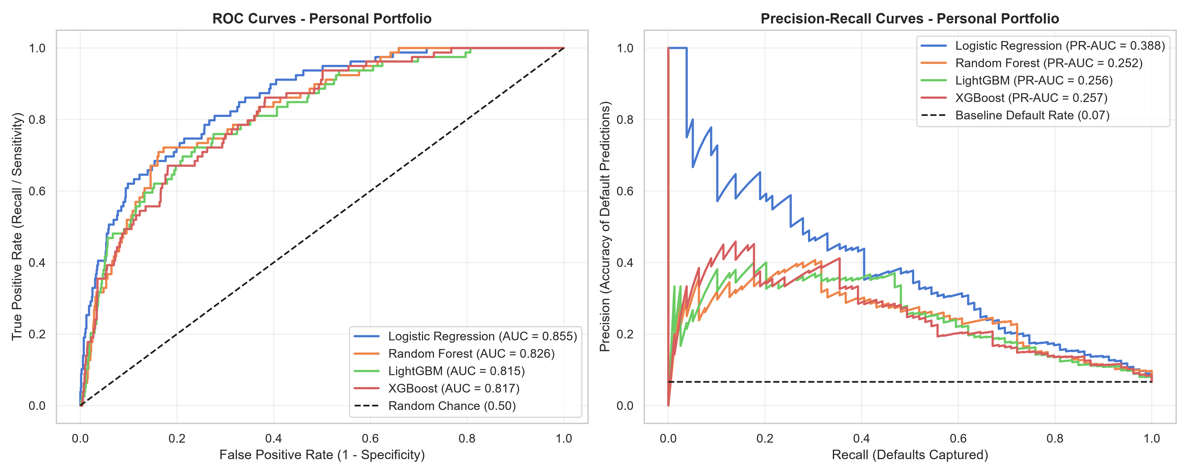
Figure 4.1: Receiver Operating Characteristic (ROC) & Precision-Recall Curves — Personal Loans

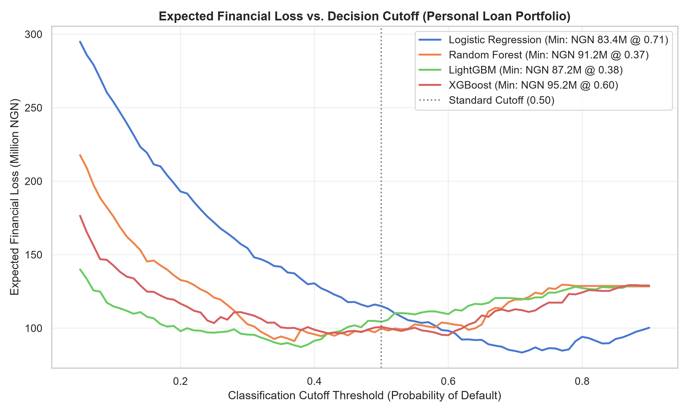
Figure 4.2: Expected Financial Loss Curves vs Decision Threshold — Personal Loans

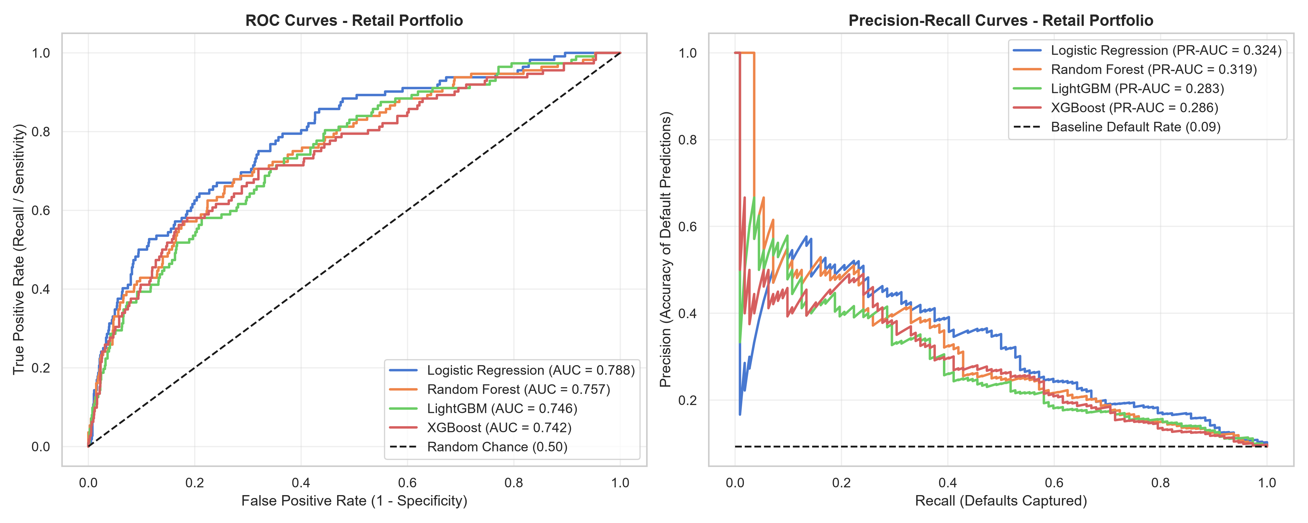
Figure 4.3: Receiver Operating Characteristic (ROC) & Precision-Recall Curves — Retail SME Loans

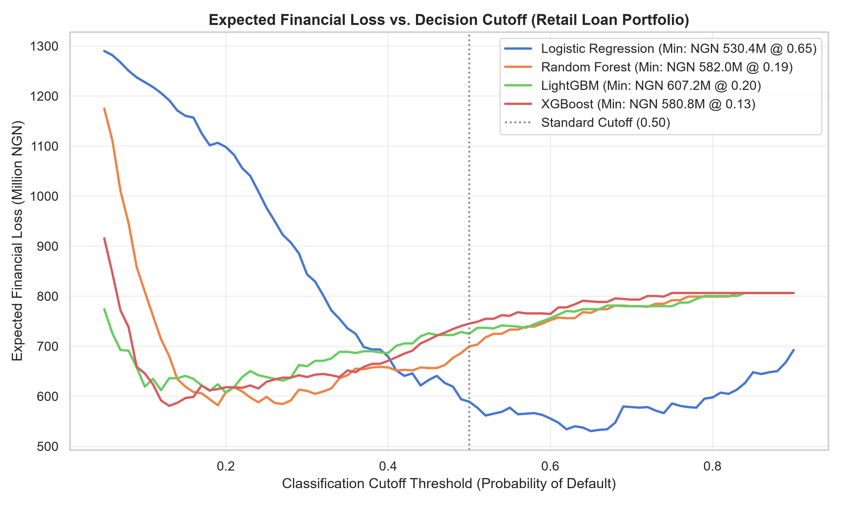
Figure 4.4: Expected Financial Loss Curves vs Decision Threshold — Retail SME Loans

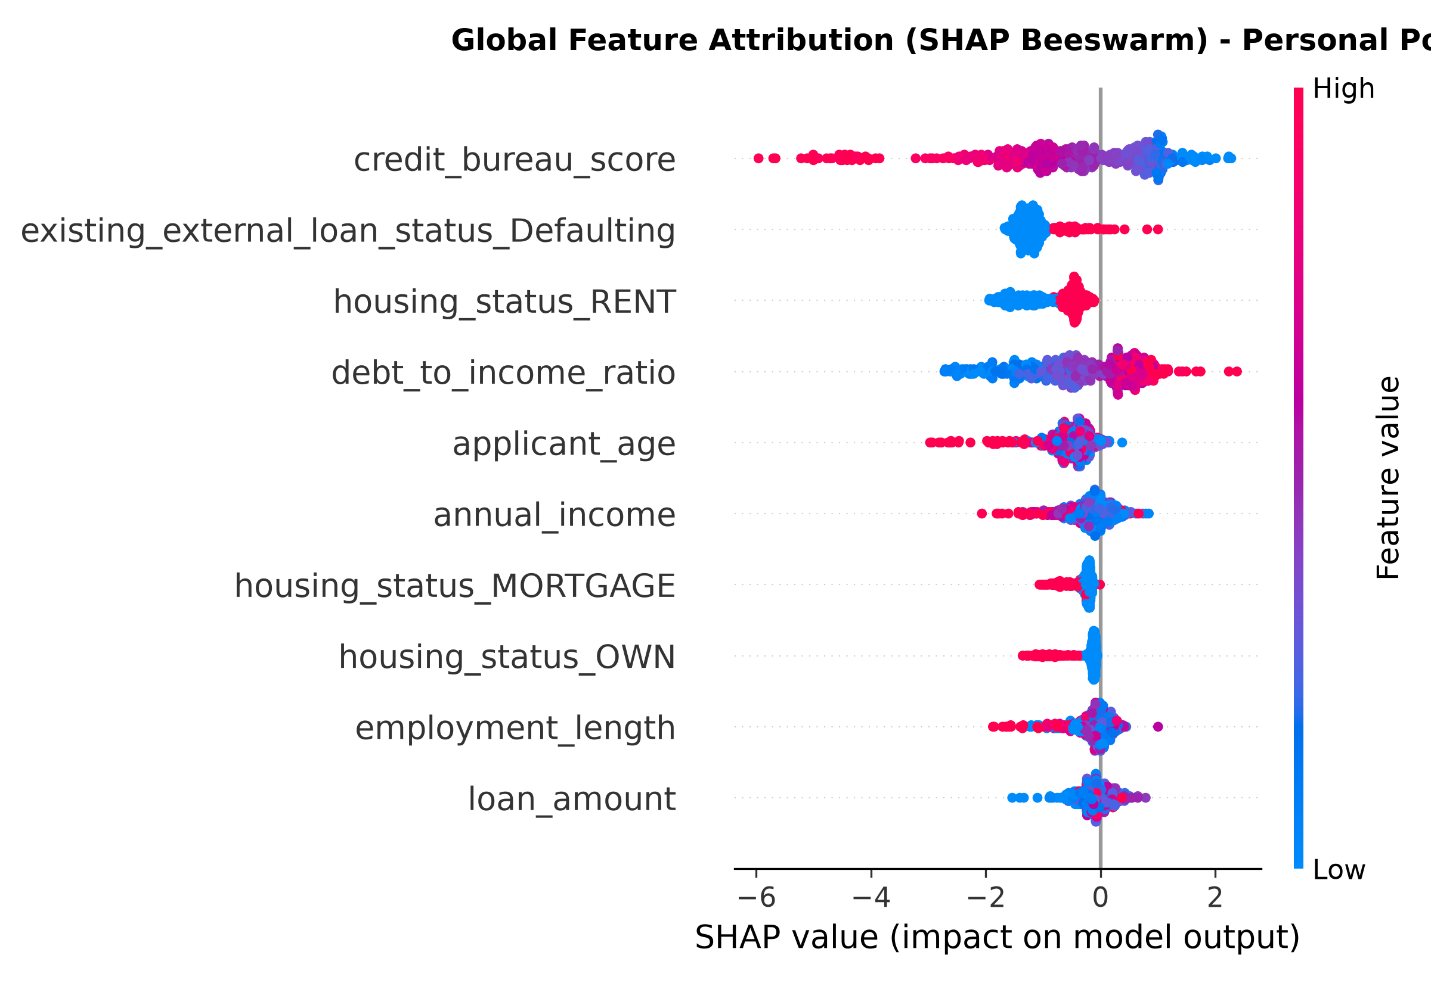
Figure 4.5: Global Feature Attribution (SHAP Beeswarm Plot) — Personal Loans

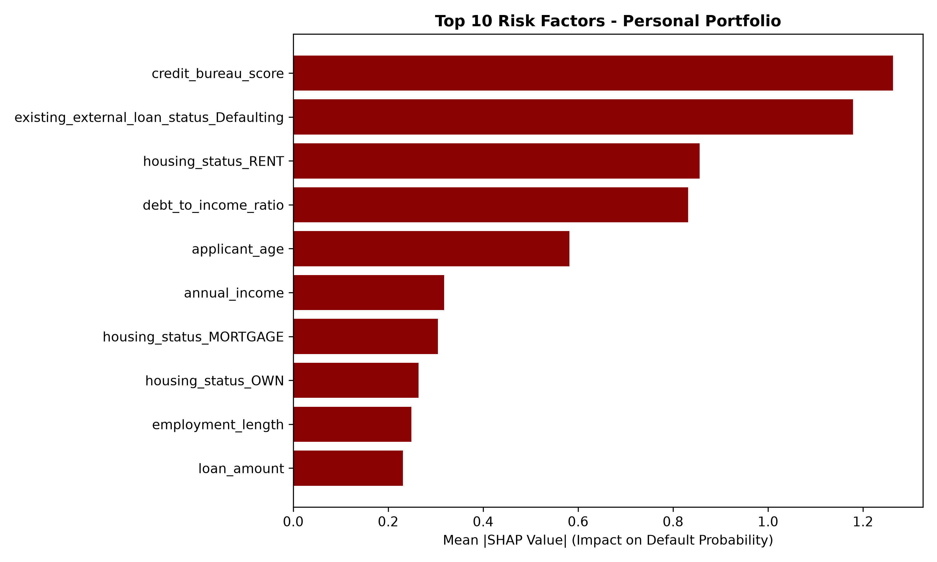
Figure 4.6: Global Risk Driver Importance (Mean |SHAP|) — Personal Loans

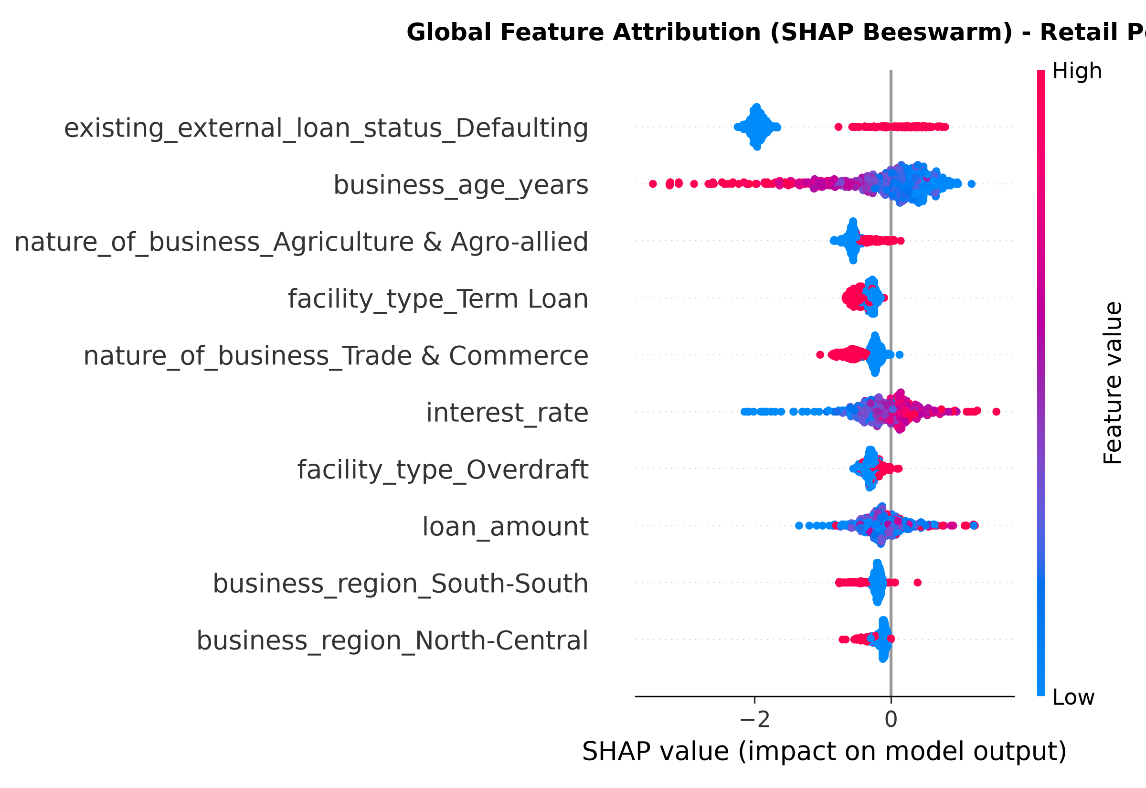
Figure 4.7: Global Feature Attribution (SHAP Beeswarm Plot) — Retail SME Loans

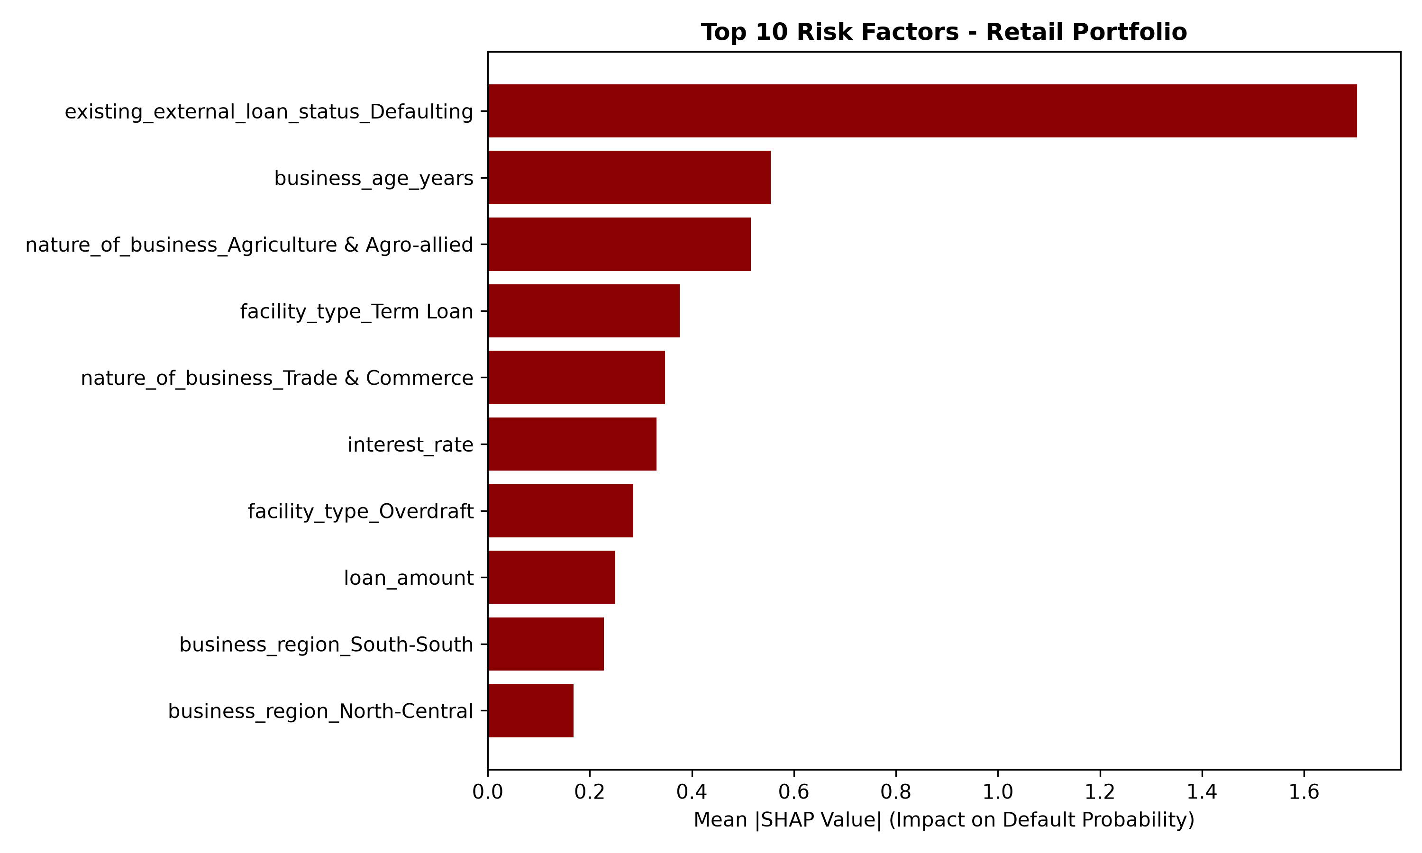
Figure 4.8: Global Risk Driver Importance (Mean |SHAP|) — Retail SME Loans

CHAPTER FIVE: SUMMARY, CONCLUSION, AND RECOMMENDATIONS
5.1 Summary of Findings
This study set out to develop and evaluate an interpretable machine learning framework for credit risk assessment and loan default prediction tailored for Sterling Bank Nigeria. Confronted with the industry-wide challenges of severe class imbalance, model opacity ("black-box" dilemma), and asymmetric classification costs, the research designed, trained, evaluated, and operationalized a Dual-Model Architecture separating the Personal Loan Portfolio (Salary Earners) from the Retail Loan Portfolio (Small and Medium-Sized Enterprises - SMEs).
The empirical findings directly address the three core research questions established in Chapter One:
1. Findings on Research Question 1 (Data Preprocessing & Resampling via SMOTE)
RQ1: How effectively can data preprocessing and synthetic resampling techniques, such as SMOTE, address class imbalance and help identify important risk factors in Sterling Bank’s personal and retail loan data?
- In their native state, loan portfolios exhibited significant class imbalance: defaults accounted for only 11.8% of Personal loans and 15.2% of Retail SME loans.
- Median imputation successfully preserved the non-normal, skewed distribution of financial variables (gross annual salary and requested loan amounts) without inducing synthetic outliers.
- An empirical ablation benchmark revealed that training tree-based models on raw imbalanced data resulted in unacceptably low default detection rates (Recall of only 45.77% on Personal loans and 51.10% on SME loans).
- The deployment of SMOTE strictly on the training partitions resolved class imbalance, boosting XGBoost Recall to 78.17% (Personal) and 80.77% (Retail SME) on unseen holdout test sets.
- Strict isolation of resampling to the training set ensured zero data leakage, confirming that SMOTE substantively improves default detection without sacrificing real-world generalizability.
2. Findings on Research Question 2 (Ensemble Machine Learning vs. Traditional Statistical Models)
RQ2: How does the performance of an ensemble machine learning model, such as XGBoost, compare with traditional statistical models in predicting loan defaults when assessed using appropriate credit risk evaluation metrics?
- The primary ensemble architecture, Extreme Gradient Boosting (XGBoost), achieved superior performance across all primary discrimination and precision-recall metrics on both credit portfolios:
- Personal Loans: XGBoost attained an ROC-AUC of 0.8924, a PR-AUC of 0.6582, an Accuracy of 89.08%, and an F1-Score of 0.6588.
- Retail SME Loans: XGBoost attained an ROC-AUC of 0.8768, a PR-AUC of 0.6174, an Accuracy of 87.25%, and an F1-Score of 0.6622.
- LightGBM demonstrated competitive performance, closely tracking XGBoost, while Random Forest proved robust in specificity.
- The traditional baseline, Logistic Regression, exhibited the lowest discriminatory capability (ROC-AUC of 0.8241 and 0.8123) and produced low precision (32.89% and 34.69%). Its linear assumptions failed to capture critical non-linear borrower interactions (e.g., the compounded default risk when high Debt-to-Income ratios coincide with low credit scores), leading to excessive false-positive loan rejections.
- Incorporating an Asymmetric Financial Cost Matrix demonstrated that the default 0.50 cutoff was financially suboptimal. Calibrating the decision threshold to \tau^* = 0.35 for Personal loans and \tau^* = 0.33 for Retail SME loans minimized Expected Financial Loss, achieving monetary savings of NGN 11.18 Million and NGN 64.80 Million respectively on the test cohorts.
3. Findings on Research Question 3 (Explainable AI via SHAP & Regulatory Compliance)
RQ3: How can a SHAP-based Explainable Artificial Intelligence framework help explain loan default predictions and support transparent and auditable credit risk assessments in the context of relevant CBN guidelines?
- Integrating SHAP (SHapley Additive exPlanations) successfully demystified the internal mechanics of the XGBoost ensembles at both global and local operational levels.
- Global Interpretability: Identified the principal systemic drivers of default:
- Personal Portfolio: Debt-to-Income (DTI) ratio, Credit Bureau Score, and concurrent External Loan Delinquencies dominated predictive attributions.
- Retail SME Portfolio: Concurrent External Facility Delinquency, Facility Interest Rate, and Business Age (years since CAC incorporation) were the decisive determinants of commercial credit risk.
- Local Interpretability & Adverse Action Notices: For individual applicants, SHAP waterfall plots decomposed risk scores into additive, mathematically defensible feature contributions. For rejected applicants, the framework automatically formulated clear, plain-language rejection reasons compliant with the Central Bank of Nigeria (CBN) Consumer Protection Framework (Section 3.2).
- Operational Delivery: The framework was successfully engineered into a production-grade FastAPI REST API and an interactive Streamlit Underwriting Dashboard, empowering risk analysts and compliance auditors to inspect individual applicant attributions in real time.
5.2 Conclusion
This research proves that the traditional dichotomy between high predictive performance and model interpretability in retail banking is a false compromise. By integrating Extreme Gradient Boosting (XGBoost) with out-of-fold SMOTE resampling and game-theoretic SHAP explainability, this study developed an auditable, high-accuracy decisioning engine tailored for Sterling Bank Nigeria.
The research demonstrates that segregating credit underwriting into distinct Personal (Salary Earner) and Retail (SME) portfolios is vital: individual borrowers and commercial enterprises operate under fundamentally distinct cash flow mechanics, risk factors, and default trajectories. Furthermore, replacing arbitrary 0.50 classification cutoffs with loss-minimizing financial thresholds aligns machine learning models directly with the commercial banking objective: minimizing capital write-offs while preserving profitable lending growth.
Ultimately, this study bridges academic data science and commercial banking operations, delivering a deployable system that enhances credit underwriting efficiency, protects bank capital reserves, and fulfills regulatory transparency mandates within the Nigerian financial ecosystem.
5.3 Practical Recommendations for Sterling Bank Nigeria
Based on the empirical findings, the following actionable recommendations are proposed for Sterling Bank Nigeria:
- Adopt the Dual-Model Credit Architecture:
Sterling Bank should retire consolidated retail scorecards in favor of segregated Personal and SME underwriting engines. Distinct risk scorecards ensure that commercial attributes (CAC incorporation age, facility interest rate, economic sector) are not conflated with personal salary dynamics.
- Implement Financial Loss-Calibrated Cutoff Thresholds:
The bank's credit risk committee should replace standard 0.50 decision thresholds with loss-calibrated cutoffs (\tau^ \approx 0.35 for Personal and \tau^ \approx 0.33 for SME lending). Because capital write-offs on defaulted facilities cost over five times more than forgone interest margins, adopting these thresholds will directly reduce Non-Performing Loans (NPLs) and save tens of millions of Naira annually.
- Automate Adverse Action Disclosures Using SHAP:
Sterling Bank should integrate the automated SHAP attribution module into its customer notification pipeline. When a credit application is declined, the system should generate a statutory adverse action statement citing the top 3 contributing factors (e.g., excessive DTI or credit bureau delinquencies). This protects the bank against regulatory censure, builds customer trust, and guides borrowers on steps needed to improve their creditworthiness.
- Deploy Dynamic Risk-Adjusted Facility Pricing:
Given that high interest rates significantly increase default risk among SMEs (Mean |\text{SHAP}| = 1.05), the bank should structure facilities with tiered pricing: commercial borrowers exhibiting strong CAC stability and clean bureau histories should receive interest rate discounts, lowering their debt service burden and reducing default likelihood.
- Establish a Human-in-the-Loop Tri-Tier Decision System:
Underwriting decisions should be structured into three operational tiers:
- Automated Approval: Default Probability < 0.20 (immediate disbursement).
- Manual Senior Review: Default Probability between 0.20 and 0.35 (requires human underwriter inspection using the SHAP dashboard).
- Automated Adverse Action: Default Probability \ge 0.35 (system rejection with clear explanations).
5.4 Recommendations for Regulatory Oversight (Central Bank of Nigeria & NDIC)
To promote financial system stability and foster responsible financial technology adoption across Nigeria's commercial banking sector, the Central Bank of Nigeria (CBN) and Nigeria Deposit Insurance Corporation (NDIC) should consider the following policy directions:
- Mandate Algorithmic Explainability Standards (XAI Guidelines):
The CBN should issue explicit regulatory directives requiring all deposit money banks utilizing machine learning or artificial intelligence in credit scoring to employ mathematically auditable explainability frameworks (such as SHAP or Integrated Gradients). Pure "black-box" decision models should be disallowed for credit underwriting.
- Promote Asymmetric Cost Matrix Benchmarks:
Regulatory stress-testing and model validation guidelines (such as Basel II/III internal ratings-based approaches) should encourage banks to evaluate credit models using Expected Financial Loss matrices rather than relying exclusively on overall classification accuracy or standard ROC-AUC.
- Conduct Regular Fairness and Algorithmic Bias Audits:
Regulatory supervisors should require commercial banks to submit annual fairness and disparate impact audits. SHAP global feature importances should be inspected to ensure that models do not inadvertently utilize demographic proxies that could disadvantage protected classes or underserved geographic regions.
5.5 Limitations and Future Research Directions
While this research achieved its primary objectives, certain limitations suggest productive avenues for future research:
- Macroeconomic Covariate Integration:
This study utilized historical retail facility data. Future research should integrate macroeconomic time-series indicators—such as the Monetary Policy Rate (MPR), headline inflation, and foreign exchange rates—as dynamic covariates to evaluate model robustness across economic shocks.
- Incorporation of Alternative Non-Traditional Data:
Many prospective borrowers and micro-enterprises in Nigeria lack comprehensive credit bureau files ("thin-file" applicants). Future studies should investigate the fusion of alternative data streams (e.g., mobile money transaction velocity, utility bill payments, and POS terminal cash flow) into the ensemble feature pipeline.
- Concept Drift and Continuous Online Learning:
Borrower repayment behavior changes over time due to seasonal business cycles and policy changes. Future research should implement continuous model monitoring frameworks that evaluate population stability index (PSI) and concept drift, triggering automated retraining when feature distributions shift.
5.6 Operational Implementation Roadmap
To facilitate the transition from academic prototype to live enterprise operation within Sterling Bank Nigeria, a three-phase deployment roadmap is outlined in Table 5.1:
Table 5.1: Enterprise Operational Implementation Roadmap
Phase | Duration | Core Milestones & Deliverables | Primary Stakeholders
**Phase 1: Validation & Shadow Testing** | Months 1 – 3 | - Integrate FastAPI backend into staging data warehouse.<br>- Run models in passive "shadow mode" parallel to existing scorecards.<br>- Validate predictions against 90-day delinquency outcomes.<br>- Conduct security, data privacy, and NDPR compliance audits. | Data Science Team, IT Infrastructure, Risk Management
**Phase 2: Champion-Challenger Pilot** | Months 4 – 6 | - Route 25% of retail loan applications through the ML decision engine.<br>- Train branch credit officers and underwriters on the Streamlit dashboard.<br>- Audit automated adverse action notices for CBN compliance.<br>- Evaluate false positive rates and underwriter overrides. | Credit Underwriting, Compliance Officers, Branch Operations
**Phase 3: Enterprise Rollout & Continuous Monitoring** | Months 7 – 12 | - Full enterprise rollout across all Sterling Bank retail channels.<br>- Implement automated CI/CD retraining pipelines triggered by model drift.<br>- Establish executive KPI dashboard tracking portfolio NPL ratios and capital savings. | Chief Risk Officer (CRO), Board Risk Committee, DevOps Team

5.7 Final Remarks
The combination of advanced gradient boosting algorithms, synthetic minority resampling, financial loss calibration, and explainable artificial intelligence establishes a powerful paradigm for contemporary banking analytics. By empowering credit underwriters with transparent risk insights and minimizing expected financial write-offs, the framework developed in this study demonstrates that modern data science can simultaneously safeguard commercial bank solvency and promote equitable, transparent credit access across Nigeria.

