**The Most Favorite Workplace of the 3rd Year B.Sc. IT Students**

**Advisor**

Dr. Patcharaporn Lavangnananda

**Members**

Jirapa Songchom 59130500012 (Valentine)

Jetchuta Jailuk 59130500013 (Vitamin)

Thitapa Sintuchawet 59130500021 (Tina)

Nonlapan Saisuwan 59130500041 (Estelle)

Nitjawan Buasatit 59130500043 (Noel)

Pureewat Kaewpoi 59130500049 (Doge)

Chayamon Sangtitanu 59130500125 (Elsa)

Pronsawan Donpraiwan 59130500142 (Mona)

**LNG201 Content-based Language Learning II**

**Semester 2/2018**

**Project Title** The Most Favorite Workplace of the 3rd Year B.Sc. IT Students

**Project Credit** 3

**Candidates** Miss Jirapa Songchom (Valentine)

Miss Jetchuta Jailuk (Vitamin)

Miss Thitapa Sintuchawet (Tina)

Miss Nonlapan Saisuwan (Estelle)

Miss Nitjawan Buasatit (Noel)

Mr. Pureewat Kaewpoi (Doge)

Miss Chayamon Sangtitanu (Elsa)

Miss Pronsawan Donpraiwan (Mona)

**Advisor** Dr. Patcharaporn Lavangnananda

**Degree of Study** Bachelor of Science

**Faculty** School of Information Technology

**Academic Year** 2018

**Abstract (Valentine)**

The Questionnaire of The Most Favorite Workplace of the 3rd Year B.Sc. IT Students is for collecting the response of the 3rd year B.Sc. IT students to know about their favorite workplace.

We want to know where the most favorite place to work is and what the reason is. Therefore, we wrote the questions together and selected best 8 questions to add them to our questionnaire. To make the questionnaire to be the best, we asked our friends to do the pilot test for us, to comment on the questionnaire and correct it to be the best.

We used the google form to collect the response and posted it on Facebook group to invite our target group, the 3rd year B.Sc. IT students to do the questionnaire for us.

**Key words:** Favorite Workplace, Google Form, IT Students, Questionnaire, Survey

**Contents**

Abstract A

Contents B

Introduction 1

Background 1

Purpose 1

Methodology 1

Scope 1

Discussion 1 Baht 2

Figure 1: The Amount of Time Spending on Doing Outside Class Study 2

Figure 2: Favorite Time to Do Outside Class Study 3

Figure 3: Favorite Place to Do Outside Class Study 4

Figure 4: The Frequency to Do Outside Class Study 5

Figure 5: The Reason of Going to Workplace 6

Figure 6: The Preferred Facilities 7

Figure 7: The Expense of Study Outside the Classroom 8

Figure 8: The Amount of People to Go with When Going to Workplace 9

Conclusion 10

Recommendation 10

Appendix 11

**Introduction**

**Background (Mona)**

Nowadays, workplaces are not just in an office. People can do their work anywhere. They can choose the place that answers their demand such as a co-working space or the coffee shop. Therefore, we want to study about the most favorite workplace of the 3rd year B.Sc. IT students and the reason why they choose that place.

**Purpose (Noel)**

The main purpose was to study about the most favorite workplace of the third year B.Sc. IT students because we wanted to know where the safe place for them is, what the reason is, and why they choose that place.

**Methodology (Estelle)**

We designed the questionnaire from our own experience as the students when we did our outside class study. The questionnaire included eight questions. When we finished the design, we tested the validation of our questionnaire design on a group of the third year of B.Sc.IT students. This practice is known as a “Pilot Test”. Then, we distributed the questionnaire to the third year of B.Sc. IT students by using an online questionnaire form on “Google Form”.

**Scope (Elsa)**

The survey was limited to the B.Sc. IT 3rd year students studying at the 5 School of Information Technology at King Mongkut’s University of Technology Thonburi. The total number of students was 67.

(Estelle)

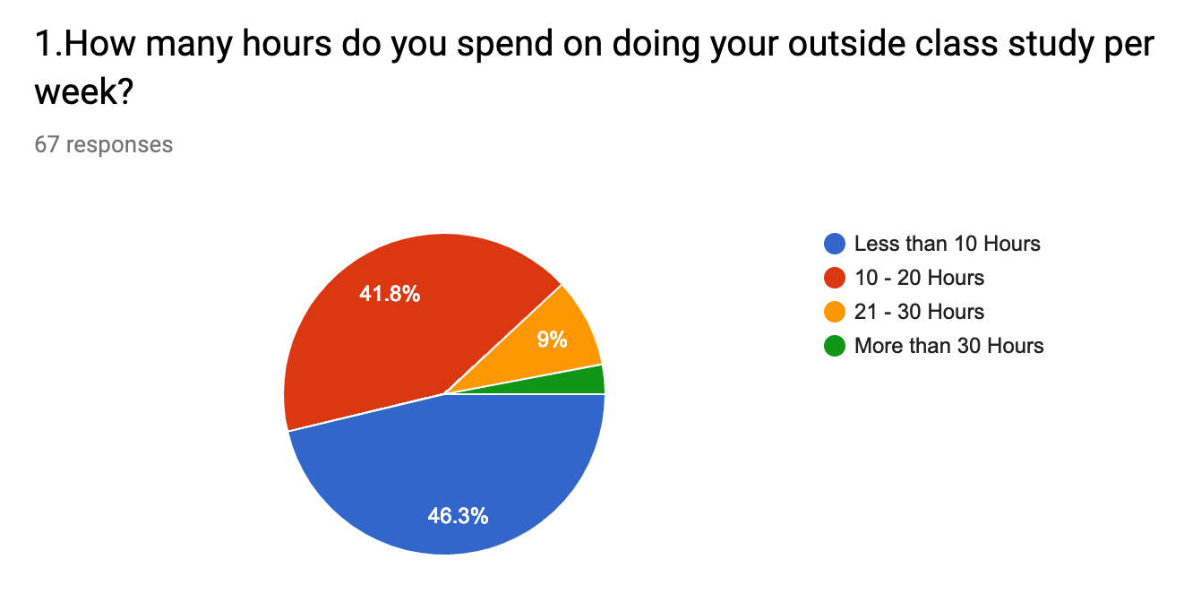

**Figure 1: The Amount of Time -.25 Spending on Doing Outside Class Study**

This figure illustrates the percentage of the third year B.Sc.IT students’ the amount of time in doing their outside class study per week. There are 4 ranges: Less than 10 Hours, 10-20 Hours, 21-30 Hours and More than 30 Hours.

The majority of the third year B.Sc. IT students spent less than 10 Hours, and the minority spent more than 30 Hours, forty-one point eight percent 10-20 Hours and nine percent 21-30 Hours.

From the figure, we conclude that most of the third year B.Sc. IT students spent time less than 10 Hours. This may be because people cannot spend too much time on work and they have other activities to do.

(Valentine)

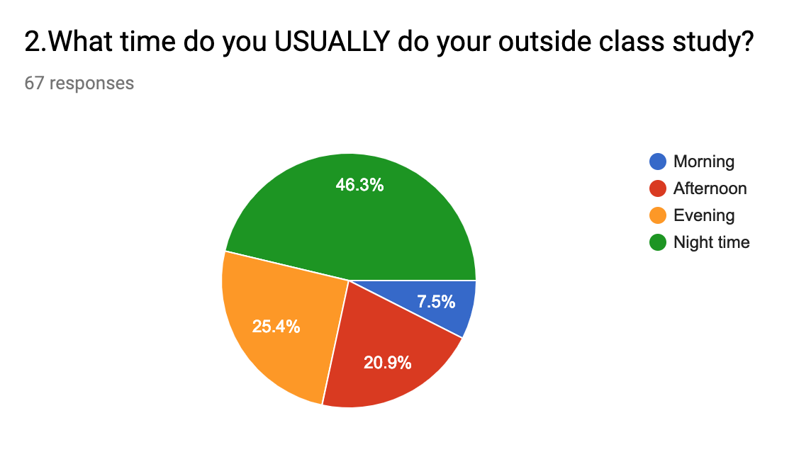

**Figure 2: Favorite Time to Do Outside Class Study**

This pie chart shows the percentage of the favorite time to work of the 3rd year B.Sc. IT students. There are 4 choices for choosing: Morning, Afternoon, Evening and Night time.

Most of students chose night time for 46.3% and the second place was Evening 25.4%. Moreover, afternoon was chosen by 20.9% and the minority was morning, chosen by 7.5%.

From the chart, we can conclude that most of the 3rd year B.Sc. IT students usually work at the night time. This may be because night time is the free time from class. On the opposite, the 3rd year B.Sc. IT students did not like to work in the morning. This may be because young people these day do not wake up early in the morning.

(Noel)

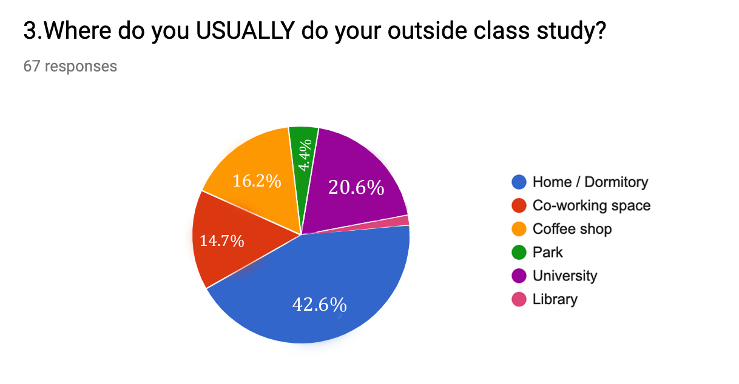

**Figure 3: Favorite Place to Do Outside Class Study**

The pie chart shows the percentage of favorite place to do outside class study of the third year B.Sc. IT students. There are six groups of places: Home or Dormitory, Co-working space, Coffee shop, Park, University, and Library.

The majority of the favorite places, whose percentage constituted 42.6% of the total, are home or dormitory, The less number, 20.6% are university,16.2% coffee shop, 14.7% co-working space, 4.4% park and 1.5% which was the minority library.

Form the chart, we can see that the most favorite place to do outside class study of the third year B.Sc.IT students is home or dormitory. This may be because home or dormitory is the convenient place to do outside class study in term of facilities. They can use their facilities easily. This reduces cost of transportation and meal. However, few of them chose library. This may be because library is crowded and does not have enough facilities such as charging point.

(Tina)

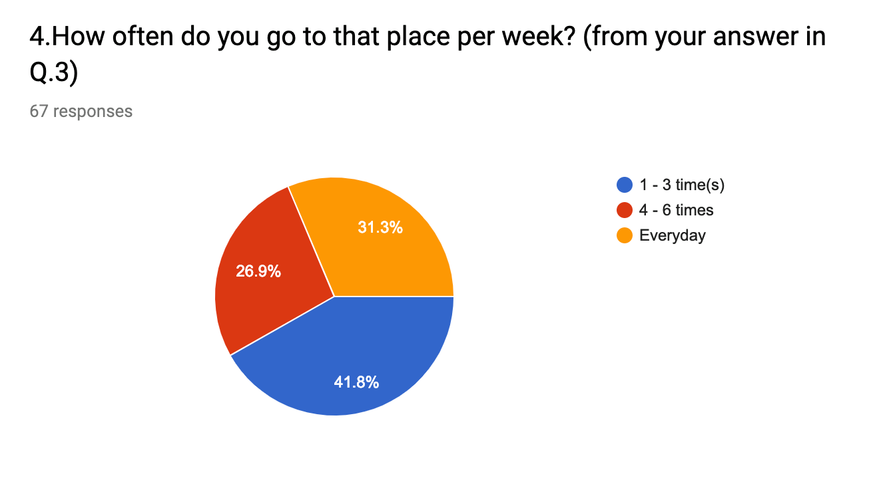

**Figure 4: The Frequency to Do Outside Class Study**

This figure shows the percentage of the frequency to do outside class study per week of the 3rd year B.Sc. IT students, there are 3 choices for choosing: 1-3 time(s),

4-6 times and Every day.

The majority of the 3rd year B.Sc. IT students (41.8%) do outside class study 1-3 time(s) per week. Every day was chosen by 31.3% and the minority (26.9%) 4-6 times.

From the figure, we can conclude that most of the 3rd year B.Sc. IT students do outside class study 1-3 time(s) per week. This is because studying or doing homework at the university, home or dormitory is convenient in term of location and facilities. That can save time and cost of transportation. However, in some cases, students need to go to do outside class study or some people may want to change the environment. This is the reason that in one week most students chose to work at the university, home or dormitory rather than going to work outside.

(Elsa)

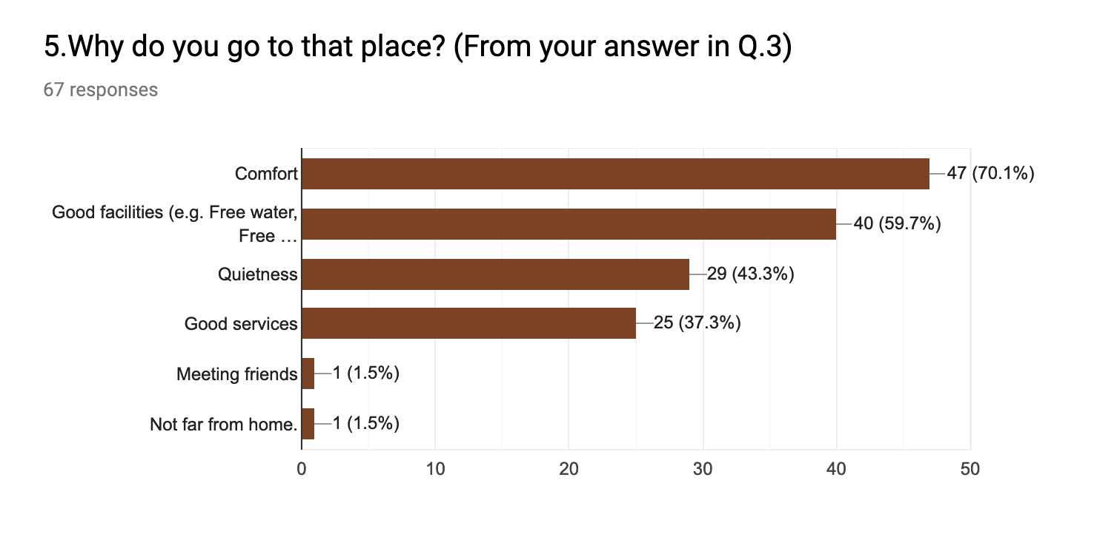

**Figure 5: The Reason of Going to Workplace**

This bar graph shows the percentage of the 3rd year B.Sc. IT students' choice of reason to choose place for work. There are six choices: Comfort, Good facilities, Quietness, Good services, Meeting friends, and Not far from home.

The majority of the B.Sc. IT 3rd year students concerned Comfort. Fifty-nine point seven percent concerned Good facilities. Forty-three point three percent concerned the Quietness, thirty-seven point three percent Good services and the minority Meeting friends and Not far from home, equally.

From the bar graph, we can conclude that the 3rd year B.Sc. IT students concerned Comfort the most when they go to that place. This may be because most people want to work in good environment.

(Doge)

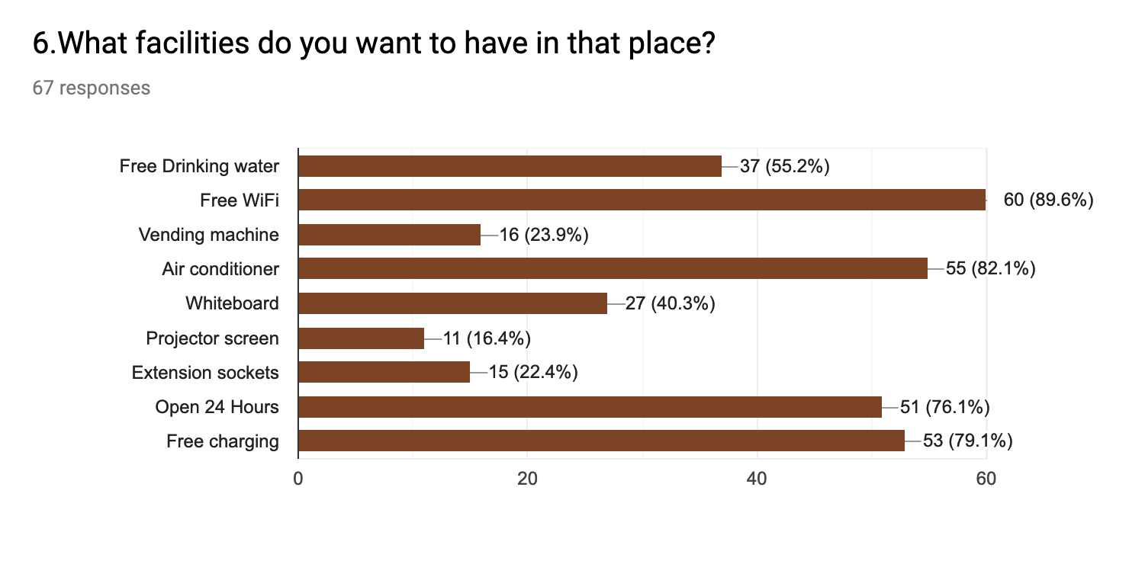

**Figure 6: The Preferred Facilities**

The bar chart shows the percentage of the 3rd year B.Sc. IT students' preferred facilities. There are 9 choices for choosing: Free Drinking water, Free WiFi, Vending machine, Air conditioner, Whiteboard, Projector screen, Extension sockets, Open 24 Hours, Free charging.

Most of the 3rd year B.Sc. IT students preferred free WiFi for 89.6%, second air conditioner for 82.1%, free charging for 79.1%, open 24 hours for 76.1%, free drinking water for 55.2%, whiteboard for 40.3%, vending machine for 23.9%, extension sockets for 22.4% and project screen for 16.4%

From the chart, high priority choices (more than 75%) are free WiFi, air conditioner, free charging and open 24 hours. This may be because free WiFi and free charging are necessary for working and favorite time for working is midnight, so 24 hours is a good place. Moreover, air conditioner makes good environment for working.

(Vitamin)

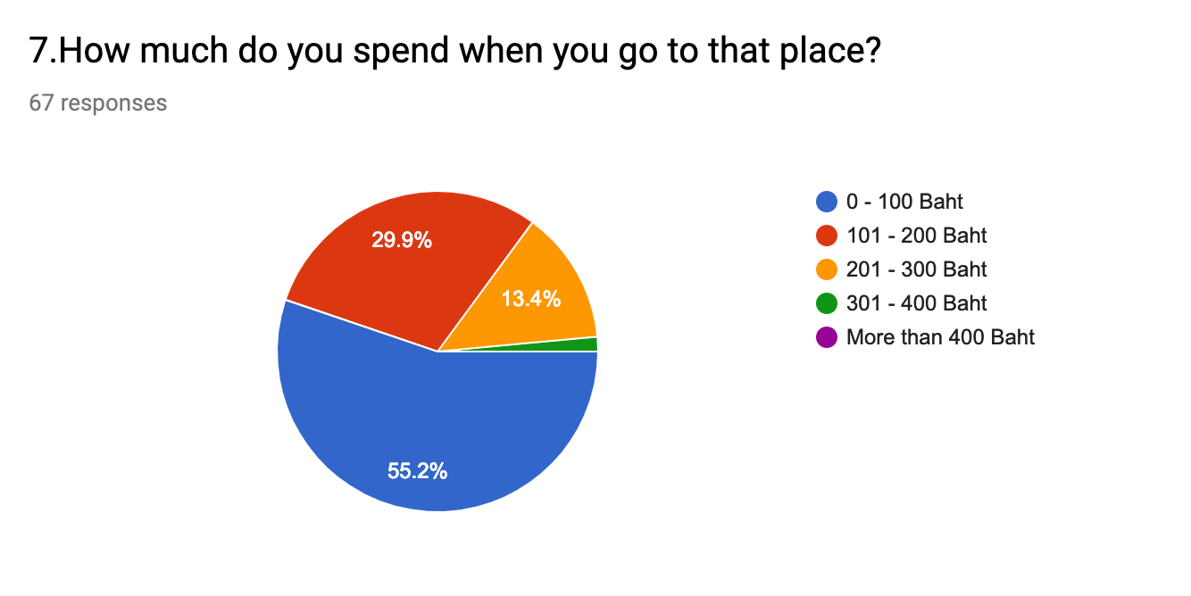

**Figure 7: The Expense of Study Outside the Classroom**

The pie chart shows the expense to do outside class study of the 3rd year B.Sc. IT students. There are 5 choices for choosing: 0-100 Baht, 101-200 Baht, 201-300 Baht, 301-400 Baht and More than 400 Baht.

The majority of students, whose percentage constituted 55.2% of the total, spent 0-100 Baht. The lesser number, 29.9% spent 101-200 Baht, 13.4% 201-300 Baht and 1.5% which was the minority 301-400 Baht.

From the chart, we can see that the top expense to study outside the classroom of

the 3rd year B.Sc. IT students is 0-100 Baht. This may be because most students want to save daily money whereas with more than 400 Baht, no one chose because it is too expensive for them.

(Mona)

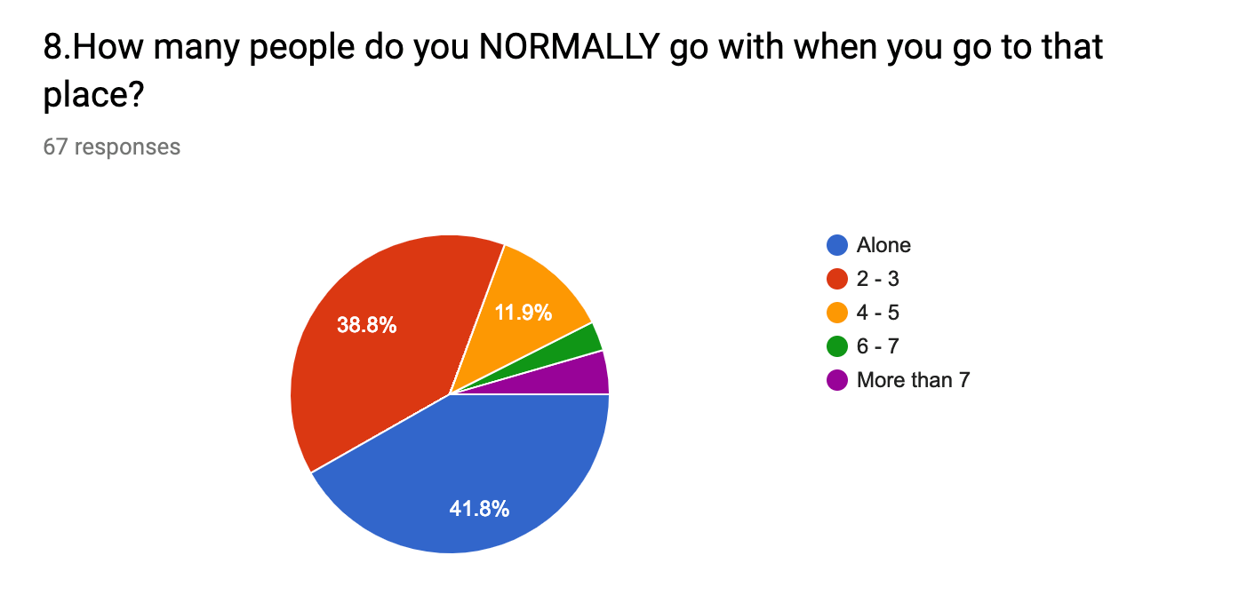

**Figure 8: The Amount of People to Go with When Going to Workplace**

This pie chart shows the number of people that the 3rd year B.Sc. IT students go with when going to work. There are 5 choices for choosing: Alone, With 2-3 persons, With 4-5 persons, With 6-7 persons, With more than 7 persons.

Most of the students chose to go Alone for 41.8%, the second place with 2-3 persons 38.8%, with 4-5 persons 11.9% and with the 6-7 persons chosen by 7.5%.

From the chart, we can conclude that most of the 3rd year B.Sc. IT students usually go alone when they want to work. This may be because it is easier to concentrate on their work. On the opposite the 3rd-year B.Sc. IT students do not like to go with many people for working, This may be because it is more flexible about time and plan to work.

**Conclusion** (Tina)

From the results of the questionnaire, we can conclude that most of the 3rd year B.Sc. IT students usually spend less than 10 hours per week for doing outside class study. That takes time during the night for doing outside class study and they like to do at home or dormitory more than outside. However, if they have to go outside, the most important thing to consider is convenience, for example, free Wi-Fi, Vending machine, free charging, 24 hours service, etc. Moreover, the expense is about 0-100 baht per time and they usually go alone.

**Recommendation (Doge)**

As you can see from our report, any family who wants your child to stay at home for work or cafe owner who wants to get more student customers, we recommend them to consider this list:

1. Comfort place (appropriate air conditioner, humidity, ergonomic desk)
2. Good facilities (high-speed internet connection, free water, clean restroom)
3. 24 Hours or Midnight service time
4. Not too expensive because more than half of the students are happy to pay from 0 - 100 baht.