**Location Based Service for Red Cab Taxi**

Software Requirement Specification

By

**Mr. Nattawood Thobood 552115025**

Department of Software Engineering   
College of Arts, Media and Technology   
Chiang Mai University

Project Advisor

Dr. Noppon Choosri

**Document History**

|  |  |  |  |  |  |  |  |
| --- | --- | --- | --- | --- | --- | --- | --- |
| **Document Name** | **Version** | **Status** | **Date** | | **Viewable** | **Reviewer** | **Responsible** |
| **Documents** | | | | | | | |
| Location based service for Red Cab taxi_ Software Requirement Specification_V.0.1.docx | **0.1**  **- Add Chapter One**  **- Add Chapter Two**  **- Add Chapter Three**  **- Add Chapter Four**  **- Add Chapter Five** | Draft | | June 23rd, 2015 | NT, NC | NT | NT e |

**\*NT = Nattawood Thobood *NC = Noppon Choosri**

Table of Contents

1. Chapter One | Introduction 1

1.1 Purpose 1

1.2 Project Overview 1

1.3 Project Scope 1

1.4 User Characteristics 1

1.5 Acronyms and Definitions 1

2. Chapter Two | Overall Description 1

2.1 Product Feature 1

2.2 Operation Environment 1

2.3 Design and Implementation Constrains 1

3. Chapter Three | User Requirements Specification 1

3.1 User Requirement Specification 1

3.2 User Requirement Specification with the Software Requirement Specification 1

4. Chapter Four | Specific Requirement 1

4.1 Use Case Scenarios 1

4.1.1 Use Case Diagram (Authentication system) 1

4.1.2 Use Case Diagram (Red Cab driver management system) 1

4.2 Use Case Description 1

**Chapter Five | Reference** 1

1. Chapter One | Introduction
   1. Purpose

The purpose of a software requirement specification (SRS) is to describe the functional requirements of the Location Based Service for Red Cab taxi. The requirements in the SRS are involved with the administrator and the driver of the system. The software requirement specification provides developers and users to understand each other in term of the structural details of the system. The system will be designed followed this SRS.

* 1. Project Overview

Location Based Service for Red Cab taxi helps the drivers and the passengers communicate less. Eliminate the fraud of fare from the driver by calculating the fare before get in a Red Cab. Know the driver's information and the car registration number. Show travel route of the Red Cab. Also, help to promote tourism in Chiang Mai by providing tourist information while traveling. Then managing the application will send the passenger a notification and give the information about that place. This can help promote tourist attractions in Chiang Mai, also. Then, the server retrieves data from database and transmit to tablet to represent the passenger information on the screen.

* 1. Project Scope

“Location Based Service of Red Cab taxi” is a mobile application, which uses Android OS. This application is develop to solve the communication between the travelers and the red cab. Users can identify the destination through the map from the application of their smartphone. This method will help the red cab driver knows the location they have to go. The system will send the location information from travelers to the red cab driver. After the driver accepts this trip, they will know the route to go there. Moreover, “Location Based Service of Red Cab taxi” will notify the users and give the information of the famous building if they are around within 300 meters to promote tourism.

The main feature of “Location Based Service of Red Cab taxi” are as follows:

* Authentication system.
* Red cabdriver management system.
* Connecting system.
* Notification system.
* Travelling service system.
  1. User Characteristics

Location Based Service for Red Cab taxi helps managing driver agrees to pick up that passenger, the application will send the information of that destination to the driver and calculate the shortest way to go there and show the map to both the driver and the passenger. It helps save the fuel and also the passenger would know the exact way to go there. The users who involve in the project are:

**Administrator–** Manages the user’s authentication system, view the driver information and also can manage the data information in the system.

**Driver**- Driver the user’s authentication system, view the route map information, manage the list order of passenger information in the system

**Passenger**- User the authentication system, choose destination, view driver information and get notification of important places.

* 1. Acronyms and Definitions

1.5.1 Acronyms

LBS Location Based Service for Red Cab taxi

AD Activity Diagram

SRS Software Requirement Specification

UC Use Case

URS User Requirement Specification

1.5.2 Definitions

**Feature**  Transformation of input parameters to output parameters based on a specified algorithm. It describes the functionality of a product in the language of the product. Used for requirements analysis, design, coding, testing or maintenance.

**User interface** User interface (UI) is everything designed into an information device with which a human being may interact including display screen, keyboard, mouse, light pen, the appearance of a desktop, illuminated characters, help messages, and how an application program or a Web site invites interaction and responds to it.[1]

**UML** The Unified Modeling Language (UML) is a general -purpose [modeling language](http://en.wikipedia.org/wiki/Modeling_language) in the field of [software engineering](http://en.wikipedia.org/wiki/Software_engineering), which is designed to provide a standard way to visualize the design of a system. [2]

**Activity diagram**  Activity diagrams are graphical representations of workflows of stepwise activities and actions with support for choice, iteration and concurrency. Activity diagrams show the overall flow of control. [3]

**Use case** A use case is a methodology used in system analysis to identify, clarify, and organize system requirements. The use case is made up of a set of possible sequences of interactions between systems and users in a particular environment and related to a particular goal. It consists of a group of elements (for example, classes and interfaces) that can be used together in a way that will have an effect larger than the sum of the separate elements combined. [4]

**Use case diagram** A use case diagram at its simplest is a representation of a user’s interaction with the system and depicting the specifications of a [use case](http://en.wikipedia.org/wiki/Use_Case). A use case diagram can portray the different types of users of a system and the various ways that they interact with the system. [5]

1. Chapter Two | Overall Description
   1. Product Feature

Location based service for Red Cab taxi project has separated the whole project to four processors. The description is shown below:

Progress I:

Feature#1 Authentication system.

Feature#2 Red Cab driver management system

* 1. Operation Environment

Mobile phone: Android Operating System

--Oppo R8006

CPU: Quad core 1.6GHz

Memory: 1 GB

Operating System: Android OS (V. 4.3)

* 1. Design and Implementation Constrains

There are the limit of data in the mobile application because mobile device have limited memory than computers. Developers have to consider about limit of the body size, feature, and hardware from different mobile devices.

1. Chapter Three | User Requirements Specification

3.1 User Requirement Specification

**Feature #1 Authentication system.**

1. Administrator can login to web server.
2. Administrator can log-out from web server.
3. Driver can login to mobile application.
4. Driver can log-out from mobile application.

**Feature #2 Red cab driver management system.**

1. Administrator can add the driver to the web server.
2. Administrator can update the driver’s information (including first name, last name, driving license no., and license plate, etc.) the web server.
3. Administrator can delete the driver from the web server.
4. Administrator can search the driver’s information (including first name, last name, driving license no., and license plate, etc.) in the web server.
5. Administrator can view information (including first name, last name, driving license no., and license plate, etc.) of a driver.

3.2 User Requirement Specification with the Software Requirement Specification

**URS-01: Administrator can login to web server.**

**Requirement**

SRS-01: System shall provide interface login to the administrator.

SRS-02: System shall provide to show error message “Username cannot be blank.” when administrator didn’t fill in the username.

SRS-03: System shall provide to show error message “Password cannot be blank” when administrator didn’t fill in the password.

SRS-04: System shall provide to show error message “Incorrect username or password.” when username or password is incorrect.

SRS-05: System shall provide the submit button to login.

SRS-06: System shall bring the administrator to the main page.

**URS-02: Administrator can log-out from web server.**

**Requirement**

SRS-07: System shall provide administrator interface to log-out from the web server.

SRS-08: System shall provide log-out button to administrator.

SRS-06: System shall bring the administrator to the main page.

**URS-03: Driver can login to mobile application.**

**Requirement**

SRS-09: System shall provide interface login to the driver.

SRS-19: System shall provide to show error message “Incorrect username or password.” when username or password is incorrect.

SRS-11: System shall provide the login button.

SRS-12: System shall bring the driver to the driver menu.

**URS-04: Driver can log-out from mobile application.**

**Requirement**

SRS-13: System shall provide driver interface to log-out from the driver menu.

SRS-14: System shall provide log-out button to driver.

SRS-15: System shall bring the administrator to the main menu.

**URS-05: Administrator can add the driver to the web server.**

**Requirement**

SRS-16: System shall provide add button to create new driver.

SRS-17: System shall provide form for add driver’s information.

SRS-18: System shall provide the submit button to save.

SRS-19: System shall bring the administrator to the driver page.

**URS-06: Administrator can update the driver’s information (including first name, last name, driving license no., and license plate, etc.) the web server.**

**Requirement**

SRS-20: System shall provide edit button to update a driver’s information.

SRS-17: System shall provide form for add driver’s information.

SRS-18: System shall provide the submit button to save.

SRS-19: System shall bring the administrator to the driver page.

**URS-07: Administrator can delete the driver from the web server.**

**Requirement**

SRS-20: System shall provide delete button to delete a driver’s information.

SRS-21: System shall provide confirm box with message “Are you sure you want to delete this item?”

**URS-08: Administrator can search the driver’s information (including first name, last name, driving license no., and license plate, etc.) in the web server.**

**Requirement**

SRS-22: System shall provide table of driver’s information.

SRS-23: System shall provide search bar.

**URS-09: Administrator can view information (including first name, last name, driving license no., and license plate, etc.) of a driver.**

**Requirement**

SRS-24: System shall provide view button to view a driver’s information.

SRS-25: System shall bring the administrator to the view a driver’s information.

SRS-26: System shall provide back button.

SRS-19: System shall bring the administrator to the driver page.

1. Chapter Four | Specific Requirement
   1. Use Case Scenarios
      1. Use Case Diagram (Authentication system)

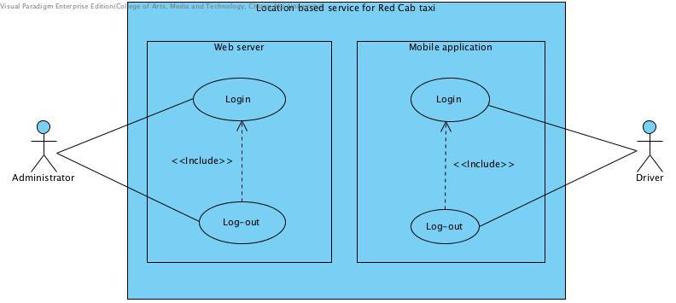

Figure 1: Authentication system user case diagram.

* + 1. Use Case Diagram (Red Cab driver management system)

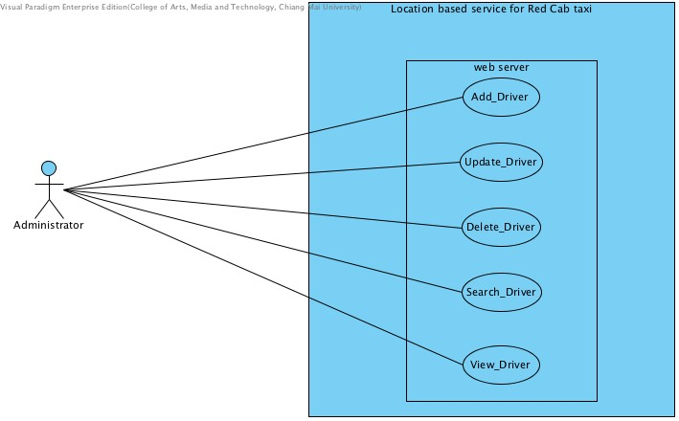

Figure 2: Red Cab driver management system user case diagram.

4.2 Use Case Description

|  |  |
| --- | --- |
| **Use case ID** | UC01 |
| **Use case name** | Login |
| **Description** | This use case is for administrator to log in to the system by input username and password into the given text field |
| **Actor(s)** | Administrator |
| **Trigger** | Administrator click login button |
| **Precondition** | Administrator have to stay at main web server |
| **Postcondition** | Administrator can access to the web server |
| **Normal Flow** | 1.The system connect to the database.  2.The system provide text field for administrator to input the username and password.  3.Administrator insert username and password in to the given text field.  4.Administrator click login button.  5.The system show main web server page for administrator. |
| **Alternative Flow** | 4.a If username is blank.  4.1 The system shall provide to show error message “Username cannot be blank.” to administrator.  4.2 The system provide interface for administrator to input username and password again.  4.b If password is blank.  4.1 The system shall provide to show error message “Password cannot be blank.” to administrator.  4.2 The system provide interface for administrator to input username and password again.  4.c username and password is invalid.  4.1 The System shall provide to show error message “Incorrect username or password.” when username or password is incorrect.  4.2 The system go to view main web server page. |
| **Exception** | - |

**Activity Diagram:**

**(AC01)**

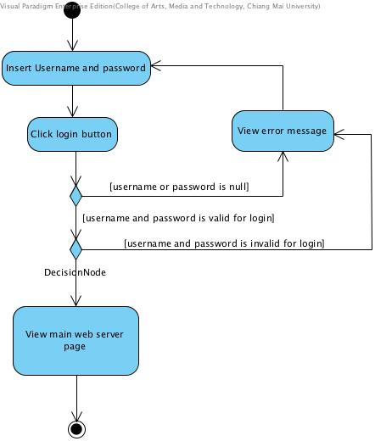

Figure 3: Administrator log in activity diagram.

|  |  |
| --- | --- |
| **Use case ID** | UC02 |
| **Use case name** | Logout |
| **Description** | This use case is for administrator to log out from the web server |
| **Actor(s)** | Administrator |
| **Trigger** | Administrator click log out button |
| **Precondition** | Administrator have to Log in (UC01) |
| **Postcondition** | Administrator can log out from the web server |
| **Normal Flow** | Administrator click log out button |
| **Alternative Flow** | - |
| **Exception** | - |

**Activity Diagram:**

**(AC02)**

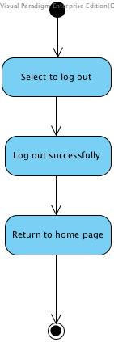

Figure 4: Administrator log out activity diagram

|  |  |
| --- | --- |
| **Use case ID** | UC03 |
| **Use case name** | Login |
| **Description** | This use case is for driver to log in to the mobile application by input username and password into the given text field |
| **Actor(s)** | Driver |
| **Trigger** | Driver click to log in button |
| **Precondition** | Driver have to stay at main application page |
| **Postcondition** | Driver can access to the application |
| **Normal Flow** | 1. The system connect to the database  2. The system provide text field for driver to input the username and password  3. Driver input username and password in to the given text field  4. Driver click login button  5. The system show main application page for driver |
| **Alternative Flow** | 4.a If username is blank  4.1 The system shall provide to show error message “Username cannot be blank.” to driver  4.2 The system provide interface for administrator to input username and password again  4.b If password is blank  4.1 The system shall provide to show error message “Password cannot be blank.” to driver  4.2 The system provide interface for administrator to input username and password again  4.c Username and Password is invalid  4.1 The System shall provide to show error message “Incorrect username or password.” when username or password is incorrect.  4.2 The system go to view main web server page |
| **Exception** | - |

**Activity Diagram:**

**(AC03)**

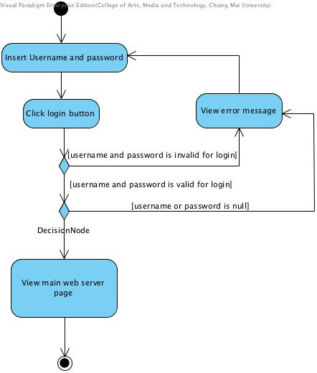

Figure 5: Driver log in to mobile activity diagram

|  |  |
| --- | --- |
| **Use case ID** | UC04 |
| **Use case name** | Logout |
| **Description** | This use case is for driver to log out from the mobile application |
| **Actor(s)** | Driver |
| **Trigger** | Driver click log out button |
| **Precondition** | Driver have to Log in (UC03) |
| **Postcondition** | Driver can log out from the application |
| **Normal Flow** | Driver click log out button |
| **Alternative Flow** | - |
| **Exception** | - |

**Activity Diagram:**

**(AC04)**



Figure 6: Driver log out from mobile activity diagram

|  |  |
| --- | --- |
| **Use case ID** | UC05 |
| **Use case name** | Add Driver |
| **Description** | This use case is for administrator to adding the driver account by inputting the username and password to the web server and store the driver account that add into the database |
| **Actor(s)** | Administrator |
| **Trigger** | Administrator click add button |
| **Precondition** | Administrator has to stay at the main web server page |
| **Postcondition** | Administrator can add the driver account to the database successfully. |
| **Normal Flow** | 1.The system connect to the database  2.The system provide add button for admin to do the adding  3.Administrator click add button.  4.The system provide interface that is adding driver for administrator to fill in the driver account information  5.Administrator input the firstname, lastname , driving license no. and license plate into the given add form  6.Administrator click submit button |
| **Alternative Flow** | 6.a Administrator click submit button  6.1The system response error message.  6.2The system provide interface for administrator to input the information again. |
| **Exception** | - |

**Activity Diagram:**

**(AC05)**

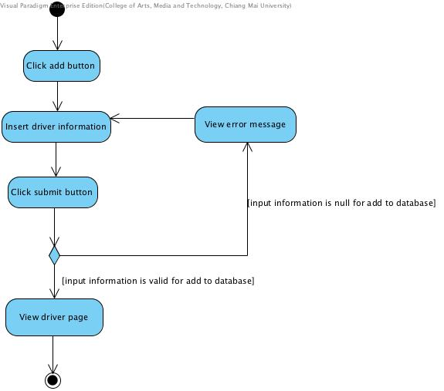

Figure 7: Add driver activity diagram.

|  |  |
| --- | --- |
| **Use case ID** | UC06 |
| **Use case name** | Update the driver’s |
| **Description** | This use case for Administrator to update driver’s information to web server |
| **Actor(s)** | Administrator |
| **Trigger** | Administrator click update driver button |
| **Precondition** | Administrator has to login |
| **Normal Flow** | 1. The system connect to the database  2.Administrator clicks update driver button  3.The system provides driver information to administrator  4.Administrator inputs new driver information  5.Administrator clicks submit button |
| **Alternative Flow** | 5.a If information is blank.  5.1 The system displays error message  5.2 The system returns to insert driver information again  5.3 Administrator inputs new driver information again  5.b If information is valid for update information  5.1 The system return to view driver page |
| **Exception** | - |

**Activity Diagram:**

**(AC06)**

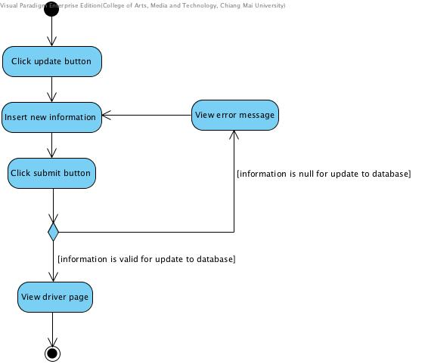

Figure 8: Update driver activity diagram

|  |  |
| --- | --- |
| **Use case ID** | UC07 |
| **Use case name** | Delete the driver |
| **Description** | This use case for administrator to delete driver information from web server |
| **Actor(s)** | Administrator |
| **Trigger** | Administrator click delete button |
| **Precondition** | Administrator has to login |
| **Normal Flow** | 1.The system connect to the database  2.Administrator click delete button  3.The system provides confirm button to admin  4.Administrator clicks confirm button |
| **Alternative Flow** | 2.a Administrator clicks delete button  2.1 The system provides confirm button to administrator  2.2 Administrator clicks cancel button  2.3 The system returns to driver page again  2.b Administrator click cancel button  2.1 The system delete driver not successfully |
| **Exception** | - |

**Activity Diagram:**

**(AC07)**

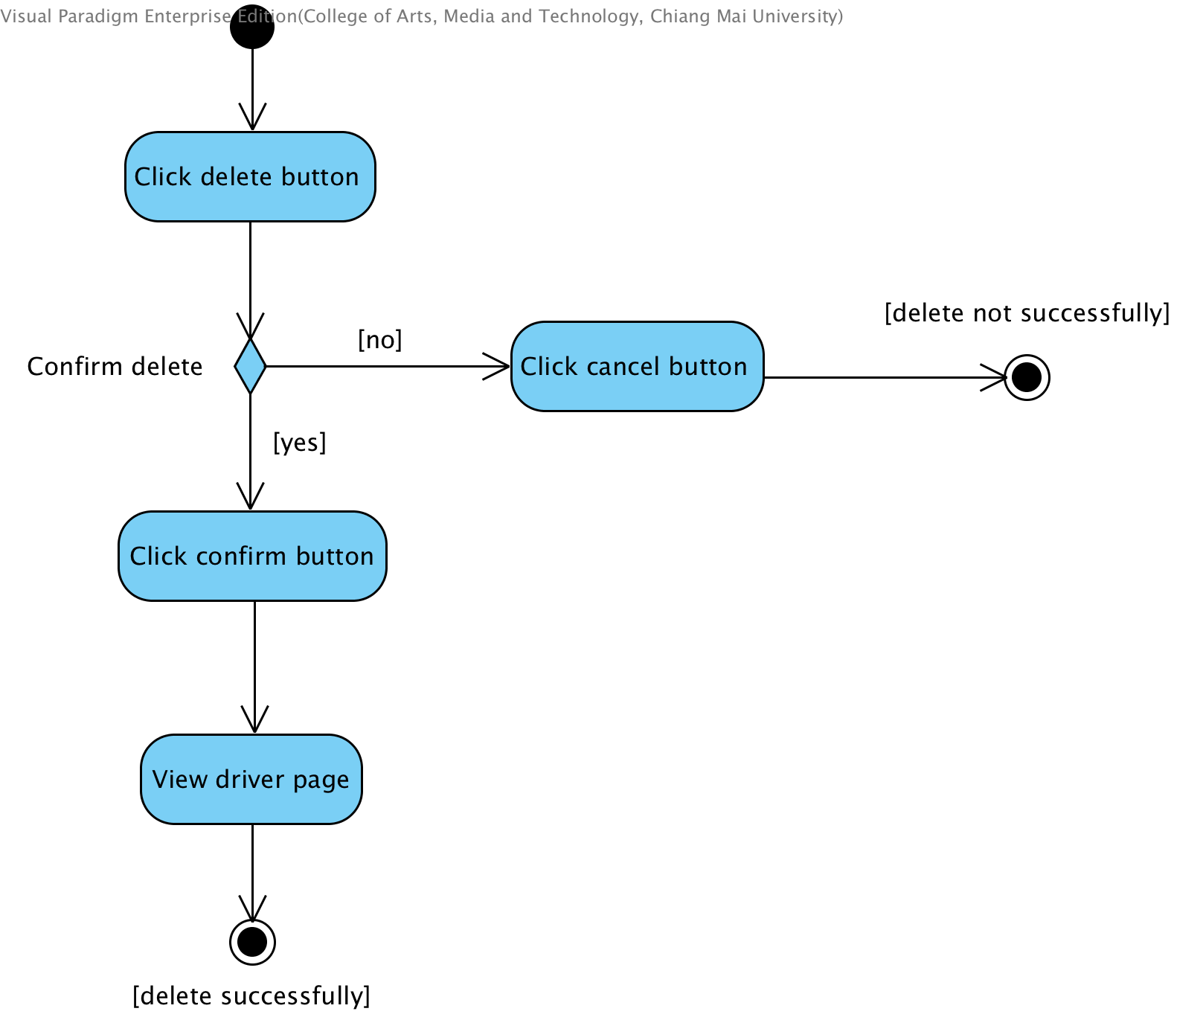

Figure 9: Delete driver activity diagram

|  |  |
| --- | --- |
| **Use case ID** | UC08 |
| **Use case name** | Administrator search driver |
| **Description** | This use case is for administrator to search driver information from web server by input the keyword in to the search bar |
| **Actor(s)** | Administrator |
| **Trigger** | Administrator click select search field |
| **Precondition** | Administrator have to login (UC01) |
| **Postcondition** | Administrator can search for the driver form web server |
| **Normal Flow** | 1.The system connect to the database  2. The system provides text filed for administrator to search  3. Administrator insert text in to text field  4.Administrator press Enter |
| **Alternative Flow** |  |
| **Exception** | - |

**Activity Diagram:**

**(AC08)**

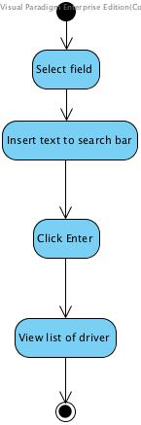

Figure 10: Search driver activity diagram

|  |  |
| --- | --- |
| **Use case ID** | UC09 |
| **Use case name** | View information |
| **Description** | This use case for administrator to view all driver information in web server |
| **Actor(s)** | Administrator |
| **Trigger** | Administrator click view driver button |
| **Precondition** | Administrator has to login |
| **Normal Flow** | 1. The system connect to the database  2. The system provide interface view information button for administrator.  3. Administrator clicks view button  4. The system provides success all the driver information to administrator. |
| **Alternative Flow** | - |
| **Exception** | - |

**Activity Diagram:**

**(AC09)**

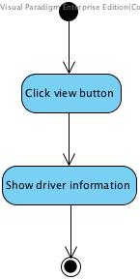

Figure 11: view information of driver activity diagram

**Chapter Five | Reference**

[1] Definition of User Interface

<http://searchsoa.techtarget.com/definition/user-interface>

[2] Definition of UML

<http://en.wikipedia.org/wiki/Unified_Modeling_Language>

[3] Definition of Activity Diagram

<http://en.wikipedia.org/wiki/Activity_diagram>

[4] Definition of Use Case

<http://searchsoftwarequality.techtarget.com/definition/use-case>

[5] Definition of Use Case Diagram

<http://en.wikipedia.org/wiki/Use_Case_Diagram>