**Location Based Service for Red Cab Taxi**

Project Plan

By

**Mr. Nattawood Thobood 552115025**

Department of Software Engineering   
College of Arts, Media and Technology   
Chiang Mai University

Project Advisor

Dr. Noppon Choosri

**Document History**

|  |  |  |  |  |  |  |  |
| --- | --- | --- | --- | --- | --- | --- | --- |
| **Document Name** | **Version** | **Status** | **Date** | | **Viewable** | **Reviewer** | **Responsible** |
| **Documents** | | | | | | | |
| Location based service for Red Cab taxi_Project Plan_V.1.0.docx | **1.0**  **- Add Chapter One**  **- Add Chapter Two**  **- Add Chapter Three**  **- Add Chapter Four**  **- Add Chapter Five**  **- Add Chapter Six**  **- Add Chapter Seven**  **- Add Chapter Eight**  **- Add Chapter Nine** | Draft | | Jun 14th,2016 | NT, NC | NT | NT e |

**\*NT = Nattawood Thobood *NC = Noppon Choosri**

**Document Approved by**

**Dr.Noppon Choosri**

Table of Contents

1. Chapter One | Introduction 4

1.1 Identification 4

1.2 Project Scope 4

1.3 Document Overview 5

1.4 Work Products to be Develop 6

1.4.1 Deliverable 6

1.4.2 Acronyms and Definitions 7

2. Chapter Two | Infrastructure 9

2.1 Software Development Life Cycle 9

2.2 Development Tools 10

2.3 Hardware and Material Resources 11

3. Chapter Three | Management Procedures 12

3.1 Project Team Structure 12

3.2 Monitoring and Controlling Mechanisms 12

3.2.1 Project Meeting 12

4. Chapter Four | Quality Planning 13

4.1 Quality Standard 13

4.1.1 Basic Profile Guide Processes 13

4.1.2 Project Management Process 14

4.1.3 Software Implementation Process 14

4.2 Reviews/Responsibility 15

4.3 Testing 15

5. Chapter Five | Schedule and Milestones 16

5.1 Project Schedule 16

6. Chapter Six | Software Configuration Management 21

6.1 Software Configuration Management 21

6.2 Filename Format 21

6.3 Change Management 21

6.4 Software Configuration Item Table 22

7. Chapter Seven | Estimated Effort and Cost 23

8. Chapter Eight | Risk Management 23

8.1 Risk Management Process 23

8.2 Risk Identification and Solution 24

9. Chapter Nine | Reference 27

1. Chapter One | Introduction
   1. Identification

“Location Based Service of Red Cab taxi” is an Android application to support the customer using a map to identify the destination. The application can create Thai text message for specify the destination. The application will send the trip name and location from a customer to taxi driver. This message is prepared to red cab driver to understand easily about the destination they will go. Moreover, this application can help the users know the famous places that are some option for the newbie travelers.

This project plan is the document for planning, scheduling activities and evaluating overall of the project so that the project will complete as successfully as possible in spite of all risks. The project plan documents the plan before starting the project. When the project starts, the project plan is used to track the progress and monitor whether the project follows the plan.

* 1. Project Scope

“Location Based Service of Red Cab taxi” is a mobile application, which uses Android OS. This application is developed to solve the communication between the travelers and the red cab. Users can identify the destination through the map from the application of their smartphone. This method will help the red cab driver knows the location they have to go. The system will send the location information from travelers to the red cab driver. After the driver accepts this trip, they will know the route to go there. Moreover, “Location Based Service of Red Cab taxi” will notify the users and give the information of the famous building if they are around within 300 meters to promote tourism.

The main feature of “Location Based Service of Red Cab taxi” are as follows:

* Authentication system.
* Connecting system.
* Notification system.
* Travelling service system.
  1. Document Overview

The purpose of the “Location Based Service of Red Cab taxi” Project Plan is to guide the project team members during the development of the project.

Progress Report I：

Feature #1 Authentication system.

1.1: The administrator can login to the web server.

1.2: The administrator can log-out from web server.

1.3: The driver can login to the mobile application.

1.4: The driver can log-out from the mobile application.

Feature #2 Red cab driver management system.

2.1: The administrator can add the driver to the web server.

2.2: The administrator can update the driver’s information in the web server.

2.3: The administrator can delete the driver from web server.

2.4: The administrator can search the driver from web server.

2.5: The administrator can view information of the driver from web server.

* 1. Work Products to be Develop
     1. Deliverable

|  |  |  |  |  |
| --- | --- | --- | --- | --- |
| No. | Deliverables/Release | Media | Copies | Date |
| 1 | **Project Proposal**   * Location Based Service for Red Cab Taxi_ Proposal _V.1.0 * Location Based Service for Red Cab Taxi_ Proposal _V.1.1 | Document  Document | 1  1 | 11-01-2016  14-01-2016 |
| 2 | Progress report I   * Location Based Service for Red Cab Taxi_ Project Plan _V.1.0 * Location Based Service for Red Cab Taxi_ Software Requirement Specification _V.1.0 * Location Based Service for Red Cab Taxi_ Software Design _V.1.0 * Location Based Service for Red Cab Taxi_ Test Plan _V.1.0 * Location Based Service for Red Cab Taxi_ Test Record _V.1.0 * Location Based Service for Red Cab Taxi_ Traceability Record _V.1.0 * Location Based Service for Red Cab Taxi_ Software Progress I _V.1.0 | Document  Document  Document  Document  Document  Document  Source Code | 1  0  0  0  0  0  0 | 28-08-2015 |

* + 1. Acronyms and Definitions
       1. Acronyms

OS Operating System

SDK Software Develop

XML Extensible Markup Language

* + - 1. Definitions

**Project Plan** Project plan is part of [project management](http://en.wikipedia.org/wiki/Project_management), which relates to the use of [schedules](http://en.wikipedia.org/wiki/Schedule_(project_management)) such as [Gantt charts](http://en.wikipedia.org/wiki/Gantt_chart) to plan and subsequently report progress within the project environment.

**Risk**  Anuncertain event or condition that, if it occurs, has a positive or negative effect on a project’s objectives. It is a function of the probability of occurrence of a given threat’s occurrence. [1]

**Risk Management**  Risk management is a software engineering practice with processes, methods, and tools for managing risks in a project. It provides a disciplined environment for proactive decision-making to assess continuously what can go wrong; determine what risks are important to deal with; and implement actions to deal with those risks. [2]

**Traceability** In [software development](http://en.wikipedia.org/wiki/Software_development), the term traceability (or [Requirements Traceability](http://en.wikipedia.org/wiki/Requirements_Traceability)) refers to the ability to link product requirements back to stakeholders' rationales and forward to corresponding design artifacts, code, and [test cases](http://en.wikipedia.org/wiki/Test_case).[3]

**Unit Test** In [computer programming](http://en.wikipedia.org/wiki/Computer_programming), unit testing is a software testing method by which individual units of [source code](http://en.wikipedia.org/wiki/Source_code), sets of one or more computer program modules together with associated control data, usage procedures, and operating procedures are tested to determine if they are fit for use. Intuitively, one can view a unit as the smallest testable part of an application. [4]

**Configuration Item** Component of an information technology (IT) structure or system under the control of configuration management. [5]

1. Chapter Two | Infrastructure
   1. Software Development Life Cycle

Incremental delivery is a combination of waterfall model and evolutionary development. It is a method for developing a system through repeated cycles in smaller portions (increments), allowing developers to make use of what was learned during the previous parts in the development, and also a quick comment back from users when exposing one increment to them. Key steps in the process start with a simple implementation of a subset of the software requirements and incrementally enhance the evolving versions until the full system is implemented. Specification, development, and validation activities are interleaved with rapid feedback cross activities.

Location based service for Red Cab taxi uses Incremental Delivery Process for development. Because in the development, there are several progresses to separate the whole system. Each progress is considered as an increment to complete a sub-set of the system functionality. The allocation of services to increments depends on the service priority which is identified by customers, with the highest-priority services implemented and delivered first. System is delivered in a number of increments. Each delivery is usable and working but has only partial functionality, and furthermore, each delivery is the same as previous one but with some new functionality. The final delivery is the full system. We use Incremental Delivery Process to fulfill and change the software with its documents. Moreover, we can get a quicker feedback from stakeholders when we deliver each completed increment.

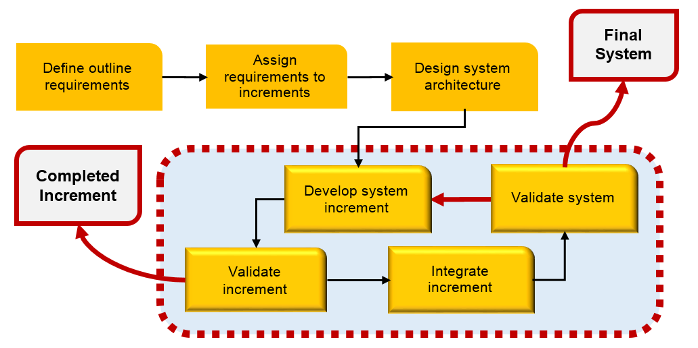

Figure 1 Incremental Delivery Process Model

* 1. Development Tools
  + Android Studio

Android Studio is the official integrated development environment (IDE) for Android application development, based on IntelliJ IDEA.

* + phpStorm

phpStorm is a commercial, cross-platform IDE for PHP built on JetBrains' IntelliJ IDEA platform. PhpStorm provides an editor for PHP, HTML and JavaScript with on-the-fly code analysis, error prevention and automated refactorings for PHP and JavaScript code. PhpStorm's code completion supports PHP 5.3, 5.4, 5.5 & 5.6 (modern and legacy projects), including generators, coroutines, the finally keyword, list in foreach, namespaces, closures, traits and short array syntax. It includes a full-fledged SQL editor with editable query results.

* + Gps

The GPS is a space-based satellite navigation system that provides location and time information in all weather conditions, anywhere on or near the earth where there is an unobstructed line of sight to four or more GPS satellites. The system provides critical capabilities to military, civil, and commercial users around the world.

* 1. Hardware and Material Resources

Laptops

--MacBook Pro (13-inch, Late 2011)

Processor: 2.4 GHz Intel Core i5

Memory: 4 GB 1333MHz DDR3

Graphics: Intel HD Graphics 3000 384 MB

Operating System: OS X Yosemite (V. 10.10.4)

Internet

Mobile phone: Android Operating System

--Oppo R8006

CPU: Quad core 1.6GHz

Memory: 1 GB

Operating System: Android OS (V. 4.3)

1. Chapter Three | Management Procedures
   1. Project Team Structure

|  |  |
| --- | --- |
| **Participants** | **Activities** |
| Nattawood Thobood | Feasibility Study |
| Project Proposal |
| Project Requirements |
| Project Plan |
| Software Architectural Design |
| Software Detailed Design |
| Implementation |
| Testing |
| Review |

* 1. Monitoring and Controlling Mechanisms
     1. Project Meeting

|  |  |
| --- | --- |
| **Participants** | **Roles** |
| Nattawood Thobood | Development |
| Noppon Choosri | Project advisor |

1. Chapter Four | Quality Planning
   1. Quality Standard

ISO 29110 is a software processes and guidelines for very small entities. A very small entity is mean an enterprise, organization, department or project having up to 25 people. The guide is based on subsets of appropriate standards elements, referred to as VSE profiles. The purpose of a VSE profile is to define a subset of ISO/IEC standards relevant to the VSE.

* + 1. Basic Profile Guide Processes

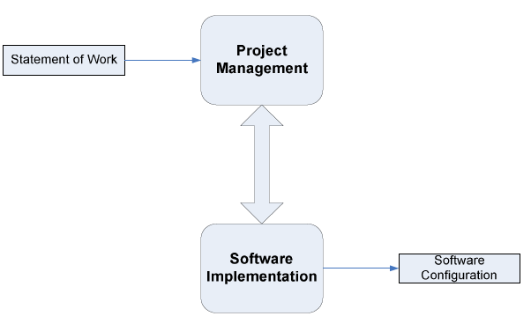

Figure 2 Incremental Delivery Process Model

Project Management (PM) process uses the customer’s statement of work to elaborate the project plan. The PM project assessment and control tasks compare the project progress against the project plan and actions are taken to eliminate deviations or incorporate changes to the project plan. The PM project closure activity delivers the software configuration, produced by SI, and gets the customer’s acceptance to formalize the end of the project. A project repository is established to save the work products and to control its versions during the project.

The execution of the Software Implementation (SI) process is driven by the project plan. SI process starts with an initiation activity of the project plan review. Project plan will guide the execution of the software requirements analysis, software architectural and detailed design, software construction, and software integration and test, and product delivery activities.

* + 1. Project Management Process

The purpose of the project management process is to establish and carry out in a systematic way the tasks of the software implementation project, which allows complying with the project’s objectives in the expected quality, time and cost.

Selected processes

4.1.2.1 Project planning process

4.1.2.2 Project plan execution process

4.1.2.3 Project assessment and control process

4.1.2.4 Project closure process

* + 1. Software Implementation Process

The purpose of the software implementation process is the systematic performance of the analysis, design, construction, integration and tests activities for new or modified software products according to the specified requirement.

Selected processes

4.1.3.1 Software implementation initiation process

4.1.3.2 Software requirement analysis process

4.1.3.3 Software architectural and detailed design process

4.1.3.4 Software construction process

4.1.3.5 Software integration and test process

4.1.3.6 Software delivery process

* 1. Reviews/Responsibility

|  |  |  |  |
| --- | --- | --- | --- |
| Stage Exit Review | | | |
| No. | Stage | Review Item | Responsibility |
| 1 | Requirement gathering | Project Proposal | NT,NC |
| 2 | Project Planning | Project Plan | NT,NC |
| 3 | Requirement Analysis and Specification | Software Requirement Specification | NT,NC |
| 4 | Architecture and Detailed Design | Software Design Document | NT,NC |
| 5 | Software Implementation | Code | NT,NC |

*NT = Nattawood Thobood *NC = Noppon Choosri

* 1. Testing

|  |  |  |
| --- | --- | --- |
| No. | Test | Responsibility |
| 1 | Unit Testing | NT |
| 2 | System Testing | NT |

*NT = Nattawood Thobood

1. Chapter Five | Schedule and Milestones
   1. Project Schedule

According to the architecture of our project and time schedule of senior project, we separated the whole project to four processes. The description is shown below:

**Five features:**

Feature#01: Authentication system.

Feature#02: Connecting system.

Feature#03: Notification system.

Feature#04: Travelling service system.

**Three processes:**

**Process 1:** Project Proposal

**Process 2 (Progress I):**

Feature#01: Authentication system.

**Process 3 (Progress II):**

Feature#02: Connecting system.

Feature#03: Notification system.

**Process 4 (ProgressIII):**

Feature#04: Travelling service system.

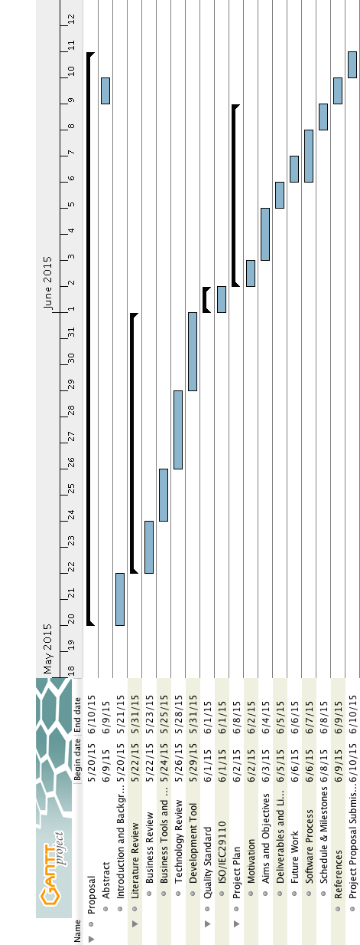

Figure 3 Project Proposal Milestone

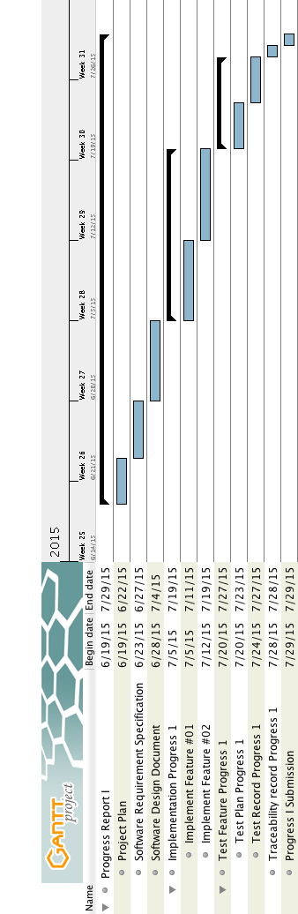

Figure 4 Progress Report I Milestone

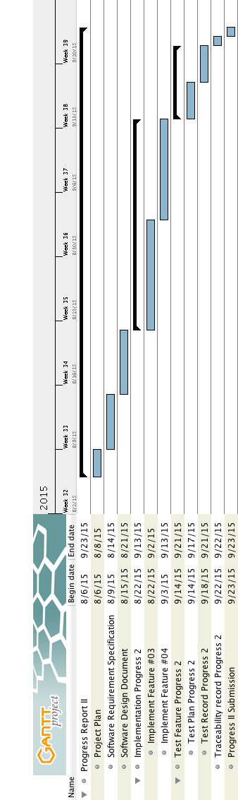

Figure 5 Progress Report II Milestone

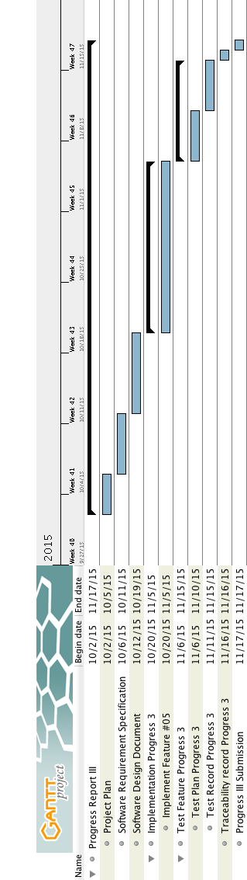

Figure 6 Final Progress Milestone

1. Chapter Six | Software Configuration Management
   1. Software Configuration Management

Software Configuration Management can coordinate the software management, which can minimize the confusion in the development. It is a set of activities designed to control changes by identifying the parts of the development that is likely to be changed, establishing relationships among them, defining mechanisms for managing different versions of them, controlling the changes imposed, and auditing and reporting on the changes made. In a word, Software Configuration Management is a methodology to control and manage a software development with its configuration. It can determine what to change and who to be responsible for the change when something goes wrong

* 1. Filename Format

For the filename format that we use for all project documents is:

Location based service for Red Cab taxi _ [Document name] _V [Version].file type

* 1. Change Management

Change Management manages all the changes in the software development of the project. All the change requests will be recorded in the Change Request Document. We use the strategy for change management as following steps:

1. Analyzing the change.
2. Designing the change plan.
3. Requesting for the change.
4. Approving the change request by project advisor.
5. Implementing the change as the approved change request.
   1. Software Configuration Item Table

|  |  |  |  |  |  |  |
| --- | --- | --- | --- | --- | --- | --- |
| No | Item | Filename | File Type | Owner | Path | Baseline Version |
| 1 | Project Proposal | Location based service for Red Cab taxi_Project Proposal_V.1.0 | .docx | NT | Location based service for Red Cab taxi/Proposal | 1.0 |
| 2 | Project Plan | Location based service for Red Cab taxi_Project Plan_V.0.1 | .docx | NT | Location based service for Red Cab taxi/Project Plan | 1.0 |
| 3 | Software Requirement Specification | Location based service for Red Cab taxi_SRS_V.0.1 | .docx | NT | Location based service for Red Cab taxi/Software Requirement Specification | 1.0 |
| 4 | Software Design | Location based service for Red Cab taxi_Software Design_V.0.1 | .docx | NT | Location based service for Red Cab taxi/Software Design | 1.0 |
| 5 | Test Plan | Location based service for Red Cab taxi_Test Plan_V.0.1 | .docx | NT | Location based service for Red Cab taxi/Test Plan | 1.0 |
| 6 | Test Record | Location based service for Red Cab taxi_Test Record_V.0.1 | .docx | NT | Location based service for Red Cab taxi/Test Record | 0.1 |
| 7 | Traceability Record | Location based service for Red Cab taxi_Traceability Record_V.0.1 | .docx | NT | Location based service for Red Cab taxi/ Traceability Record | 1.0 |

*NT = Nattawood Thobood

1. Chapter Seven | Estimated Effort and Cost

Most cost will come from learning materials and the hard copy documents. Because for this project, we develop our application with open source tools. So the most cost will be spent on buying some learning textbooks and printing the documents.

1. Chapter Eight | Risk Management
   1. Risk Management Process

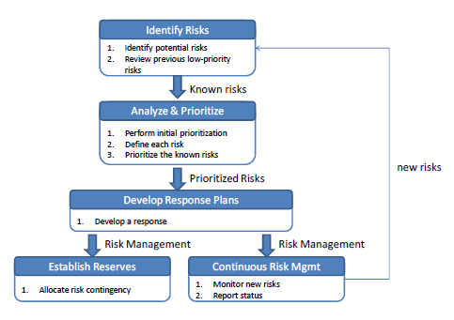

**Identify Risks**: Identify project and business risks which have the potential of affecting the project and documenting the risk’s characteristics.

**Analyze and prioritize risks**: Identify and assess the probability and impact of the risks.

**Develop response plans**: Come up with plans which will minimize or avoid threats and maximize opportunities.

a. Accepting the risk

b. Avoid the risk

c. Contingency plans

d. Transfer the risk

e. Mitigate the risk

* 1. Risk Identification and Solution

H-hight N-normal L-low

**Technology failure**

|  |  |  |  |  |  |  |
| --- | --- | --- | --- | --- | --- | --- |
| **Risk ID** | **Headline** | **Description** | **Priority Level** | **Impact** | **Likelihood of Event** | **Mitigation Strategy** |
| 1 | Sever fail | Some factors lead to the situation where the server cannot provide accurate data. | N | Users may not be satisfied with the application. | Certainty | Exception Handling. Displaying proper messages for the users. |

**Human failure**

|  |  |  |  |  |  |  |
| --- | --- | --- | --- | --- | --- | --- |
| **Risk ID** | **Headline** | **Description** | **Priority Level** | **Impact** | **Likelihood of Event** | **Mitigation Strategy** |
| 2 | Lack of responsibility of team’s member | A member of the team cannot finish her own task on time, or cannot meet the requirement of project. | H | The project cannot be delivered in time. | Somewhat likely | Report every team member’s work at project meetings, and discuss what should they finish before next meeting. |
| 3 | Lack of skills | A member of the team does not have experience and skill to do the project. In order to find/create certain functions, developers take longer time since they need to gather knowledge first. | H | It may lead to the situation where the project cannot finish in time. | Certainty | Practice and training. |
| 4 | A team member gets sick or has an accident | A team member may get sick or has an accident, and cannot work on the project. | L | It may leads to the situation where the project cannot finish in time. | Somewhat likely | **·** Adjust the plans and schedules.  **·** The absent member should assign works to the other member who can continue work on the project. |

**Process failure**

|  |  |  |  |  |  |  |
| --- | --- | --- | --- | --- | --- | --- |
| **Risk ID** | **Headline** | **Description** | **Priority Level** | **Impact** | **Likelihood of Event** | **Mitigation Strategy** |
| 5 | Project schedule changes. | Some factors may force the project schedule to change. | H | Influence progress | Certainty | Create comprehensive project timeline and adjust the project schedule according to the requirements. |
| 6 | The system faces reliability or stability issues. | Users cannot use the application or cannot get complete information because of unexpected external factors. | N | Users may not be satisfied with the application. | Somewhat likely | Manage the application and maintain the system timely. |
| 7 | Requirements might change. | New ideas from stakeholders make the project requirements change. | H | Affect the process of the application development. | Certainty | **·** Before developing each function, understand the needs as much as possible.  **·** Meet and discuss with other stakeholders. |
| 8 | Tasks are not completed in time. | Some factors may leads to the situation where the team members cannot finish their work in time. | N | Influence progress, and affect the delivery time. | Somewhat likely | **·** In project planning, team members should reserve buffer time.  **·** Meet with team members and find solutions. |
| 9 | Work cannot be traced. | The change of the requirement may lead us to change our previous work. | H | Spend a lot of time to trace back the changes. | Somewhat likely | Create the traceability record. |
| 10 | Works do not meet the requirements. | Team members did not understand the requirement clearly. | L | **·** Spend a lot of time to change.  **·** Cannot deliver the project in time. | Somewhat likely | Have a frequent meeting and share members’ understanding of the requirements. |

1. Chapter Nine | Reference

[1] Definition of project plan

http://en.wikipedia.org/wiki

[2] Definition of risk management

http://energy.gov/sites/prod/files/cioprod/documents/Risk_Management.pdf

[3] Definition of traceability

http://en.wikipedia.org/wiki

[4] Definition of unit test

http://en.wikipedia.org/wiki

[5] Definition of configuration item

http://www.businessdictionary.com/definition/configuration-item.html

[6] ADT Plug-in for Eclipse

http://developer.android.com/intl/zh-cn/tools/sdk/eclipse-adt.html