Introduction to programming

Homework 5

1. (Create an investment-value calculator) Write a program that calculates the future value of an investment at a given interest rate for a specified number of years. The formula for the calculation is as follows:

futureValue = investmentAmount \* (1 + monthlyInterestRate)^ (years \* 12)

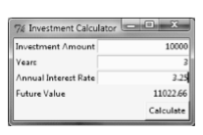

Use text fields for users to enter the investment amount, years, and interest rate. Display the future amount in a text field when the user clicks the Calculate button.

1. (Alternate two messages) Write a program to change, with a left mouse click, between two messages displayed on a canvas, “Programming is fun” and “It is fun to program,”.
2. (Traffic lights) Write a program that simulates a traffic light. The program lets the user select one of three lights: red, yellow, or green. When a radio button is selected, the light is turned on, and only one light can be on at a time (see Figure a–b). No light is on when the program starts.

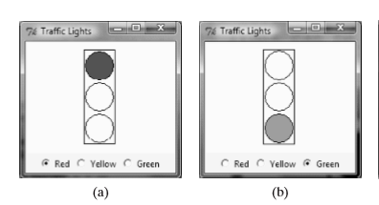

1. (Address book) Write a program that creates a user interface for displaying an address, as shown in Figure c.

