Introduction to programming

Homework 6

1. (Remove text) Write a program that removes all the occurrences of a specified string from a text file. Your program should prompt the user to enter a filename and a string to be removed. Here is a sample run:



1. (Count characters, words, and lines in a file) Write a program that will count the number of characters, words, and lines in a file. Words are separated by a whitespace character. Your program should prompt the user to enter a filename. Here is a sample run:

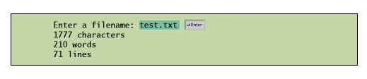

1. (Write/read data) Write a program that writes 100 integers created randomly into a file. Integers are separated by a space in the file. Read the data back from the file and display the sorted data. Your program should prompt the user to enter a filename. If the file already exists, do not override it. Here is a sample run:

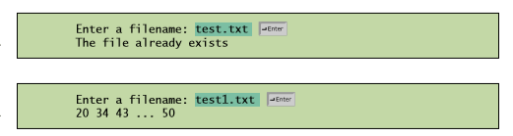

1. (Tkinter: display a graph) A graph consists of vertices and edges that connect vertices. Write a program that reads a graph from a file and displays it on a panel. The first line in the file contains a number that indicates the number of vertices (n). The vertices are labeled as 0, 1, ..., n-1. Each subsequent line, with the format u x y v1, v2, ..., describes that the vertex u is located at position (x, y) with the edges (u, v1), (u, v2), and so on. Figure a gives an example of the file for a graph. Your program prompts the user to enter the name of the file, reads data from the file, and displays the graph on a panel, as shown in Figure b.

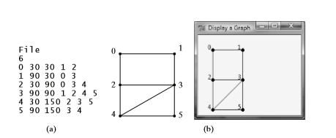

1. (Create large dataset) Create a data file with 1000 lines. Each line in the file consists of a faculty first name, last name, rank, and salary. Faculty’s first name and last name for the ith line are FirstNamei and LastNamei. The rank is randomly generated as assistant, associate, and full. The salary is randomly generated as a number with two digits after the decimal point. The salary for assistant professor should be in the range from 50,000 to 80,000, for associate professor from 60,000 to 110,000, and for full professor from 75,000 to 130,000. Save the file in Salary.txt. Here are some sample data:

FirstName1 LastName1 assistant 60055.95

FirstName2 LastName2 associate 81112.45

...

FirstName1000 LastName1000 full 92255.21