**Conditions for separating the customer types**

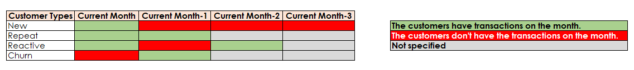

**Target Final Table for Exploring with Data Studio**

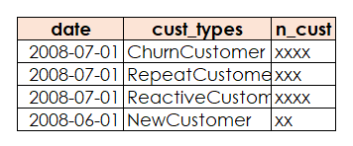

**Summary Result**

**Part1:** Separate NewCustomer, RepeatCustomer and ReactivedCustomer from raw data

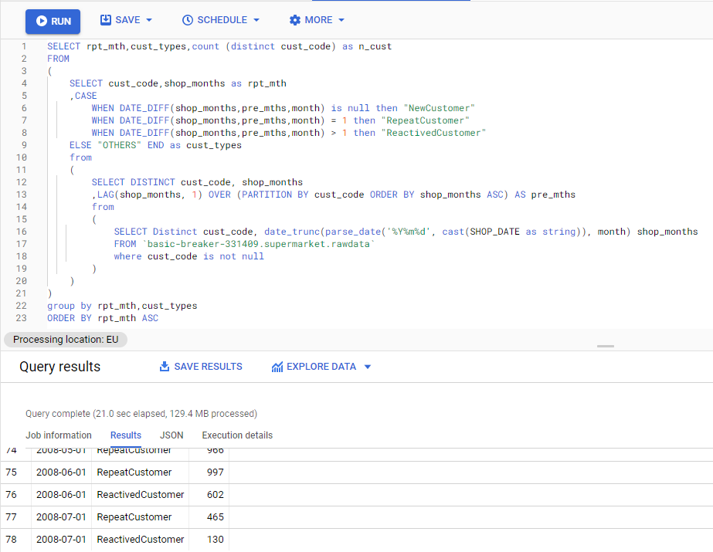

**Part2:** Separate Churn Customers from raw data

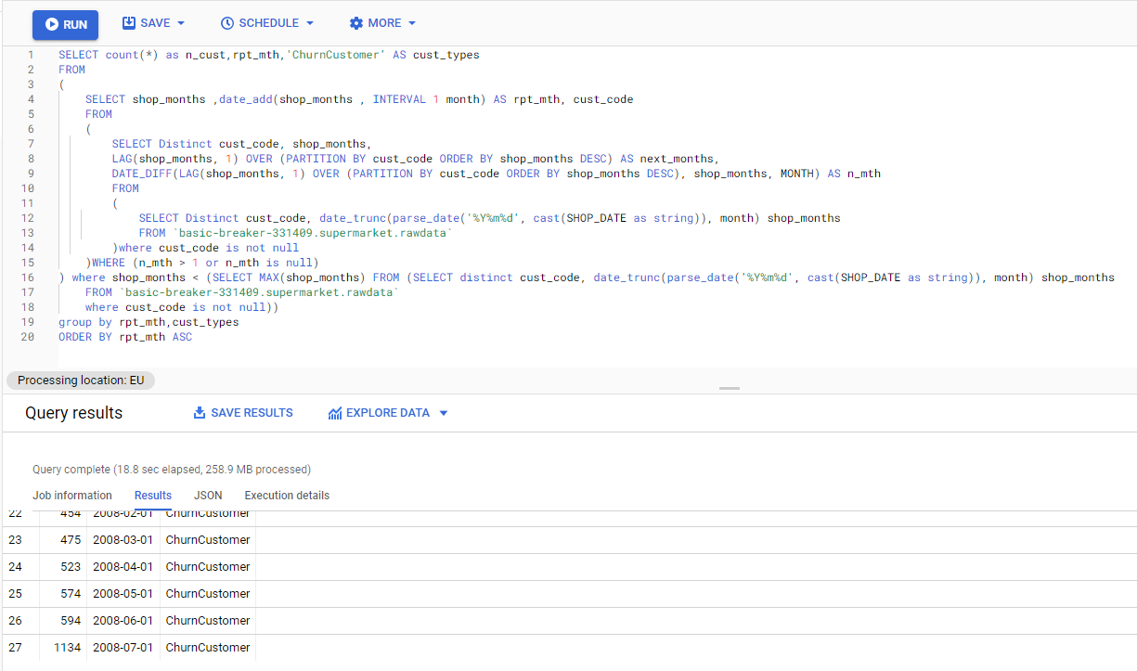

**Part3:** Combine the data in Part1 and Part2 by using union all

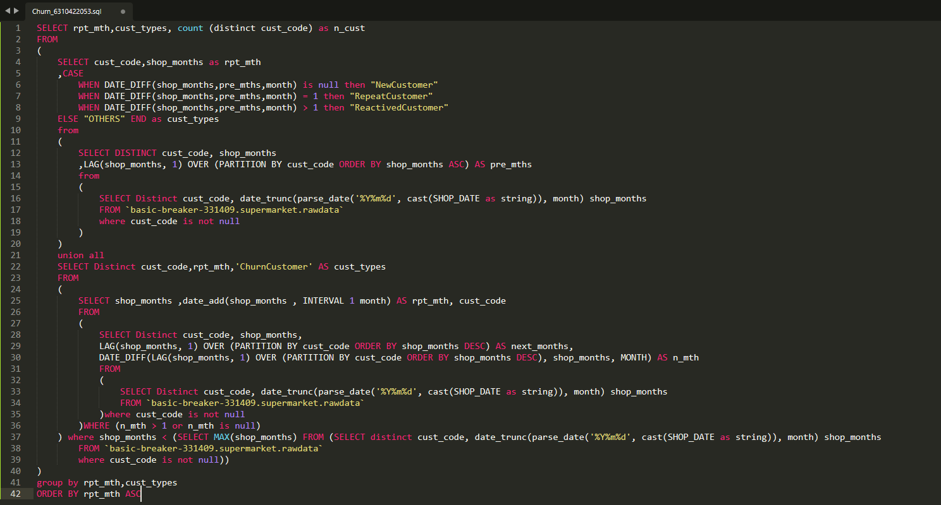

**Part4:** Result (Explore with Data Studio)

